Amenity and Facility Standards for Houses in Multiple Occupation
Reviewed 2023

Introduction 3 - 4
- Management 5 - 7
- Fire Safety 8 - 14
- Safety 15 -16
- Sleeping Accommodation – minimum room sizes 17 -18
- Space Standards 19 - 20
- Heating 21
- Personal Washing Facilities 22
- Sanitary Conveniences 23 - 24
- Storage, Preparation & Cooking of Food 25 - 30
- Refuse Disposal & Storage Facilities 31
- Housing Health & Safety Rating System (HHSRS) 32 – 33
- Planning & Building Control 34
- Further Information 35 - 36

Introduction

These Standards have been produced by Broadland District Council & South Norfolk Council for Houses in Multiple Occupation (HMO’s). It has been written to assist owners, agents and occupiers in relation to the licence application procedure (if applicable) and standards they should expect in such accommodation.

What is an HMO?
A house is a ‘House in Multiple Occupation’ (HMO) if both of the following apply:
- At least 3 persons live there, forming more than 1 household; and facilities such as a toilet, bathroom or kitchen are shared with other tenants.

A household is either a single person or members of the same family who live together. A family includes people who are:

- Married or living together - including people in same-sex relationships
- Relatives or half-relatives, for example grandparents, aunts, uncles, siblings, step-parents and step-children.

This includes shared houses and bedsits.

- An HMO is also a building which has one, or more, non-self-contained units. A non-self-contained unit is where one, or more, of the facilities is not within the occupant’s room. This applies even if the facility is for exclusive use of the occupant.
- An HMO is also a building that has been converted into self-contained flats and less than two- thirds are owner occupied and the conversion does not meet the appropriate Building Regulations. If the property was converted prior to June 1992, it must meet the 1991 Building Regulations. The property is therefore an HMO unless it meets the 1991 Building Regulations.

A Bedsit is:
- A form of accommodation made up of a single unit, (typically one room), in a property with shared facilities. The single unit is a bedroom, which may have an en-suite or contain a kitchenette. The occupant of the bedsit will share facilities such as a living room, kitchen, bathroom etc, with other tenants.
A Shared House is:
- Properties let on a joint contract with shared access to all areas of the property

The Licensing requirement:
A licence is required where HMO’s are occupied by five or more persons forming more than one household, regardless of the number of storeys.

A licence is also required for any purpose-built flats where there are up to two flats in the block and one or both are occupied as an HMO, including flats above or below shops and other businesses.

Fit & Proper Person:
If licenced, the licence holder and any manager of an HMO must be a fit and proper person. HMO licence applicants must declare relevant information and appropriate checks will be undertaken to ensure they are fit and proper to operate an HMO.

A database of rogue landlords and property agents has been introduced which can be used to verify / confirm any previous convictions.

Legal standards in HMO’s
The Housing Act 2004 and associated regulations state the minimum standards in HMO’s. This document will explain the legal requirements and provide the minimum standards for HMO’s adopted by Broadland District Council and South Norfolk Council.

Management Regulations
All HMO’s are subject to the Management Regulations irrespective of their licensable status. Please see attached link; http://www.legislation.gov.uk/uksi/2006/372/contents/made

What HMO’s does this guide cover?
These Standards are for all HMOs covered by the Licensing scheme. Further guidance is available in the document https://tinyurl.com/y9czvael

- Management

The Management of Houses in Multiple Occupation (England) Regulations 2006 apply to all standard HMO’s. Please see attached link to the Regulations;
http://www.legislation.gov.uk/uksi/2006/372/contents/made

The Regulations state the person in control of or managing the HMO has the following duties:

Table 1 Management
Provision and display of the manager’s contact information to the occupiers.
Maintenance of common parts, fixtures, fitting and appliances.
Maintenance of living accommodation.
Safety measures, including fire safety.
Supply and maintenance of gas and electricity.
Maintenance of water supply and drainage.
Provision of waste disposal facilities.

Occupiers:
Occupiers of HMO’s have a duty to ensure that they take reasonable care to avoid damage and disrepair to the property, and do not act in such a way as to obstruct the manager in complying with any Management Regulation.

Maintenance and Repair

The manager has a duty to maintain in good repair each unit of living accommodation within the HMO and any furniture supplied with it must be in a clean condition at the beginning of a person’s occupation of it.
Any fixtures, fittings or appliances within must be maintained in good repair and in clean working order.
Every window and other means of ventilation must be kept in good repair.

Asbestos and Legionella:
Comply with current statutory requirements relating to the safe management of the following:
- asbestos containing materials, and
- Legionella species risks

Pest control:
Employ a competent pest control contractor to undertake appropriate treatment of any pest infestation.

Repair timescales:
As far as is reasonably practicable keep within the following timescales in responding to information about disrepair and maintenance issues at the property:
- Emergency repairs: 24 hours (affecting health or safety e.g., dangerous electrical fault, defective fire detection system, blocked WC, no heating in cold winter conditions, etc.)
- Urgent repairs: 5 working days (affecting material comfort e.g., no heating or hot water, fridge failure, serious roof leak, etc.)
- Other non-urgent repairs: within a reasonable time, taking into consideration the extent and cost of the works required and any disruption for the occupiers.
*Please note that if an imminent risk to the safety of occupants is identified the council may take action to prohibit use of or restrict occupancy of the property.

Penalties for non-compliance:
It is an offence to fail to comply with the Regulations. The Council can prosecute when landlords or agents do not comply. On conviction, the Court can impose an unlimited fine per breach. The Council may decide to issue a civil penalty of up to £30,000 per breach as an alternative to prosecution. Not complying with each individual regulation is considered one breach. A decision on the appropriate enforcement approach to non-compliance will be made in accordance with the Council’s enforcement policy.

Equality Act 2010
The Equality Act 2010 provides the basic framework of protection against direct and indirect discrimination, harassment, and victimisation. Landlords and managers should be aware of the protected characteristics and prohibited conduct. The legislation can be accessed using the following link.
https://www.legislation.gov.uk/ukpga/2010/15/contents

All legislation can be accessed in full at www.legislation.gov.uk
- Fire Safety

The HMO manager has a duty to take safety measures, including in relation to fire safety:

All Licenced HMO’s will be required to provide the fire precautions in accordance with this document unless the HMO licence conditions specifically exempts or modifies such requirements.

Table 2.1 Fire Safety
The Regulatory Reform (Fire Safety) Order 2005 requires all HMOs to have a sufficient risk assessment regarding fire.
The Management Regulations require firefighting equipment and fire alarms to be maintained in good working order.
Norfolk Fire and Rescue Service may also enforce fire safety Regulations in communal, (shared), parts of an HMO such as shared kitchens, living rooms, hallways, stairways, etc*

*Broadland District Council & South Norfolk Council will liaise and work with Norfolk Fire and Rescue Service whenever appropriate to obtain specialist advice and guidance.
National Guidance on fire safety provisions for certain types of existing housing, published by LACORS, Housing – July 2008 (ISBN978-1-84049-638-3) is available.
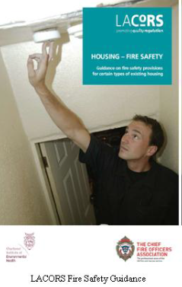

This document contains advice for landlords and fire safety enforcement officers in both local housing authorities and fire and rescue authorities on how to ensure adequate fire safety. Please use attached link to the document;
https://dashservices.org.uk/Media/Default/Docs/Lacors%20Fire%20Safety%20Guide.pdf

The following information is summarised from the Fire Safety Guidance Document and provided to help landlords understand their responsibilities and the fire safety precautions judged necessary for HMOs.
Fire Risk Assessment:
A Fire Risk Assessment is required. A Fire Risk Assessment is an organised and methodical look at the premises, the activities carried on there and the likelihood that a fire could start and cause harm to those in and around the premises.
Table 2.2 Fire Risk Assessment Aims
To identify fire hazards
To reduce the risk of those hazards causing harm to as low as reasonably practicable
To decide what physical fire precautions and management arrangements are necessary to ensure the safety of people in the premises if a fire does start

- A landlord or specialist contractor can undertake the risk assessment.
- Most properties will be relatively small and will have a straightforward and simple layout therefore, little fire safety expertise is likely to be required to carry out the risk assessment.
- In larger buildings or where the building contains different uses, i.e. commercial and residential, then specialist advice may be required.

Fire Precaution Requirements:

The requirements expected by the Council will be based on the advice detailed in the LACORS Fire Safety Guide and any specific advice from Norfolk Fire and Rescue Service.
Necessary measures may include:
- Fire Doors on high-risk rooms
- Fire separation
- Fire blanket in the kitchen
- Automatic fire detection system*
* Landlords are required to test and maintain fire alarm and emergency lighting systems in accordance with the British Standards.

Landlords should also be aware that where premises are occupied in a manner other than that intended under the original construction, compliance with the Building Regulations at the time of that construction will not necessarily negate the requirement for additional fire safety measures.

Table 2.3 Fire Alarm Systems
Grade D | - Should be tested on a regular basis, not less than monthly and more frequently whenever circumstances require.  - All detectors must be cleaned at least annually.  - Testing and maintenance must be in accordance with the manufacturer’s instructions.  - Landlords can self-certify this has been completed.
Grade A | - Should be tested on a regular basis, not less than monthly and more frequently whenever circumstances require.  - The system must be inspected and serviced at periods not exceeding six months in accordance with the recommendations of Clause 45 of BS 5839-1:2013.  - An inspection and servicing certificate of the type contained in H.6 of BS 5839-1:2013 should be issued by a suitably qualified and competent person.
Emergency lighting systems should be tested regularly, and a full system test and service must be completed annually by a competent person in line with BS5266.
Landlords are required to service firefighting equipment annually.

Non-standard layout/Higher risk homes:
If the property is of a non-standard layout or if the occupants present a higher risk due to factors such as:
- drug/alcohol dependency or
- limited mobility,
then the risk may increase, and additional precautions may need to be taken. This must be factored into your Fire Risk Assessment.

An example of a non-typical layout is ‘inner rooms’ where the bedroom is located such that the occupant passes through risk rooms (living rooms, kitchens or dining rooms) to reach the means of escape. There are various solutions available such as
- escape windows or
- water suppression systems;
these should be discussed with a case officer before undertaking works.

Fire Safety Precautions
The following fire safety precautions are based on typical properties with a simple layout, i.e., where all bedrooms lead onto the means of escape (i.e. the landing and hallway) and do not have to pass through any other room:

Low risk shared houses:
For properties let on a joint contract with shared access to all areas of the property and shared facilities the following requirements apply:

Table 2.4 Low Risk Shared Houses
Area | Measure | Required
 |  | 1-2 Storey | 3+ Storeys
Fire Doors | - Doors to kitchen and living room must be solid and close fitting. | Yes | Yes
 | - Doors to kitchen must be 30-minute fire doors with heat and smoke seals. | No | Yes
 | - Bedroom doors must be solid and close fitting. | Yes | Yes
 | - Bedroom doors must be 30-minute fire doors with heat and smoke seals. | No | Yes
 | - Fire door to living room must be 30-minute fire doors with heat and smoke seals | No | Yes
 | - Doors to any cellars must be 30-minute fire doors with heat and smoke seals. | Yes | Yes
Fire Alarm System | - BS 5839-6:2004 Grade D, LD3 fire alarm system with smoke detectors in escape route at all levels and heat detector in the kitchen. | Yes | Yes
 | - Additional interlinked smoke alarm in any cellar. | Yes | Yes
 | - Additional interlinked smoke alarm in any living room. | Yes | Yes
 | - Additional interlinked smoke alarm to bedrooms if smoke seals fitted to bedroom doors. | Yes | Yes
Firefighting equipment | - Fire blanket in kitchen. | Yes | Yes
 | - Simple multipurpose fire extinguisher in a position such that they do not obstruct the escape route. | Yes | Yes
Locks on doors | - Final exit doors have security lock that can be opened from the inside without a key, (break glass boxes not acceptable). | Yes | Yes
 | - Locks on bedroom doors, (where fitted), capable of being opened from inside without a key. | Yes | Yes
Protected escape route | - Understairs cupboards must have a ceiling that is 30-minutes fire resistant. | Yes | Yes
 | - Cellars must have a ceiling that is 30-minutes fire resistant. | Yes | Yes
 | - 30-minute protected fire route. | No | Yes
 | - Escape windows, (to current Building Regulation standard). | Yes | Yes

High risk shared houses or Bedsits:
Table 2.5 High Risk Shared Houses or Bedsits
Area | Measure | Required
 |  | 1-2 Storey | 3+ Storeys
Fire Doors | - All doors including Kitchen, living room, Bedrooms and Cellars must be 30-minute fire doors with heat and smoke seals and an overhead self-closing device. (FD30S) | Yes | Yes
Fire Alarm System | - BS 5839-6:2004 Grade D, LD2 fire alarm system with smoke detectors in escape route and (interlinked) heat detector in the kitchen. | Yes | No
 | - BS 5839-6:2004 Grade A, LD2 fire alarm system with smoke detectors in escape route and (interlinked) heat detector in the kitchen. | No | Yes
 | - Additional interlinked smoke alarm in any cellar. | Yes | Yes
 | - Additional interlinked smoke alarm in any living room. | Yes | Yes
 | - Additional interlinked smoke alarm to bedrooms | Yes | Yes
Firefighting equipment | - Fire blanket in kitchen/rooms with cooking facilities | Yes | Yes
 | - Simple multipurpose fire extinguisher in a position such that they do not obstruct the escape route. | Yes | Yes
 | - Simple multipurpose fire extinguisher in common parts on each floor | No | Yes
Locks on doors | - Final exit doors have security lock that can be opened from the inside without a key, (break glass boxes not acceptable). | Yes | Yes
 | - Locks on bedroom doors, (where fitted), capable of being opened from inside without a key. | Yes | Yes
Protected escape route | - Understairs cupboards must have a ceiling that is 30-minutes fire resistant. | Yes | Yes
 | - Cellars must have a ceiling that is 30-minutes fire resistant. | Yes | Yes
 | - 30-minute protected fire route. | Yes | Yes
 | - Escape windows, (to current Building Regulation standard). | Yes | Yes
 | - Emergency lighting to common parts (BS5266) where escape route is long or complex and there is no borrowed lighting | Yes | Yes
 | - Fire escape signage where escape route is long or complex. | Yes | Yes
Fire sprinkler system | - A fire sprinkler system (BS 9251:2005) with relaxations on the above requirements | Yes | Yes
For example, larger HMO (with 7 or more occupants), properties where kitchen facilities are in bedrooms, and/or other risk factors such as complex layouts and lack of interaction between the tenants. These properties require additional fire precautions. Each property will be risk assessed for the individual needs. The following requirements apply:
Buildings converted into flats:

Section 257 of the Housing Act 2004 applies to buildings or part of buildings that have been converted into self-contained flats. Please see the section 257 of the Act for further information.
The following table is the desired standards in a typical scenario.

*it may be appropriate to reduce this to 30 minutes for lower risk commercial premises where there is adequate fire detection and alarm systems
Table 2.6 Buildings converted into flats
60 minutes fire resistance between flats and any commercial premises*
30 minutes fire resistance between flats and common parts and other flats
30-minute fire resisting doors to the flat entrances (FD30S)
Mains wired interlinked optical type smoke detectors/alarms in common areas, basement/cellar and a heat detector in the room/lobby opening onto the escape route (BS5839-6:2004 Grade D, LD2)
Mains wired non-interlinked optical type smoke detectors/alarms in hallway (BS 5839-6:2004 Grade D, LD3)

- Safety

There are legal requirements to ensure all rented properties including HMO’s are safe for the occupants.

Carbon Monoxide and Smoke Alarms
The Smoke and Carbon Monoxide Alarm (England) Regulations 2015, as amended 1st October 2022, require all landlords to:

Table 3.1 Carbon Monoxide
Ensure a carbon monoxide alarm is equipped in any room used as living accommodation which contains a fixed combustion appliance (excluding gas cookers)
Ensure smoke alarms and carbon monoxide alarms are repaired or replaced once informed and found that they are faulty
*please note, smoke alarm specifications are contained within Section 2.
The requirements are enforced by the Council who can impose a fine of up to £5,000 where a landlord fails to comply with a remedial notice.
Further information can be found in an explanatory booklet for landlords
Electrical Safety
All landlords of privately rented properties including HMO’s must ensure compliance with the Electrical Safety Standards in the Private Rented Sector (England) Regulations 2020.
Table 3.2 Electrical Safety
Ensure the electrical installations in their rented properties are inspected and tested by a qualified and competent person at an interval of at least every 5 years.
Ensure national standards for electrical safety are met as written in British Standard 7671.
Supply the local authority with a copy of this report within 7 days of receiving a request for a copy.
Where the report shows that remedial or further investigative work is necessary, complete this work within 28 days or any shorter period if specified as necessary in the report.
Supply written confirmation of the completion of the remedial works from the electrician to the local authority within 28 days of completion of the works.
Please see Guide for landlords: electrical safety standards in the private rented sector - GOV.UK (www.gov.uk) for further information

Minimum Energy Efficiency

The Domestic Minimum Energy Efficiency Standard (MEES) Regulations 2018 set a minimum energy efficiency level of EPC band E for all domestic private rented property*¹.
The Energy Performance Certificate is valid for 10 years and should be provided to new tenants.
*¹ Any properties that are exempt from an EPC must be registered on Guidance on PRS exemptions and Exemptions Register evidence requirements - GOV.UK (www.gov.uk)

Gas Safety

As written in The Management of Houses in Multiple Occupation (England) Regulations 2006 and Gas Safety (Installation and Use) Regulations 1998, landlords have a duty to ensure gas appliances are safe.
Table 3.3 Gas Safety
Repair and maintain gas pipework, flues and appliances in safe condition
Ensure an annual gas safety check on each appliance and flue
Keep a record of each safety check
Must supply to the local housing authority within 7 days of receiving a request in writing from that authority the latest gas appliance test certificate it has received in relation to the testing of any gas appliance at the HMO by a recognised engineer.
Must not unreasonably cause the gas or electricity supply that is used by any occupier within the HMO to be interrupted.

- Sleeping Accommodation – Minimum Room sizes

Table 4 Sleeping Accommodation – Minimum Room Sizes
A usable floor area*¹ of 6.51m² – one adult (over 10 years of age)*²
A usable floor area of 10.22m² – two adults (over 10 years of age)
A usable floor area of between 4.64m² and 6.5m² may be occupied by a child under the age of ten only if the room is let / occupied in connection with the letting / occupation of a room with a useable floor area of at least 6.51m² to a parent or guardian of the child.
The obligate sharing of rooms by persons of the opposite sex over the age of 10 and who do not live as partners, shall not be permitted.

There are mandatory conditions in licences to regulate the size and use of rooms used as sleeping accommodation. This guidance is applicable to all HMO’s. The minimum sleeping room sizes are:

*¹ usable floor area of a room is where the distance between the lowest part of the floor and the ceiling measures at least 1.5m, (5ft). Any area less than 1.5m is to be disregarded.
The minimum room size is simply a standard below which a room cannot be used as sleeping accommodation. It is not intended to be the norm or the lowest common denominator.
*² A room of less than 6.51m² cannot be occupied as sleeping accommodation by any person aged 10 or over.

Any room less than 4.64m² may not be used as sleeping accommodation.
Communal space in other parts of the HMO cannot be used to compensate for rooms smaller than the prescribed minimum.
The minimum room sizes reflect those in section 326 of the Housing Act 1985 which is concerned with overcrowding in residential accommodation in England.
Licenses will be granted with a condition stating the maximum number of persons, (adults and children under 10), who may occupy the specified rooms as sleeping accommodation. Any room not specified as suitable for sleeping accommodation is prohibited from use as sleeping accommodation.
Temporary visitors are excluded from the regulations.
Hostels and charities providing temporary accommodation are also excluded from the minimum room size condition.
In the event of a pregnant woman living in a single occupancy room and the arrival of the child causing the room to become overcrowded, potential remedies could include securing alternative accommodation in the HMO or elsewhere. Alternatively, and if practicable, the overcrowding might be remedied by the enlargement of the room or the provision of an additional room (of not less than 4.64m²) for use as sleeping accommodation by the child.
Room Size Considerations:

What are the sanctions for breaching minimum room sizes?
A licence holder commits an offence if, without reasonable excuse, the licence holder breaches the licence by:
- Knowingly permitting the HMO to be occupied by more persons or households than is authorised by the licence; and
- Failing to comply with a condition of the licence such as a prohibition against occupation as sleeping accommodation.

If convicted of such an offence the licence holder is liable to an unlimited fine. A financial penalty of up to £30,000 may be imposed as an alternative to prosecution.

- Space Standards
All Licenced HMO’s will be required to comply with the space standards as detailed in this document unless the HMO licence conditions specifically exempts or modifies such requirements.
HMO’s where occupiers share kitchen facilities:
Follow the table from left to right to work out the space requirements in your HMO.
Table 5.1 Space Standards
 | Total number of people in HMO | Minimum kitchen size | 1 to 2 storey HMO minimum living space | 3+ storey HMO minimum living / dining space
 | 3-5 people | 7m² | 11m² separate living room; or  18m² combined kitchen/living room | Either: 11m² separate living room within 1 floor distance of kitchen; or  13m² kitchen/diner and 11 m² living room elsewhere; or  18m² combined kitchen/living/dining room.
 | 6-10 people | 10m² | 14m² separate living room; or  24m² combined kitchen / living room | Either: 14m² separate living room within 1 floor distance of kitchen; or  16m² kitchen/diner and 14m² living room elsewhere; or  24m² combined kitchen/living/dining room.
- The minimum kitchen area must be provided in all cases.
- A living room will be accepted as a dining room and vice versa, provided the minimum space requirements are fulfilled.

Bedsits

A bedsit is where:
- sleeping, living and cooking amenities are provided for exclusive use by occupants within a single unit accommodation, (i.e., one room) but where an amenity, i.e., a toilet, personal washing facilities or cooking facilities, are shared with the occupants of other bedsits in the building.
- Tenants will not always know each other and may have locks on bedroom doors.
A bedsit can be occupied by a maximum of two persons:
- Room sizes:
1 person bedroom/sitting room/kitchen: minimum of 13m²
2 person bedroom/sitting room/kitchen: minimum of 20m²

Self-Contained Flats

Table 5.2 1 or 2 person self-contained flats contained within a licensable HMO:
A self-contained flat is typically where all basic amenities are available for the exclusive use of its occupants and no amenities are shared with the occupants of other accommodation in the same building.
The bedrooms in self-contained flats must meet the minimum sizes of 6.51m² for one occupant and 10.22m² for two occupants

(N.B. Within a self-contained flat, if the kitchen is in the same room as the bedroom the minimum room sizes detailed for bedsits above must be met, i.e., 1 person bedroom/sitting room/kitchen: minimum of 13m² and 2 person bedroom/sitting room/kitchen: 20m²).
Notes:
- The measured space in any room must be ‘usable space’. The room should be able to accommodate the required amount of appropriate furniture easily and still allow space for movement about the room.

- Any floor space that has a ceiling height of less than 1.5m (5ft) shall be disregarded for the purpose of measuring the total space in the room.

- Heating

The Licensing and Management of Houses in Multiple Occupation and Other Houses (Miscellaneous Provisions) (England) Regulations 2006 schedule 3 prescribes that there should be suitable space heating.
HMO’s shall be provided with the following heating provision:

- Each unit of living accommodation in an HMO must be equipped with adequate means of space heating, capable of economically maintaining temperatures of 21ºC in living rooms and 18ºC in bathrooms when the outside temperature is –1ºC.

- The fixed space-heating appliance may be an adequate central heating system with thermostatic radiator valves (TRVs), or a fixed, hardwired electrical appliance.

- Each occupant should be provided with controls to allow them to regulate the temperature and timing settings within their unit of accommodation.

- Personal Washing Facilities

To meet the requirements of adequate size, layout, and fit for purpose, Broadland District Council & South Norfolk Council have adopted the following minimum standards:
Table 7 Personal Washing Facilities
 | An efficient and safe fixed space-heating appliance must be provided in the bathroom/personal washing room that can maintain a minimum temperature of 18ºC when the outside temperature is -1ºC*.
 | Bathrooms must have mechanical ventilation to the outside air at a minimum extraction rate of 15 litres/second in addition to any window(s). The system is to be either coupled to the light switch and incorporate a suitable over-run period, or an appropriately set humidistat.
 | A tiled splash-back shall be provided to all baths and wash hand basins.
 | Shower cubicles shall have fully tiled walls and be provided with a suitable water-resistant curtain or door to the cubicle.
 | Bathrooms and shower rooms shall have smooth, impervious wall and ceiling surfaces, which can be easily cleaned.
 | The flooring should be capable of being easily cleaned and slip-resistant.
 | Bathrooms and shower rooms must be constructed in such a way as to ensure and protect the privacy of the users.
 | Minimum dimensions shall apply:
 | Item | Dimension
 | Wash hand basin | 500mm X 400mm
 | Splashback | 300mm high
 | Bath | 1700mm X 700mm
 | Shower | 800mm X 800mm

*The fixed space-heating appliance may be an adequate central heating system with thermostatic radiator valves (TRVs) or a fixed electrical appliance. The heating must be under the control of the occupiers for timings and temperature settings.

- Sanitary Conveniences (Toilet Facilities)
To meet the requirements for sanitary conveniences, Broadland District Council & South Norfolk Council have adopted the following minimum standards:
Table 8.1 Sanitary Conveniences (toilet facilities)
Separate toilet compartments should be a minimum dimension of 1300mm × 900mm with 750mm in front of the toilet.
Each toilet in a separate compartment is required to have a window equivalent to 1/20th of the floor area or mechanical ventilation to the outside air at a minimum extraction rate of six litres/second.
An efficient and safe fixed space-heating appliance that can maintain each room at a minimum temperature of 18ºC when the outside temperature is –1ºC must be provided.
Toilets shall be readily accessible and normally not more than one floor away from the user. Shared facilities shall be accessible from a communal area. Facilities must be inside the building.
A wash hand basin must be provided in the same compartment as the toilet.
Compartments must be constructed in such a way as to ensure and protect the privacy of the users.

Table 8.2 Sharing Ratios for Bathrooms & Sanitary Conveniences
The Licensing and Management of Houses in Multiple Occupation and Other Houses (Miscellaneous Provisions) (England) Regulations 2006 set standards for sanitary conveniences.
Where there are four or fewer occupiers sharing facilities, there must be one bathroom with fixed bath or shower and a toilet, (which may be situated in the bathroom).
Where there are five or more occupiers sharing facilities, there must be:
- One separate toilet with wash hand basin for every five sharing occupiers.
- One bathroom, (which may contain a toilet), with a fixed bath or shower for every five sharing occupiers.

Please see the next page for further information about sharing ratios
Table 8.3 Facility sharing ratios
Number of people (irrespective of age) | Facilities required  (If a child under 10 lives at the property, a bath must be provided)
1 – 4 people | The minimum provision is 1 bathroom containing toilet, bath or shower and wash hand basin.  The bathroom and toilet may be in the same room.
5 people | The minimum provision is 1 bathroom with a bath or shower and 1 separate toilet with wash hand basin.  The separate toilet may be located in a second bathroom.
6 – 10 people | The minimum provision is:  • 2 bathrooms containing a bath or shower  • 2 toilets with wash hand basins, one of which must be in a separate room.
11 – 15 people | The minimum provision is:  • 3 bathrooms containing a bath or shower  • 3 toilets with wash hand basins, one of which must be in a separate room.
Bedrooms with en-suites | Where a room is provided with a complete en-suite facility (bath/shower, toilet, and wash hand basin) for the exclusive use of that occupant then that occupant will be disregarded when considering the provision of sanitary facilities. For example, six occupants and one occupant had exclusive use of a fully equipped en-suite. The requirement for the remaining occupants would be for five people.  If, however, the en-suite only provides one facility (either a bath/shower or a WC) then the occupant will not be disregarded for the missing amenity.

- Facilities for the Storage, Preparation & Cooking of Food

To meet the requirements, Broadland District Council & South Norfolk Council have adopted the following minimum standards:
Table 9.1 Facilities for the Storage, Preparation & Cooking of Food
Location:
The kitchen must be contained in the main building and located not more than one floor distant from the bedrooms. If this is not practicable in HMOs of not more than three storeys and not more than 10 persons, communal kitchens may be provided up to two floors distant from some bedrooms.
All kitchen facilities must be available for use 24 hours a day
Layout:
The kitchen layout must be safe, convenient and allow good hygienic practices.
Cookers should be located away from doorways and have enough floor space for items to be safely retrieved from the oven.
It must be possible to stand directly in front of the cooker and sink and to place utensils down on both sides of each.
If two sets of facilities are provided the layout must allow them to be used safely at the same time.

Suitable kitchen size:
- For three to five residents, kitchens shall have a usable floor area of at least 7m².
- For six to ten residents, kitchens shall have a usable floor area of at least 10m².
- The width of the kitchen must be at least 1.8m to allow safe movement of occupants.

Suitable kitchen layouts must be in place to allow for safe use. Below are examples of kitchen layouts:
Things to consider are the position of doors, cookers, sinks and electrical sockets for portable equipment.
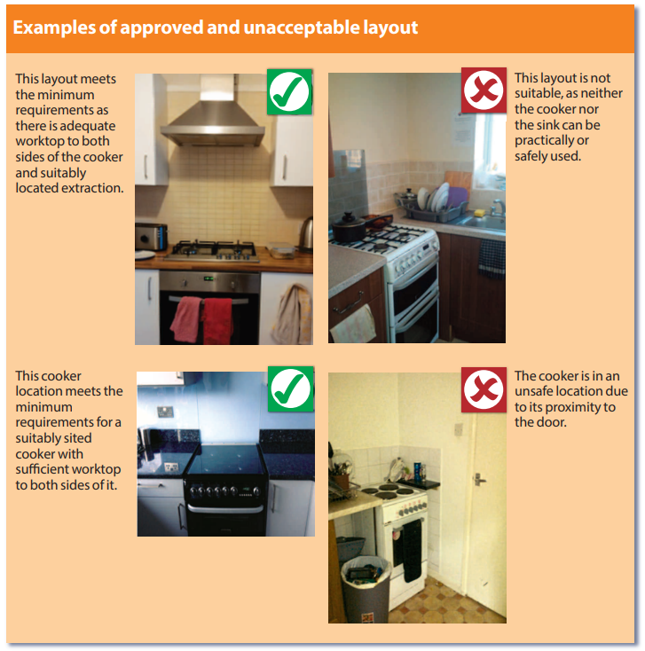
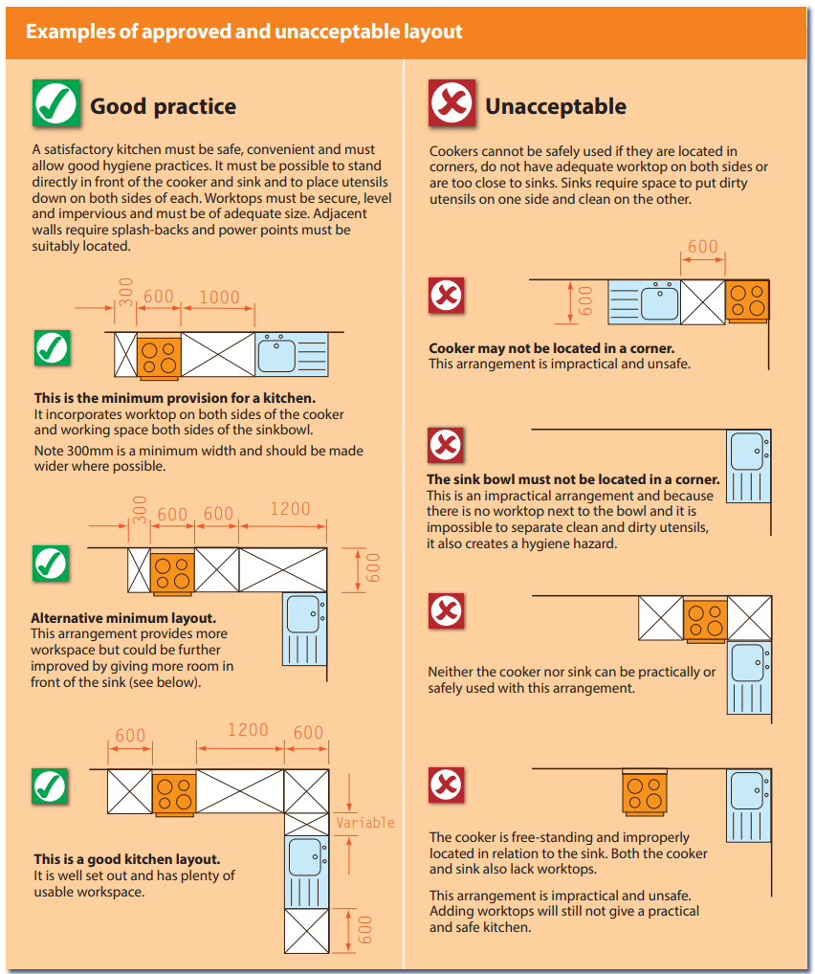

Table 9.2 A complete Set of Kitchen Facilities:
 | Sink | A stainless steel sink, integral drainer and a tiled splash-back, on a base unit. The sink must have constant supplies of hot and cold running water and be properly connected to the drains. The cold water must come directly from the rising water main. It must be possible to stand directly in front of the cooker and sink and to place utensils down on both sides of each.
 | Cooker | A gas or electric cooker with four ring burners, oven and grill, that are capable of simultaneous use. The cooker is to be located away from doorways with a minimum of 300mm worktop to both sides.
 | Electrical Sockets | At least three double 13amp electrical power points (in addition to those used for fixed appliances, such as washing machines).
 | Worktop | A kitchen worktop that is level, secure and impervious. The minimum dimensions are 1000mm length and 600mm width.
 | Storage | A food storage cupboard for each occupant that is at least one 500mm wide base unit or a 1000mm wide wall unit. This may be provided within each occupant’s room. (The space in the unit beneath the sink and drainer is not allowable for food storage).
 | Fridge/Freezer | A refrigerator with a minimum capacity of 130 litres plus a freezer with a minimum capacity of 60 litres. If not in the kitchen the fridge/freezer must be freely accessible and adjoining the kitchen.
 | Refuse Disposal | Appropriate refuse disposal facilities must be provided.
 | Ventilation | Mechanical ventilation to the outside air, in accordance with current Building Regulations. This is in addition to any windows.
 | Fire Precautions | Please see fire safety section.

Table 9.3 Minimum Provision of Kitchen Facilities
Number of people (irrespective of age) |  | Minimum Provision of Kitchen Facilities
3 – 5 people | A complete set of kitchen facilities as above.
6 – 7 people | Two complete sets of kitchen facilities as above with a 1500mm x 600mm work surface. However;  • a combination microwave is acceptable as a second cooker  • a dishwasher is acceptable as a second sink.
8 – 10 people | Two complete sets of kitchen facilities as above with a 2000mm × 600mm work surface.
11 – 12 people | At least two separate kitchens containing three complete sets of kitchen facilities as above, each kitchen with 2500mm x 600mm of work surface. However;  • a combination microwave will be acceptable as a third cooker  • a dishwasher will be acceptable as a third sink  • Two × 130 litre refrigerators with an additional 20 litres capacity of refrigerator space per person over 10  • Two × 60 litre freezer space with an additional 10 litres capacity of freezer space per person over 10.
13 – 15 people | At least two separate kitchens containing three complete sets of kitchen facilities as above, each kitchen with 5000mm × 600mm of work surface.

Kitchens for exclusive use (bedsits):
Legal requirement:
The Licensing and Management of Houses in Multiple Occupation and Other Houses (Miscellaneous Provisions) (England) Regulations 2006 requires rooms without shared amenities to be provided with adequate equipment.
Cooking | A gas* or electric cooker with a minimum two-ring hob, oven, and grill.
Storage | A 130-litre refrigerator with freezer compartment plus at least one food storage cupboard for each occupant in the bedsit (base units shall be 500mm wide and wall units shall be 1000mm wide). The sink base unit cannot be used for food storage.
Preparation | Worktop of at least 500mm deep and 1000mm long, comprising a minimum of 300mm both sides of the cooking appliance to enable utensils and pans to be placed down. All worktops must be securely supported, impervious and easy to clean.
Electricity | Two double 13-amp power sockets suitably positioned at worktop height for use by portable appliances, in addition to sockets used by fixed kitchen appliances, plus two double sockets located elsewhere within the bedsit.
Washing | A stainless-steel sink and integral drainer set on a base unit with constant supplies of hot and cold running water. The sink shall be properly connected to the drainage system. The cold water shall be direct from the mains supply. A tiled splash-back shall be provided behind the sink and drainer.
Ventilation | Mechanical ventilation to the outside air at a minimum extraction rate of 60 litres/second or 30 litres/second if the fan is sited within 300mm of the centre of the hob. This is in addition to any windows.
Layout | The same principles of safe layout and design apply in bedsits as for shared kitchens. Cookers must not be located near doorways to avoid collisions.
To achieve compliance with the requirements for adequate size, layout and equipment, Broadland District Council & South Norfolk Council have adopted the following minimum standards:
*Where a gas appliance is provided within a unit of accommodation, a carbon monoxide detector should also be provided.
Proprietary micro-style kitchenettes incorporating the above features may be suitable in certain situations, following consultation with a case officer.
- Refuse Disposal & Storage Facilities
Table 10.1 Refuse Disposal & Storage Facilities
The Council provides bins for household waste collection to all households in the district who pay Council Tax as follows:
A standard set of 240 litre bins for household (Broadland – one green bin for general refuse and one grey bin for recycling & South Norfolk – one black bin for general refuse and one green bin for recycling)
A larger 360 litre green/black bin to households of 5 or more
A larger 360 litre grey/green bin is available to any household with larger amounts of extra recycling at each collection
An extra set of bins may be delivered if there is more than one family residing in a property, or an annexe, and is paying separate Council Tax
Other arrangements can be put in place where there are exceptional circumstances at a property, e.g, a large number of residents or residents with special needs
Large communal bins are only provided where there is not space for smaller bins to be provided
Table 10.2 Refuse Disposal & Storage Facilities
The Council operates an alternate weekly collection of refuse and recycling waste. To comply with the requirements of the licence the landlord must:
Agree suitable waste storage and collection arrangements with the Council at the earliest opportunity.
Store all household waste from the property safely and securely within the boundary of the property.
Ensure all household waste is contained within bins provided by the Council and that any other waste is dealt with promptly and legally to prevent any potential nuisance/issue.
Ensure all tenants are aware of the household waste collection arrangements for the property including what can be accepted through the refuse and recycling scheme (details are available on the Council’s website or from the Environmental Services Department at the Council).
Ensure that all household bins are presented by 07:00 on the day of collection and are returned to the property following collection
Legally dispose of any waste generated in any maintenance of the property, including any DIY and construction and demolition waste. The landlord must be able to provide a Waste Transfer Note upon request for such controlled waste.
HMO licences will require the licence holder to comply with their local authority policy for the provision of facilities for the proper disposal and storage of domestic refuse.

- Housing Health and Safety Rating System (HHSRS)
The Housing Health and Safety Rating System, (HHSRS), is the legislation which gives minimum standards for all homes, including HMO’s. When HMO’s are inspected, any defects found as part of this procedure will be subject to HHSRS.
It is a risk-based evaluation tool to help local authorities identify and protect against potential risks and hazards to health and safety from any deficiencies identified in properties. There are 29 hazards detailed within the HHSRS, the most common being:
Table 11 HHSRS Common Hazards
 | Damp and Mould Growth | Houses should be warm, dry, well-ventilated and maintained free from rising and penetrating damp and condensation. There should be adequate provision for the safe removal of steam / moisture to prevent damp and mould growth.
 | Excess Cold | Houses should be adequately insulated to prevent excessive heat loss and have an effective heating system capable of maintaining temperature.  An Energy Performance Certificate, (EPC), is required every time a home is put up for sale or for rent. There are a few exceptions, i.e. for a room that’s being rented out by a resident landlord and listed buildings may also be exempt.
 | Entry by Intruders | Houses should be capable of being secured against unauthorised entry. Windows and doors must be robust and fitted with adequate security. Externally, the curtilage of the property should be restricted and secure. Sheds and outbuildings should be maintained secure and in good repair.
 | Lighting | All habitable rooms should have an adequate level of natural lighting. All rooms and circulation areas should have provision for electric lighting.
 | Electrical Hazards | The electrical installation should be maintained in a safe condition. There is a legal requirement for the electrical installations in HMO’s to be inspected by a competent person every five years.

 | Flames, hot surfaces, etc. | Heating and cooking appliances should be maintained in a safe condition and be suitably located so as not to become hazardous. Cooking appliances should be set on an even surface and heating appliances securely fixed in a suitable position within the room.
 | Falls | Internally, floors should be even, non-slip and be maintained in a good condition. Stairs should be maintained in good condition and be free from disrepair. Stair coverings should be securely fitted and should not be worn or loose. A securely fixed handrail should be provided the full length of the stairway. Balconies and basement light wells should have securely fixed guarding.  Externally, paths should be even, properly drained and steps should be maintained in good condition and be free from disrepair.
 | Personal hygiene, sanitation and drainage | Bathroom and kitchen surface finishes should be capable of being readily cleaned. The external of the property should be free from disrepair and free from access by pests, such as rats and mice. There should also be suitable provision for the storage of domestic waste inside and adequate receptacles outside the property – see additional section on new licensing requirements for refuse disposal and storage facilities.
 | Water Supply | An adequate supply of potable drinking water should be available from the kitchen sink. All pipework should be adequately protected from frost damage.  Further guidance can be found on the Housing and Safety Rating System via the following link;  https://www.gov.uk/government/publications/housing-health-and-safety-rating-system-guidance-for-landlords-and-property-related-professionals

- Planning and Building Control
Table 12 Planning
HMO with 3 to 6 persons | HMO’s occupied by between three and six unrelated persons are defined as Use Class C4 by the Town and Country Planning (Use Classes) Order 1987 (as amended). Dwellings occupied by families or fewer than three unrelated people are defined as Use Class C3.  Planning permission may be required from the Council to change the use of a dwelling to an HMO in Use Class C4.
HMO with 7+ occupiers | HMO’s with seven or more occupiers require planning permission and owners and managers are recommended to contact the Planning Department to clarify the planning status of the property*

*South Norfolk Council:
The Horizon Centre, Broadland Business Park, Peachman Way, Norwich, NR7 0WF
Telephone: 01508 533813
*Broadland District Council:
The Horizon Centre, Broadland Business Park, Peachman Way, Norwich, NR7 0WF
Telephone: 01603 430509
*Email: (Broadland and South Norfolk)
planning@southnorfolkandbroadland.gov.uk
Building Control
Alteration / improvement works, including those requested by the Council such as window replacement, drainage works or alterations to the electrical system, etc. may require Building Regulation or Building Notice approval.

For Further Information:

Address: CNC Building Control, The Horizon Centre, Broadland Business Park, Peachman Way, Norwich, NR7 0WF

Telephone: 0808 168 5041

Quotations: quotations@cncbuildingcontrol.gov.uk
General Enquiries: enquiries@cncbuildingcontrol.gov.uk
Applications: applications@cncbuildingcontrol.gov.uk
Amendments: amendments@cncbuildingcontrol.gov.uk

Further Information
For further information on the licensing of HMO’s or to make an application for a licence, please visit the Council’s website by clicking on the following link.
https://www.southnorfolkandbroadland.gov.uk/licensing-2/houses-multiple-occupation

Or email the Housing Standards Team:

South Norfolk Council: hstandards.snc@southnorfolkandbroadland.gov.uk

Broadland District Council: hstandards.bdc@southnorfolkandbroadland.gov.uk

Keeping Housing Standards informed of changes:
Change/s: | What to do:
Changes in licence holder | Notify the Council in writing of any changes to the name, address, or any other contact details, (including email address), of the licence holder, manager or any other person involved in the management of the property, within 14 days of that change.
Changes to property layout or room numbering | Do not make alterations to any aspect of the layout of the property, or number of rooms, without first gaining written consent from the Council. Requests should be made in writing to the Council and include a full description of the proposed changes.
Changes in the way the property is occupied | Notify the Council of any proposed changes to the way the property is occupied to determine any consequent need for alterations to the required levels of amenity and facility provision or the permitted number of occupants.
Increase in occupation above the permitted numbers | If the occupation of the property rises beyond the maximum permitted number, inform the Council in writing within 28 days of the over occupation occurring.

Relations with neighbours and dealing with anti-social behaviour
Anti-social behaviour by tenants | Take all reasonable and practicable steps to prevent or reduce anti-social behaviour by persons occupying or visiting the house.
Illegal activity | Take all reasonable steps to ensure that the property is not used for illegal or immoral purposes.
Property appearance | Take all reasonable steps to maintain the external appearance of the property in a reasonable condition taking into account its age of the property, character and locality.
Monitor for anti-social behaviour | Arrange inspections of the property on a regular basis to check standards and assess if there is evidence of anti-social behaviour; this should be at least quarterly, but more frequently if anti-social behaviour has been established.

