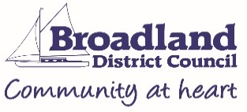 | Application to Register for Acupuncture, Electrolysis, Tattooing, Semi-Permanent Skin-Colouring, Cosmetic Piercing, Ear Piercing.

I/we hereby make application under the Local Government (Miscellaneous Provisions) Act 1982 (as amended by the Local Government Act 2003) for registration of the following:
☐ Acupuncture ☐ Electrolysis
☐ Tattooing ☐ Semi-permanent skin-colouring
☐ Cosmetic piercing ☐ Ear piercing

Area in which the business is to be registered (click to open drop-down menu):

Choose an item.

Full name(s) of applicant(s)

Digital photograph of practitioner(s) (attach in line or as an additional file in submission email)

Home address(es) of applicant(s)

Contact telephone number(s)

Email address(es)

Trading name (if appropriate) and address of premises for which registration is required

Brief sketch of business layout (i.e., room layout, position of hand washing, toilet facilities etc.)
(please attach a separate sheet if necessary)

You must not start to practice until you are registered and then you must be confident that you are complying with the byelaws. A copy is attached below, along with the CIEH tattoo and body-piercing toolkit. (Double click to open).

In reference to the byelaws, please briefly describe how you plan to comply with the following:

- Appropriate training. Please attach and send proof of training for both an infection control course and for the skin piercing procedure.

- Treatment area to be hygienically cleaned and disinfected
This would include any equipment, couch roll, other barriers and chemicals used.

- Excellent levels of personal hygiene and techniques used.
This would include use of a dedicated washbasin with a clean running hot water supply, in the near vicinity for practitioner sole use.

- Suitable storage and disposal of sharps and clinical waste

- Use of appropriate paperwork for pre-treatment and post procedural care

- All persons/procedures to be covered with relevant insurance

Have you previously been registered for any of the above in any other district? If the answer is ’Yes', please state which district:

I wish to apply for the registration of the above premises for the purposes shown and certify that the details given are correct. I also confirm that my business and practices conform to the byelaws, and that once the registration fee has been paid, this is non-refundable.

Signed

Position in company

Date

Please return this form by email to: foodandsafety@southnorfolkandbroadland.gov.uk
or post to: Food, Safety & Licensing Team, Horizon Centre, Peachman Way, Norwich. NR7 OWF.

Once validated, the business support team will contact you to obtain payment. Payment is non-refundable. The most up to date fees can be found on our website at:
https://www.southnorfolkandbroadland.gov.uk/health-safety/skin-piercing-registrations

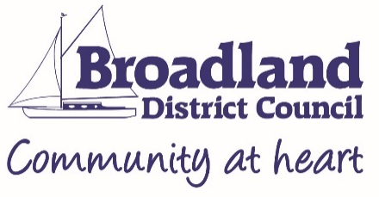

Privacy Notice – fulfilling Article 13 paragraph1 General Data Protection Regulation (GDPR) (EU) 2016/679
About Us

Broadland and South Norfolk Council takes your privacy very seriously and provides the following information in compliance with data protection legislation. Broadland and South Norfolk Council, in determining the purpose and means of processing your personal data, are for these purposes what is known as the ‘Data Controller’.

What We Do with Your Data

The purpose of collecting your personal data is to allow Broadland and South Norfolk Council to register you for acupuncture, tattooing, ear piercing and electrolysis activities as appropriate. An electronic file is created to record information associated with your business with regards to Health & Safety law and public health. The lawful basis for processing your personal data is ‘processing is necessary for the performance of statutory duties which lie in the interest of the public’.

Retention Period/Criteria

Your personal data will be retained by Broadland and South Norfolk Council for 6 years after closure. Any information relating to any legal action that may be taken could be held for up to 10 years.

Your rights

Under data protection law you have the right to request access to, rectification, restriction or objection to the processing of your personal data, as detailed in our Privacy Policy (on our website). You can contact our Data Protection Officer at right2know@s-norfolk.gov.uk (South Norfolk) or dpo@broadland.gov.uk (Broadland). You also have the right to lodge a complaint with the regulator, the Information Commissioner’s Office.

Third party processing

Please note, the information supplied may also be shared with Trading Standards, Broadland and South Norfolk Council Business Rates Department, Food Standards Agency and Public Health England. Such information may be provided to assist them in carrying out their normal duties, or to assist/inform them of an issue that presents a risk to public health.

