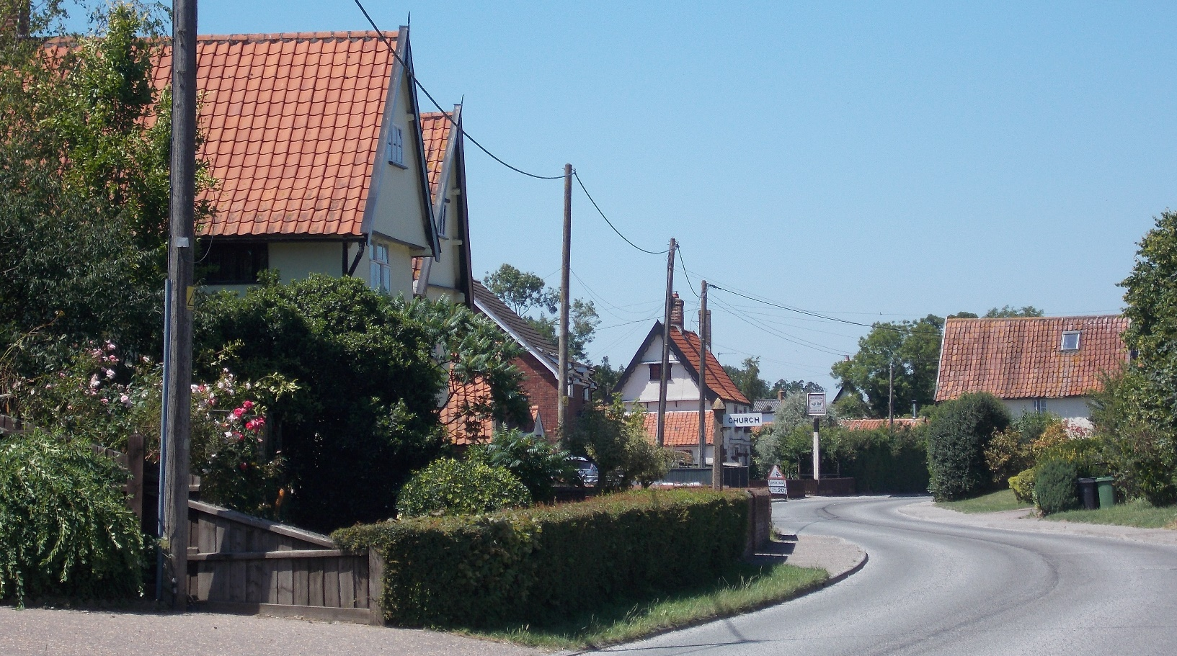
Winfarthing
Conservation Area Character Appraisal
and Management Guidelines

July 2021

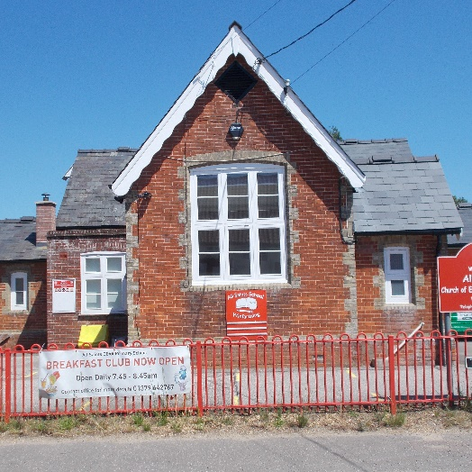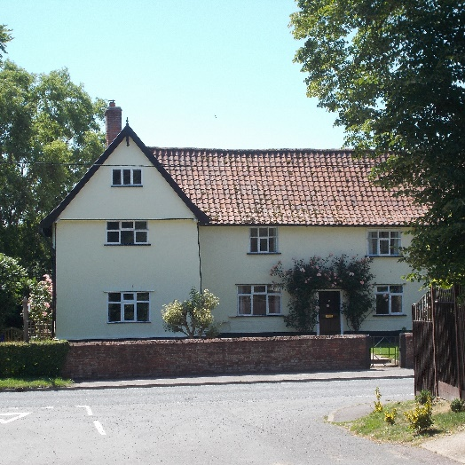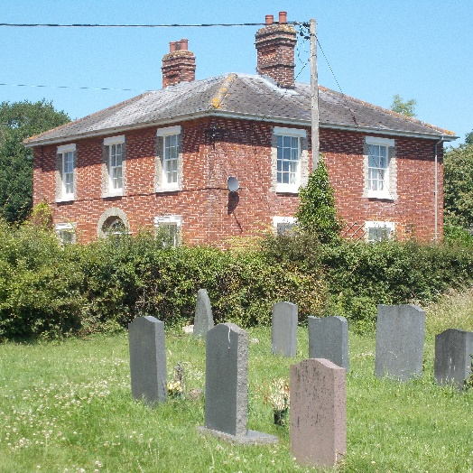
Content

Introduction 3

Historical Development 4

Character Assessment 5

Conservation Management Guidelines 12

Appendix 1(i) - Listed Buildings in 14 Winfarthing Conservation Area

Appendix 1(ii) - Unlisted Buildings in 14
Winfarthing which are of townscape significance

Appendix 2 - Policy & Consultation 15

Appendix 3 - Conservation Area Boundary 16

Appendix 4 - Historic Map 17

Appendix 5 - Streetscape 18

Appendix 6 - Natural Character 19

Introduction
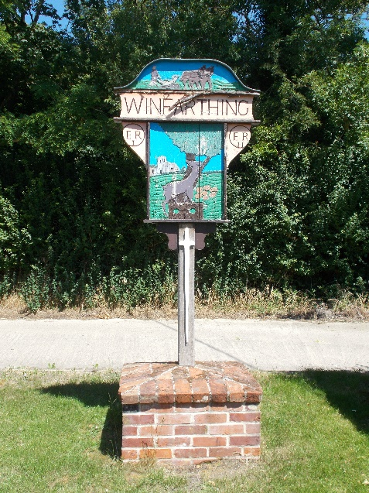  The village sign | The village of Winfarthing follows the B1077 about 4 miles north of Diss. The conservation area covers a short section of the centre of the village on both sides of the road.  Under the terms of Planning (Listed Buildings and Conservation Areas) Act 1990, the Local Planning Authority is required to identify areas of special architectural or historic interest whose character or appearance it is desirable to preserve or enhance, and to designate them as a Conservation Area. The 1990 Act also requires local authorities to prepare management guidance and proposals for Conservation Areas. Winfarthing conservation area was originally designated in 1994. This document should be read in conjunction with the adopted Local Plan, the National Planning Policy Framework and Planning Practice Guidance.
Key Characteristics
- Significant historic buildings in key positions

- Positive contribution of trees and natural spaces

- Original spaces between historic buildings largely infilled by modern dwellings

Historical Development (also see historic map in Appendix 4 p17)
The name “Winfarthing” could derive from the Danish “Winning” or “Wina” and “forthing”, which means a division of land or quarter ie. “Wina’s Forthing”, and with “ing” meaning son or descendent, the settlement could have been originated by the son of Wineforth. Domesday Book records it as “Wineferthic”. Whatever the origins, it seems that Winfarthing is the only place in England having that name. Domesday Book records that the settlement was one league long and half a league wide and was of some importance, being the centre of the Winfarthing Hundred. The Area was heavily wooded and in the 11th century was considered to be the prime woodland in Norfolk. One particular tree, known as the “Winfarthing Oak” grew near Park Farm and was reportedly 700 years old when it blew down in a gale in 1930. The importance of the village continued into the 16th Century when in 1593, the inhabitants secured exemption from certain civil duties and taxes. This was authenticated by Elizabeth 1st.

The heyday for the parish was in the 19th century when the population rose to around 700 and like many others, the village supported a number of craftsmen and traders. A poor house was provided and survives as Guildhall Cottages. The village has three rectories. The first, the Old Rectory, is of early 17th century date. Its successor, now Yew Tree House, was begun in the late 17th century but extensively altered in 1877. The Rector now lives in the modern house to the west of the Church. The school was also built at this time, in 1854, on Glebe Land to the south, accommodating at first over 80 children.

The population of the village has remained much the same for most of the 20th century at around 400. In 2001 the figure was 403, with the latest estimate in 2011 of 503.

Character Assessment
(Also see Streetscape and Natural Character Maps in Appendices 5 and 6 pages 18 and 19)

Winfarthing and its setting

Winfarthing has developed as a linear settlement along the B1077 which runs from Attleborough to Diss .A matrix of unclassified minor roads and footpaths connects the village to its neighbours.

The Parish of Winfarthing includes the minor hamlets of Short Green and Goose Green: an area generally characterised by dispersed farmsteads but whose farmhouses and their associated buildings retain their place in the main streets.

The village is surrounded by large open fields which give distant views along the shallow valley to the south the ground forming the gently rolling northern slopes of the River Waveney. The "edge" between the village and surrounding countryside can be quite dramatic and heightened by trees and hedges.

Conservation Area Boundary

The Conservation area encompasses The Street to generally a single plot depth from the school in the south to Stocks Hill in the north. An expanded area to the east includes the Church and properties to the north.

Some changes have been agreed to reflect changes to property boundaries, to include Tracey’s Wood but to exclude part of the field south of the churchyard

Street Patterns and Historic grain

The street pattern, with the subtle curves of The Street and the secluded areas around the Church and Church Lane, helps to create several interesting and varied vistas shaped and enhanced by mature trees, hedges and walls.

The Street is itself a linear development of single plot frontage with a few historic buildings located along its length. Church Lane is more intimate, with an informal group of historic buildings set amongst mature trees and open green spaces.

Significant buildings in the conservation area are scheduled in Appendix 1 and shown on the Map on p18.

Most of the historic buildings are two storey farmhouses and cottages, sometimes with attic rooms. Most are good examples of the building types found in South Norfolk dating from around 17th century and constructed largely of timber framing and render with steep pitched pantiled roofs.

In some cases, historic "out buildings" survive, some now in residential use, which contribute to the general character and help to give depth to the linear settlement.

Perambulation

Church Lane

Church Lane gives access to some noticeable buildings, but the area is dominated by mature trees and hedges.

The boundaries to the churchyard are formed by prominent trees, hedges with a ditch along the lane. The importance of the church, and its churchyard is not therefore, immediately apparent.

But once behind those natural boundaries, the church is impressive, set on higher ground which helps to heighten its impact.

The combination of traditional materials: stone, flint and lead work, with mature trees and natural landscape create a most attractive space.

The gates and railings are of interest.

To the south lies the new rectory set in a heavily treed garden. It has been sensitively designed with a dominant roof but is largely hidden from view.

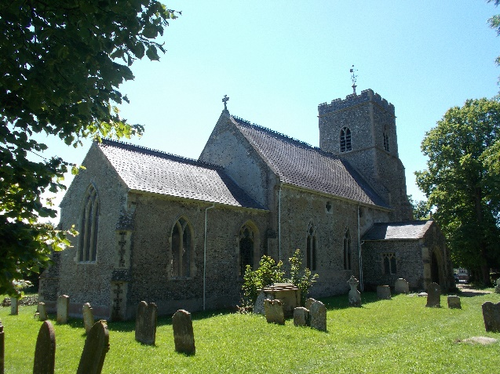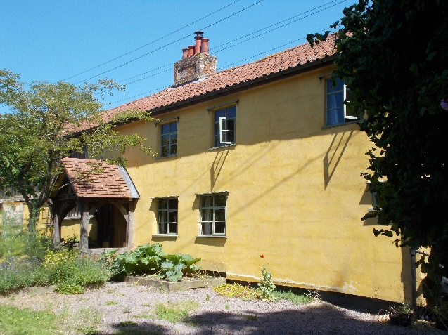

St Mary’s Church Church Hill Farm Cottages

The Old Parsonage is a prominent building on the other corner of the lane. It appears to be of generally 19th Century construction although it may contain fabric from an earlier date. It is a large L-shaped building. It has a well- designed wall and railing to the lane. The garden surrounding the house to the north east and west has many mature trees which add significantly to the landscape quality.

The Old Rectory is set back, again shrouded in the trees of its mature garden. The building has been subject to extensions and a separate garage building has been added which complement the character of the building

To the east of the Old Rectory is a grassed track which gives access to "Clerks Cottage" to the north. It is also a public footpath. It is bounded on one side by a pleasant hedge and the charming cottage garden to Church Hill Farm Cottages. These have been carefully restored and with its rendered and timbered walls, is most attractive. The track and footpath end abruptly at Clerk’s Cottage, which has been altered in recent times, but the original form still dominates.

The western boundary to this group of buildings is formed by Church Farm. The main barn is now converted to a separate dwelling with its former brick and tiled outbuildings prominent in the views of the lane.

To the north of the land is “Woodsfield” a Georgian style building with an impressive modern extension.

At the junction with The Street is a small village green with the village sign and notice board. The access track leads to the gravelled car park for the school which is screened from The Street by a tall hedge.

The Street - South of Church Lane

Immediately opposite the junction of Church Lane is Church Farm House. This prominent house, of great interest has rendered walls and tiled roofs and closes the vista from Church Lane to The Street. Its eastern boundary to The Street is formed by a low screen wall. Farthing House to the south, is also dominant in the street but its wide access and hard surfaced parking area is unfortunate. The road is usually wide at this point to accommodate the path to the school and lay bye although the hedge on this side is welcomed

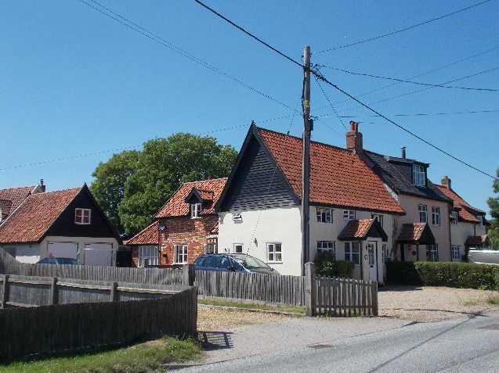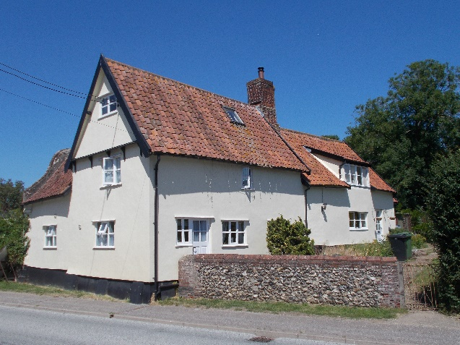
April Cottage Church Farm House

April Cottage, Schoolhouse and Elsey Cottages, with Bradstock House behind, mark the entrance to the area at the south end. Their setting would be improved if their open front gardens were more enclosed by walls/or hedges.

The school itself is set back from the street behind brightly coloured railings and while there has been much alteration and addition to the building, the character of the original building is still strong with its decorative barge boards, gault brick quoining and window dressings.

The playing field to the north provides an attractive green space associated with the school, enclosed on three sides by hedging.

The Street - From Church Farm House to Holly Farm and Stocks Hill.

To the north of Church Farm House lie the associated farmyard buildings, some traditional, in flint and brick, some modern.

The road frontage is provided by a continuation of the low screen wall to the house in flint and brickwork, with the farm access separating the wall with a later version beyond. This contrasts with the fence and hedge opposite.

A run of modern houses now front the street until Guildhall Cottages and The Fighting Cocks Public House which serve to narrow the view in a pleasing manner. The Guildhall has a modest “Dutch” gable on its north wing. Again, the mix of render and pantile and low flint walls pick up the historic character.

The Fighting Cocks public house has a busy forecourt with a low paling fence with a large multi purpose area at the rear.

The next section of the street consists mainly of modern infill development .

Trees/hedgerows still make a positive contribution both along the street as a backdrop behind dwellings on both sides of the road.

The area is terminated to the north by Holly Farm House and Stocks Hill Farm House. Both are in mature gardens with trees and hedges which significantly limits their public impact. Holly Farm House is the only building in the village which has blue/black glazed tiles and is reached by a “causeway bridge” over a “moat”. The latter is an extremely attractive feature in the village scene providing as it does a green shadowed area adjacent to the thoroughfare.

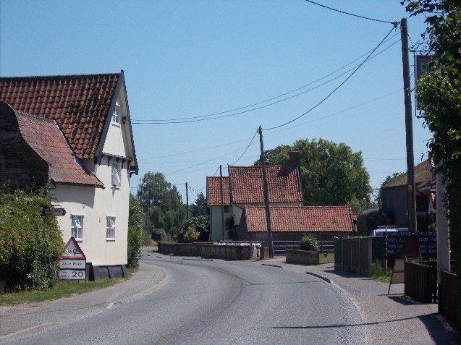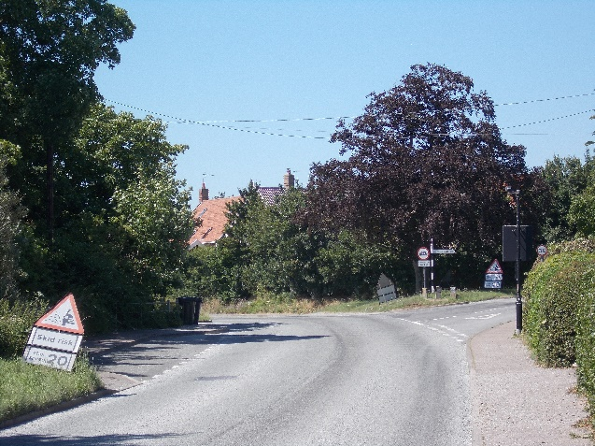
View looking along The Street looking View to the north of Fighting Cocks Inn
south from Fighting Cocks Inn

The barn to Holly Farmhouse is now a separate dwelling.

Aside from the tree on the green, the vista to the north features the traditionally designed houses around Diamond Close and the double pair of houses on the west side.

Traditional Materials & Architectural Details

Examples of most building materials traditional to South Norfolk can be found within the Conservation Area.  Red/ orange clay pantiles are the prevalent roofing material with only one building having blue/black glazed tiles (Holly Farm House).  Flat modern pantiles are found on Yew Tree House and slates on "Woodsfield", the primary school and the Church.  Most of the 16th century buildings are rendered and painted over either a timber frame (16th or 17th century) or clay lump. Sometimes the buildings have a black painted plinth.  Some colour washed brickwork is found on the Fighting Cocks Public House.  Other buildings are generally in red brickwork with some grey gault brickwork for quoins and window dressings at Yew Tree House, Woodsfield and the Primary School.  Stained weather boarding is found on April Cottage and generally for barge boards and sometimes dormer cheeks.  Flint and stone are only found on St. Marys Church.  Chimneys are an important feature of most of the historic buildings, together with generous overhangs at eaves and gable ends. There are decorative barge boards on the school, and a modest “Dutch” gable on Guildhall Cottage. There is brick detailing on the eaves and gables of The Old Parsonage. | 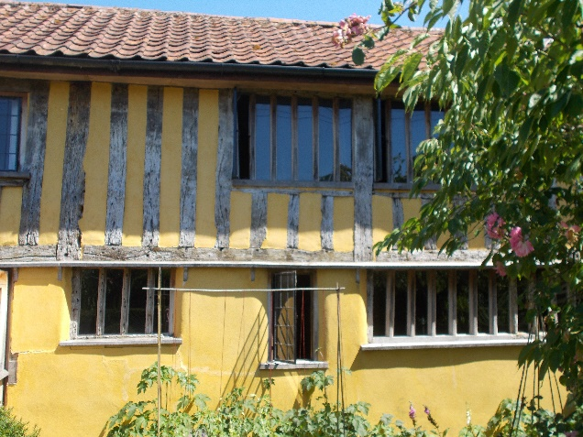  Stud timber framing and render  Church Hill Farm Cottages  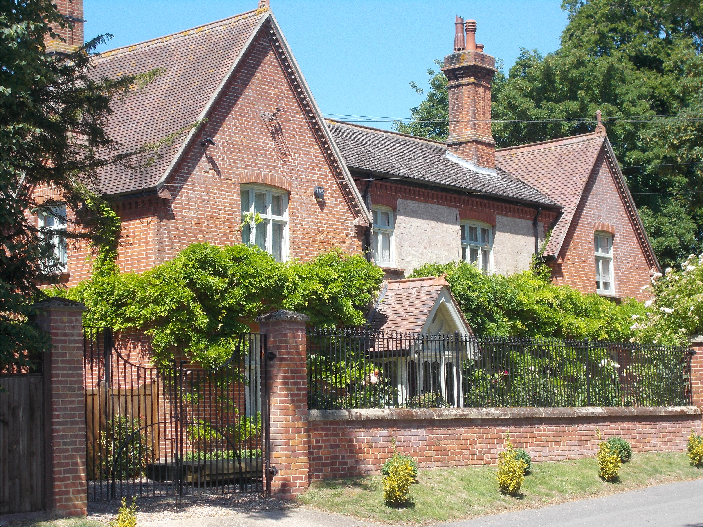  The Old Parsonage.  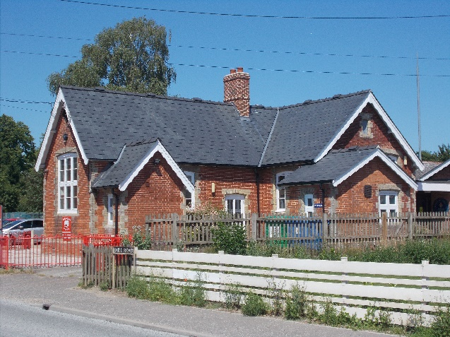  Village School

Natural Character

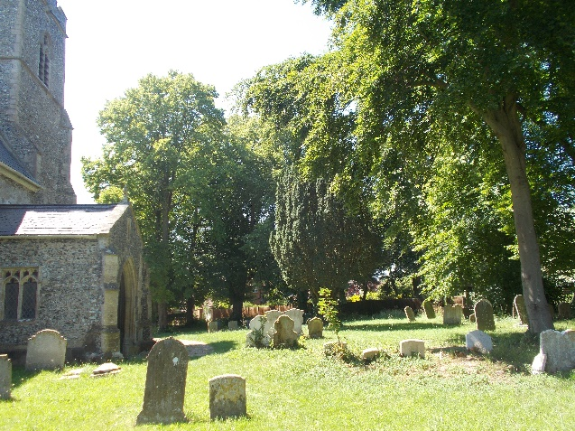  St Mary’s Churchyard  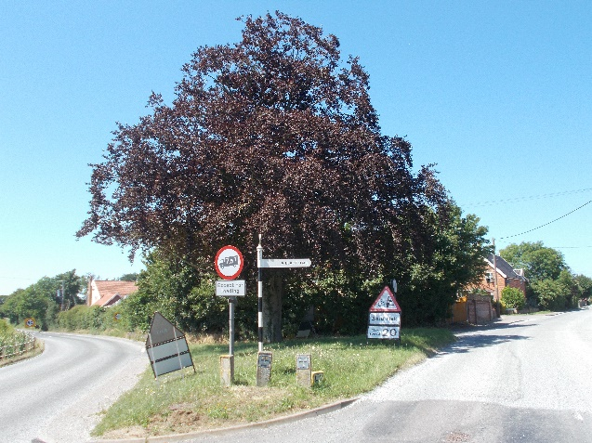  Trees at Stocks Hill | The heavily treed area around the Church, Churchyard and Church Lane provides a natural setting for this part of the area. The space opens out to the east of the graveyard. The trees in Tracey’s Wood provide an attractive backdrop.  This area also contains some prominent hedging which combined with the grass banks, enhances the rural atmosphere considerably.  To the south of the Church is another significant open space, the School playing field, which is surrounded by mature hedging to the north, east and west where it is a good screen to the car park.  To the north of The Street the mature trees and hedges around the major farmhouses, Holly Tree Farm and Stocks Hill farm contribute greatly to landscape of the area.  The prominent grass ditch in front of Holly Tree Farm is also an attractive feature creating a moat like feel to this area. Grass banks are very much in prominence in this part of the village reinforced by the triangle of grass and the mature tree located at the junction of Hall Road and The Street. The tree naturally terminates the view to the north.

Street Furniture, Walls and Railings

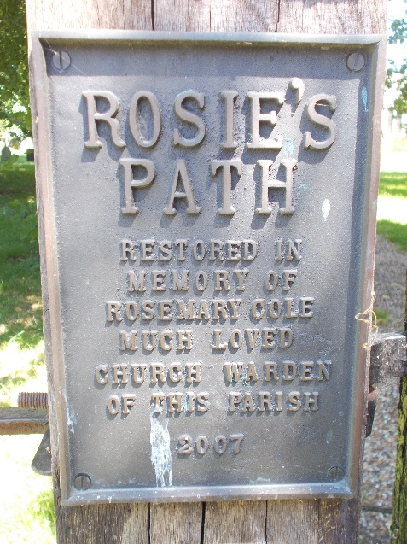  Memorial Sign – Rosie’s Plaque  .  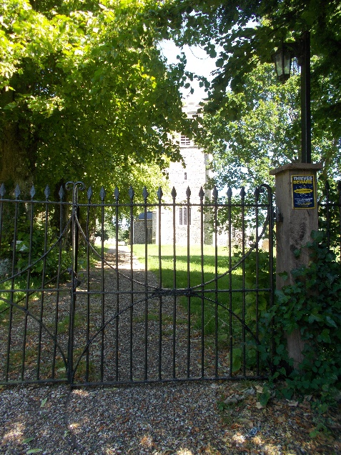  Gates to church | Roads and pavements are generally tarmacadam. Areas of grass are found on road banks and to the open spaces along The Street and Church Lane.  The overhead wire spoil the views.  There is an attractive village sign and notice board on the small village green to the west of the Church. There is a seat and plastic rubbish bin, the view hidden by the hedging to the north and south.  The public house has an attractive "stand alone" sign.  The small triangle of grass at Stocks Hill contains several signs.  Traditional screen walls survive only at Guildhall Cottages and Church Farm, while the new front wall/railing to The Old Parsonage is well designed. The sense of openness to the newer dwellings is noticeable, additional planting of trees, taller hedges, appropriate fencing or walling would have a positive impact.

Conservation Management Guidelines
Highways
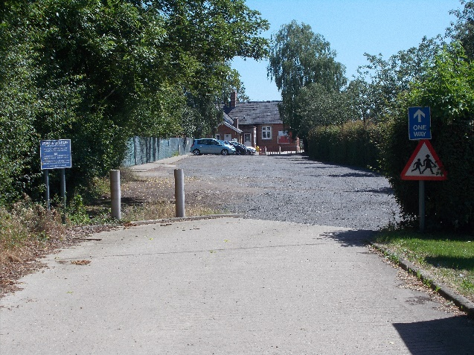 | The problem of traffic on The Street is perhaps the major physical problem facing  the village. Although the road has subtle the speed of vehicles is still a concern.  The location of the school also means that there is heavy traffic congestion at times although this has been eased by the car park and lay bye.  Although verges should be kept informal there may be a need to give some protection to the verge on the west side of the lane.
Upgrading Windows and Doors
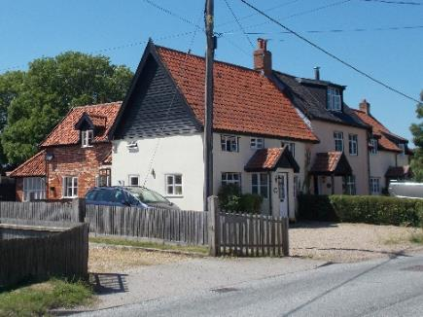 | In some cases, windows and doors have been replaced with different materials and/or different styles. If original doors or windows need to be replaced, they should ideally be replaced to match. However, if different materials are chosen then the window style should remain the same ( if original).  The opportunity should be taken to reinstate traditional styled windows where they have been unsympathetically replaced in the past.

Front boundaries
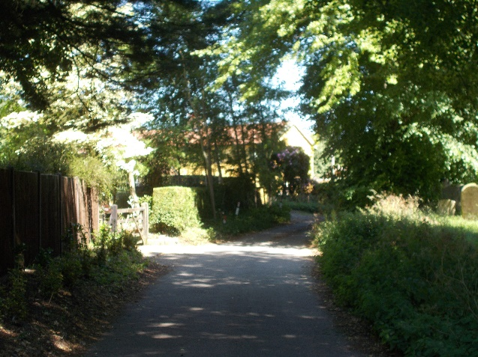 | Most of the front boundaries tend to be hedges and low walls and this is part of the character of the area. Close boarded fences alongside lanes can detract from the rural character of the village  Their retention should be encouraged and any scope for new indigenous planting should be supported, subject to highway considerations.

Painting/colour washing buildings
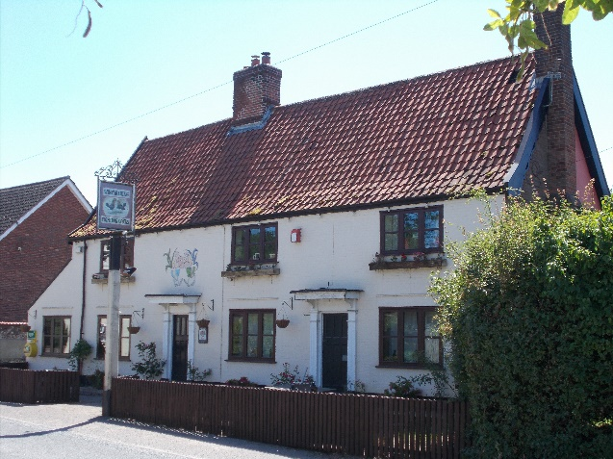 | Some of the buildings are rendered or brick with a light colour pastel finish that sits comfortably with the historic character of the area.  With any redecoration, the colours should be chosen to maintain that pattern.

Appendix 1 (i)

Listed Buildings (All Grade II, except as noted)

Church Lane St Marys Church (Grade 1)

The Old Rectory.

Clerks Cottage.

Church Hill Farm Cottages.

"Woodsfield".

The Street Stocks Hill Farm.

Holly Farm

The Fighting Cocks Public House.

Guildhall Cottages.

Church Farm House.

April Cottage

Appendix 1 (ii)

Unlisted Buildings of townscape significance

Church Lane Out buildings to Woodsfield.
Church Hill Farm Barn
The Old Parsonage

The Street School House Cottage.
Winfarthing Primary School.
Outbuilding to Church Farmhouse
The Shingles
Laburham Cottage
Holly farm barn

Appendix 2

Policy background

In recent years, the approach to conservation area designation has changed considerably. It is now recognised that development plan policies, development control decisions, and proposals for the preservation or enhancement and the management of conservation areas, can best be achieved when there is a sound understanding of the special interest of the conservation area.

This position is reinforced as follows:

The Planning (Listed Buildings and Conservation Areas) Act 1990 in section 66(1) makes it a duty of local authorities when considering applications to have special regard to the desirability of preserving a listed building or its setting or any features of special architectural or historic interest.

Under section 72 of the same Act, it is a duty with respect to any buildings or land in a conservation area, to pay special attention to the desirability of preserving or enhancing the character or appearance of that area.

Department for Communities and Local Government. National Planning Policy Framework (NPPF) 2018 Paragraphs 184 to 202 cover “Conserving and enhancing the historic environment”.

Joint Core Strategy- Policy 2 : Promoting Good design South Norfolk Local Plan

The South Norfolk Local Plan Development Management Policies Document was adopted in 2015 and policy 4.10 covers Heritage Assets.

Public Consultation

An informal ‘walkabout’ of the area was organised with the Parish Council on 20th February 2020. This informed the proposed boundary changes and the conservation management guidelines within the draft appraisal. The public consultation on the draft appraisal took place from 15th February to 15th March 2021, with attendance at the parish meeting on 23rd February 2021. Due to the Covid-19 Lockdown regulations the public meeting was carried out through virtual attendance at the parish council meeting online. The consultation and parish council meeting were advertised through:

• An advert in village notice board and local publicity by the parish council
• The draft appraisal being available to view on the council’s website.
• Emailing Ward Councillors, County Councillors, the Parish Council and Historic England.
• Contacting residents directly affected by the proposed boundary changes by letter informing them of the consequences of being included in the conservation area.

As a result of the consultation corrections were made to the appraisal, and some of the proposed boundary changes recommended in the draft appraisal were not taken forward.

Appendix 3
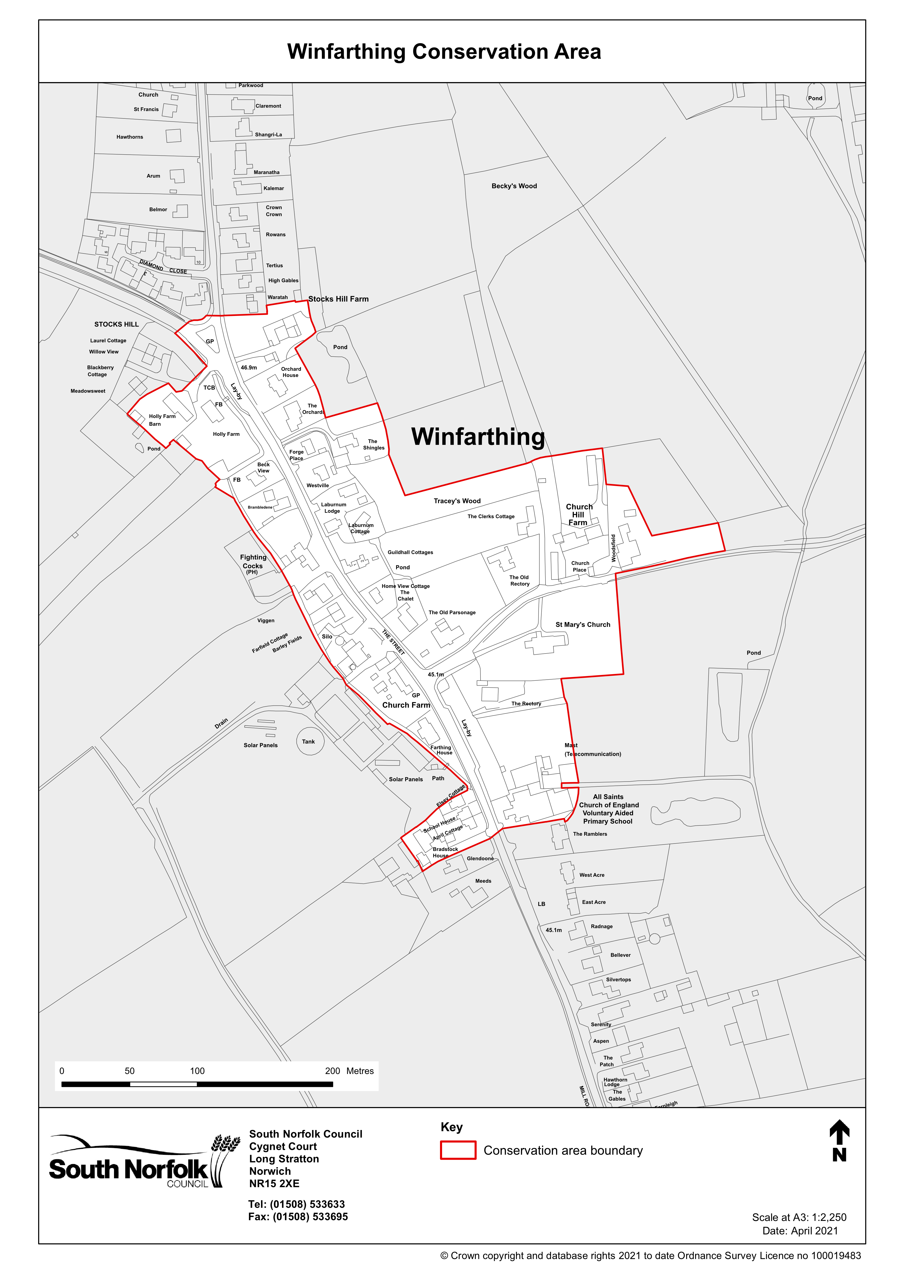
Appendix 4
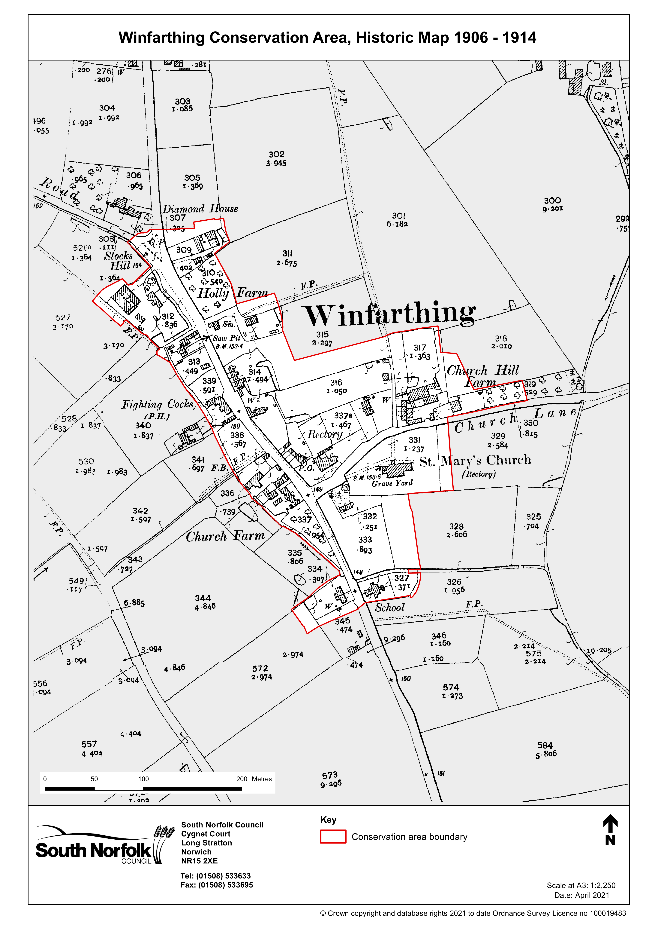

Appendix 5
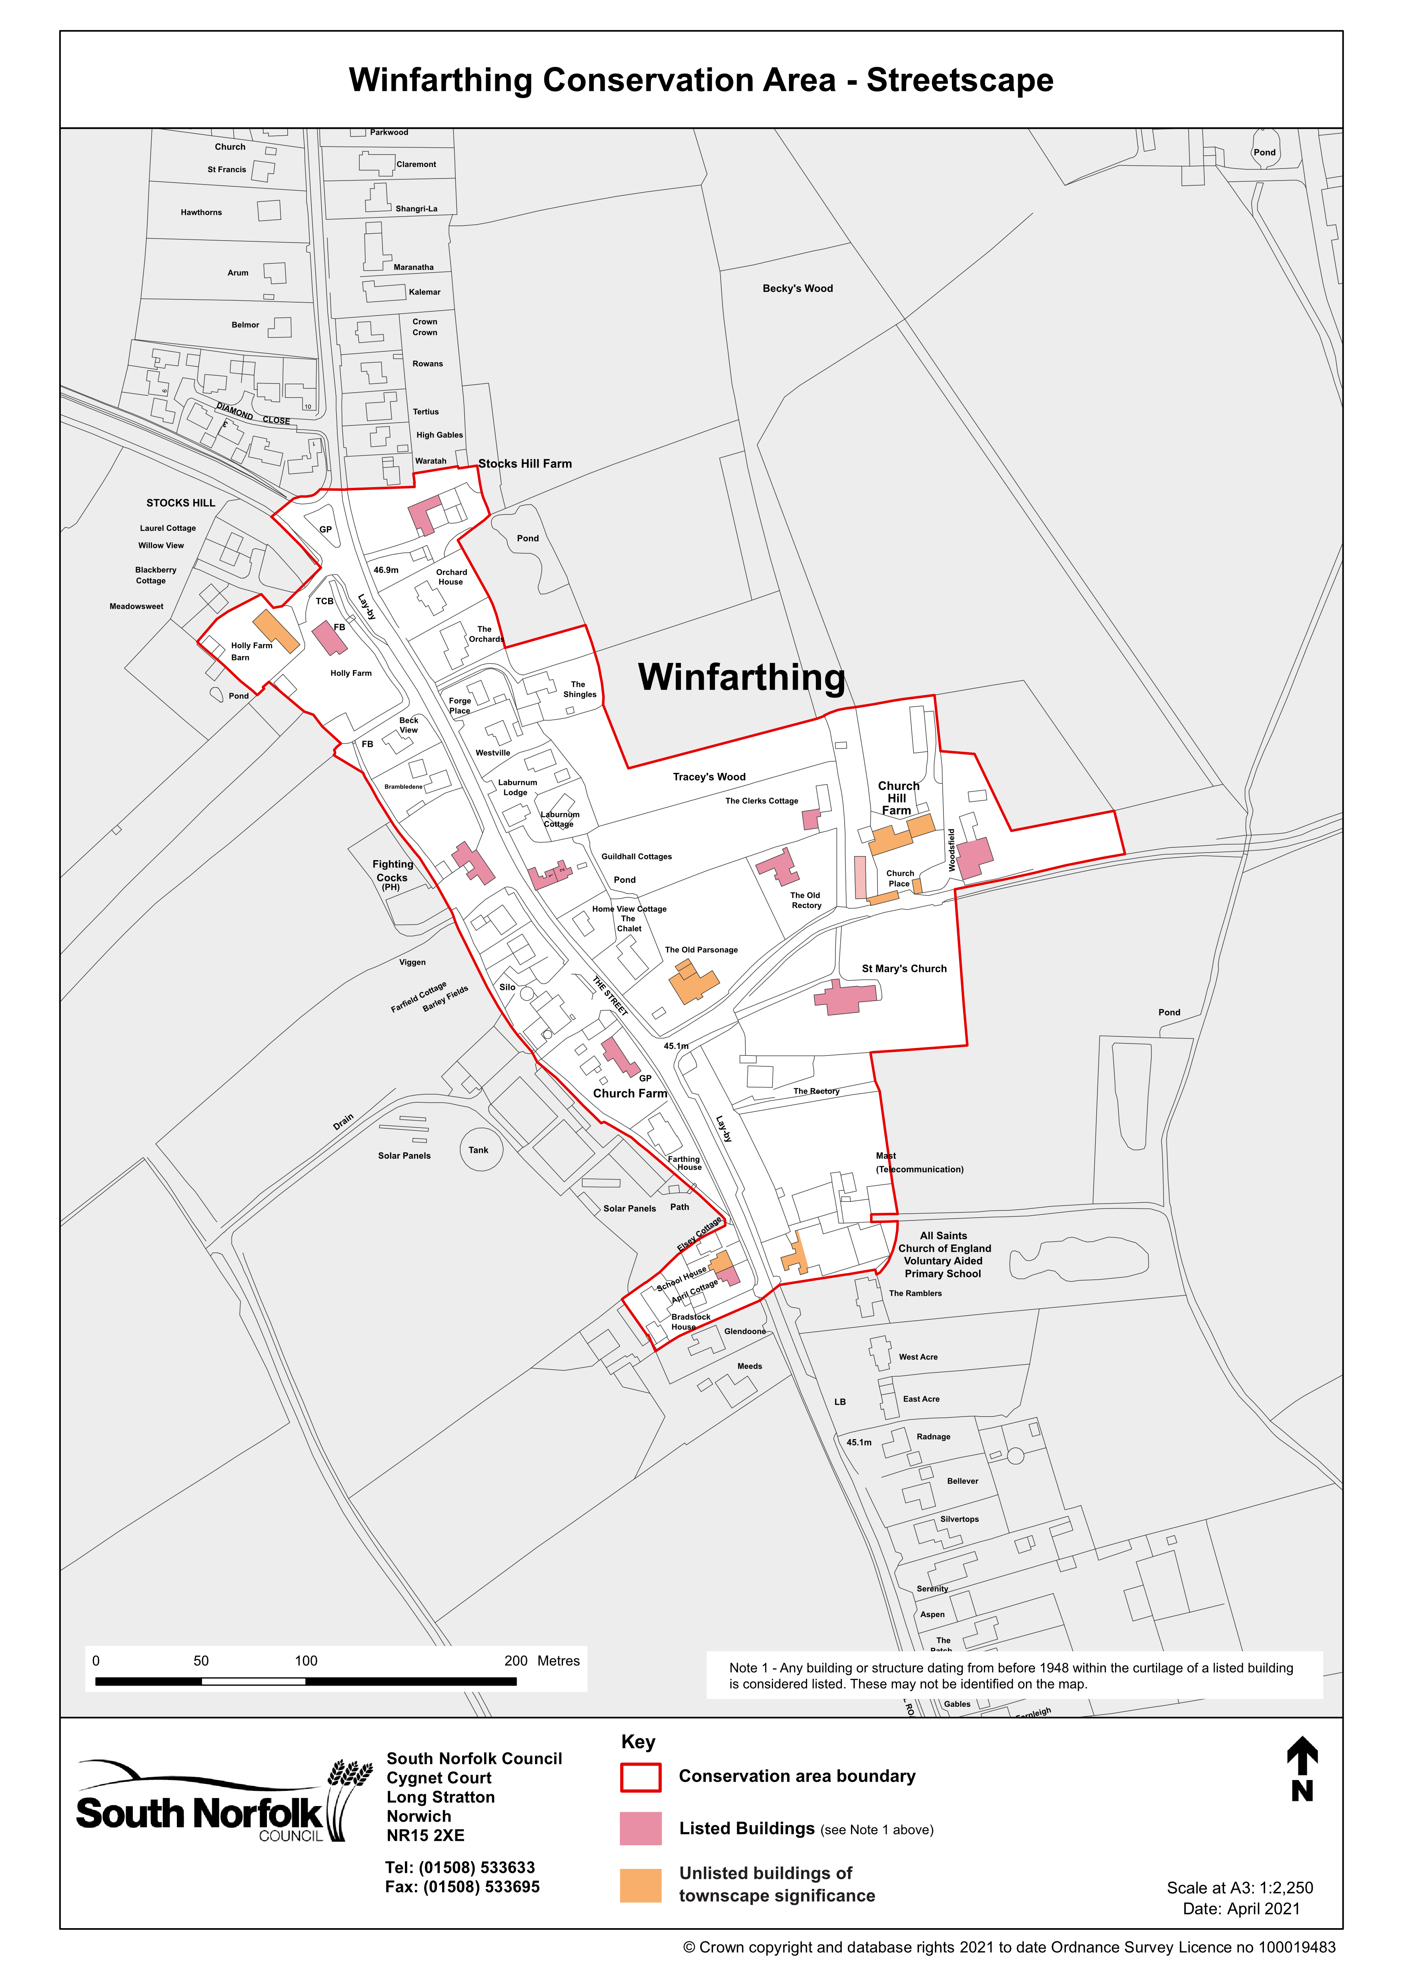
Appendix 6
