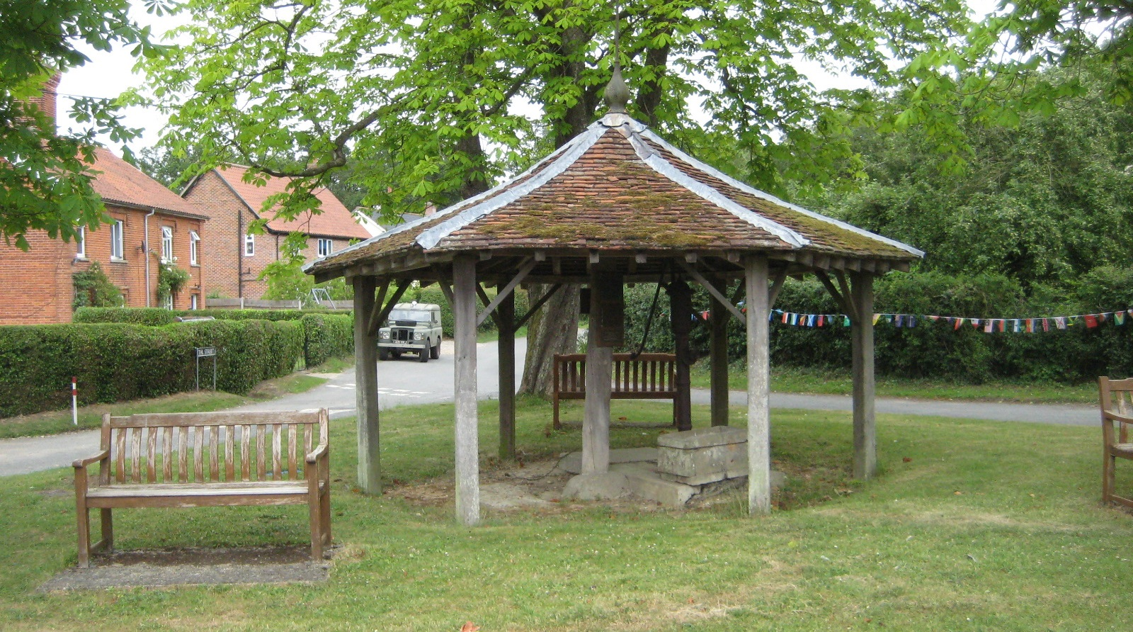
Thorpe Abbotts
Conservation Area Character Appraisal
and Management Guidelines

July 2021

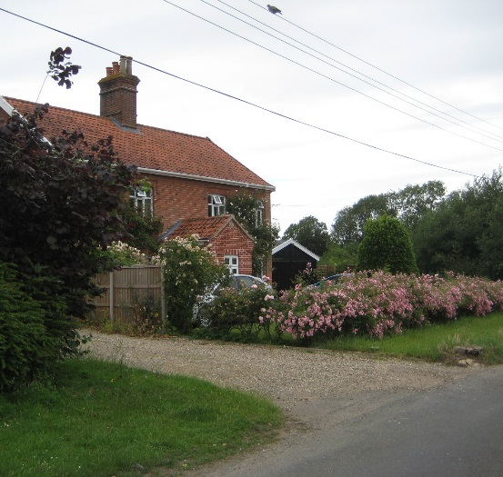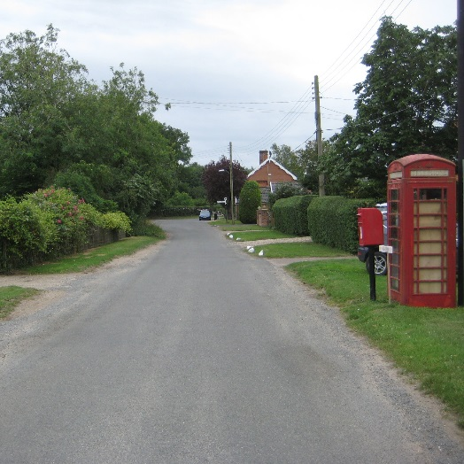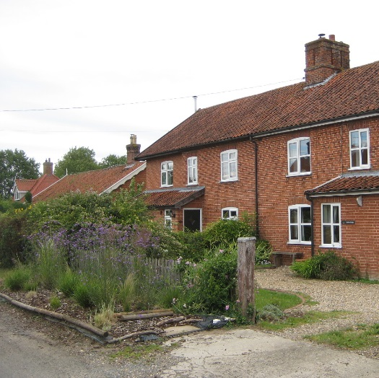

Content

Introduction 3

Historical Development 4

Character Assessment 4

Conservation Management Guidelines 14

Appendix 1(i) - Listed Buildings in 16 Thorpe Abbotts Conservation Area

Appendix 1(ii) - Unlisted Buildings in 16
Thorpe Abbotts which are of townscape significance

Appendix 2 - Policy & Consultation 17

Appendix 3 - Conservation Area Boundary 18

Appendix 4 - Historic Map 19

Appendix 5 - Streetscape 20

Appendix 6 - Natural Character 21

Introduction
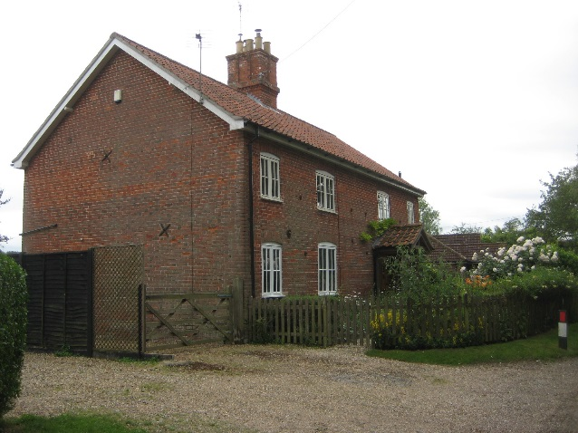  Typical red brick estate house | Thorpe Abbotts is a small rural settlement, much of its character defined by its former estate housing. The form of the hamlet is that of a three-armed settlement, with the green marking its centre. Buildings mostly date from the 19th century and despite more recent development, the overall appearance is that of a Victorian estate village. It has a number of listed buildings, which interestingly are distributed at both the extremities of the conservation area and at its centre.  .
Under the terms of Planning (Listed Buildings and Conservation Areas) Act 1990, the Local Planning Authority is required to identify areas of special architectural or historic interest whose character or appearance it is desirable to preserve or enhance, and to designate them as a Conservation Area. The Thorpe Abbotts Conservation Area was first designated in 1994. The 1990 Act also requires local authorities to prepare management guidance and proposals for Conservation Areas. This document should be read in conjunction with the adopted Local Plan, the National Planning Policy Framework and Planning Practice Guidance.
Key Characteristics
- Victorian estate village defined by modest sized red brick cottages/houses
- Hierarchy of estate houses
- Strong natural character provided by mature trees, hedgerows
- Wide grass verges either side of the road
- Dense woodland areas to the southeast and northwest

Historical Development (also see historic map in Appendix 4 p19)
The name ‘Thorpe Abbotts’ is reference to it being a secondary settlement or hamlet belonging to the abbots of Bury St Edmund. The primary settlement may be taken as nearby Brockdish, which remains the more dominant of the two villages. Thorpe Abbotts itself has developed as two separate smaller settlements; one around the church, outside the conservation area to the southwest and the other, the subject of this document, a hamlet north east of the church, at the junction of three roads.

The 1823 map shows Thorpe Abbotts (the settlement) was around the Church. There was a medieval Chapter House on the site of the current Thorpe Hall which was built in 1701. During the late 18th and early 19th centuries the village was referred to as Thorpe Cornwallis after the Cornwallis of Brome family who owned the Estate at this time. The 1840 plans for the Rectory use this name.

In the early nineteenth century the population of the parish was 281. During this period the land was divided between two major landowners. The lord of the manor at this time was the Rev. E. Holland and the second landowner the wife of Edward Bridgman, Esq. the owner of the Hall estate.

Enclosure of the village lands took place in 1803 and at that time 42 acres of land was awarded to the lord of the manor, subject to a yearly payment of £5 for distribution in coals among the poor". Enclosure is often seen as an oppressive process but here is evidence of at least a token of collective parish responsibility for the destitute. An older, anonymous donation of land already produced a yearly rent of £4 which was "carried to the poor rates."

These changes in land management in the early 19th century were accompanied by new building, most notably by the Rev. K. Wallace B. A., who had "lately built a neat parsonage house." A tradition of parsons of substance was well established in this part of Norfolk as the lord of the manor at the time testified.

The statistical account of 1845 does not record many other persons of substance, instead a small community supported a single wheelwright, the landlord of the one pub and six farmers. We may suppose that the remainder of the population were employed on the land or associated work, as no other commercial activity is recorded.

The part of the village identified as the conservation area reflects the earlier estate village, established from the late 18th century, although there are a number of surviving much earlier buildings.

Character Assessment
(Also see Streetscape and Natural Character Maps in Appendices 5 and 6 pages 20 and 21)
Thorpe Abbotts and its setting

Looking at the landscape setting of Thorpe Abbotts, to the south and east it is largely characterised by several kinds of planted woodland, whilst to the west and north the character is defined by hedged fields of varying size with hedgerow trees enclosing the conservation area. The land around the settlement is part of the plateau north of the Waveney Valley and is level with no noticeable contours. As with other settlements on the plateau there are many ponds. A water course flows off the airfield passing through the wood and under Mill Road south of Locks Pyghtle. It then joins the stream going through Brockdish and on to the Waveney.

The southern edge of the conservation area is bordered by parkland trees which dominate in views either side of The Street along the eastern approach. The tall parkland trees are clearly visible from the green at the centre of the conservation area and create the sense of a settlement in the shadow of a great house. Thorpe Abbots Place and its adjacent park have played this role since the creation of the hamlet. | 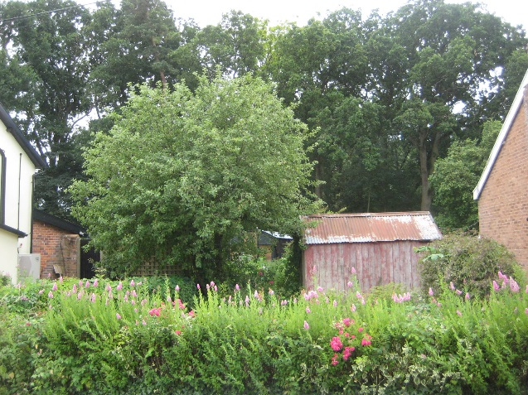  Parkland trees in glimpsed views  at southern end of the boundary

By contrast, Mill Road is much less enclosed with occasional trees within the individual gardens and the sight of hedgerow trees behind the properties. Here the views are more open along the road. The view north along Mill Road is closed by a clump of trees set around one of the several ponds, which dot the landscape around the settlement.

Conservation Area Boundary

Most of the conservation area boundary follows the rear garden boundaries of dwellings. Starting at the southwest corner of the conservation area at The Street, the boundary follows the roadside northwards to the village hall where it then continues north behind the hall following the field boundary and then along the garden boundaries of properties on the west side of Mill Road. It then follows the line of woodland, before finally skirting the boundary of part of The Homestead, an addition to the conservation area, before going eastward and then south along the rear garden boundaries of Mill Road. It then extends east just north of The Green along rear gardens of houses in The Street after which it encloses a large area of pasture and the southern half of Home Farm. From Home Farm the boundary goes south along Mormor Lane from which it then crosses Grove Road and goes west following the drainage ditch and enclosing Thorpe Abbotts Place. It then skirts the south boundaries of three dwellings that were formerly Highfields Farm before finally reaching The Street at the far southwest corner.

Street Patterns and Historic grain

Historically the settlement has developed in three separate areas; at Thorpe Abbotts Place, either side of the green at the village centre and at the north end of Mill Road. The pattern of development is a loose linear form extending from the green, with other parts of the settlement being groups of buildings set back from the road. These three main areas of the earlier settlement were originally separated by fields and woodland but infill development in the 20th century has continued the linear development pattern extending from the green although an open field with overgrown hedgerows and small trees still separates the settlement at the west side of Mill Road. The size of infill dwellings is generally in keeping with the modest scale of earlier dwellings, which allows them to sit comfortably in the street scene.

Perambulation

The buildings of the conservation area have a remarkable consistency of scale and type, despite differences of date, detail and to some limited extent, size. Their materials also vary but not so much as to disrupt an otherwise generally coherent architectural character. The streetscape of the conservation area is thus low key and consistently rural. This uniformity of character is the result of the settlement being mostly an estate village, with few of the original house types and only minor variations among those.

As the observer approaches from the southwest, the water pump and its shelter become visible on the green as the focal point of the settlement. On each side of the road the cottages and later Victorian houses, though of different materials and sizes, are respectful of each other and no single building dominates. Instead the trees form the largest objects in view and hold the composition. The small scale of the central shelter reflects the modesty of the character of the hamlet. Views of the green at the centre are framed by the mature hedges, cottages and trees of their gardens. The gentle curve of the road southeast and southwest of the green prevent longer views whereas there is a clear vista looking northward up Mill Road.

The predominant building type is the estate cottage and the evolution of this important Norfolk building type in the village is evident over a period of more than one hundred years.
The listed buildings in the conservation area form a group which is less characteristic of the place as a whole than is usual in rural villages. This is because unlike the majority of the buildings they are either singular (as the pump shelter), or of 'important status’ (as the farmhouses of different dates.) Of the six listed dwellings in the conservation area, three are 17th century timber frame houses: Lock’s Pyghtle near to the north boundary being the earliest; another house is of 19th century date, with the remaining two listed structures being an 18th century wall and the village water pump on the green. Fadens map of 1797 indicates a number of houses Locks Pyghtle, Cringle Cottage, houses in the wood south of Locks Pyghtle (no longer in existence), Keepers Cottage and Highfields Farmhouse. The map also indicates a larger house near the pump which might have been the (Red) Lion Public House.

Mill Road

Lock's Pyghtle is a timber framed house of modest size but an example of a dwelling originally belonging to an owner of substance for the period. Opposite the copse south of Lock's Pyghtle stand two relatively recent houses designed carefully within the local vernacular tradition of rendered walls beneath a low-pitched tiled roof and two-light casement windows. These make a positive contribution to the conservation area. A rather more modern detached brick house then stands adjacent but is more set back from road and is of a general traditional design.

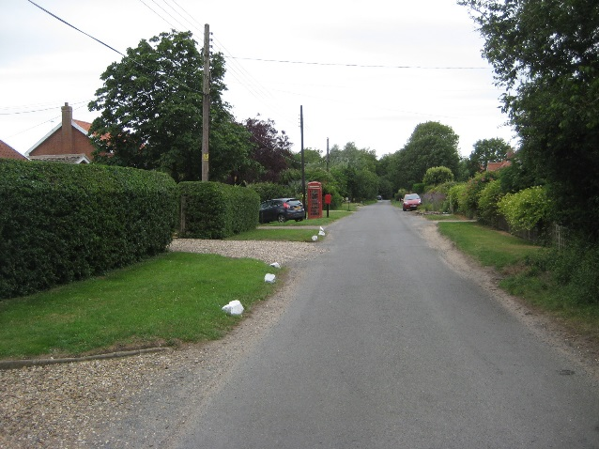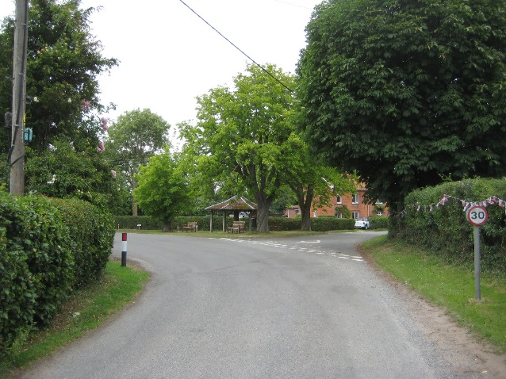
Looking northwards up Mill Road The approach to the green
from the South West from the East
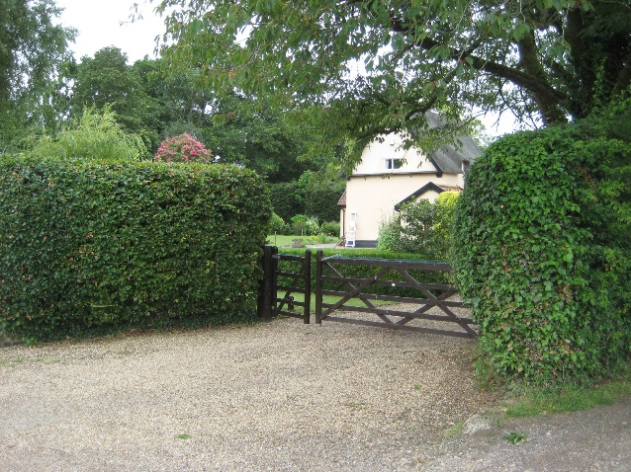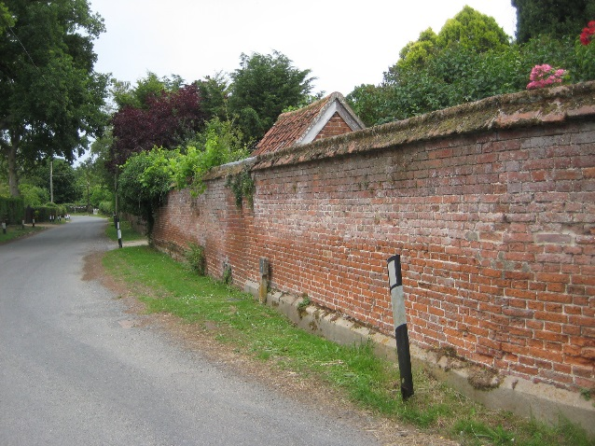
Lock’s Pyghtle - the oldest building The listed boundary wall at
in the Conservation Area Highfields Farmhouse

Next on this eastern side of Mill Road are a former pair of estate cottages, now one house. After these are two modern bungalows and then what originally appears to have been earlier cottages, possibly in clay lump, that now form a single dwelling. Cringle Cottage here is of Clay Lump construction with a brick outer skin probably done by William Valliant the Landlord of the Lion and the local Bricklayer. There is an inscription “John Valliant 1880” on the West gable end, referring to his son who would have been a boy at the time, perhaps helping his father.

It is sensible to assume that these represented the first type of estate cottage built in the settlement. Going further south continuing the east side is the much later infill development around a loose courtyard area. The close form hedging and wide grass verges at this part of Mill Road at the east side help to blend in the development with the remaining natural landscape opposite. The infill houses are of two storeys and respect the scale of the rest of the hamlet. They are built of brick, the larger detached dwelling with square hipped roof having a rendered finish. Roofs are red clay pantiles and windows simple traditional style casements. Next is a pyramidal roofed bungalow that has been remodelled, its form marking the point of transition in the road between the more recent loose courtyard layout and the older traditional row of houses to the south side, the latter including Rosary Cottage, an attractive early 19th century "cottage ornee" style with decorative bargeboards.

Rosary Cottage was in fact built as an Almshouse and used to have three front doors of a similar design to that which is there today. The roof ridge line still indicates where there would have been a second chimney stack. The conversion into a single dwelling was during the 1970s when most of the estate houses were sold off.

Continuing southward on this east side are two pairs of estate red brick cottages with central chimney stacks. The first pair have been extended either side. After the cottages is an area of rough grass land which corners the central green together with the adjacent well-maintained garden of an estate cottage at the entrance to The Street. The rough grassland is part screened by boundary vegetation but does add to the rural character towards the centre of the village.

Looking at the west side of Mill Road, there are Victorian estate cottages together with 20th century houses of the same scale and form. The later houses have been designed to give a similar appearance to the earlier pairs of cottages, but their detailing is not of the same quality, although they generally sit comfortably in the overall street scene. At this side close to the road there is a red K6 telephone box and its accompanying post box on its black iron post, both providing a visual focus in views looking north from the green.

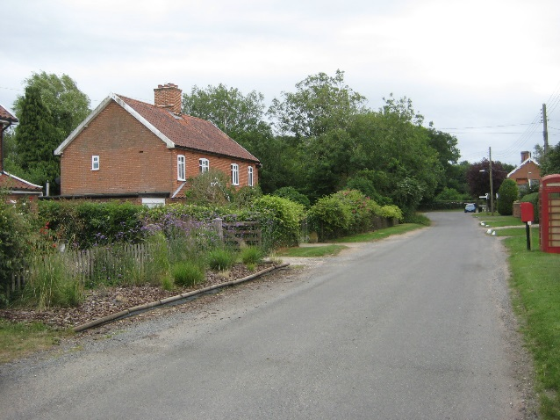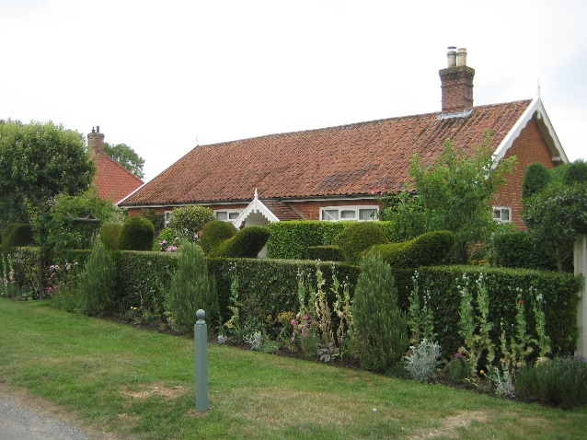
Pair of estate cottages, Mill Road Rosary Cottage built in the early 19th
century "cottage ornee" style

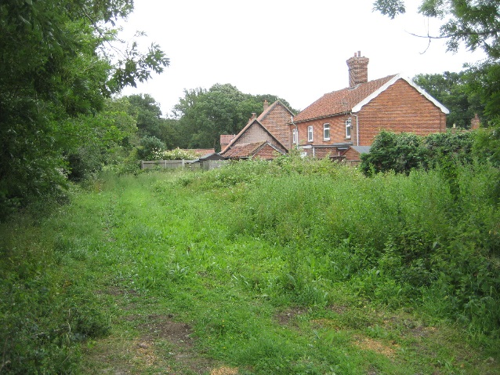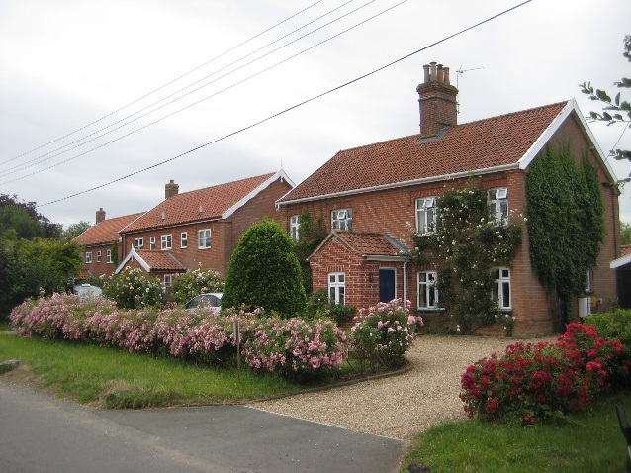
Rough grassland to side of green Estate cottage with similar style
new build to left

The Green

The townscape of the whole hamlet is focused upon the green and its pump shelter at the centre. Opposite the green to the south side is a high thorn hedge which conceals Keeper's Cottage. This is a grade II listed 17th century house with 19th century Gothic style windows. A traditional wrought iron gate within the hedge allows a glimpse of the cottage, which is backed by large mature pine, oak and beech trees to the south which form part of the tree belt of the park of Thorpe Abbotts Place. These parkland trees rise well above Keeper's Cottage and are an important backdrop enclosing the settlement.

Other Victorian estate dwellings at the green are a pair of cottages 5 & 6 The Street immediately to the east side, and Lion House, a larger detached dwelling at the entrance to The Street from the southwest. The latter is an important character building that is prominent in the conservation area. Lion House dates from the mid 1800’s and was built as a public house, replacing an earlier building in same use. The earliest record comes in 1826 from the Earsham License Registers which indicates at the time it was owned by the Harleston Brewery. It is interesting looking at the building which had a Bricklayer (William Valliant) as its licensee who may well have been involved in its construction with the style being replicated in all of the estate houses which were built 1880-1906. Number 23 was the last house to be built and was referred to as “the New House”,

Historically the Pub was referred to as the Red Lion (Bryant’s 1826 map) but at some stage became the Lion. The house and its outbuilding have black glazed pantiles which are a pleasing contrast with the red brickwork and make the building stand out. There is a gravel front courtyard in front which is separated from the road by new railings recently installed in a traditional style.

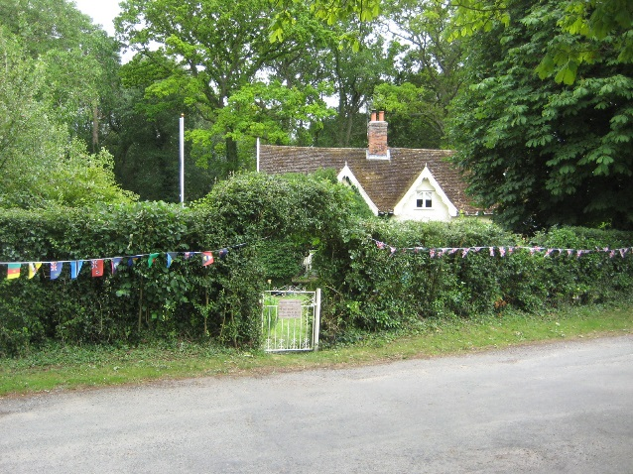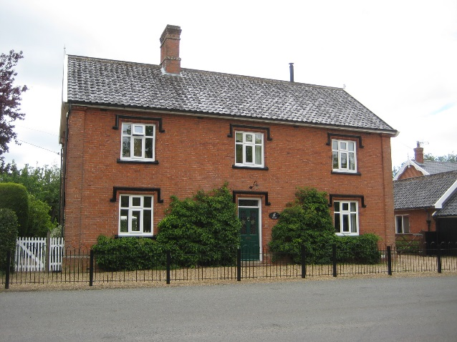
Keepers Cottage Lion House

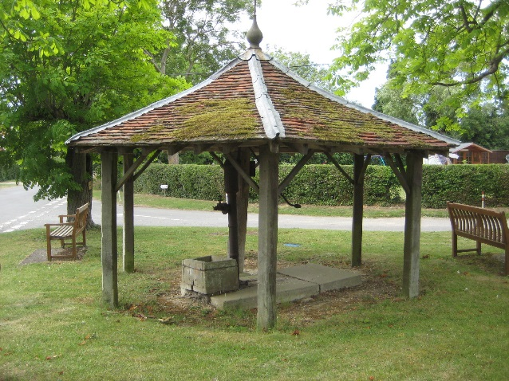 The Pump Shelter | The pump shelter on the green is dated by an inscription to 1867 and the simplicity of its design suggests an 18th century origin. The Pump was the village water supply until mains water arrived in 1954.  The simple oak post hexagonal plan construction with its peg tile low pitch roof adds much to the historic character at the centre of the conservation area. The small green around the shelter is short cut grass, whilst underneath York stone provides a base for the central post of the shelter and for the pump itself. The traditional wooden benches and adjacent mature lime tree and horse chestnut trees do not cramp the shelter but add further interest, providing an attractive immediate setting for the building.

The Street (East)

Trees dominate either side of the road along the eastern approach, closing off views. Where Grove Road turns into The Street, they line the highway on either side behind wide grass verges and neatly cut low thorn hedges, giving the impression of a right of way inside a landscape park. This impression of a consciously designed landscape is heightened at this point by the curious arrangement of a pair of perfectly circular tree clumps standing in open paddock to the north side of the road. Once the conservation area boundary is crossed, the vista reveals no buildings, the parkland described above being the dominant feature. The lane, which has been gently sinuous up to this point, becomes straight and the prospect of a settlement is anticipated.

The first indication of this to the north side where the outbuildings of the Home Farm can be seen, past which is the main farmhouse, clearly visible from the road. At the end of the vista between the trees, the first glimpse of the hamlet can be seen. The first houses on the right are what appear to have originally been a pair of brick estate cottages, as seen elsewhere, but these have been rendered and the pantile roof replaced with dark plain tiles. The cottage to the east side has been extended. The house is a little closer to the road than those beyond and this together with its white finish makes it more dominant in street views. Despite later alterations the building still retains a strong traditional character.

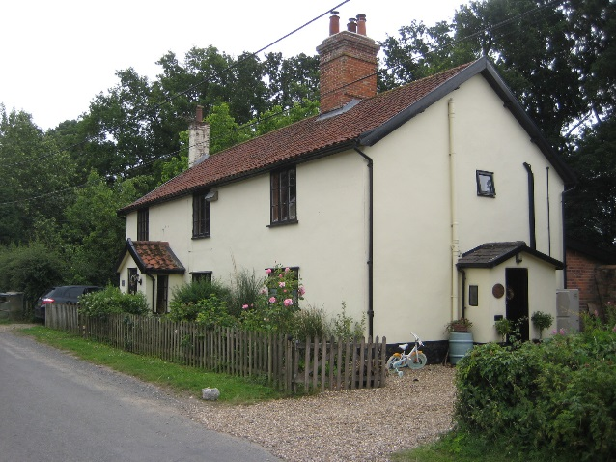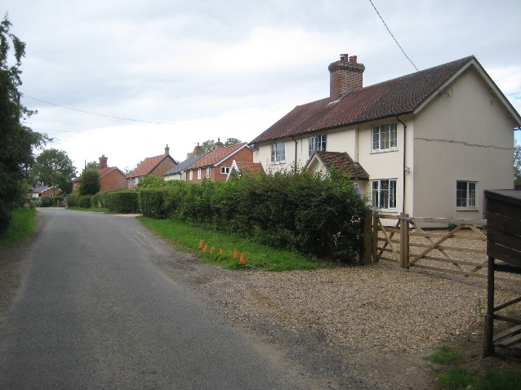
Pheasant Cottage Rendered estate houses with more
recent builds to left

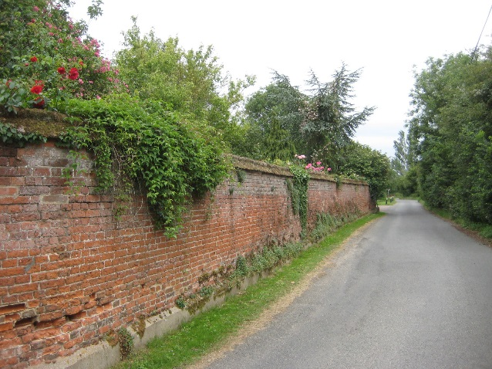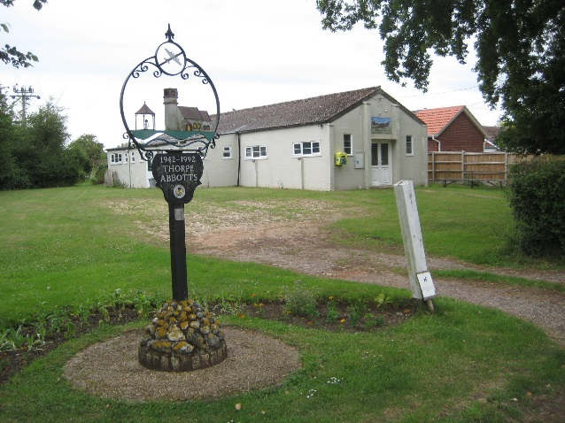
Boundary wall at Highfield House The village hall and village sign

Beyond this on the north side of the road are three quite recent new houses, which generally conform to the type described above in Mill Road, having low pitched roofs with bargeboards, traditional style casement windows, brick and rendered finishes with clay pantile roofs. They make a quiet positive contribution to the streetscape at this point.

The next notable building is on the left, a rendered two storey dwelling, Pheasant Cottage, which has a traditional pantile roof, off-set gabled porch and three light casement windows. This clay lump cottage was originally three dwellings. It has an attractive paling fence close to its frontage. At this point in the road, which narrows slightly, the centre of the settlement starts to come into view.

The next house on the left is a slightly smaller, the Old Post Office, which appears to be a clay lump building that has been clad in the recent past with a skin of buff brick, giving the impression of a later date. It is of two low storeys and has a central brick stack. The cottage retains its large clay lump and weather boarded outbuilding which adds much to the historic character of the street scene. This modest group is an important element of traditional streetscape within the conservation area.

The Street (West Side)

Moving from the centre southwest towards Highfield Farmhouse, the road is only partly enclosed either side by mature hedgerows above grass verges. On the left is a recent house of red brick, Highfields Cottage, which is undistinguished in its design although its scale and general appearance respects that of the pairs of brick estate cottages seen elsewhere. Looking back, the curve in the road conceals views of the green.

Continuing on the same side of the road are two new houses, which also have a traditional appearance but are set further back from the road and mostly screened by closely planted trees at the road boundary. In front of the houses is a large gravelled courtyard area which is partly visible from the road. The tree boundary with low timber fence below moves away from the mature front boundary hedgerows which are so characteristic elsewhere in the conservation area.
Opposite on the north side of the road are three modern bungalows and then the village hall, all set well back behind a line of mature front boundary hedgerows, which is interrupted by four oak trees.

Next, the village hall’s design and construction does not follow that of other buildings and is built of rendered concrete block in a standard military format and dates from 1954. The single hall has a buttressed entrance facade with clasping buttresses at the corners and pressed metal three light windows set symmetrically on either side of the panelled two light door. The flank walls have dwarf buttresses set below six light long pressed metal windows with side opening lights. An out-shut on the western side has a low-pitched roof and two light windows. Roofing material is corrugated asbestos and cast-iron rainwater goods drain it. Although not in keeping with the more traditional historic character of the conservation area, the village hall is set well back from the road and in no way detracts from the main character of the area. The village sign at the front boundary close to the road is particularly attractive adding interest to the street scene.

Opposite the village hall at the turn in the road, one of the earliest uses of brick in the conservation area can be seen in the listed boundary brick garden wall of Highfield Farmhouse. This is a typical eighteenth century soft red Norfolk brick with fine gauged joints in lime mortar, a brick plinth and saddle back coping. The brick bond used is of interest, being English bond in the lower part of the wall and Flemish bond in the upper part, suggesting a heightening in the latter part of the century. The wall encloses the road on this southern side and creates a point of townscape interest.

The first sight of the southern entry into the conservation area is of a closely hedged road with grassed verges. Beyond this can be viewed a large number of mature trees within the settlement whilst views of the open countryside to the west side are closed-off by the overgrown hedgerow and closely planted small trees.

Traditional Materials & Architectural Details

The materials of the older buildings within the conservation area are all without exception of local provenance. Even the nineteenth century buildings use lucid brick and dye which may have been brought by rail but appears to have come no further than from Suffolk. Other than oak timber frame, clay would be one of the earliest materials used both for infill in timber frame houses, such as at Lock’s Pyghtle, and later for clay lump block as can be seen in the outbuilding at No.26 The Street.  Reed thatch for the earlier dwellings would have been readily available from the river washes of the Waveney. Wheat straw may also have been used as it would have been more readily available on the farming plateau north and west of Thorpe Abbotts. Lock’s Pyghtle is the only surviving thatched building.  Other materials are traditional Norfolk soft red brick and clay pantiles, which can be seen on most of the estate houses, with brick being first used for the 18th century boundary wall at Highfield Farmhouse  Specially moulded bricks have been used to create hood mould details above doors and windows on estate houses together with fine gauged brick heads. Raised brick pilasters with capitals can also be seen on a number of the estate houses.  Other than some decorative barge boards, Gothic style windows on Keepers Cottage and the large chimneys with decorative moulded details on the estate houses, there are few other architectural details of note.  The 1950’s village hall, with its functional military style design is the only building that really stands out in contrast to the more traditional historic architecture in the conservation area. | 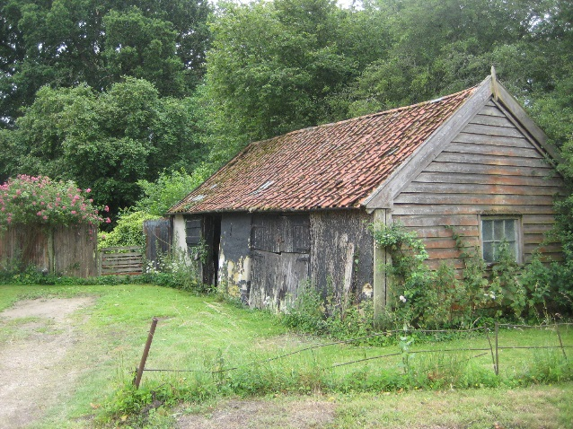  Clay lump outbuilding in The Street  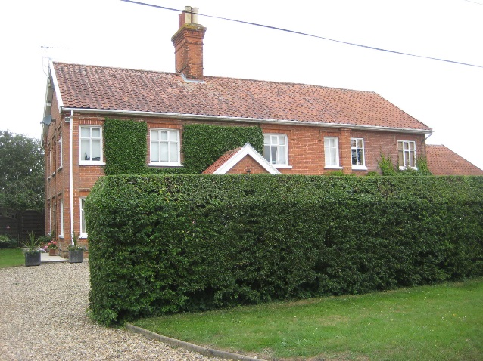  Tall chimney stack as seen on most  of the estate cottages.  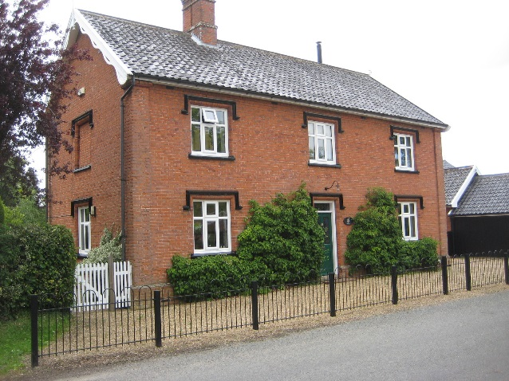  Hood moulds and decorative  bargeboards at Lion House
Natural Character
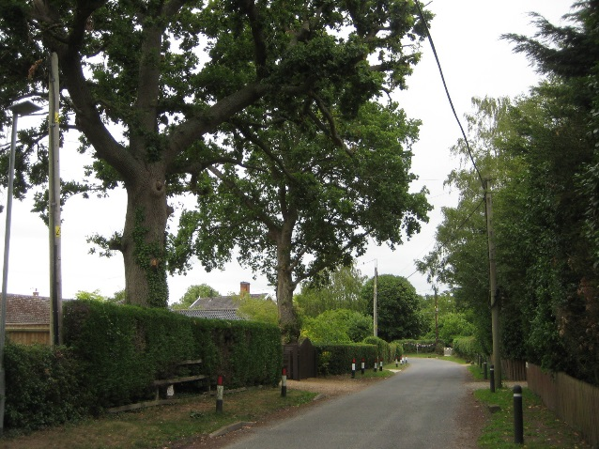  Trees and hedgerows dominate  many street views | The strong natural character of the conservation area is defined by both open parkland and woodland with natural grass verges, mature hedgerows and trees dominating many views. There are glimpses of the wider countryside beyond in some views between properties. At the east side of the conservation area is the parkland of Thorpe Abbotts Place and opposite this to the north side, the parkland of Home Farm, both with areas of dense woodland. The other much smaller area of woodland is at the north end of Mill Road.
Street Furniture, Walls and Railings

There is not a large amount of street furniture but the following are of note: weather vane and three wooden benches at the pump shelter on the green; the traditional highways sign post opposite the green with its cast iron crest; the village sign; the K6 telephone box and its accompanying post box along Mill Road which are both of tested quality and durability.  Whilst the majority of the front boundaries of dwellings are mature hedgerows, where there is fencing, this is mostly tradition pale fencing which is appropriate for the traditional character of the area. There is some square trellis fencing along Mill Road and also a large close boarded fence fronting the road at Thorpe Abbotts Place, which rather detracts from the rural character of the street scene.  There are one or two relatively recent sections of brick boundary wall along the road but of most interest is the boundary wall at Highfield Farmhouse, as previously referred to. There is relatively new set of metal railings in a traditional style in front of Lion House opposite the green. | 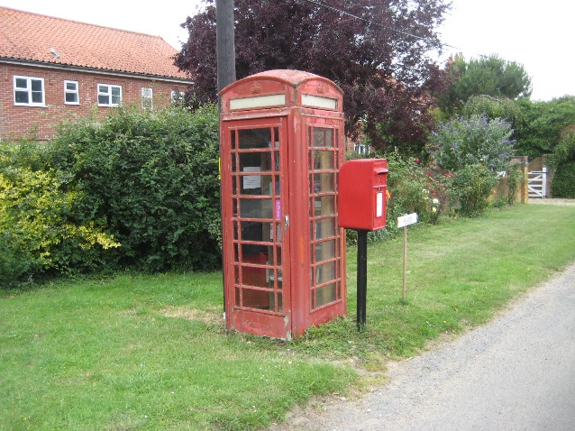  K6 telephone box and post box
Conservation Management Guidelines
Highways
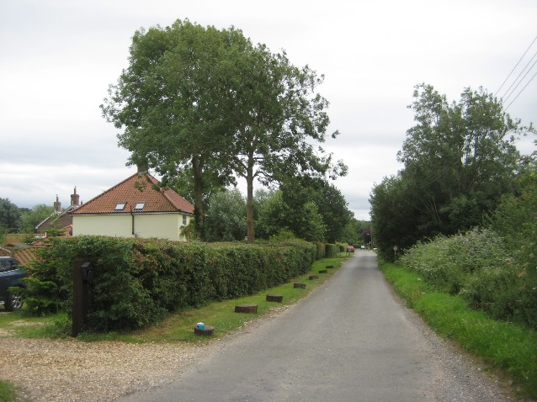 | Other than one or two speed signs, reflective plastic bollards at The Street (east side) and the traditional mid-20th century road sign opposite the green, there are no other highways signs in the conservation area. Roads have natural grass verges which are very much part of the rural character of the settlement.  The lack of highways signage helps to retain the traditional rural character of the conservation area and therefore any new signage should be kept to a minimum. The use of road kerbs should be avoided as these will only detract from the rural character. Small timber posts fixed at intervals can sometimes be a more sympathetic alternative.
Upgrading Windows and Doors
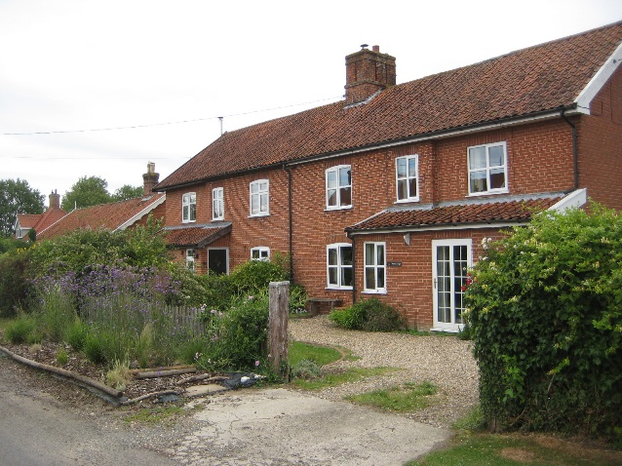  Ground Surfacing  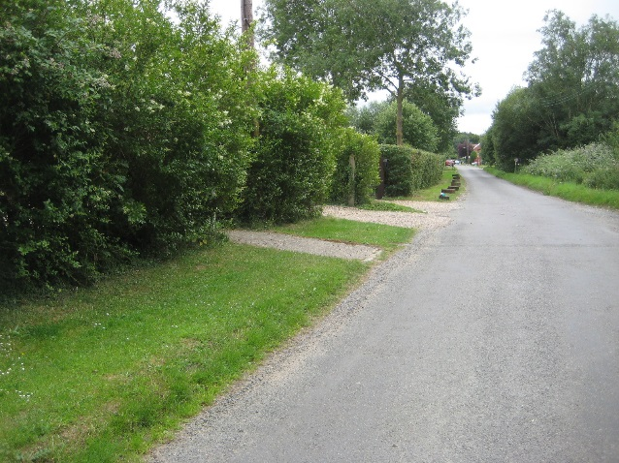 | In some cases original timber windows and doors on traditional buildings have been replaced with different materials and/or different styles. If original doors or windows need to be replaced, they should ideally be replaced to match. However, if different materials are chosen then the window style should match the original design.  Where windows/doors have been unsympathetically replaced in the past then the opportunity should be taken to reinstate traditional windows with more correct proportions.  All road surfacing is tarmacadam between natural grass verges and nearly all driveways have a natural gravel finish.  The use of more modern surface materials such as paviors on driveways should be avoided as this will have a detrimental impact on the character of the conservation area.

Front boundaries

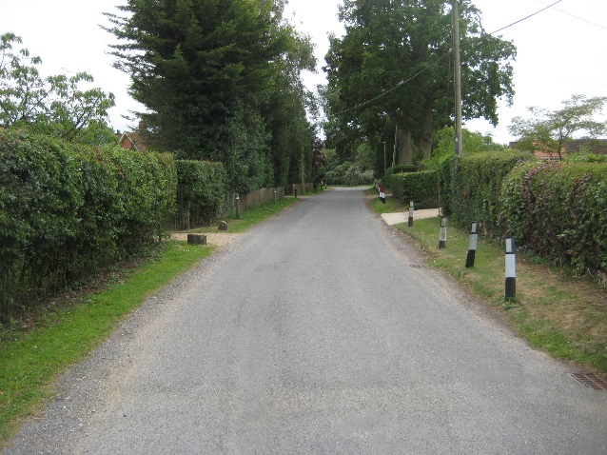 | An important part of the character of the conservation area is defined by the line of mature hedgerows along the front boundaries of properties.  Whilst fencing has been used for a small number of boundaries every effort should be made to retain hedgerow boundaries, which form such an important part of the character of the conservation area.
Painting/colour washing buildings
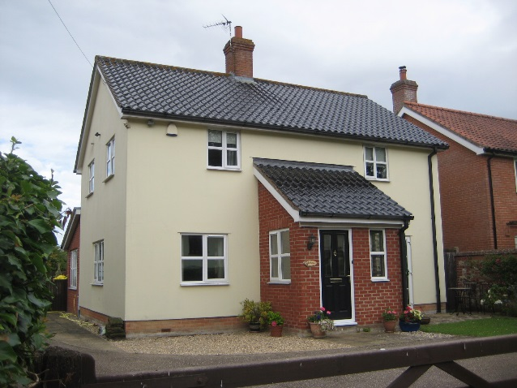 | The majority of buildings in the conservation area have a natural brick finish although painted render can be seen on a few buildings.  Careful consideration should be given to paint colours to ensure the visual harmony of buildings in the village is retained.

Appendix 1 (i)

Listed Buildings (All Grade II, except as noted)

The Street (east side) Home Farmhouse.

The Street – (west side) Highfield Farmhouse
Boundary wall to Highfield Farmhouse

The Green Keepers Cottage (formerly Yew Tree Cottage).
Village pump and shelter.

Mill Road Locks Pyghtle

Appendix 1 (ii)

Unlisted Buildings of townscape significance

Mill Road Clay lump barn at The Homestead
Wildwood
Cringle Cottage
K6 Telephone kiosk & post box
Oak Lodge
Rose Cottage
The Willows
Numbers 8, 12,12a,14, 23

The Street (East) 1 & 2 Thorpe Abbotts Place
Outbuilding close to road at Thorpe Abbotts Place
Pheasant Cottage
Numbers 5, 6, 24, 25, 26
Clay lump outbuilding at 26

The Street (West) Village Hall and sign

The Green Lion House and its outbuilding

Appendix 2

Policy background

In recent years, the approach to conservation area designation has changed considerably. It is now recognised that development plan policies, development control decisions, and proposals for the preservation or enhancement and the management of conservation areas, can best be achieved when there is a sound understanding of the special interest of the conservation area.

This position is reinforced as follows:

The Planning (Listed Buildings and Conservation Areas) Act 1990 in section 66(1) makes it a duty of local authorities when considering applications to have special regard to the desirability of preserving a listed building or its setting or any features of special architectural or historic interest.

Under section 72 of the same Act, it is a duty with respect to any buildings or land in a conservation area, to pay special attention to the desirability of preserving or enhancing the character or appearance of that area.

Department for Communities and Local Government. National Planning Policy Framework (NPPF) 2018 Paragraphs 184 to 202 cover “Conserving and enhancing the historic environment”.

Joint Core Strategy- Policy 2 : Promoting Good design

The South Norfolk Local Plan Development Management Policies Document was adopted in 2015 and policy 4.10 covers Heritage Assets.

Public Consultation

An informal ‘walkabout’ of the area was organised with the Parish Council on 20th February 2020. This informed the proposed boundary changes and the conservation management guidelines within the draft appraisal. The public consultation on the draft appraisal took place from 15th February to 15th March 2021, with attendance at the parish meeting on 23rd February. Due to the Covid-19 Lockdown regulations the public meeting was carried out through virtual attendance at the parish council meeting online. The consultation and parish council meeting were advertised through:

• An advert in village notice board and local publicity by the parish council
• The draft appraisal being available to view on the council’s website.
• Emailing Ward Councillors, County Councillors, the Parish Council and Historic England.
• Contacting residents directly affected by the proposed boundary changes by letter informing them of the consequences of being included in the conservation area.

As a result of the consultation corrections were made to the appraisal, however the boundary changes remain the same as outlined in the consultation draft.

Appendix 3
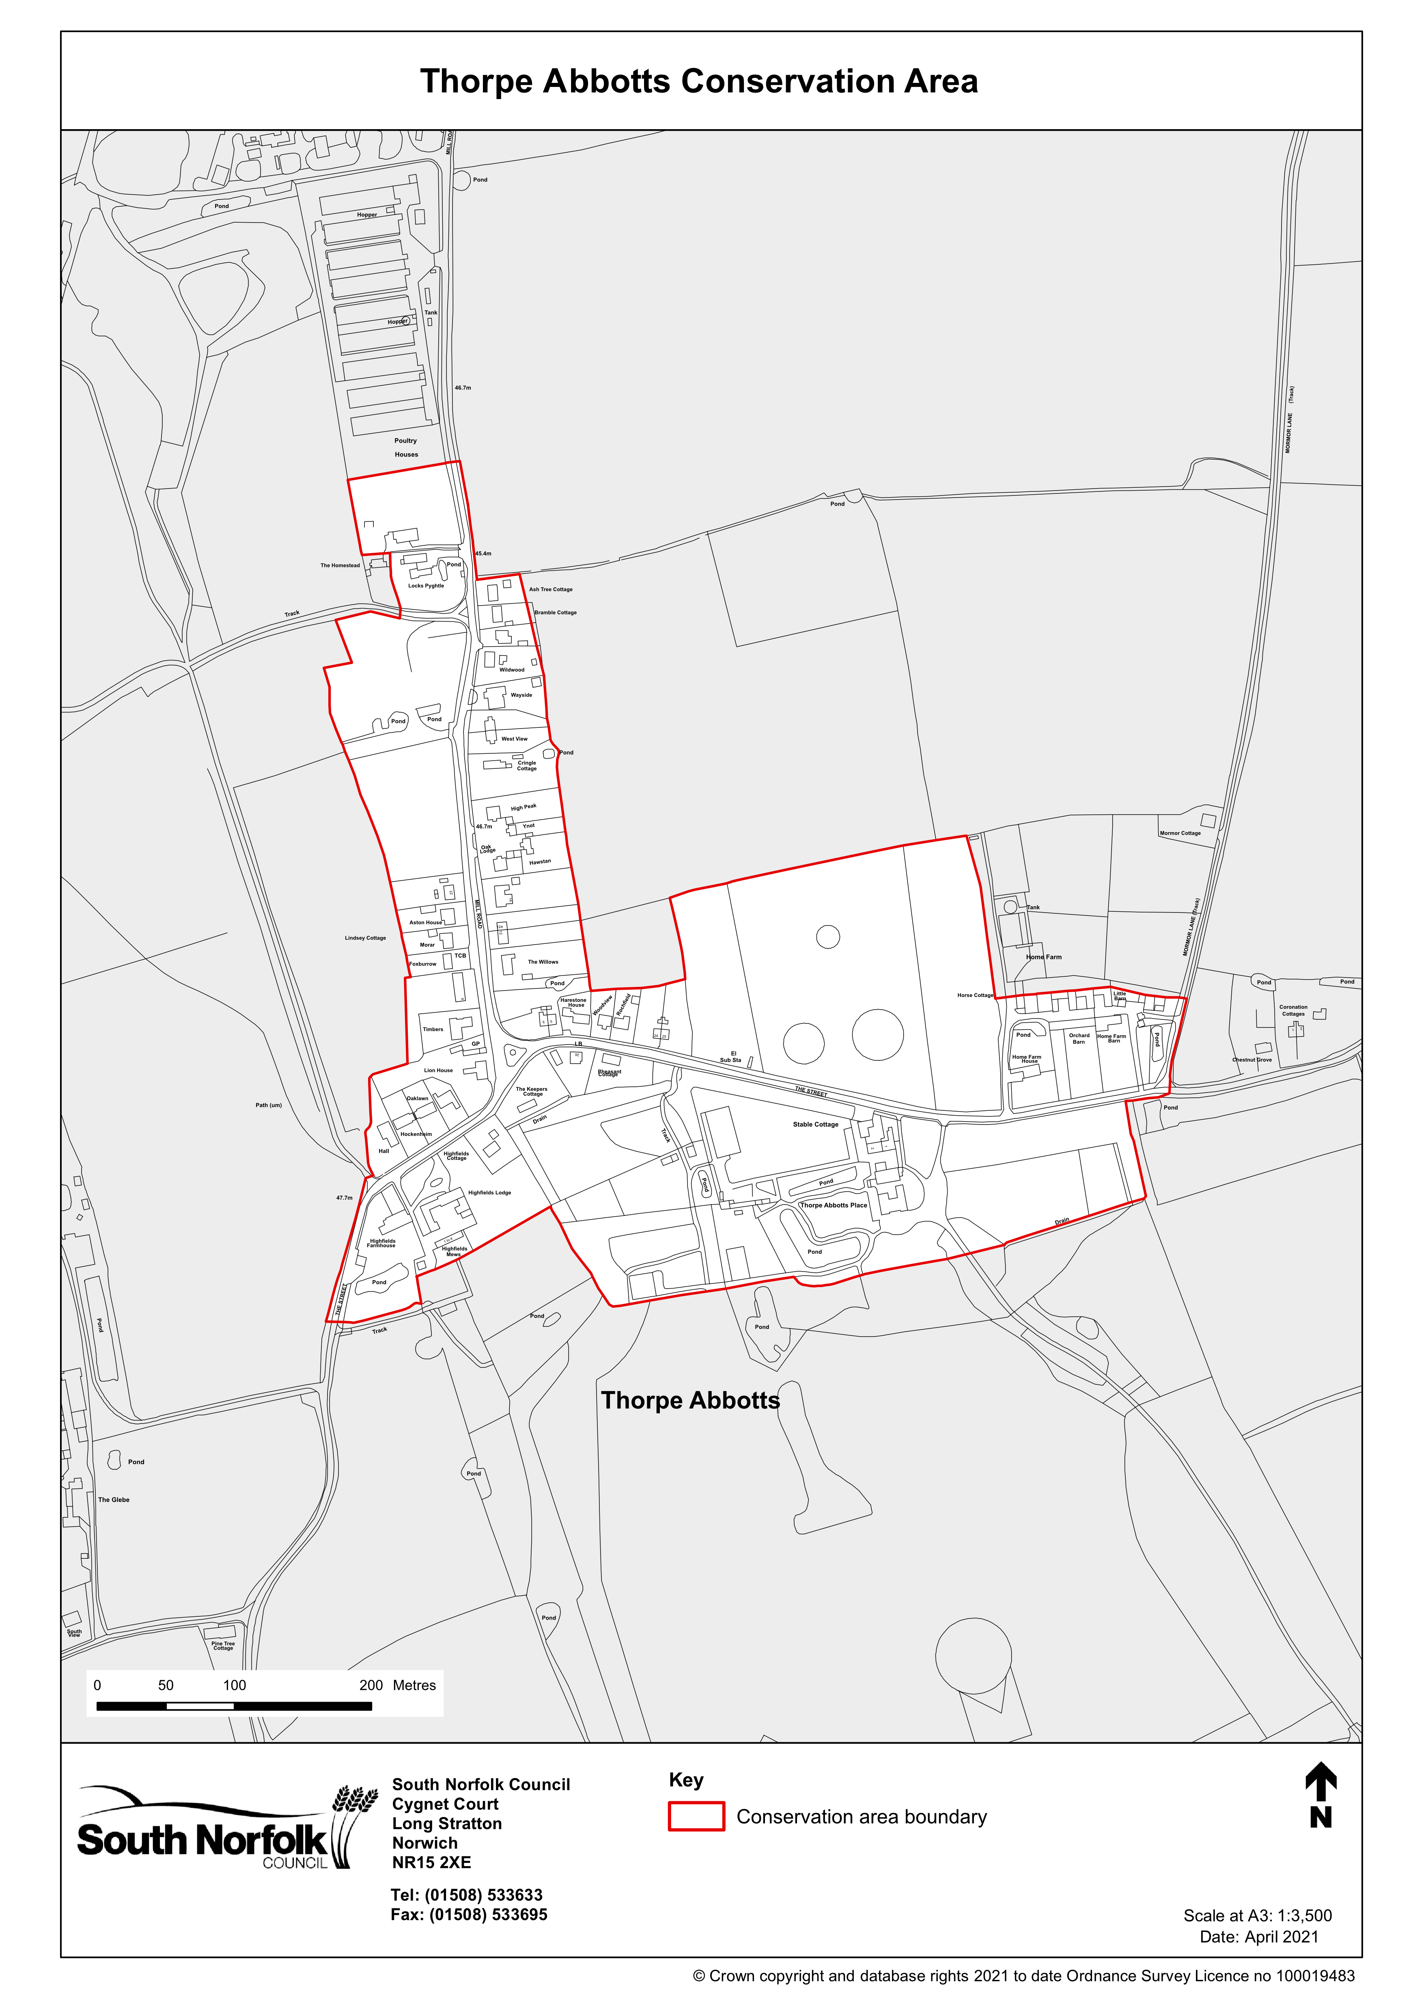
Appendix 4
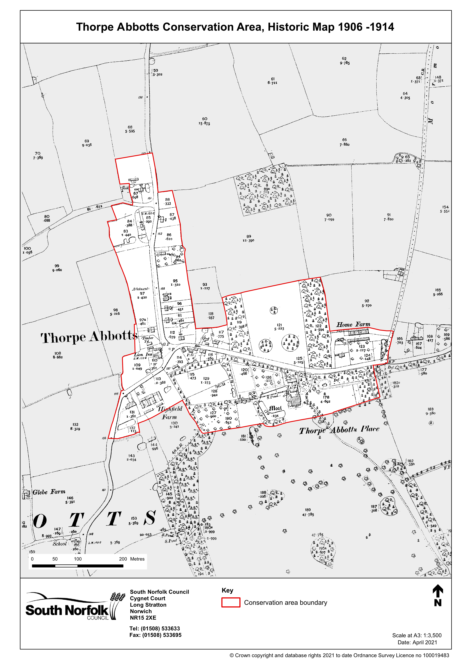
Appendix 5
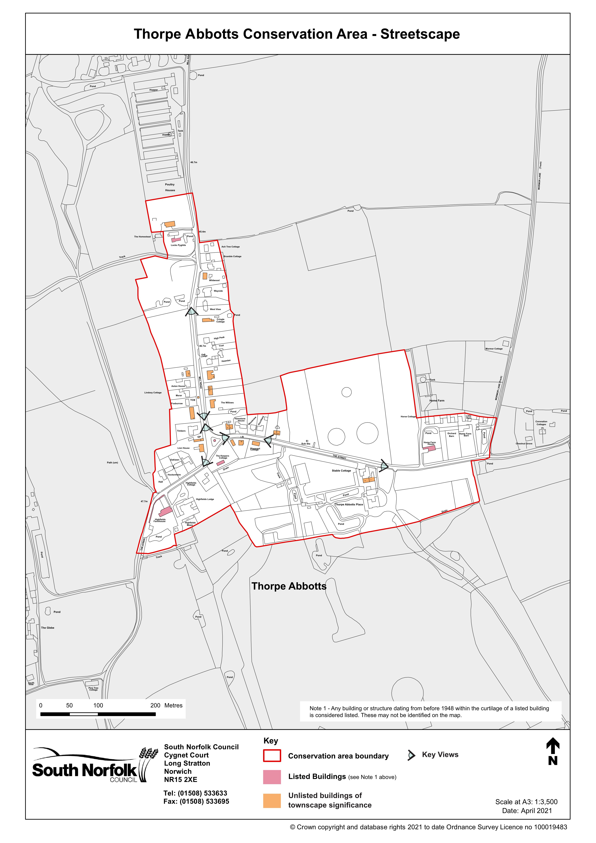
Appendix 6
