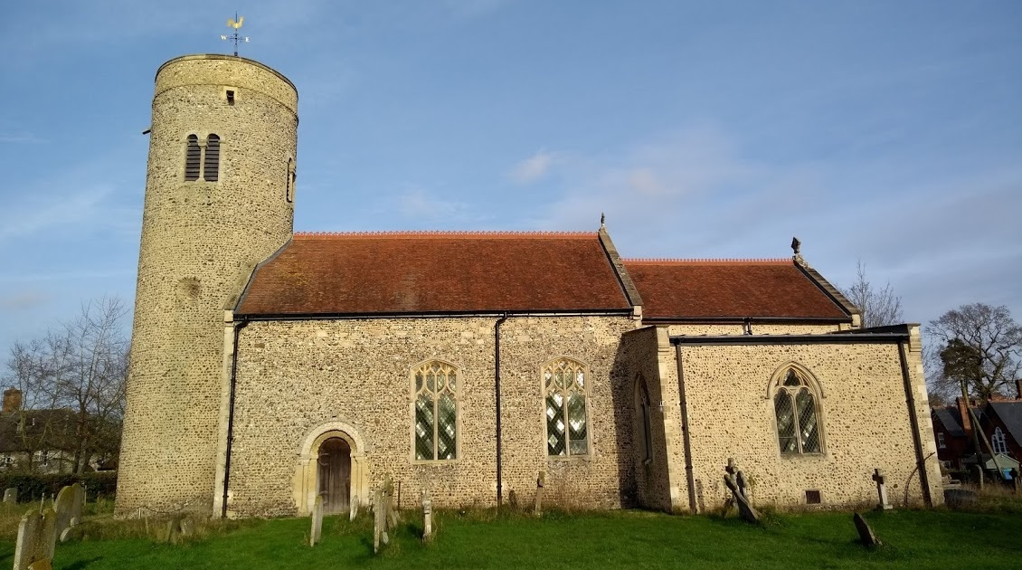
Gissing
Conservation Area Character Appraisal
and Management Guidelines

July 2021

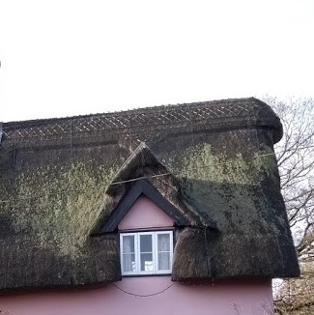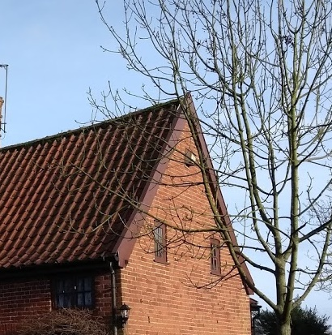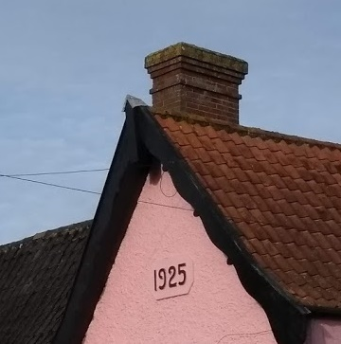
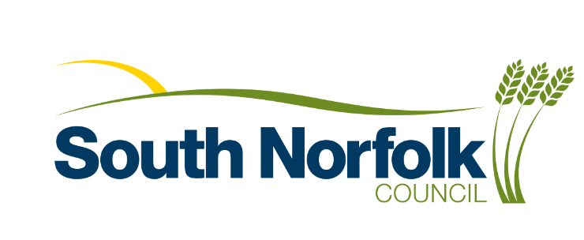
Content

Introduction 3

Historical Development 4

Character Assessment 5

Conservation Management Guidelines 12

Appendix 1(i) - Listed Buildings in 13 Gissing Conservation Area

Appendix 1(ii) - Unlisted Buildings in 13
Gissing which are of townscape significance

Appendix 2 - Policy & Consultation 14

Appendix 3 - Conservation Area Boundary 15

Appendix 4 - Historic Map 16

Appendix 5 - Streetscape 17

Appendix 6 - Natural Character 18

Introduction
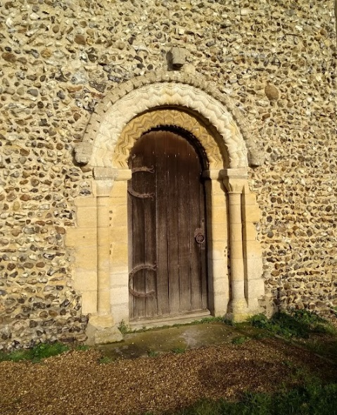  Norman South doorway | Despite being less than a mile from the Norwich to London railway mainline, Gissing has the feel of a hidden and remote village; rich in history and relatively untouched by time. The conservation area is formed mainly of the two separate areas of clustering around Upper Street to the west and Lower Street to the east, between which and to the south lies the former parkland to the old hall (demolished in c1700.)  The settlement has seen little development during the 20th and 21st centuries with only a handful of more modern detached dwellings, most to the south of the church. In recent years the church has been repaired, and there is an award-winning extension of the former school to create a well used new community hub.
Under the terms of Planning (Listed Buildings and Conservation Areas) Act 1990, the Local Planning Authority is required to identify areas of special architectural or historic interest whose character or appearance it is desirable to preserve or enhance, and to designate them as a Conservation Area. The 1990 Act also requires local authorities to prepare management guidance and proposals for Conservation Areas. Gissing conservation area was originally designated in 1994. This document should be read in conjunction with the adopted Local Plan, the National Planning Policy Framework and Planning Practice Guidance.

Key Characteristics
Key buildings include the Church of St Mary, the Crown public house and the Community Hall (formerly the Village Board School and recently extended.)
- Two clustered areas of housing in Upper Street and Lower Street.
- Large area of former parkland with tree belts to the old hall, now farmed, between the two clusters.
- The church, community hall and The Crown public house are located in Lower Street which can be considered the village centre
- Houses mainly dating from 16th to 19th century with very little modern development

Historical Development (also see historic map in Appendix 4 p16)
The oldest building in the village and the most interesting in terms of historic development is the parish church. The church has Norman features but also some Saxon elements which date at least some of the church from the earlier period. Externally there is a striking contrast between the simplicity of the Saxon/Norman round tower with unknapped and course flint, and the flush-work of the knapped flints used to decorate the 15th century north porch (built in 1474). Unusually the porch is on the north side rather than the more normal south side – no reason has been found why.

The church is also however rich in Norman Romanesque detailing with arches of chevron detailing to both north and south entrances (the north arch contained within the later medieval porch.) The round windows half-way up the tower are identifiable as being of Norman origin though - they are known to have used round baskets as a frame to set the flints around. Saxon foundations have also been found under the north porch.

Internally there are features of interest too, with the two side chapels being associated with the Kemps, who were Lords of the Manor from 1324. The 15th century double hammerbeam roof with winged angels, unusually ornate for such a small rural church, is outstanding.

The Kemp family mausoleum is within the north chapel, which has a vault and is lined with an impressive collection of funereal monuments. The south chapel contains the family pew. Prior to the Kemps, the lords of the manor in the 13th century were the de Hastings who gave half of the patronage of the church to the monastery of Butley in Suffolk. The church was restored in 1876 and the south chapel was rebuilt in 1879 without disturbing the vault below. The floor has Victorian tiles dating from this period. A further extensive repair was carried out in 2017.

The ancient manor house of the Hastings and later the Kemps survived until c1700 when it was recorded as being torn down when the Kemp family moved to Ubbeston in Suffolk. The 1883 Kelly Directory records that Sir Robert Kemp suffered greatly for his loyalty to Charles 1st, who had made him a baronet. A decline in their fortunes may have been part of the reason for the move away from Gissing.

The second baronet, who was a member of parliament from 1675 to 1685, married Mary Sone, the only surviving daughter of John Sone of Ubbeston, following the death of his first wife. She inherited the estate, and hence the reason for the move of the Kemps to Ubbeston, although members of the family continued to be buried in the vault at Gissing. Blomefield described the former hall as having a remarkable collection of heraldic stained glass. The parkland was converted by the Kemps into a farm, with the collection of farm buildings to the south of the hall being retained. Part of the barn complex has now been converted to residential and the double moated site of the earlier manorial building survives to the north (NH10942.)

The present Gissing Hall is mostly hidden from view on Upper Street with its crenelated upper stories being glimpsed through and above the hedgerows. From the east it can be seen sitting slightly incongruously across the fields, rather like a red brick castle. The hall mostly dates in terms of its style and appearance from the rebuilding of the former rectory in the 1820s by the Reverend Sir William Robert Kemp. Being both the Lord of the Manor and vicar he combined the rectory with his manorial residence. The bulk of the house appears Jacobean in style, but is in fact a later 19th century copy. The house originally dated to the 17th century and parts of the original building appear to have been incorporated into the later dwelling. The hall remained in the ownership of the Kemps until the 1920s.

In the 19th century the Kelly directory described Gissing as ‘a pleasant scattered village, 5 miles N. by E. of record that the parish registers were "destroyed by fire at the rectory some years ago" but that some 16th century fragments survived. Besides the Kemps the landowners are recorded as being the Norwich Free School and Doughty's Hospital in Norwich. Blomefield recounts that one hundred and fifty communicants were counted for the year 1603 in the church records.

By 1735 fifty-one houses and about three hundred inhabitants were recorded. Fifty years later the village was described thus:- "...it hath a fair, yearly on St James' Day (July 25th 1781) which in 1378 was granted to Sir Thomas de Gissing Knight together with a weekly market at Gissing, but that is now disused. The country hereabouts is a deep clay soil, and the roads very indifferent."

In 1881 the population was 454, showing that over the previous hundred and fifty years the village had grown by about fifty percent. The occupations this time include a shopkeeper, bailiff, wheelwright and post office keeper, eight farmers (one a woman), blacksmith and miller, three publicans, a plumber/shopkeeper, a baker/corndealer and a shoemaker. A Wesylan Chapel was built in 1860.

The population of Gissing declined from 364 in 1911 to 219 in 1981, but has recovered since to 265 in 1996. The settlement has a population of 252 in 99 households in the 2011 census.

In 1876 the Board School was also constructed, built for 88 children at a cost of £700, but closed in 1978 due to declining pupil numbers. The former school house was adjacent to the school. Both buildings have been used as a community centre since 1982.

A significant recent development of the village is the extension of the former school as a Children’s Centre, incorporating a pre-school, and a new community hall, by the Heart of Gissing organisation. As part of the project a large extension was built to the east side of the school and completed in 2017, receiving a South Norfolk design award. The former village hall on Rectory Lane, dating from 1906, and a simple wooden structure on a brick plinth, is now disused and there is planning permission for a replacement dwelling. The church also underwent significant repairs with the help of a Heritage Lottery Grant in 2017. A History of Gissing Church is available by Avril Pierssene http://fogchurch.org.uk/media/GISSING-CHURCH-HISTORY-Avril.pdf

Character Assessment
(Also see Streetscape and Natural Character Maps in Appendices 5 and 6 pages 17 and 18)
Gissing and its setting
The conservation area is broken into two village clusters around Upper Street to the north west and Lower Street to the south east. There is also a cluster of housing to the south and other scattered houses around the area, including some houses near the railway bridge, which are considered part of the village settlement but are not within the conservation area.
The two areas within the conservation area are separated by fields and wooded areas which to the south of New Road formed part of the former parkland to the old hall. Although the tree plantation belts remain, the scattered parkland trees have been removed (still evident on the historic map) and the fields turned to arable. New Road links the two parts of the village and is in effect a rural lane free from development. Although the wider area is very flat, the extensive tree planting in the surrounding countryside limits longer distance views.
Lower Street is characterised by the irregular clustering around small greens on the corner. The church and community centre (the former school) and the Crown public house are in effect the centre and heart of the village. The group of buildings are viewed within a relatively spacious rural setting with open aspect to fields to the east and views across from Rectory Road when approaching the village from the west. The church is very prominent along Lower Street and the church’s round tower is visible from surrounding fields.
Upper Street buildings are arranged along rural lanes with buildings slightly set back and with extensive mature landscaping and hedging which limit views of the relative flat open countryside. The main house in the village, Gissing Hall, is set back from the road within its grounds and hidden from the street and public viewpoints – only its crenelated towers and roofline partially glimpsed through the hedgerow. Between Marlers Farmhouse and the other houses un Upper Street there are two long rectangular village meadows which are proposed to be include in the conservation area.

Conservation Area Boundary
The conservation area was first designated in 1994. It centres on three areas of Upper Street, Lower Street and the rural former rural parkland of Gissing Old Hall, which includes the former moated site with Hall Farm to the south. The fields are farmed but there are various remaining tree plantation belts which assist in define what was the former park area.

As part of the current assessment Upper Street area has been extended to include Marlers Farm and two meadows which are historic an important feature of this part of the settlement. At Lower Street the conservation area boundary house been altered to include the trees to the front of Pheasants Roost, but not the rest of the plot. Also, the conservation area has been widened to the east to include the new community building extension and the newly planted village orchard.

Street Patterns and Historic grain
The conservation area is quite loose knit and there is not a regular street pattern, with dwellings grouped into the two clusters of Upper Street and Lower Street. Due to the lack of more modern development, the setting of the church, the former school buildings and the Crown public house remain with a relatively spacious setting. New houses to the north east of the pub fit in with the existing character. In Upper Street the domestic properties generally address and front towards the lane but there is variety in plot sizes and building lines. This creates a very informal and rural character to the village which it is important to preserve.

Perambulation
There are three parts of the conservation separated by fields and open countryside, the part of the conservation area around Lower Street the form to the south church to the south east, and the part around Upper Street, including Gissing Hall to the north west, and the part to the south which was the former park land to the hall.
Upper Street area
Starting at the north end, there is marked transition during the approach along Common Road at the junction from Wash Lane from the flat Norfolk countryside of arable fields to the more enclosed character of buildings, trees and hedgerows.
On the east side is a cottage, now two properties, faced in red brick with a clay pantiled roof. The steep roof and low eaves indicate that the property was likely to be thatched and timber framed internally. The next house, 31, was built at a right angle to the street and was two cottages. In the noughties, the house was remodelled into a small cottage with traditional casement windows and a porch, and additional lean-to to the west. Behind is no. 33, again this was a row of small labourers’ cottages, but is now combined to form one house with a low eaves and two eyebrow dormers, and brick gable ends.
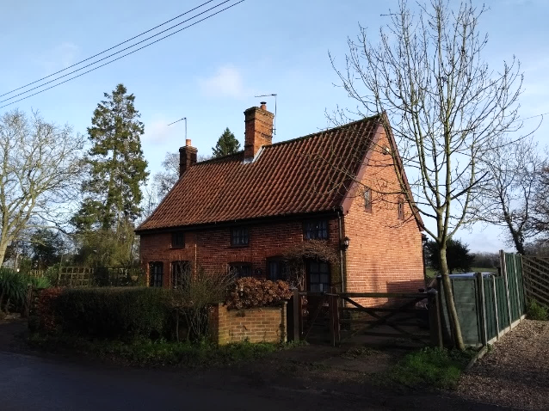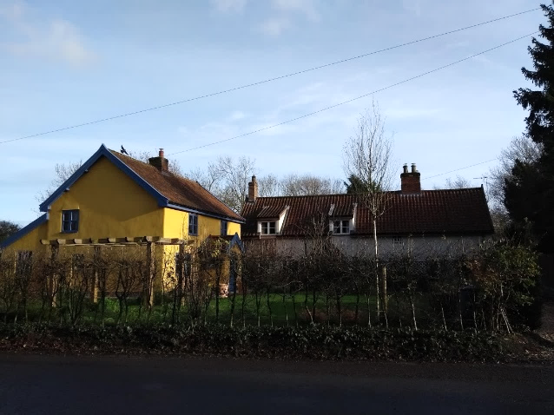
28 & 29 Upper Street 31 and 33 Upper Street

On the corner with Upper Street and New Road is the Old Post Office, a simple 17th /18th century gabled timber framed house. There are numerous architectural features – the remains of mullion windows at the north west end, and pargetted render. Pargetting is more of a tradition of Suffolk and Essex - although there are some examples in south Norfolk. On the south side is a good early 18th century door on the south end. A single storey extension to the west has a crow stepped gable and was the post office. To the south east corner is a small 19th century clay lump stables, now converted to residential. The south end wall is weatherboarded.
The houses on the west of Upper Street up to the junction with New Road are completely obscured by vegetation. Hidden from view 26 and 27 Upper Street is a 16th and 17th century timber framed and rendered with early 19th and more modern casements. More visible through the hedge is the large 16th and 17th century timber framed house with fragmentary remains of pargetting. The north part is a 17th century cross wing with jettied first floor on brackets and a jettied gable. These elevations have later sash windows inserted alongside earlier mullion windows which have been blocked up but with timber work re-exposed as a feature.
Following the junction on the west side there is again a low 18th century cottage with eyebrow dormer. The building was once single storey. The south end of the building was the bakehouse. This is followed by a modern brick house set back from the road, and a large farmhouse. The following cottage on the west side, the Chequers, is the picturesque thatched former pub, originally dating from the late 16th/17th century.
To the east side of Upper Street obscured by hedgerows and trees is Gissing Hall. The Hall was significantly remodelled in the Tudor/Jacobean style from the former rectory, which dating from the 17th century. The materials are predominantly red brick and slate, with crenulations, turrets and a clock tower. There is a more modern house now erected in the grounds to the west.
Further along the road following the bend, there is Firs Cottage – a former estate house now extended, and includes a coat of arms on the east gable end. Also, followed on the next corner by the listed 17th century Marlers Farmhouse. It is proposed to now include the paddock/field on the north side of the road and there are good views across to the collection of pantile roof pitches.

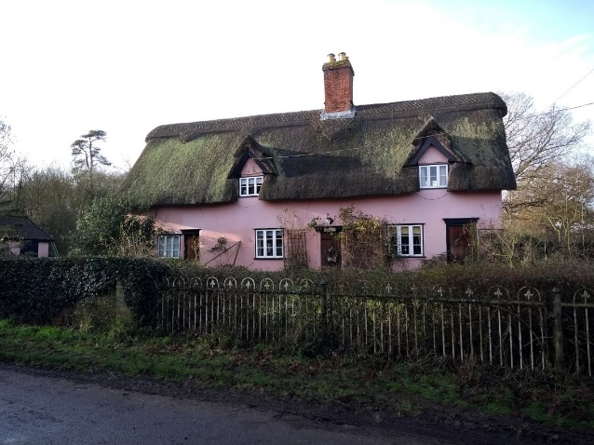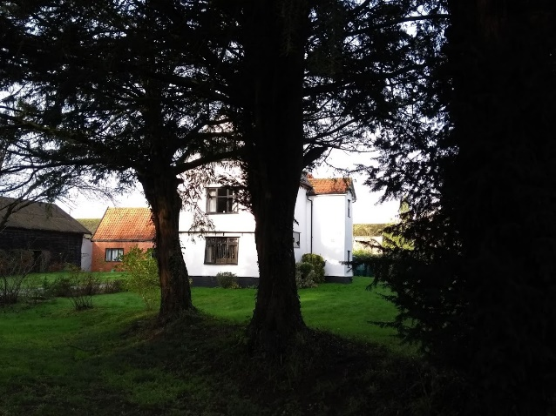
Chequers Marlers Farm

Along New Road there is a 19th century house on the south side gable end to the street. A simple dwelling, rendered with modern casement windows, but very prominent thick overhanging bargeboards. Moving east along New Road there is thick tree planting on either side of the road, and there is no indication that there is another part of the settlement. Passing along the road there are views to the south east towards the Norman round church tower across the former parkland area.

Lower Street
The church is the oldest building within the area and stands out as a local landmark. The church, village pub and community centre are all focal points for the local area. The church stands out in approach view along Rectory Road, which has thick landscaping on the south side, but open views to the north. To the south of the church is a bowling green.
As well as the Norman-style stone carvings, there is another early feature on the main external fabric of the nave: the scratch (or mass) dial. It’s located on the left side of the south doorway at about eye-level height. It shows a large hole in the centre and sixteen small holes circling below. A metal or wooden peg (a ‘gnomon’) was inserted in the central hole so that, if the sun was shining, a shadow was cast as a line that would give an indication of the time of day. This was a helpful guide for the priest so that he could tell when he needed to be ready to take the next service. It was called a mass dial after the word ‘mass’ meaning a church service.
From the west the first house is the converted Georgian chapel. Hedgerows provide a rural boundary treatment but gravestones and memorials can be glimpsed through the gaps. On the east side is the c19 red brick of the former village shop – with the shop front preserved below and the first floor surmounted by a crow stepped gable. The church provides a focal point on the other side of the small triangular green, with an unceremonious telegraph pole in the centre of it. There is a pleasant group of render coated cottages to the north – now divided into three cottages – with steep slate roof and casement windows in a cruciform style. Formerly one large, probably early 18th century, house.

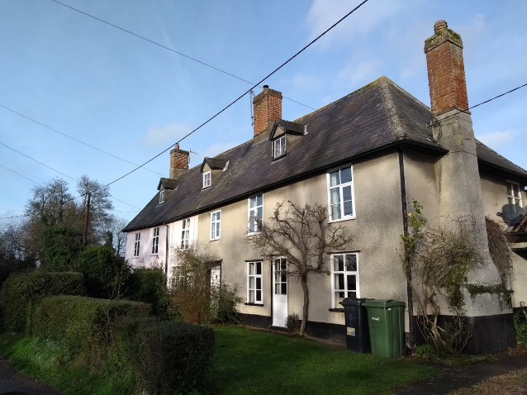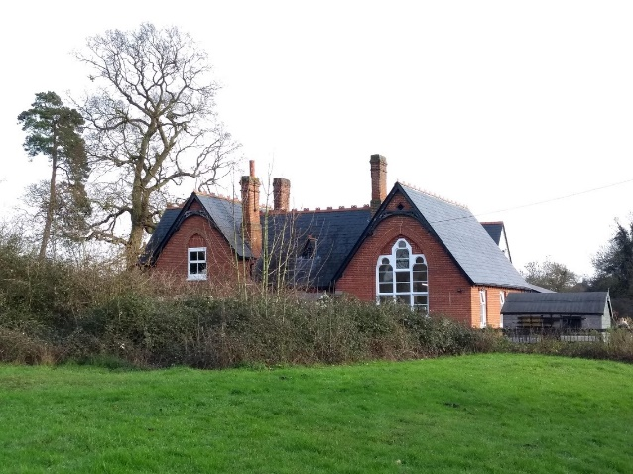
52, 53 & 54 Lower Street The Old School building
/Community Hall
Adjacent to these cottages to the north is the Crown Public House, altered in the 1925 with a thick coating of roughcast render, and also now having modern style casement windows. Crown Cottage is a smaller more traditional adjoining cottage also in render. There is a new development of rendered cottages to the north east, with traditional form and scale and therefore fitting in quite harmoniously.
To the east is the former Board School and School House dating from 1875, typically in Victorian period revival style, steep roofs of slate and ridge tiles with bargeboards. A new extension was built for the community centre in 2017 on the east side with grey weatherboarding as a contrast. To the south of the community building is a K6 telephone box. This was relocated from Wash Lane.
On the corner of Rectory Road is a simple red brick cottage with central stack and dark pantiles called The Lodge. This is actually later brick 19th red brickwork encasing an earlier timber frame construction.

Area around moated site of Former Hall
This is essentially now an area of rural agricultural landscape, but with the remains of the tree belt plantations dating from the former parkland setting of the former hall, and the double moated site of the hall now also covered in thick vegetation. The existing farm complex has been converted into housing.
The farm buildings are approached along a drive and are red brick, dating from the 17th with some later 18th century work. There is also the survival of one bay of a 17th century house. The main barn has an unusual cranked queen post jointed to the tie which is an unusual feature of note. A historic building report on the barns from June 2008 can be found at the Heritage Environment Record or planning application 2008/0755.

Traditional Materials & Architectural Details

The materials of the buildings in the Gissing Conservation Area are typical of this part of Norfolk and are displayed in the fabric of the buildings using techniques traditional to the area.  The majority of buildings in the Conservation Area have rendered walls with a variety of colour washes. Two houses have remains of pargetting.  Plain red brick walls appear in 19th century buildings, notably the Hall, the School and school house and as a facade material upon an older front wall at nos. 28 and 29 Upper Street. Norfolk red brick also appears in Lower Street as the walling material on the former shop opposite the Wesleyan chapel and as the facade of the early 19th century cottage at the Tivetshall turning.  The surviving farm buildings on the Old Hall site, now converted, are also of soft red brick. The estate cottage at the western extremity of the Conservation Area in Chequers Lane is also built of soft reds.  There are two notable buildings that are the exception in terms of their different walling material. The church has different types of flintwork showing the development of this typical South Norfolk material from the 11th to the 19th century. In Upper Street next to the Bakery is a timber clad weatherboarded outhouse rising from a brick base  Most of the roofs are clay pantiled, a majority of them with black smut and glazed tiles. In some cases a mixture of red and black tiles occurs and one roof and there are examples of contrasting red and black sections of roof in the same building.  The church is unusually tiled with red plain tiles while close by the school and schoolhouse are roofed with large Welsh slates. Plain tiles can pre-date the arrival of pantiles, although in this case they are likely to have been put on as part of the 19th century restoration. Welsh slate is also usually a later 19th ‘import’ following better transport connections used for the row of early 18th century cottages next to the Crown and the Wesleyan chapel further along Lower Street. At Upper Street Gissing Hall is also Welsh slated. Also, at Upper Street the Chequers is thatched with a decorative scalloped ridge. | 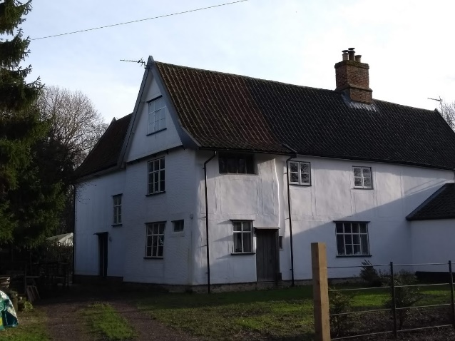  Pargetting at 40 Upper Street  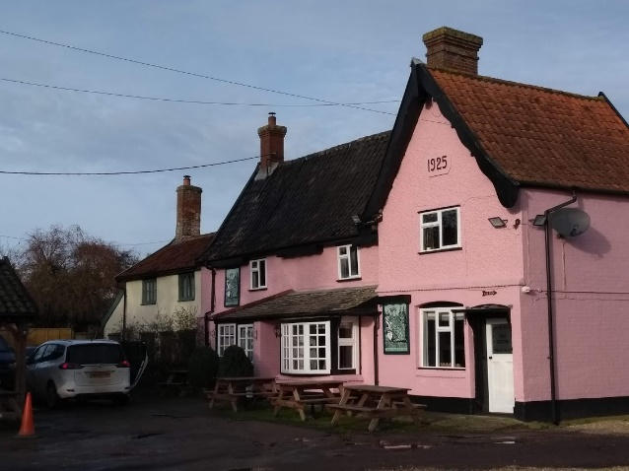  Pastel colour render, steep pitched  roof and later C19th bargeboards  at the Crown  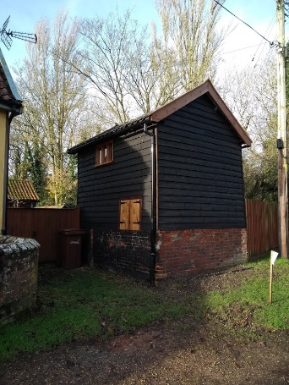  Weatherboarding outbuilding at the  Old Bakery in Upper Street
Natural Character

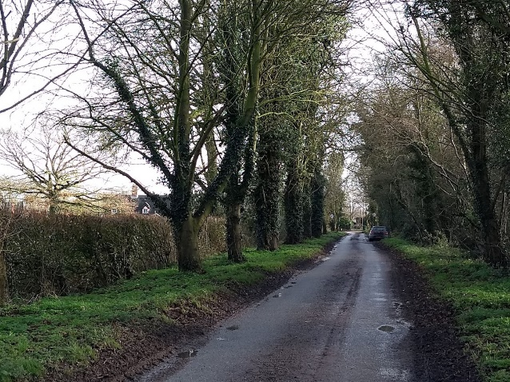  The approach to Upper Street from west | The natural character is important to retaining the rural character of the village. Building are set amongst trees and hedges with village paddocks to the edge.  The conservation area contains several tree plantations to the south which are the remains of the former parkland to the old hall. These are remnants of the former parkland landscape, although the enclosed parkland is now farmland and no longer recognisable.
Street Furniture, Walls and Railings
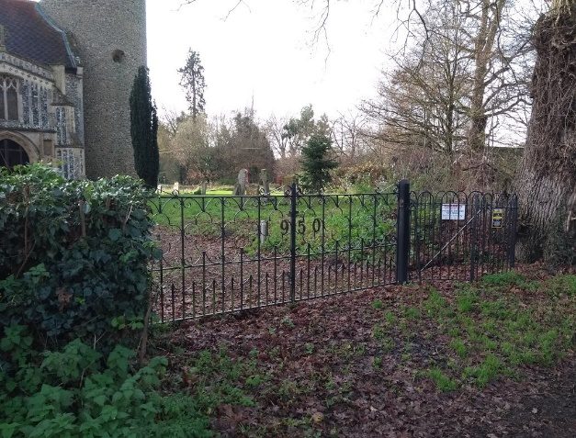  Church gates with ‘1950’ date  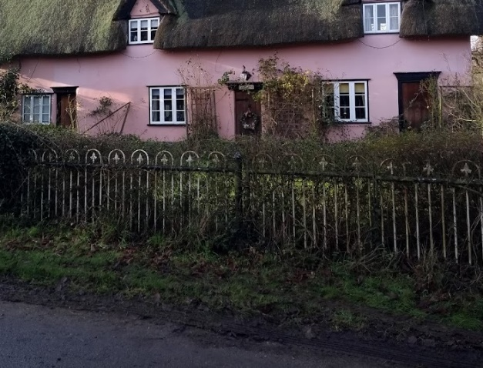  Railings at Chequers | Being a relatively small village and very rural in character there is little street furniture.  A K6 telephone box was moved from its original position on Wash Lane to south of the community centre in 2018.  The listed war memorial is in the south west corner of the churchyard facing toward the road.  There are interesting railings around the church from different dates. Also, some railings to the front of Chequers on Upper Street.

Conservation Management Guidelines
Highways
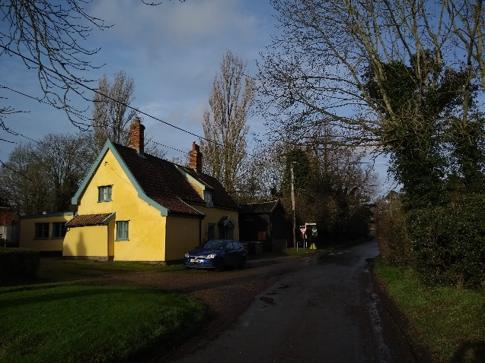  Informal rural character to the streets | The character of the village is very informal and rural, and although pavements can offer safety benefits they can also ‘urbanise’ informal rural streets.  Verges should be kept informal. Careful consideration needs to be given to footpath materials.
Upgrading Windows and Doors
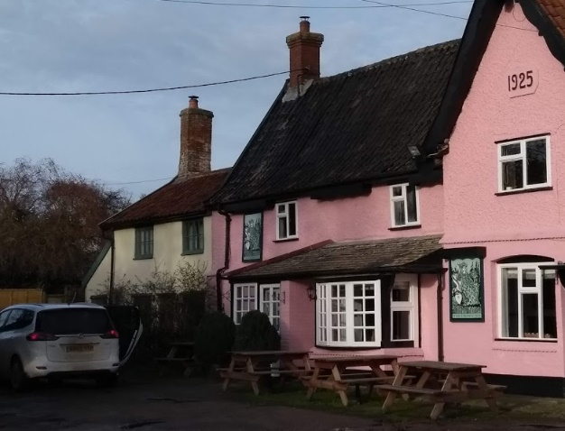  Modern windows can be replaced  with more traditional original style | In some cases windows and doors have been replaced with different materials such as uPVC and/or different styles.  If door or window frames need to be replaced they should ideally be replaced with the original style of windows and materials. The opportunity should be taken to reinstate traditional style windows where they have been unsympathetically replaced in the past.

Painting/colour washing buildings
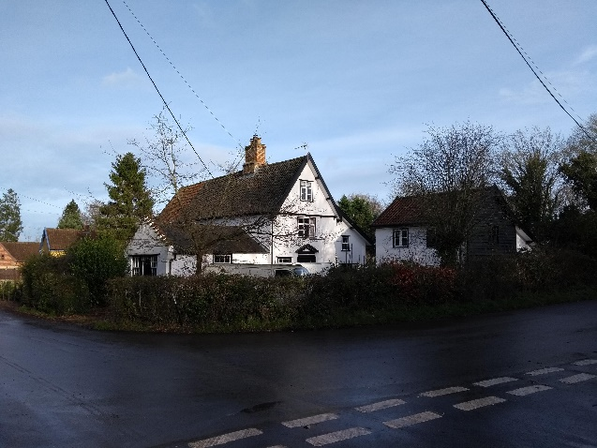  The Old post office | A number of properties within the conservation area are timber framed and rendered. Although there is a variety of colours, the colours chosen are generally whites or pastels to match historic limewash and well chosen.  Colours should be well chosen to match historic limewash colours.
Appendix 1 (i)

Listed Buildings

Burston Road Barn approximately 50m east, south east of Old Hall Barn and Cowhouse east of Old Hall.

Lower Street Nos. 52, 53 & 54 Crown Hill Cottages
Church of St. Mary (Grade I)
Crown Public House
Crown Cottage

Upper Street Nos. 26 & 27, 28 & 29, 33 & 34, 40 & 41, 42
Stables south of No.41
Gissing Hall
The Cottage
Broomfield House
The Chequers

Appendix 1 (ii)

Unlisted Buildings of townscape significance

Chequers Lane Firs Cottage

Lower Street Former school and school house
Old Chapel House
The Lodge

Upper Street Former stables and barns to Gissing Hall
White Lodge
No.31, outbuilding north of The Cottage
Outbuilding to the former Bakery

Appendix 2

Policy background

In recent years, the approach to conservation area designation has changed considerably. It is now recognised that development plan policies, development control decisions, and proposals for the preservation or enhancement and the management of conservation areas, can best be achieved when there is a sound understanding of the special interest of the conservation area.

This position is reinforced as follows:

The Planning (Listed Buildings and Conservation Areas) Act 1990 in section 66(1) makes it a duty of local authorities when considering applications to have special regard to the desirability of preserving a listed building or its setting or any features of special architectural or historic interest.

Under section 72 of the same Act, it is a duty with respect to any buildings or land in a conservation area, to pay special attention to the desirability of preserving or enhancing the character or appearance of that area.

Department for Communities and Local Government. National Planning Policy Framework (NPPF) 2018 Paragraphs 184 to 202 cover “Conserving and enhancing the historic environment”.

Joint Core Strategy- Policy 2: Promoting Good design South Norfolk Local Plan

The South Norfolk Local Plan Development Management Policies Document was adopted in 2015 and policy 4.10 covers Heritage Assets.

Public Consultation

An informal ‘walkabout’ of the area was organised with the Parish Council on 3rd March 2020. This informed the proposed boundary changes and the conservation management guidelines within the draft appraisal. The public consultation on the draft appraisal took place from 15th February to 15th March 2021, with attendance at the parish meeting on 9th March 2021. Due to the Covid-19 Lockdown regulations the public meeting was carried out through virtual attendance at the parish council meeting online. The consultation and parish council meeting were advertised through:

• An advert in village notice board and local publicity by the parish council
• The draft appraisal being available to view on the council’s website.
• Emailing Ward Councillors, County Councillors, the Parish Council and Historic England.
• Contacting residents directly affected by the proposed boundary changes by letter informing them of the consequences of being included in the conservation area.

As a result of the consultation some minor corrections were made to the appraisal with the revised boundary remaining as proposed in the draft.

Appendix 3
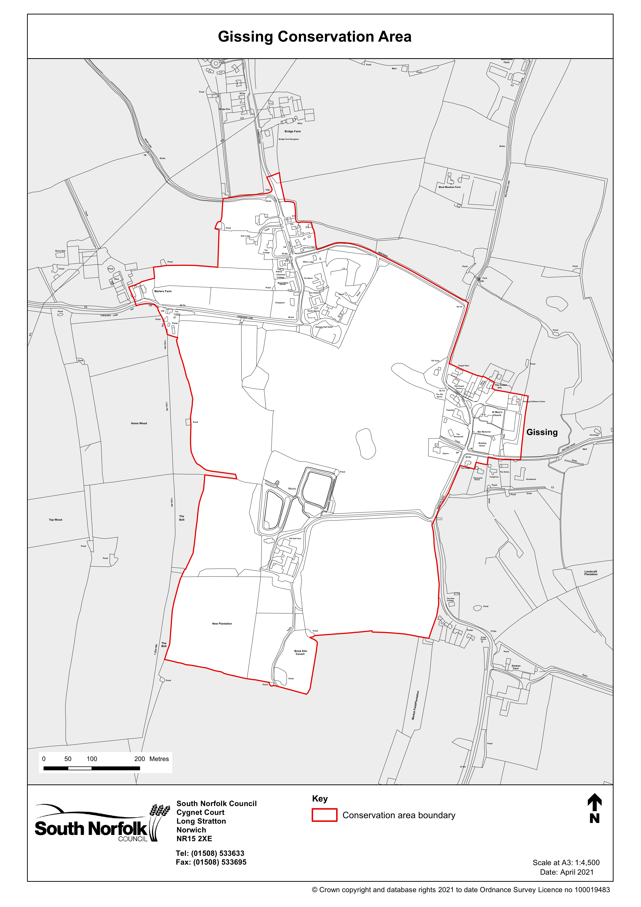
Appendix 4
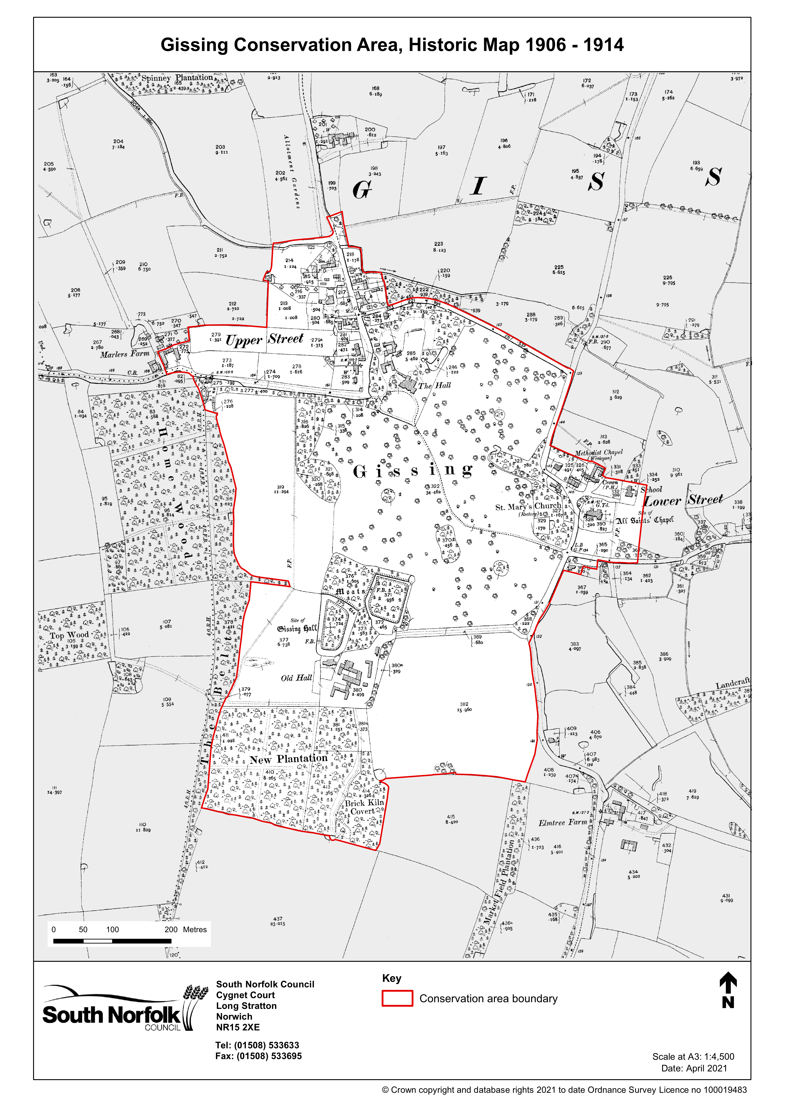
Appendix 5
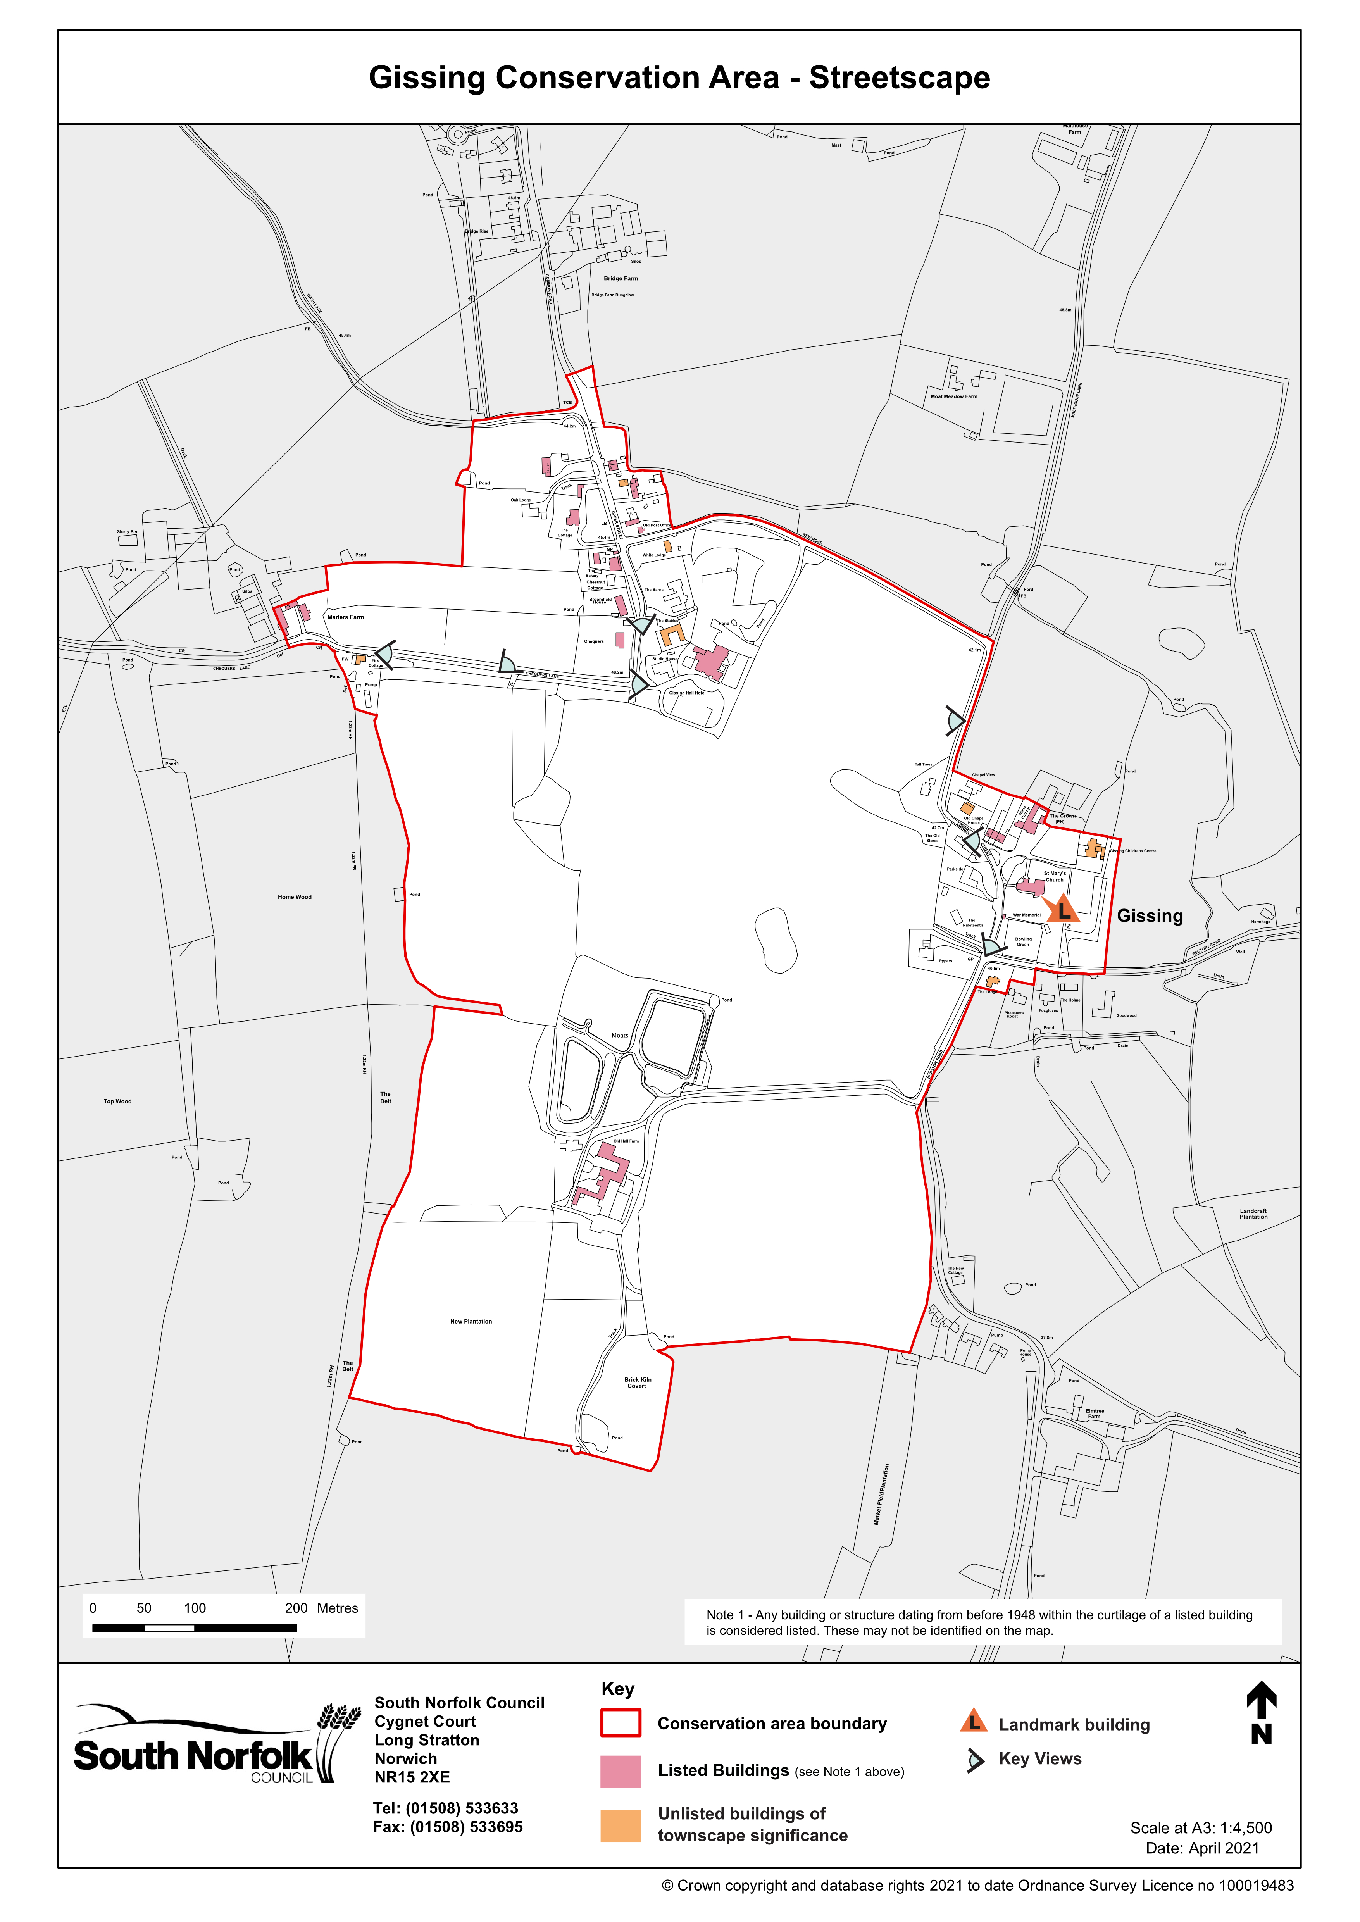
Appendix 6
