Assets of Community Value and

Community Right to Bid

Information Pack
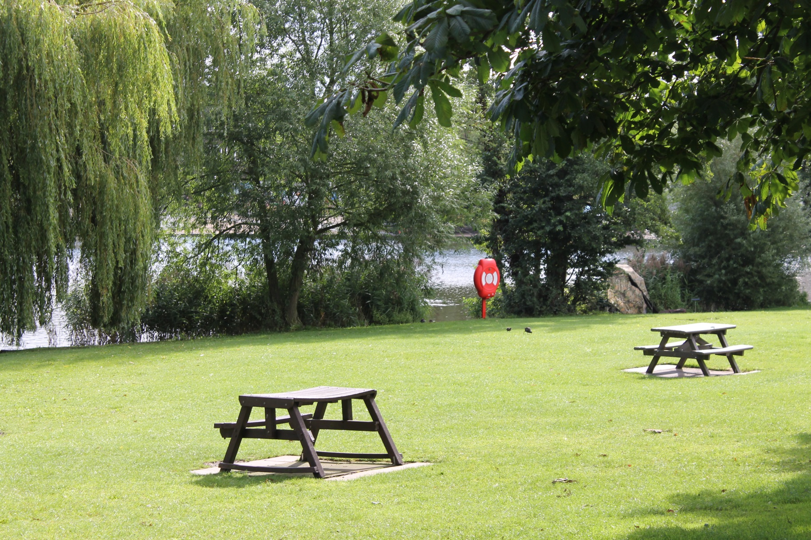

Assets of Community Value & the Community Right to Bid: Information Pack
Introduction

Across Broadland and South Norfolk there are buildings, amenities and land (assets) which are important to local people. The Localism Act 2011 introduced a procedure designed to give communities the opportunity to protect these assets by allowing relevant groups to nominate them as “assets of community value”.

When a property is registered as an Asset of Community Value (ACV) the process temporarily stops certain proposed sales of property so that community groups can put together a bid to buy it; allowing local people to protect places which are important to their social interests and wellbeing. This is referred to as the “Community Right to Bid” (CRTB).

This information pack is designed to offer guidance to all who have an involvement in part, or all, of this process.
What is in this pack?
For ease, we have separated the ACV and CTRB elements of the process. It is quite possible that on some occasions these will occur in tandem, but in the majority of cases – they will be quite separate from one another.
The ACV and CRTB process is managed by the Communities Team. Should you have any questions, or wish to speak to someone about the content of this pack please contact us by email or telephone:
Email: communities@southnorfolkandbroadland.gov.uk Telephone: 01508 533914

Assets of Community Value: Overview

Introduction

Across Broadland and South Norfolk there are buildings, amenities and land (assets) which are important to local people. The Localism Act 2011 introduced a procedure designed to give the community the opportunity to protect these assets by allowing relevant groups to nominate them as “assets of community value”.

For land or buildings to be listed an Asset of Community Value (ACV), their current (or recent past) use must benefit the social wellbeing and interests of the community; and it must be reasonable to assume that it will continue do so in the future. Social interests include sporting, cultural or recreational uses.

There are some limited situations where land or buildings are exempt from being listed as an Asset of Community Value, including residential property.

The process temporarily stops certain proposed sales of property so that community groups can put together a bid to buy it; enabling local people to protect places which are important to their social interests and wellbeing. This is referred to as the “Community Right to Bid”. Please see the Community Right to Bid – Statutory Procedure for further details.

This document will outline the process for registering an asset of community value and what that means.

What ACV is not…

Whilst this statutory procedure is a very useful tool for communities who want to protect and retain community assets, there are limitations to the legislation. It is important to note that the scheme does not:

- Force a property owner to sell their asset to a community group or give a community group the right of first refusal
- Prevent a property owner from selling their property on the open market indefinitely
- Empower Broadland or South Norfolk Council to make any judgement on whether the property should be sold to the community group or not.

Nominations

In order to nominate a property as an ACV, a voluntary or community group must make a request to the council for the building or piece of land to be added to the ‘community asset register’.

All voluntary and community bodies making nominations must be able to demonstrate a local connection by demonstrating that their activities are wholly or partly concerned with the local authority area where the asset sits and/or for a neighbouring authority’s area.
On receipt of eligible applications, applicants and the land owner will be notified of whether the asset has been listed within 8 weeks of the application. The owner then has a further 8 weeks to appeal against any listing.

Assessment and Listing of an ACV

A set process is followed and will assess the nomination against the Criteria and Guidance Notes to determine whether the application is compliant with prescribed requirements. This document has been developed by amalgamating the requirements set out in the Localism Act 2011, relevant Regulations, and our own.
If the nomination is accepted by the council, the property will be listed on Broadland or South Norfolk Council’s ‘Register of Successful Bids for Assets of Community Value’ for a period of five years. Nominations which are unsuccessful will be listed on the ‘Register of Unsuccessful Bids for Assets of Community Value’ for a period of five years

An unsuccessful nomination can be resubmitted if new information is included within the application.

Appeals: The Internal Review Process

In either case, the owner of an asset can request an internal review of the Councils decision. This review is carried out by the Monitoring Officer, or if unavailable, the Deputy Monitoring Officer. The Appeals Process can be found later in this pack

Asset Owner’s Responsibilities after Registration

The owner of a registered ACV must contact the Communities Team whenever they are intending to sell the registered property. If the sale is a relevant disposal, then the Community Right to Bid process will begin. The terms of a relevant disposal can be found in the CRTB Guidance Notes

The owner is advised to contact the Communities Team at the earliest opportunity as it is not possible to shorten the time taken to carry out the statutory procedure.

Asset of Community Value Process

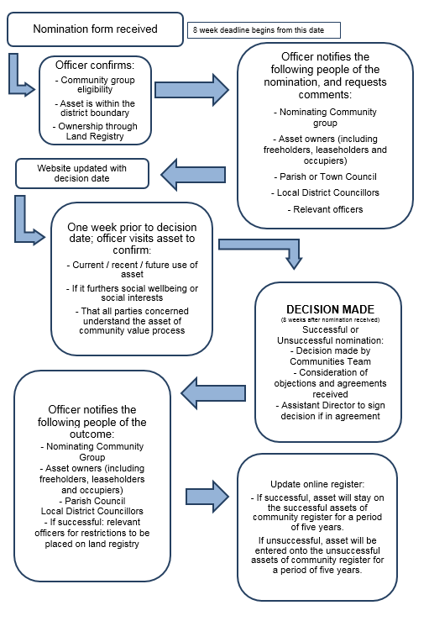

Asset of Community Value: Criteria and Guidance Notes

This document is to assist eligible community groups in understanding whether a piece of land and/or building would meet the criteria to qualify as an Asset of Community Value.

Criteria

A building or piece of land must meet the following criteria (as outlined in the Localism Act 2011) to become a community asset:

- If the asset does not fall within one of the exemptions set out in the Localism Act and regulations it is automatically excluded from listing, and the remaining criteria does not have to be considered.

Properties which are exempt:

a) residential properties and land which it is reasonable to consider to be part of a residence, such as a garden and outbuildings (integral residences in buildings which otherwise could be listed, such as a pub or caretaker’s flat, are not included);
b) an ‘ancillary’ use, such as a café within a workplace;
c) land licensed for use as a residential caravan property (and some types of residential caravan property which do not need a licence
d) operational land of statutory undertakers (such as a utility company) as defined in section 263 of the Town and Country Planning Act 1993.

2. The use of the land or building currently, or in the recent past, furthers the social wellbeing, or the cultural, recreational or sporting interests of the local community. Local authorities will interpret and define ‘recent past’ themselves and the Communities Team will consider each nomination on a case by case basis, with particular reference to the benefit is has to the community.

Those nominating a building or piece of land are advised to include examples of how the community uses the asset. For example, ‘…the youth centre is used by many community groups including; a weekly Scouts group, morning crèche sessions; fitness classes…’ etc.

3. The social use of the building or land is not deemed ‘ancillary’, i.e. of secondary purpose. This means that the use of the land or building to further social wellbeing or interests of the community must be its principal use. For example, a schools primary purpose is educational. The aspects of the asset which fulfil social and community purposes are ancillary to this and therefore the asset would not be listed.

4. The use of the land/building will continue to further the social wellbeing or interests of the local community in the future.

a). Where an asset is presently in social use there should be a presumption of continued viability, unless clear evidence suggests otherwise.
b). For a social use which has lapsed and needs to be re-established the Council will need to take a view on the realism of re-establishing this within the next five years.
NB: The type of social use of the building/land is allowed to change at any time.

Guidance: What is meant by social wellbeing or social interests of a local community?

The table below outlines the kind of properties which will be considered to ‘further the social wellbeing or social interests of the local community’ if they are actively in use at present – or the nominator can prove that they have been in the recent past. Please note – each case will be considered on its individual merits, being on this list does not automatically guarantee that an asset will be registered as an ACV.

The provision of public services directly to the public for the purposes of health and wellbeing, or community safety. | Including:  - Nurseries  - Children’s centres  - Health centre, surgeries and hospitals
Sport, recreation and culture | Including:  - Parks and open green spaces  - Sports and leisure centres  - Libraries  - Theatres and cinemas  - Museums or heritage sites  - Swimming pools and lidos
Community services | Including  - Community centres  - Youth centres
Local Democracy | Including:  - Town halls  - Civic halls
Any economic use, which also provides an important local social benefit. In these cases, it is the social value of the business that counts, not just the nature of the business. | Including:  - Pub  - Shop including Post Office

Other Considerations:

- Where the owner of a listed asset, such as pub, applies for change of use, then the fact that the asset is listed as an asset of community value may be a material consideration in making a decision on the planning application.

- The Broadland and South Norfolk Local Plan seeks to promote the retention and development of important local services and community facilities in villages, such as local shops, meeting places, sports venues, cultural buildings, public houses and places of worship. The importance of these facilities to the local community will be taken into account when considering planning applications, whether the facility is or is not listed as an asset of community value.
Assets of Community Value: Appeals Process

Internal Review

Within eight weeks of being notified of their property being listed as an ‘asset of community value’, the owner can appeal to the council’s Monitoring Officer for a ‘listing review'. The asset will remain listed during the review period. The owner and the council will bear their own costs associated with the review.

An appeal to the Monitoring Officer must be done in writing to:

Monitoring Officer
Broadland and South Norfolk District Council
Horizon Building,
Peachman Way,
Broadland Business Park
Norwich
NR7 0WF

The council will then have eight weeks from the date of receiving the request to carry out the review.

Upon completion of the internal review, the council will produce a report of its findings and notify the owner and the community group of the outcome. Where a change in the status of the property occurs out of the review, it will then be moved to the appropriate register.

If the owner of an asset has been successful in having the asset moved to the ‘Register of unsuccessful nominations’, there will be no right of appeal for the nominating community group.

Tribunal Review

If the owner is dissatisfied with the internal review, they will have 28 days from the date on which the council notifies them of the internal review decision to appeal for a review by the General Regulatory Chamber of the First-Tier Tribunal.

Owners must submit their appeal in writing to the First-Tier Tribunal by:

Email: grc.communityrights@hmcts.gsi.gov.uk

Post: Tribunal Clerk,
Community Right to Bid Appeals,
HM Court & Tribunals,
First-tier Tribunal (General Regulatory Chamber),
P.O. Box 9300, Leicester, LE1 8DJ. 10

Appeal by the nominator

There is not a process by which a nominator can appeal a decision made. However, the nominator is able to submit a nomination for an asset as many times as they wish.
Community Right to Bid: Overview

Introduction

Across Broadland and South Norfolk there are buildings, amenities and land which are important to local people. The Localism Act 2011 put in place a process designed to give the community the opportunity to protect local “Assets of Community Value” (ACV). Please see the Assets of Community Value documents in this information pack for further details.

When a property is registered as an ACV the process temporarily stops certain proposed sales of property so that community groups can put together a bid to buy it; allowing local people to protect places which are important to their social interests and wellbeing. This is referred to as the “Community Right to Bid”.

The Community Right to Bid (CRTB) aims to give community interest groups the opportunity to bid for them when those assets are placed on the market for sale by their owners. The CRTB allows local community groups the opportunity to prepare a business plan and gather finances in order to buy the asset if it became available, and thereby continue its use in the interest of the community.

Property Owner’s Responsibilities after Registration of an ACV

The owner of a registered ACV must contact the Communities Team whenever they are intending to sell their property and enter into a ‘relevant disposal’.

This document will outline the statutory process which is triggered whenever the property owner of an Asset of Community Value (ACV) intends to enter into a relevant disposal, which means they plan to:

- Sell the property with vacant possession
- Grant a lease of more than 25 years with vacant possession
- Assign the lease of the property (where the property owner is a Tenant of the property and their lease was initially granted for a term of more than 25 years)
- Enter into a contract to do any of the above

What will not trigger the procedure?

Even when a property is registered as an Asset of Community Value there are still many things that can take place without triggering the statutory CRTB procedure.
Some examples are listed below (this list is not exhaustive):

- Granting a lease of the property for a term of less than 25 years
- Selling the property subject to an existing lease (i.e. with a tenant in place)
- Any assignment or underletting of the property by the Tenant (where the property is subject to a lease and the property owner as defined by the legislation is the Landlord)
- Granting rights over the property such as a right of way
- Applying restrictive covenants to the property
- Giving the property away
- Selling the property to certain family members
- If the property is part of a business, selling the property as part of the business as a going concern
- Selling the property to fulfil a separation agreement between spouses or civil partners
- Selling the property to fulfil a court order
- Transferring the property to fulfil certain types of contract that were in place before the property was listed as an ACV

The list above demonstrates that there are various ways in which the registered ACV could change hands without triggering the statutory CRTB procedure. In addition to this, there are rules which apply in special cases such as the death or insolvency of the property owner; part listed properties and properties in trust.

When an owner of an ACV should contact the council

Even if a transfer of a property falls within one of the listed exceptions, the owner is requested to contact the Communities Team when any of the above takes place - and if a new owner or lease is involved, to inform us of their details.

It is advised that the owner who intends to enter into a relevant disposal contacts the Communities Team at the earliest opportunity as it is not possible to shorten the time taken to carry out the statutory procedure.

Details of the property and the proposed transaction should be sent to:

Communities Team
Broadland and South Norfolk District Council
Horizon Building,
Peachman Way,
Broadland Business Park
Norwich
NR7 0WF

Tel: 01508 533914 Email: communities@southnorfolkandbroadland.gov.uk

The statutory procedure will begin on the date that Broadland and South Norfolk Council receives notification of the proposed disposal.

Community Right to Bid process

The Community Right to Bid: Statutory Procedure

Following confirmation that the owner is entering a relevant disposal the following procedure applies
Stage One: The Interim Moratorium

The first stage of the procedure is a six week moratorium. This means that the property owner cannot proceed with the transaction for this time period in order to give community groups an opportunity to request to be treated as a potential bidder for the property.

During the six week interim moratorium, the Communities Team will:

- Update the Register of Successful ACVs to show:
- That notice of a proposed relevant disposal has been received
- The date on which the notice was received; and
- The date on which the interim moratorium will end.
- Notify the group that nominated the asset that notice of a proposed disposal has been received.
- Publicise that a proposed disposal has been received within the area local to the property
- Inform the property owner and update register of ACV if a community group notifies that it wishes to be treated as a potential bidder for the property.

During the six week interim moratorium, the property owner can:

- Conduct negotiations to move the transaction forward (i.e. instruct solicitors, negotiate contract etc.)
- Sell the property to any community group that is eligible to request to be treated as a potential bidder for the property

The property owner cannot:
- Complete the transaction that triggered the procedure

During the six week interim moratorium, a community group can:
- Notify the Communities Team that it wishes to be treated as a potential bidder to buy the property. This can be any community interest group (as defined by the Localism Act) and does not have to be the group that originally nominated the property to become an Asset of Community Value.

If no community group expresses interest in the property during this
six-week interim holding period then the statutory procedure
ends here and the property owner may sell the property to
whoever they choose, and at their chosen price.

Stage Two: The Full Moratorium

This second stage will only be triggered if a community group has notified the Communities Team that it wishes to be treated as a potential bidder for a property. This means that the owner cannot proceed with the proposed disposal for a total period of six months, in order to give the community group an opportunity to put together a bid to buy the property.

This six-month period begins at the date the Communities Team originally received notice of the relevant disposal from the property owner (Diagram A)

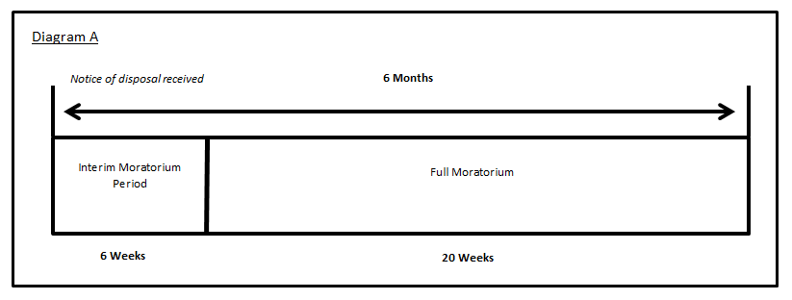

During the full moratorium, the property owner can:
- Conduct negotiations to move the transaction forward (i.e. instruct solicitors, negotiate contract etc.)
- Sell the property to any community group that is eligible to request to be treated as a potential bidder for the property
The property owner CANNOT:
- Complete the transaction that triggered the procedure

During the full moratorium, a community group can:
- Put a bid directly to the property owner to purchase the property

Stage Three: The Protected Period

After the full moratorium has ended, the property owner may sell the property to whomever they choose, and at their chosen price. Even if a community group has made a bid to purchase the property during the moratorium period, the owner does not have to sell the asset to the group.

The protected period lasts for 18 months, beginning at the date that Broadland and South Norfolk Council’s originally received notice of the relevant disposal from the property owner (Diagram B)

Once the 18-month protected period is over, the statutory procedure will once again apply and the property owner must notify the Communities Team of any proposed relevant disposals.

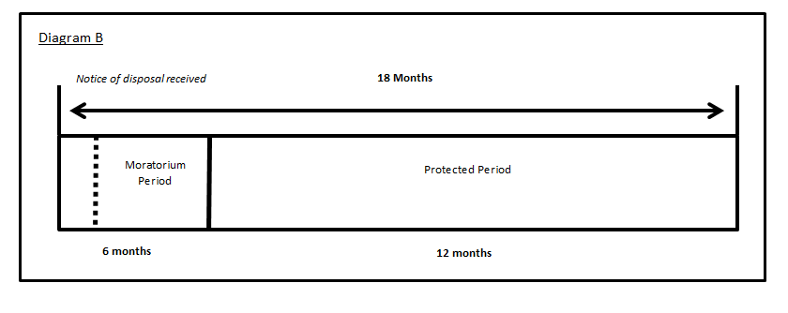

Enforcement

The statutory procedure is enforced by making sure that potential purchasers of a property are aware if it is registered as an Asset of Community Value. Broadland and South Norfolk Councils are required to notify potential purchasers of a property that it is a registered Asset of Community Value by:

- Placing it on the Community Asset Register
- Registering the property as an Asset of Community Value on the local land charges register
- In the case of the registered lane, applying for a restriction to be placed on the land registry title

If the Community Right to Bid procedure has not been followed correctly the sale may be considered void in law.

Compensation

Broadland and South Norfolk Councils are required to provide a compensation scheme to reduce the potential for financial loss to property owners as a result of following the statutory procedure.

Who can apply?

Private owners may claim compensation from the council for losses and expenses incurred which would not have occurred if the land had not been included on the list. This includes, for example:

• A delay in entering into a binding agreement to sell which is wholly caused by the moratorium period;
• Legal expenses incurred in a successful appeal to the Tribunal.

Who is not eligible for compensation?

The compensation scheme does not extend to public bodies defined as:

• Government departments, authorities and other bodies to which section 6 of the National Audit Act 1983 applies;
• Bodies which receive the majority of their funding from public sources which may be examined by the Comptroller and Auditor General under section 7 of the National Audit Act 1983; and,
• Local authorities and other public authorities and bodies that are required to be audited under section 2 of the Audit Commission Act 1998.

Applying for compensation

A compensation claim must be made by the owner within whatever is earlier out of 13 weeks from the end of the interim or full moratorium period, or from the date when the land ceased to be listed.

Claims must be made in writing to the council, stating the amount of compensation sought and providing the necessary supporting evidence. The burden of providing the claim will fall upon the owner.

Requests for compensation should be sent to:
Monitoring Officer
Broadland and South Norfolk District Council
Horizon Building,
Peachman Way,
Broadland Business Park
Norwich
NR7 0WF

The council will consider the validity of the claim as soon as practical. There is no specific time frame for this due to the potential complexities of the case, for which the council may need some time to consider and assemble all the necessary evidence.

