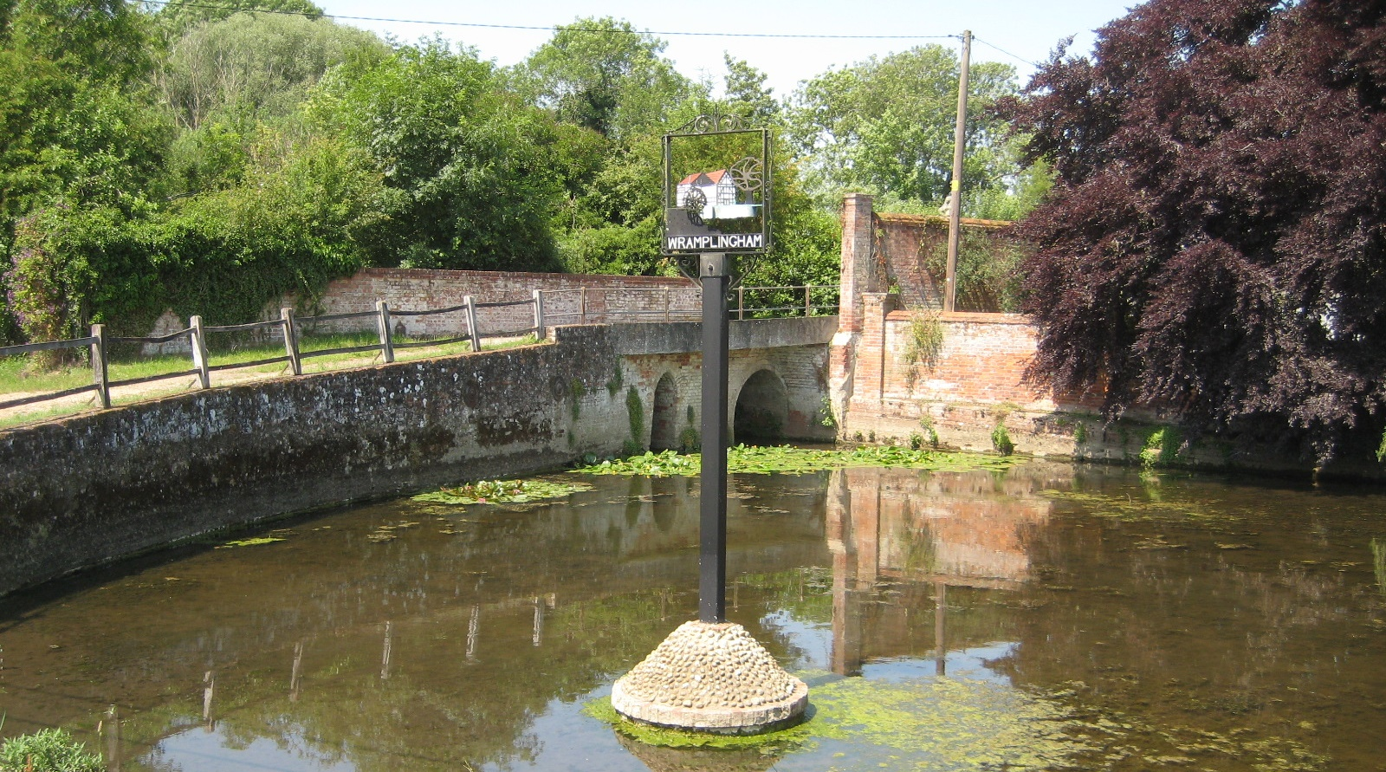Wramplingham

Conservation Area Character Appraisal

and Management Guidelines

July 2021

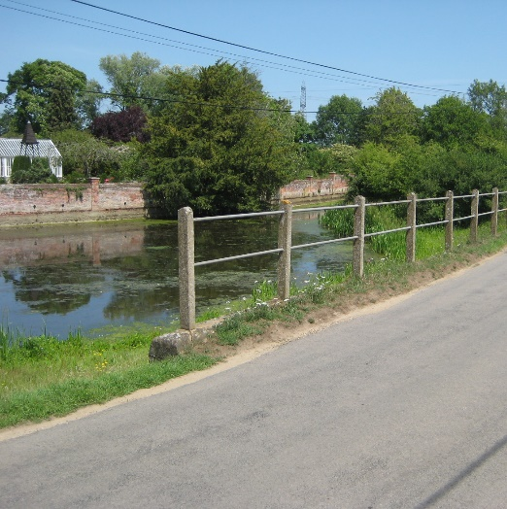 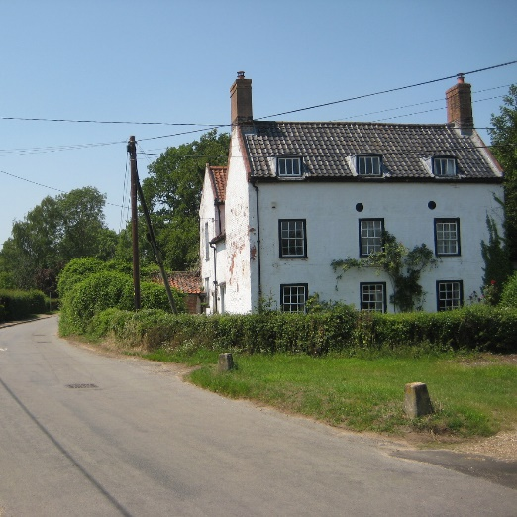 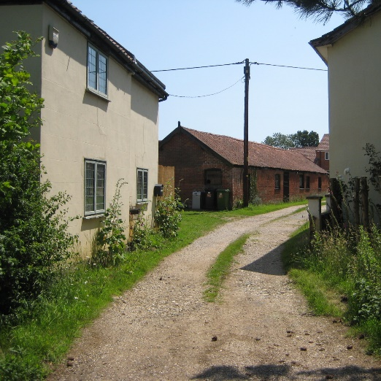



Content

Introduction 3

Historical Development 4

Character Assessment 4

Conservation Management Guidelines 10

Appendix 1(i) - Listed Buildings in 12 Burston Conservation Area

Appendix 1(ii) - Unlisted Buildings in 12

Burston which are of townscape significance

Appendix 2 - Policy & Consultation 13

Appendix 3 - Conservation Area Boundary 14

Appendix 4 - Historic Map 15

Appendix 5 - Streetscape 16

Appendix 6 - Natural Character 17

Introduction

|  |  |
| --- | --- |
| A picture of the Street  View along The Street looking East | Wramplingham is a small rural settlement on the river Tiffey, 7 miles west of the city of Norwich and about 4 miles north of the market town of Wymondham. Nestling in the lower slopes of the Tiffey Valley, the village enjoys the protection of the rising land to the south from which there are distant views across the village and beyond. Its strong natural character with large numbers of mature trees allows it to blend in to views of the surrounding countryside |

|  |  |
| --- | --- |
|  | Under the terms of Planning (Listed Buildings and Conservation Areas) Act 1990, the Local Planning Authority is required to identify areas of special architectural or historic interest whose character or appearance it is desirable to preserve or enhance, and to designate them as a Conservation Area. The 1990 Act also requires local authorities to prepare management guidance and proposals for Conservation Areas. Wramplingham conservation area was originally designated in 1994. This document should be read in conjunction with the adopted Local Plan, the National Planning Policy Framework and Planning Practice Guidance. |

**Key Characteristics**

* River valley
* Large pond with historic buildings at its centre
* Open front gardens
* Strong natural character
* Church overlooks the village
* Distant views of wider landscape from the south

Historical Development (also see historic map in Appendix 4 p15)

The Parish of Wramplingham was established by the time of the Norman Conquest and is included in the Domesday Book, which details its population, land ownership and productive resources. The derivation of the name appears uncertain, but it may have originated from a nickname formed from the base of such words as "wramp" meaning a "twist" (17th century) and "wrimpled" (wrinckled), c1430.

The most obvious reminder of Wramplingham’s medieval heritage is its parish church dedicated to St Peter and St Paul. The building features a 13th century round tower with a tall lancet doorway. The nave dates from the 11th/12th century but the chancel was rebuilt in 1448 and the arcade and north aisle date from 1872. The medieval churchyard was much larger than the existing one. Other than the church there are no other medieval structures that survive in village.

In 1851 the population was 245 which had dropped to 168 by 1911, mostly due to the migration of younger people. By 2011 this had dropped further to 115.

Character Assessment

(Also see Streetscape and Natural Character Maps in Appendices 5 and 6 pages 16 and 17)

**Wramplingham and its setting**

Wramplingham is surrounded by open countryside which is visible well beyond the conservation area in landscape views from the higher ground of the valley to the south side. At the southern entrance to the conservation area from the church, the road meanders down the valley offering extensive views over the village and beyond. However, due to vegetation and topography, there are few clues as to the character of the conservation area in these longer views.

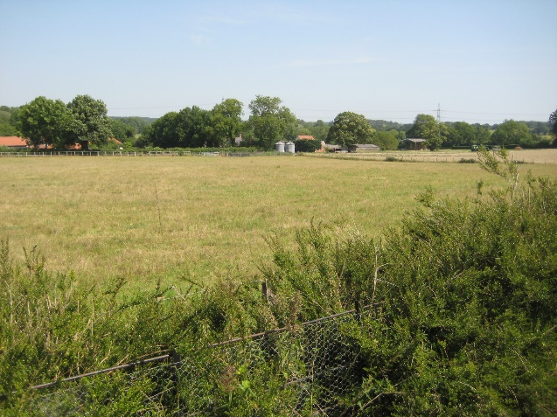 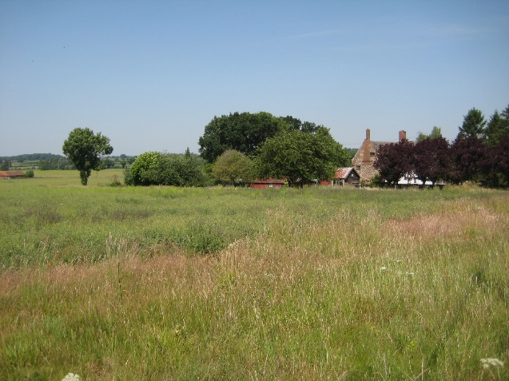

View looking northeast to conservation View looking west away from the

area from churchyard conservation area

From the extreme east and west sides of the settlement, the view back is dominated by the church which occupies a commanding position near the crest of the hill to the southeast. From the main street through the village, views are more enclosed due to the line of dwellings, an exception being at the centre where the street unexpectedly opens out, from which there are longer views across Glebe Farm to the south opposite Mill Pond. The church, so dominant to the south, is not visible to any significant degree from along The Street. Mature hedgerows and grass verges line the road through most of the conservation area with mature trees dominating many views.

**Conservation Area Boundary**

The River Tiffey forms the northern boundary of the conservation area extending from Riverside Cottage in the east to Hall Cottages in the west. To the south, the boundary runs along School Lane breaking off to include the Parish Church and The Old Rectory, the latter being an addition to the conservation area as part of this review.

**Street Patterns and Historic grain**

Historically, moving west to east, Crow Hall Farm, Church Farm, Mill Farm, Glebe Farm and Low Farm have dominated the pattern of the settlement. Along the main street are several buildings of historic importance including Mill Farmhouse. The village here is also a place of contrasts: the open frontages of The Bowers compared to the walled enclosures of Mill Farm and River House; the closing-in of the street by the trees and wall of Mill House and its sudden 'release' by the mill pond and meadows where the road and river come together with more distant views to the top of the valley to the south. Finally, there is the unusual cluster of cottages at the east end compared with the open spacious character to the west.

Another puzzle lies in the unusual "pattern" of the buildings. To the south of The Street, it seems as though they are set in ranks with Mill Farm and Quaker Farmhouse forming the front tier, The Bowers right behind, with Church Farm and Crow Hall to the rear. Since the last appraisal Glebe Farmhouse, largely an 18th century building, has been demolished but would have be ranked alongside The Bowers. The whole arrangement is presided over by the Church of St Peter and St Paul.

**Perambulation**

The Church is not only the most significant building historically and architecturally, but geographically as well. Its commanding position near the top of the valley allows it to dominate the village below and provides a re-assuring presence in views back from the east and west boundaries. The mature hedge, and large trees at its front boundary do not hide the church, its status being apparent in views from the road.

From the south, the church is shielded by the dense woodland grounds of The Rectory, an impressive mid-19th century house with a large garden, all of which is completely hidden from view on all sides by the surrounding dense woodland. The road continues north from the church with mature hedgerows and narrow grass verges either side, the hedges not being so high as to prevent a glimpse of longer landscape views towards the conservation area to the northwest.

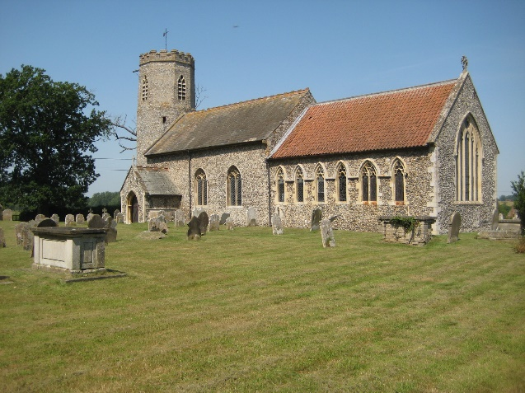 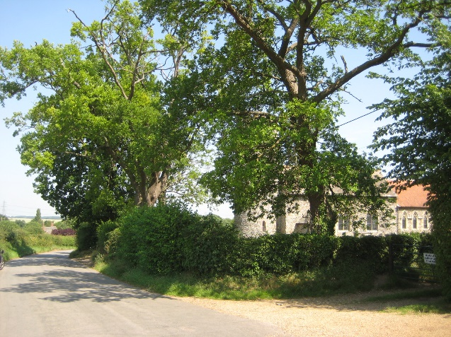

St Peter & St Paul View from The Street

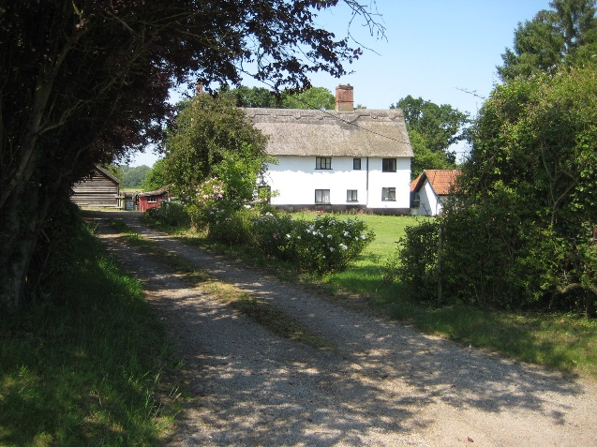 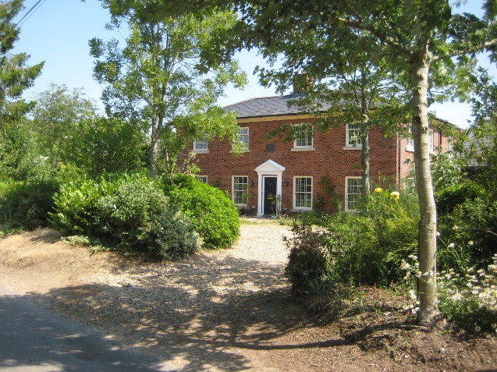

Crow Hall Replacement farm dwelling

From the church, the first buildings on the left-hand side are Crow Hall and its barn, both separate dwellings set some distance back from the road. Crow Hall is a rendered 17th century timber frame house, which is grade II listed, and is the only thatched building in the conservation area. On the opposite side of the road, since the last review of the conservation area the original clay lump house of Church Farm has been replaced with a new Georgian style red brick house. Although the new dwelling does not reflect the vernacular style of the original house, its scale, modest detailing and well-chosen external materials allow it to sit comfortably in the street scene, providing interest. After Church Farm the road turns sharp right opposite the stone War Memorial into The Street.

**The Street**

There are only five dwellings at north side of The Street, views being dominated by woodland along the line of the river. The walled edge west of Mill House, together with the profusion of trees and shrubs, contrasts with the open and deep front gardens of the dwellings opposite to the south side at The Bowers. On entering from the west, houses to the south are 20th century in character but their modest scale and locations back from the road behind mature hedgerows and trees, allows the natural character to dominate.

|  |  |
| --- | --- |
| A picture of the Quaker Farmhouse  Quaker Farmhouse | The buildings along the main street vary in importance but are mostly quite modest in scale and set back from the road. The only notable exceptions are Quaker Farmhouse, an attractive 17th century house perpendicular to the road which contributes much to the historic character of the street scene, and Wramplingham House at the eastern entrance of the conservation area, which is rather too large so that its more modern less sympathetic character dominates its neighbours and the street scene. |

At the centre of the conservation area, The River House, a grade II listed Georgian house, is situated behind the mill pond and is partly hidden by walls and trees, although its formal front elevation and large chimney stacks make it an important focal point. By contrast, two key buildings, Mill Farmhouse and Mill House, are set on the edge of road creating a gateway along the mid-point of The Street, where views open out. Mill Farmhouse has superb crow stepped gables with a similar detail on the crenelated top of its boundary wall. The moulded chimneys to Mill Farmhouse and its rear wing add stature to the building. The view is, however, somewhat spoilt by the telegraph poles and overhead wires. Crow stepped gable ends can also be seen at Quaker House further east.

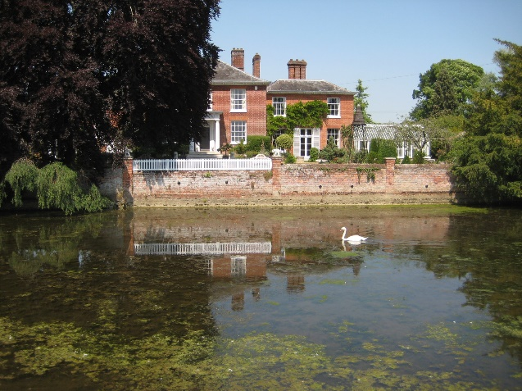 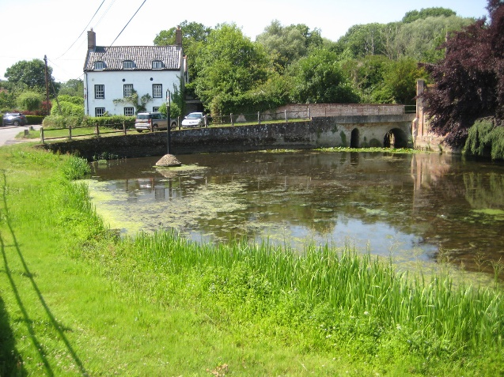

The River House River Meadows

Mill House and River House are both fine examples of 18th century Georgian Houses albeit of different character. River House is in some way the more impressive building being more formal in appearance with side wings in brick, slate roof and a traditional timber conservatory. The fine Beech tree and the brick terrace add mystery and status to its character. The mill pond is cradled in the middle of these fine buildings with a modern railing and concrete posts marking its boundary with the road. These are somewhat of a disappointment and could be replaced with something more appropriate to enhance the street scene. The position of the sign within the pond with its conical shaped flint base is unusual but appropriate, adding interest and character to views.

Moving further eastward, the space opens out to the river and its meadows on the north side where the road and river come together and meander away to the north. Here, mature hedgerows continue to define front boundaries with the road. Opposite, the eye is drawn to the large open view across the meadow of Glebe Farm, its outbuildings visible and of interest. Next moving eastward is a new two-storey dwelling, which has replaced a modern bungalow. Although clearly a modern addition, the overall design of the new dwelling is plain but generally sympathetic and its position back from the road allows it to sit reasonably comfortably.

|  |  |
| --- | --- |
| Further east is Quaker Farmhouse, which is listed grade II*. This is of exceptional significance and one of the larger dwellings in the conservation area. Its rendered finish with brick gable ends and plain tile roof provide a particularly attractive appearance that stands out and dominates street views here. The tasteful entrance design with iron gates together with the the crow stepped gables, diaper brickwork and steep roof pitch of the house all draw attention. The house has been carefully restored in recent years with a sympathetically designed rear extension. By contrast, its ancillary farm buildings are of much less interest. | A picture of the Quaker Farmhouse  Quaker Farmhouse |

Moving further eastward from Quaker Farmhouse just before reaching the Old Kings Head, of particular note is the surviving timber churn stand, which is a more unusual feature. This together with the decorative brick of the wall behind adds interest to the street scene.

Next is an unexpected cluster of buildings before the east boundary of the conservation area is reached. They have been altered but are modest in scale and form a tightly knit group without precedent elsewhere in the conservation area. Riverside House survives unaltered while the outbuilding to the rear of Meadow View, and the front wall of Low Farm, both in red brick, deserve special mention. The over dominance of Wramplingham House opposite on the east boundary of the conservation area has already been referred to.

**Traditional Materials & Architectural Details**

|  |  |
| --- | --- |
| Examples of most of the building materials traditional to South Norfolk can be found within the conservation area.  Roofs: Clay pantiles are the most common, both red and black can be found often on the same building, for example the Mill House. There are two notable plain tiled roofs - one on the nave of the church, and the other on Quaker Farmhouse. Slate survives on River House and has been used on the new dwelling at Church Farm. The only thatched roof survives on Crow Hall.  Walls: The prevailing material is red brick although a significant number of the buildings have exceptionally good brickwork either with a "diaper" pattern or with flint. The quality of brickwork is enhanced by the use of crow steps to the gables, crenelated walls, and in shaped chimney stacks. The Mill House has painted brickwork, while there are a number of rendered houses disguising timber frames, clay lump or brick. Black boarding has been used to good effect on the converted barn at Church Farm.  The church is the most outstanding flint building although the gable walls to Crow Hall are in flint and brick. Of particular note is its round tower with octagonal bell-stage and its 13th century lancet windows either side of the chancel.  Other than the medieval Gothic detailing of the church, crenelated boundary walls and crow stepped gable ends there are few other architectural details of note but worth mentioning are the Classical door surround and large chimneys at The River House and the original Georgian sash windows at Mill House. | A picture of the timber churn stand  Surviving timber churn stand  A picture of the crenelated walls at Mill Farmhouse  Crenelated walls at Mill Farmhouse  A picture of the Mill Farmhouse  Crow stepped gables at Mill Farmhouse |

|  |
| --- |
| **Natural Character and open spaces**  The trees west of Mill House are the most significant group while in many other places, it is individual trees that are noticeable. Worth noting are the three Oak trees that line the north side of The Street moving east from Quaker House. There are good hedgerows along School Lane and some survive to delineate the field boundaries. Mature hedgerows either side of the road are a key feature throughout much of the conservation area along Wymondham Road and The Street.  Other than the open setting of the churchyard the only other key open spaces are the river meadows east of the mill pond and the large field opposite of Glebe Farm. At the river meadow a large area of the land has been maintained with traditional wooden benches installed.  **Surface materials and street furniture**  All public roads are tarmacadam with grass verges. There are a variety of surfaces for private drives though most tend to be compacted sand and gravel.  Road signs are not too intrusive. There are a number of overhead cables and poles which interrupt the appearance of the area especially at Mill Farm and in landscape views to the west from the churchyard. The area around the mill pond could be rationalised with the modern railing with concrete posts being replaced with something more sympathetic. The telephone kiosk and traditional post box should be safeguarded. The village sign, on a cobbled base set in the mill pond is unusual and adds much to the character at the village centre. |

Conservation Management Guidelines

**Highways**

|  |  |
| --- | --- |
| A picture of the main street | The speed of vehicles going through the village has previously been a concern. There is little traffic congestion and no great need for significant numbers of cars to park along the main street. The natural grass verges add much to the rural character along the main street through the village.  **The use of kerbs along the road should be avoided in order to retain the rural character of the street scene.** |

**Upgrading Windows and Doors**

|  |  |
| --- | --- |
| A picture of a house in Wramplingham | In some cases, windows and doors have been replaced with different materials and/or different styles. If original doors or windows need to be replaced, they should ideally be replaced to match. However, if different materials are chosen then the window style should remain the same ( if original).  **The opportunity should be taken to reinstate traditional styled windows where they have been unsympathetically replaced in the past.** |

**Painting/colour washing buildings**

|  |  |
| --- | --- |
| A picture of a house in Wramplingham  **Trees/open spaces**  **A picture of the meadows in Wramplingham**  **Street Furniture**  **A picture of the Mill pond** | Some of the buildings are rendered or brick with a light colour pastel finish that sits comfortably with the historic character of the area.  **With any redecoration, the colours should be chosen to maintain the existing pattern.**  The trees/woodland and open spaces of the meadows are a particularly important part of the character of the conservation area, north along the line of the river and provide an important back drop to the street scene.  **It is important that lines of trees and woodland areas along the river meadows together with small groups of mature trees along the street are retained to preserve the strong natural character of the village. The carefully managed section of the river meadow is an attractive part of the conservation area and this should continue to be maintained in this way for both the benefit of the conservation area and local community.**  The railings at the mill pond could be replaced with something more in keeping with the historic character of the street scene.  **Street furniture should be kept to a minimum and where it is necessary, should be designed to be sympathetic to the rural character of the conservation area.** |

Appendix 1 (i)

**Listed Buildings (All Grade II, except as noted)**

Wymondham RoadChurch of St Peter & St Paul (grade I**)**

Old Rectory

Crow Hall

The Street Mill Farmhouse

Boundary walls to Mill Farmhouse

K6 Kiosk

Mill House

River House

Quaker Farmhouse (grade II*)

Appendix 1 (ii)

**Unlisted Buildings of townscape significance**

Wymondham Road Swallow Barn

Former Outbuildings at Church Farm

The Street Riverside House

Outbuildings to south east of the former Old Kings Head

Front boundary wall to Low Farm

Outbuildings at Glebe Farm

Range of buildings to south of Mill Farm

Boundary wall to The River House

Hall Lane Hall Cottage and wall to east

Hall Cottages

Wren Cottage

Appendix 2

**Policy background**

In recent years, the approach to conservation area designation has changed considerably. It is now recognised that development plan policies, development control decisions, and proposals for the preservation or enhancement and the management of conservation areas, can best be achieved when there is a sound understanding of the special interest of the conservation area.

This position is reinforced as follows:

The Planning (Listed Buildings and Conservation Areas) Act 1990 in section 66(1) makes it a duty of local authorities when considering applications to have special regard to the desirability of preserving a listed building or its setting or any features of special architectural or historic interest.

Under section 72 of the same Act, it is a duty with respect to any buildings or land in a conservation area, to pay special attention to the desirability of preserving or enhancing the character or appearance of that area.

Department for Communities and Local Government. National Planning Policy Framework (NPPF) 2018 Paragraphs 184 to 202 cover “Conserving and enhancing the historic environment”.

Joint Core Strategy- Policy 2 : Promoting Good design South Norfolk Local Plan

The South Norfolk Local Plan Development Management Policies Document was adopted in 2015 and policy 4.10 covers Heritage Assets.

**Public Consultation**

An informal ‘walkabout’ of the area was organised with the Parish Council on 13th February 2020. This informed the proposed boundary changes and the conservation management guidelines within the draft appraisal. The public consultation on the draft appraisal took place from 15th February to 15th March 2021, with attendance at the parish meeting on 16th . Due to the Covid-19 Lockdown regulations the public meeting was carried out through virtual attendance at the parish council meeting online. The consultation and parish council meeting were advertised through:

• An advert in village notice board and local publicity by the parish council

• The draft appraisal being available to view on the council’s website.

• Emailing Ward Councillors, County Councillors, the Parish Council and Historic England.

• Contacting residents directly affected by the proposed boundary changes by letter informing them of the consequences of being included in the conservation area.

As a result of the consultation corrections were made to the appraisal and some additional information added.

Appendix 3

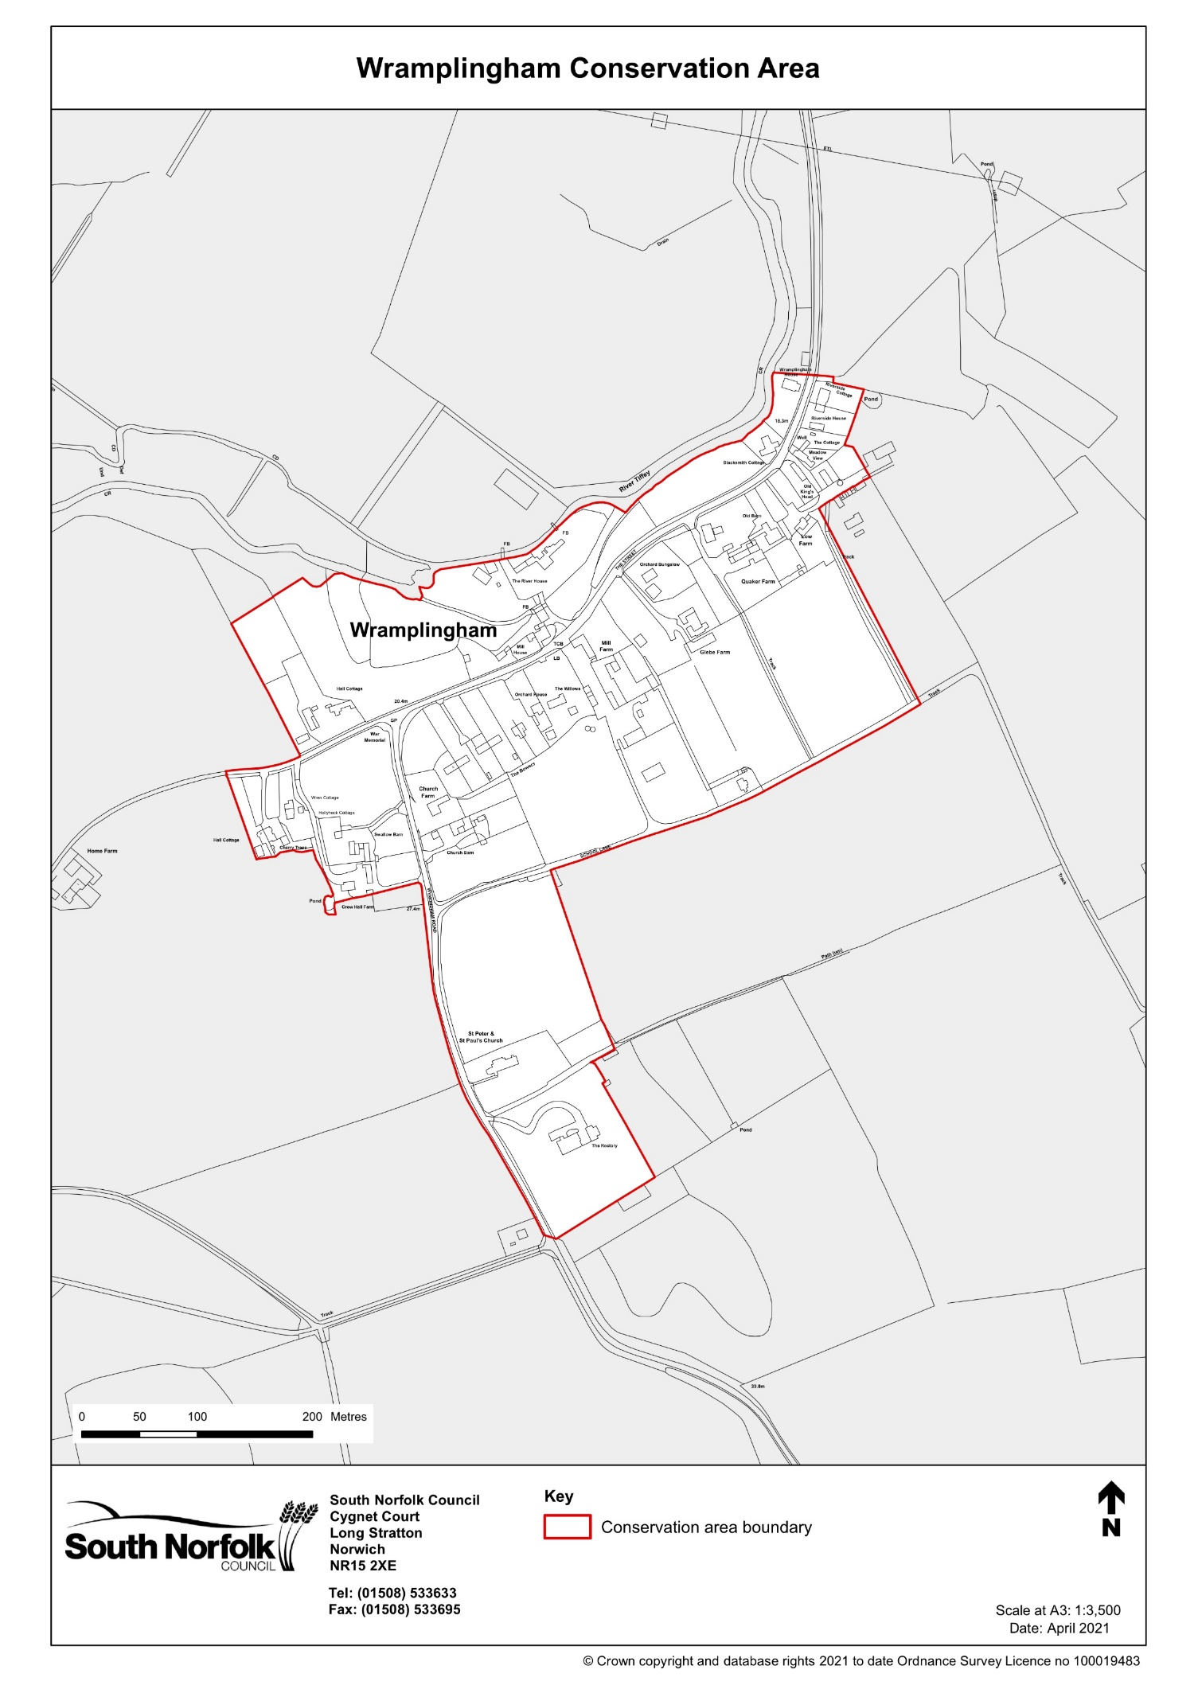

Appendix 4

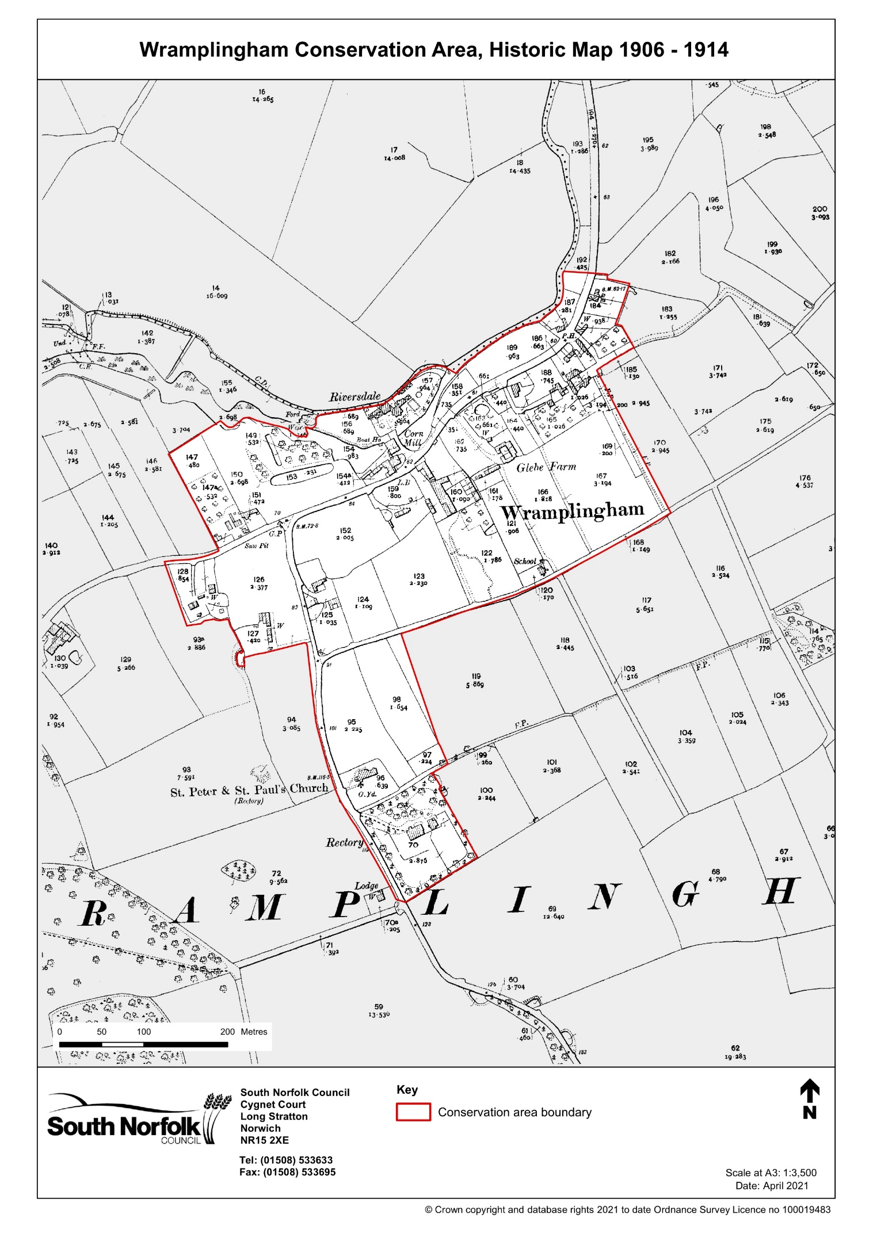

Appendix 5

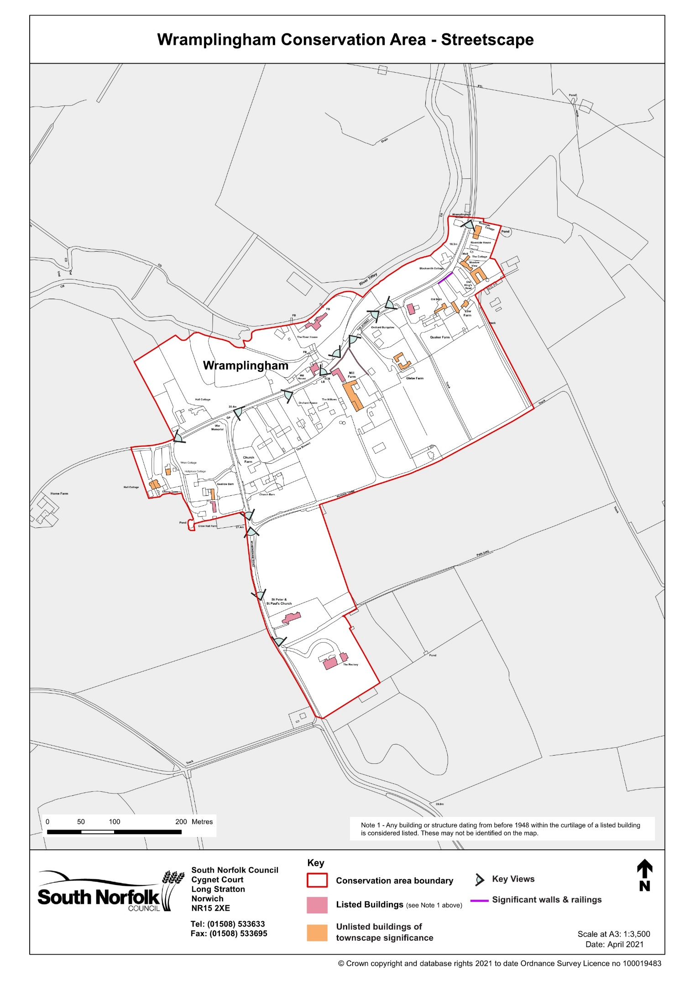

Appendix 6

