
VE Day Grant
ABOUT YOU
Your Name
Town Council, Parish Council or Community Organisation Name

Address (Inc. postcode)
Telephone
Email
If you are applying on behalf of another organisation, please provide their name, address and contact number
TELL US ABOUT YOUR VE DAY EVENT
Remember to be realistic and specific in your event planning…
Provide the venue and full address of where your VE Day event will take place (including the postcode). If the venue has not been chosen, please provide as much detail as possible.
What activities are you planning? Please indicate any licensable activities. All licensable activities should be communicated with our licencing team. Licencing information can be found here:
www.southnorfolkandbroadland.gov.uk/licensing-2/safety-advisory-group
When will this event take place? Please specify dates and times.
How many people do you hope will attend your VE Day event?

How will local people find out about your VE Day event and how will you publicise it?
How much of the grant are you applying for (up to £300) and what will you spend this on? Please give a breakdown of costs.

If you are in receipt of this grant, we would require a short, post-event summary and pictures of the event. This will allow us to evaluate what the grant has contributed towards. Please tick the box if you consent to this.

BANK ACCOUNT DETAILS:
Account Name
Account Number
Sort Code
Address that bank account is registered to

Important Payment Information
All grant applications must have a separate confirmation of bank details to evidence that they are valid. This evidence must be a copy (paper copy, photo, scanned picture) of either a paying in slip or header of a bank statement.

Declaration and Consent:
The information provided is to the best of my knowledge, and I understand that the details given in this application will be used solely for the purpose of the application. I consent to the details contained in this application being held by South Norfolk and Broadland District Council’s for a period of up to three years. I understand that I can withdraw this consent at any time by contacting South Norfolk and Broadland District Council’s.

Applicant Signature
Print Name
Date

Please e-mail your completed application and bank evidence to: communities@southnorfolkandbroadland.gov.uk

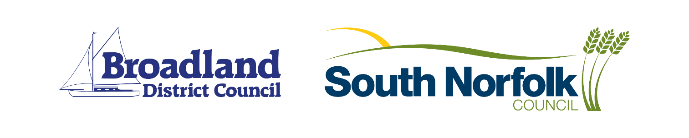
If you require further help, please telephone the communities team on 01603 430611

