**PALC (Public Access for Land Charges) User Guide**

To access PALC, go the South Norfolk and Broadland website Local Land Charges page, https://www.southnorfolkandbroadland.gov.uk/planning/local-land-charges-search/4 and click on the link for PALC.

You will need to register, giving a name and password, to enable entering searches onto the PALC system. If you are working for a company, a generic email and password would be the best option, so all staff could use the system.

Use the first screen to **Register** or **Log In** and if you have forgotten your password, click **Forgotten Password**, to see screen to enter new password, this will trigger an email, with a link to click on, to activate your new password.

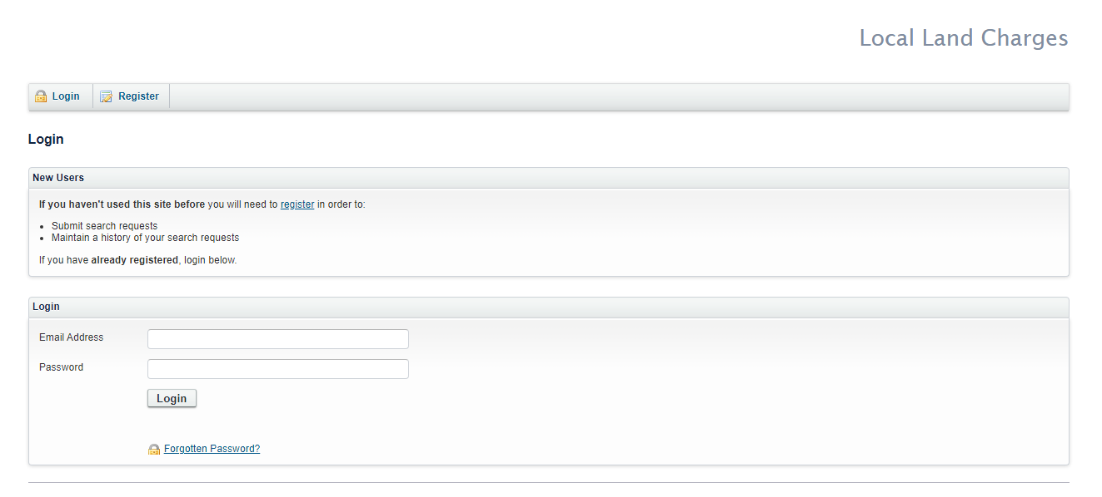

If you wish to use the pay later option, you will need to ask the Land Charges team for a client reference number, which will be required to be entered in the Additional Information box, when entering a search on PALC.

Once logged in click on **‘New Search’** on the menu bar to start a new search

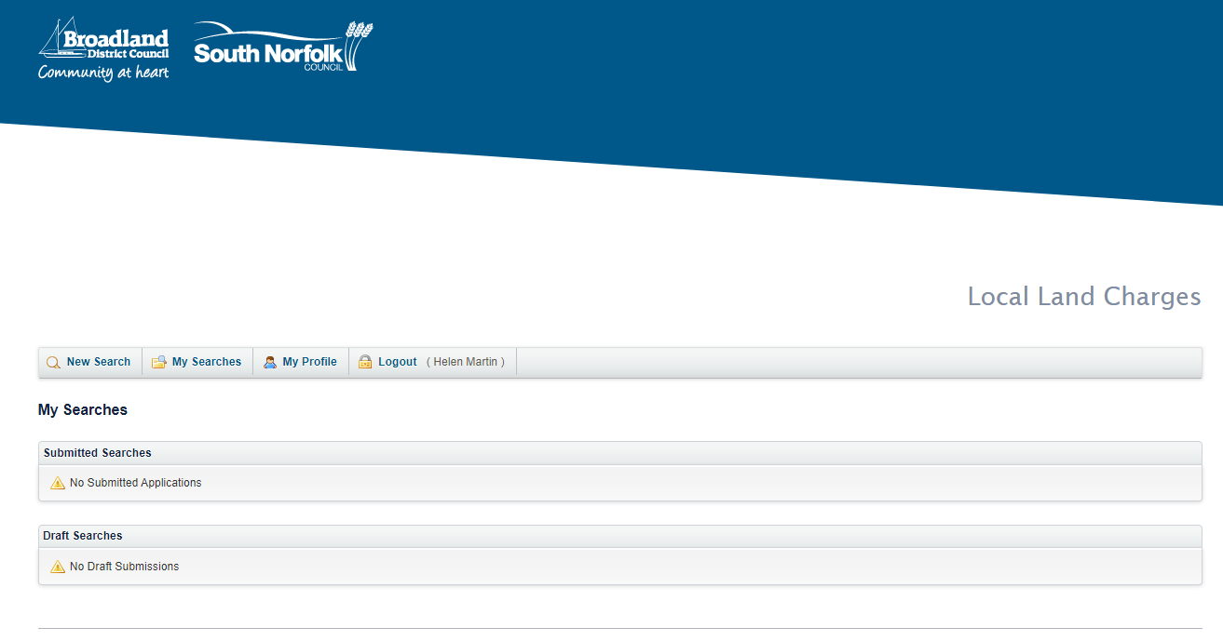

In Section 1 Complete a Form - Click on ‘**Local Land Charges Search Request’**

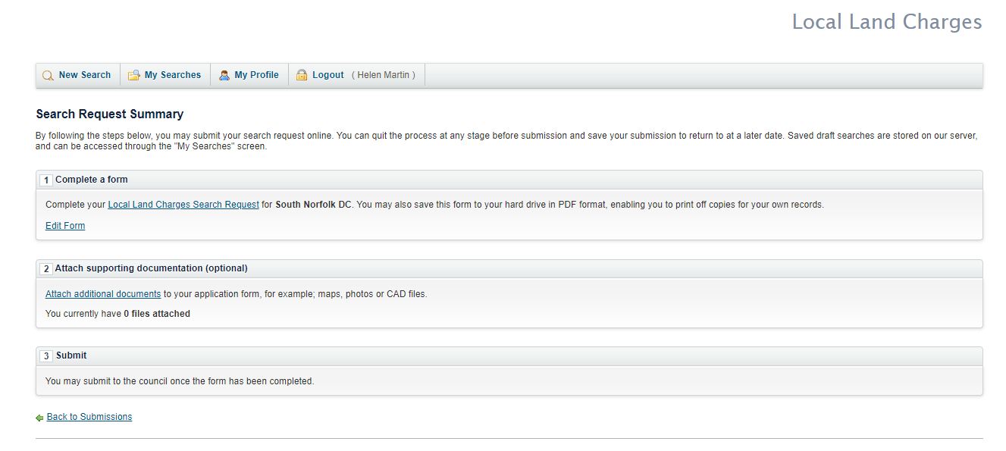

This shows your PALC reference number (the official search number will be revealed on your reply email, once The Council has accepted the search). Enter your reference if required.

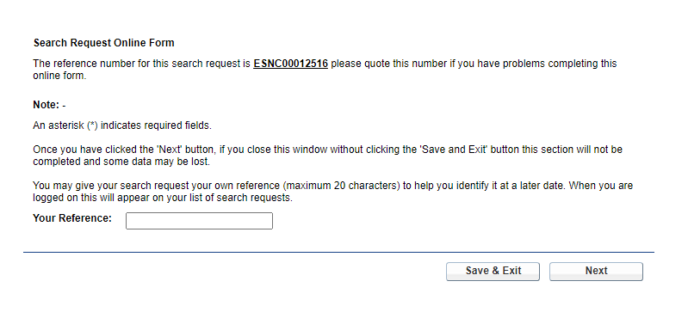

Click ‘Next’ to enter address of property

Enter either **Building Name** **or Number**, **Street, Town and Postcode**, click ‘Next’ and choose the relevant property from the list on the next screen, or click on **‘Manual Address’** if it does not appear on list

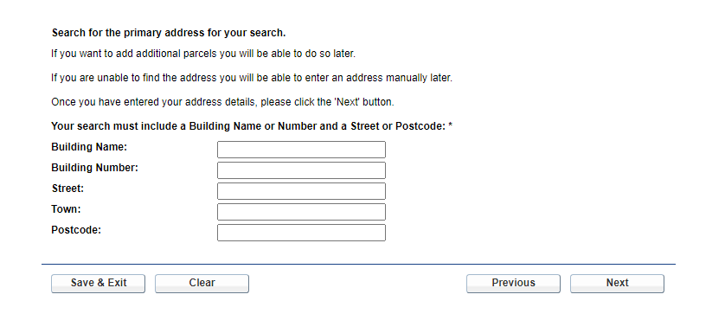

Complete **‘Primary Address Property Type’** and if you wish to **add additional addresses/parcels** do so here

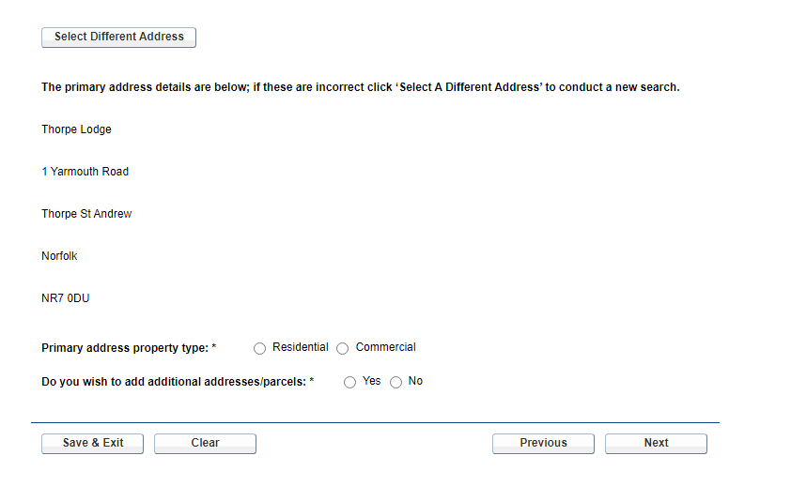

Click ‘Next’

If you wish to add additional addresses, click on **‘Add Additional Address’** and do same as above

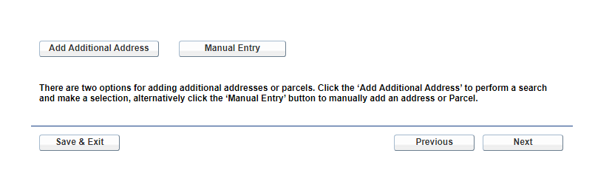

Complete **‘Search Types’** required, click ‘Next’

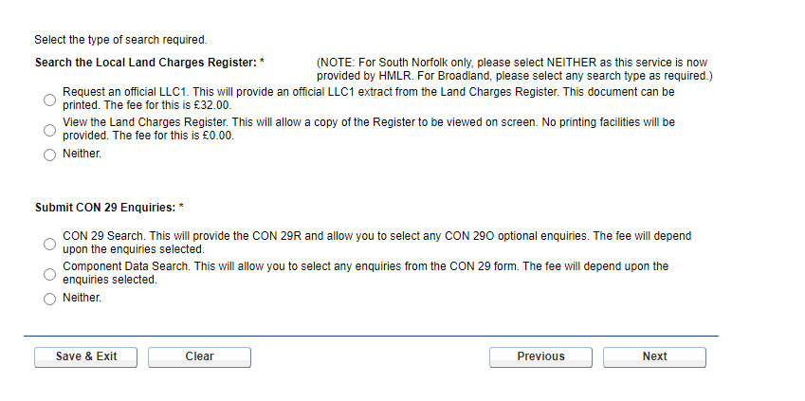

Enter any additional text for **Box C – Other Roads, Footways and Footpaths.** Click ‘Next'

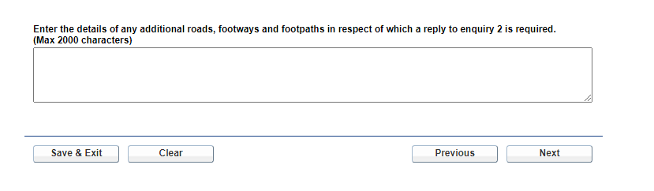

Select any **‘Optional Enquiries’** required or click **Select all**, click ‘Next’

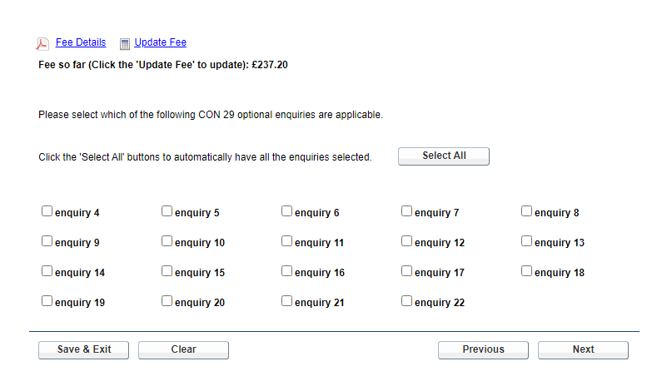

Complete **‘Additional Enquiries’** if required, click ‘Next’

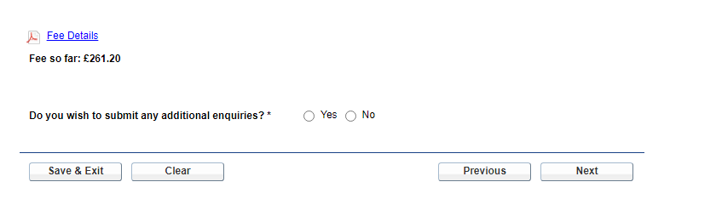

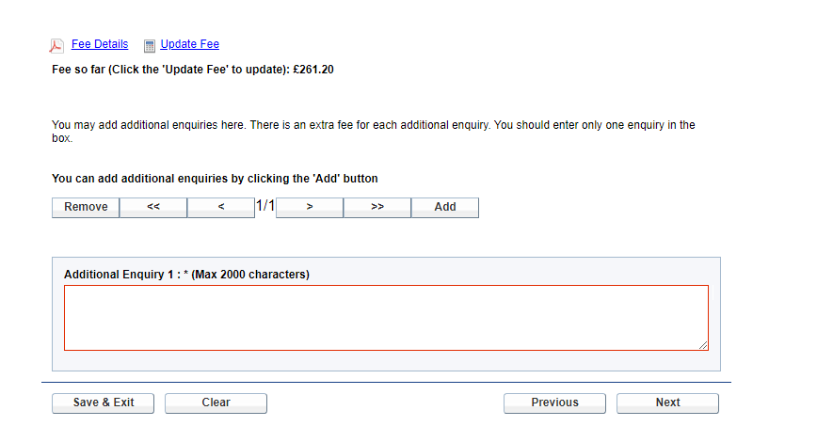

Check ‘**Enquirers’** details are correct or change if necessary, click ‘Next’

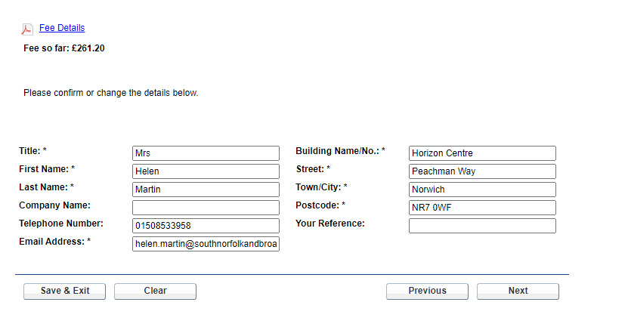

Enter any **‘Additional Information’**, which you think may be useful, click ‘Next’

For the Pay Later Option, this is where to enter your client reference number and the payment method of ‘BACS’

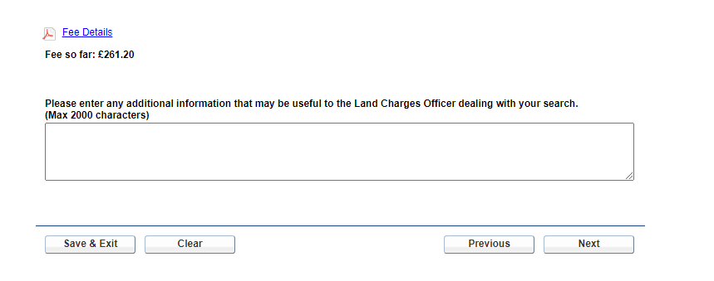

Review your search by clicking ‘**Review’** button, this will take you through all the screens again and give you your search number again, click ‘Next’

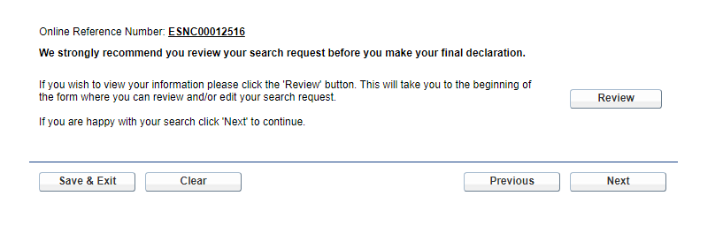

Tick the **‘Declaration’** box and click ‘Next’ to proceed to Complete screen

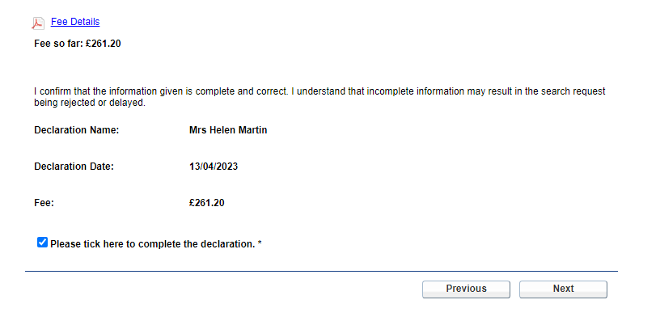

You can ‘**Review’**  your search again page by page, by clicking Review or view the completed form by clicking Preview, then click **‘Complete’** to proceed to next screen for adding plans/attachments

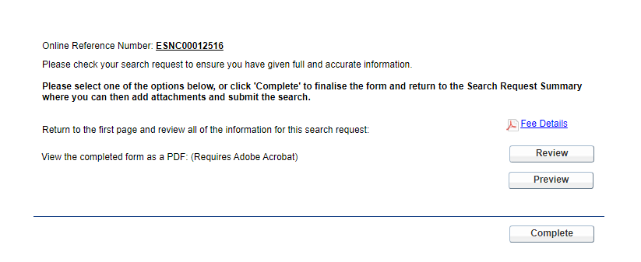

To attach plan, click on **‘Attach additional documents’ in Box 2**

**Please note that file sizes must not be any larger than 4MB**

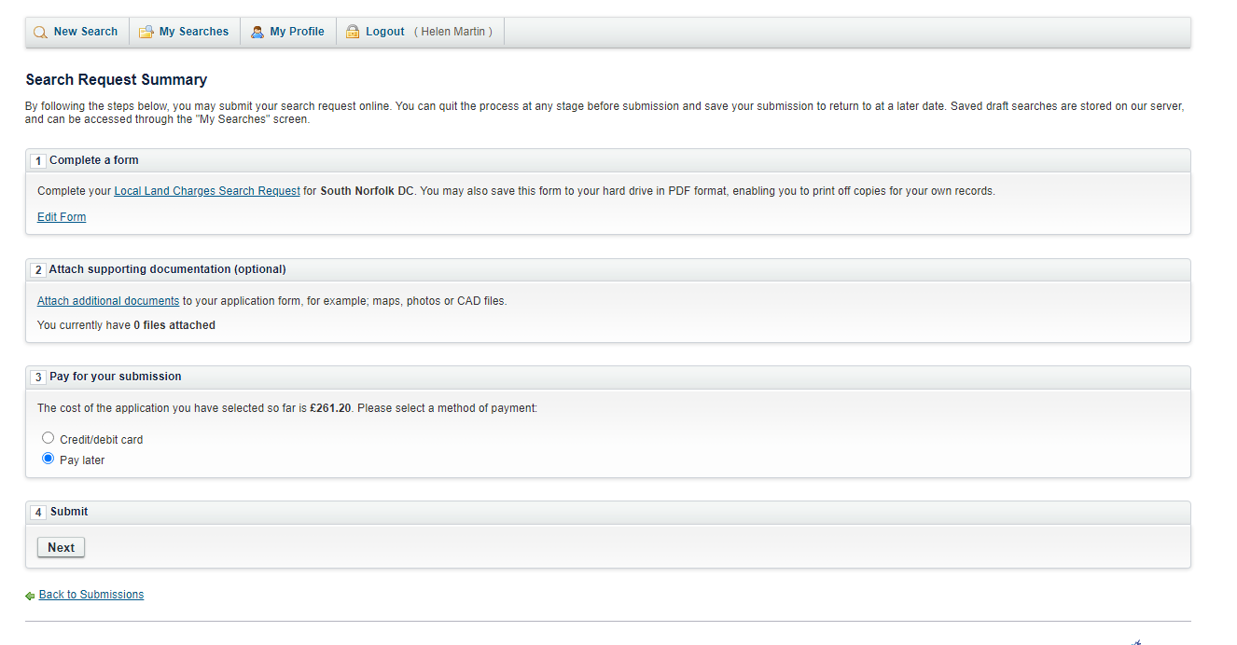

Click on ‘**Browse**’ to add your location plan, click **‘Upload’**, this adds your plan into the Attached Document list. Repeat this if you need to attach more than one document.

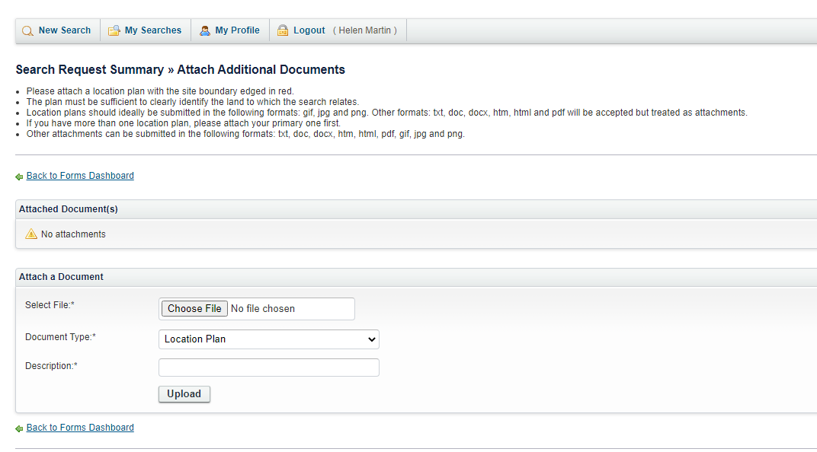

Click **Back to Forms Dashboard**

For **Pay Later Searches** this returns you to Search Request Summary – Submission Summary, click Submit, this returns a Submission Success screen

**To pay for your search**, go to **Box 3** and tick Credit/Debit Card or ‘Pay Later’ option. If you choose **pay later** option, this needs to be paid as soon as possible, as the search will not be completed and returned, until payment is received.

**Box 4** - Click on **Submit**, this takes you to a Submission Summary screen, where you can either **Cancel** the search or **Submit** the search, this then takes you to the payment screen if you are submitting a card payment search.

For the **Pay Later Option**, the Council will only accept BACS payments, bank details as below:

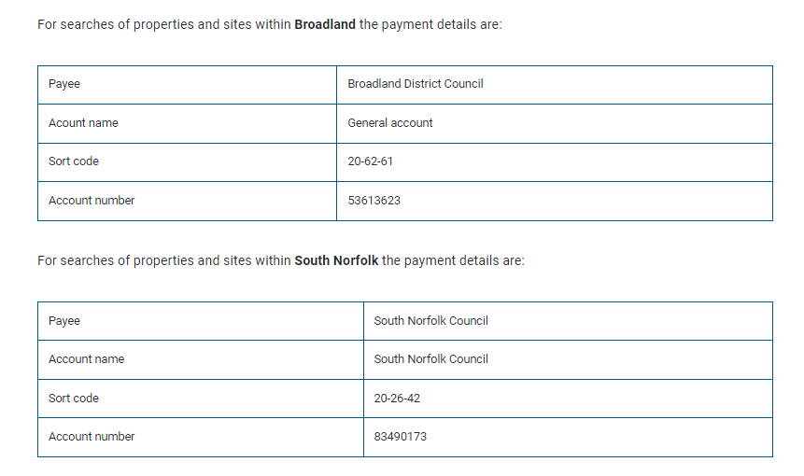

Please email informing the team that this search is a pay later option, please include PALC reference and address.

Broadland – [landcharges.bdc@southnorfolkandbroadland.gov.uk](mailto:landcharges.bdc@southnorfolkandbroadland.gov.uk)

South Norfolk – [landcharges.snc@southnorfolkandbroadland.gov.uk](mailto:landcharges.snc@southnorfolkandbroadland.gov.uk)

Card Payment Screen

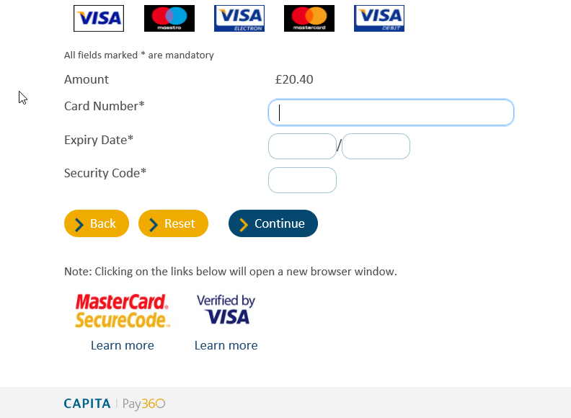

Click **Continue** to go to Additional Information screen;

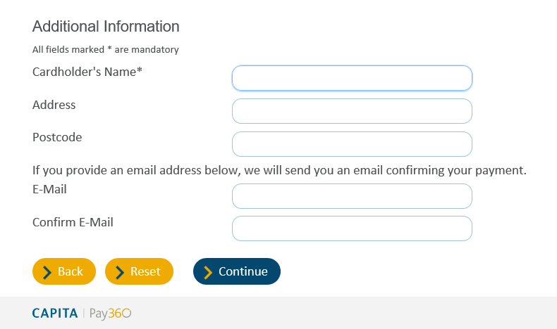

Enter card details and email address, then click on the ‘**Continue’** button to be taken the Payment Confirmation Page.

Payment Confirmation Page

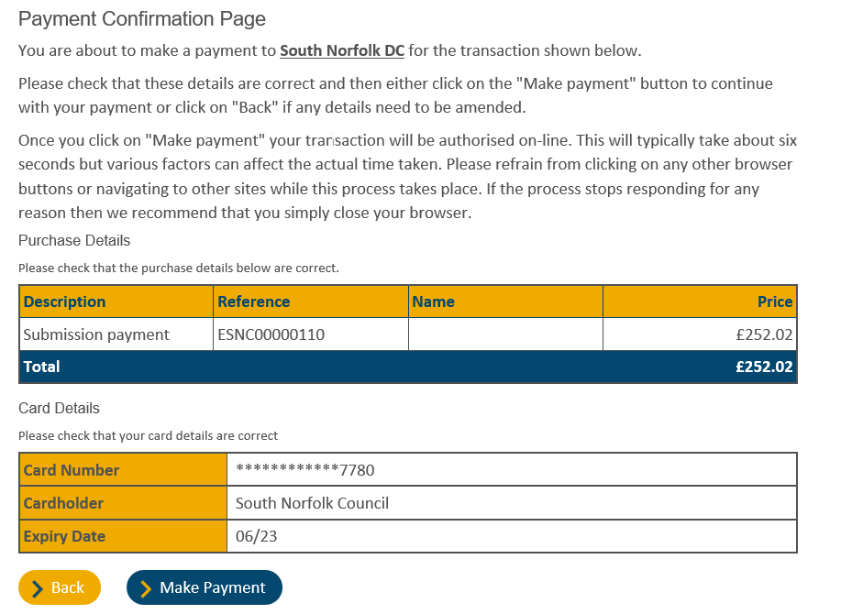

Click **Make Payment** for payment to be made and receipt emailed to you.

Once your search is fully submitted, you will receive an email stating **‘Search Request Submission Success’**.

After The Council have processed your search request, you will receive an email stating **‘Search Request Submission Acceptance’**

Once your search is completed, you will receive an email stating **‘Search Request Submission Complete’**, use the link within the email, to view and print/save the completed search. If you have requested a Personal search, the print option is not available, but you are available save the search result.