# Photo of Burston's Village signBurston

Conservation Area Character Appraisal

and Management Guidelines

July 2021

A photo of a gravestone

 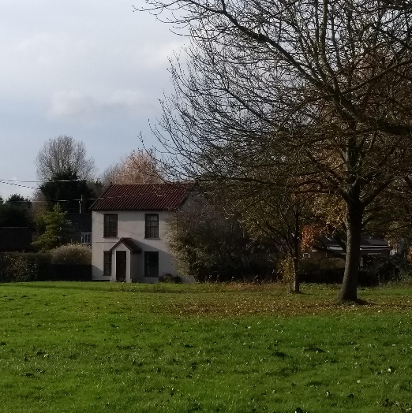 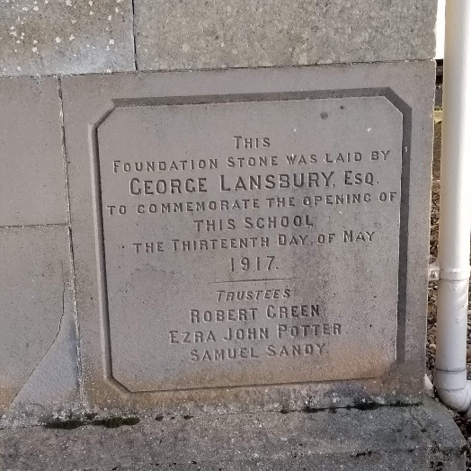



## Content

Introduction 3

Historical Development 4

Character Assessment 5

Conservation Management Guidelines 13

Appendix 1(i) - Listed Buildings in 15 Burston Conservation Area

Appendix 1(ii) - Unlisted Buildings in 15

Burston which are of townscape significance

Appendix 2 - Policy & Consultation 16

Appendix 3 - Conservation Area Boundary 17

Appendix 4 - Historic Map 18

Appendix 5 - Streetscape 19

Appendix 6 - Natural Character 20

## Introduction

|  |  |
| --- | --- |
| A photo of the church of St Mary set amongst trees  Church of St Mary set amongst trees | The historic core of Burston is concentrated around the Church of St Mary, the village green and the Burston Strike School. The landscape character is also important to the village with a number of important trees in the centre of the village and existing hedgerows. Consequently, although the village has seen some growth in the 20th century, it still retains a very rural character. |

|  |
| --- |
| Under the terms of Planning (Listed Buildings and Conservation Areas) Act 1990, the Local Planning Authority is required to identify areas of special architectural or historic interest whose character or appearance it is desirable to preserve or enhance, and to designate them as a Conservation Area. The 1990 Act also requires local authorities to prepare management guidance and proposals for Conservation Areas. Burston conservation area was originally designated in 1994. This document should be read in conjunction with the adopted Local Plan, the National Planning Policy Framework and Planning Practice Guidance. |

### Key Characteristics

* Key buildings within the area include the Church of St Mary, the Crown public house and the Burston Strike School
* The Strike School is grade II* and of national historic importance to the labour movement
* The centre of the village retains its rural character with landscaping and open spaces including the churchyard and the village green, trees and hedgerows.
* Dwellings are predominantly detached with a varied grain typical of a smaller rural village.

Historical Development (also see historic map in Appendix 4 p18)

In the Doomsday Book (1086) the village is referred to as Borstuna, in a 12th century record as Birston, and in records of the 13th century as both Burstone and Burston. Its meaning is possibly tun (homestead or village) [by the] byrst (landslip). Old English in origin, the name indicates an Anglo-Saxon settlement, predating the Norman Conquest. Blomefield’s History of Norfolk refers to the village “at first being three parts,…,the whole town then being two miles long and one mile broad.” In 1736 there were 48 houses.

The oldest building in the village is the church, dedicated to the Virgin Mary. The church previously had a round tower and was Saxon or early Norman in origin. The church was described by Blomefield as “The Church is small, and is leaded; the south porch and chancel are tiled; the steeple is round at bottom, and octangular at top, having five bells.” The tower fell in 1754 and unfortunately the villages could not raise £225 to rebuild it, so permission was given by the Bishop to sell four of the bells to Tibenham to pay for the repair of the wall. The church then had a wooden turret erected for the one remaining bell, replaced later with the small bell turret which exists now. There was a Methodist chapel in Burston at least as early as 1845. The present building dates from the 1860s.

There were at least two moated sites associated with the village. To the north of the Crown are the remains of a moated site (NH 10991) and it is proposed to include this site within the area. The South and East side of the moat are still filled with water, whilst the north and west sides have been filled in but can be seen as depressions. There is also a moated site to the south west just outside the conservation area (NH 10992), although a modern house now stands on the platform.

The relatively quiet rural life of this small country village changed with the building of the railway line from London to Norwich in 1840. The line passes a little east of the main village and a station was opened in 1840 but closed in 1966. Interestingly the Strike School has several stones laid with inscriptions from various railway union branches across the country showing the connections the village had to the railway line.

The Strike School, built in 1917, is the site of the longest recorded strike in England’s history. It is listed grade II* and of national significance to the trade union and labour movements despite its relatively humble origins and construction. The school teachers Kitty Higdon and her husband Tom came to Burston in 1911 to take charge of the school. She was a fully qualified teacher. He worked as her assistant and was also a Primitive Methodist lay preacher as well as an active supporter of the Agricultural Labourers' Union. In their previous post at Wood Dalling they had not only complained about the condition of the school building, but had also drawn attention to the bad housing conditions and low agricultural wages in the village. Conflict with the school managers, mostly local landowners or farmers, came to a head when Tom Higdon was accused of assaulting a farmer for employing a boy who should have been at school. The Higdons had been given the options of dismissal from the school service or of moving to Burston.

Unlike many villages Burston had no resident squire and was largely run by tenant farmers and the Rector. As School Managers, their purpose, as they saw it, was to ensure that the children were brought up "in the fear of the Lord", to respect their social "betters" and to fit the role for which most of them were destined : the boys as farm labourers, the girls as domestic servants and then mothers. Few at this time would have quarrelled with these ideas, least of all in the countryside, but the Higdons stood for other values. They encouraged their pupils' interests outside the classroom and beyond the "three Rs", came and set them higher aspirations for their lives. Though as Christian Socialists, they attached to the Bible as much importance as the Rector did, the social gospel which they drew from it questioned the status-quo.

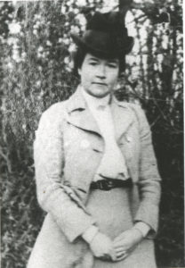 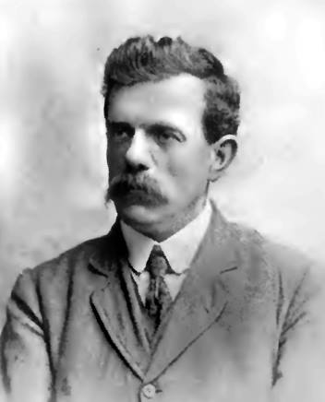 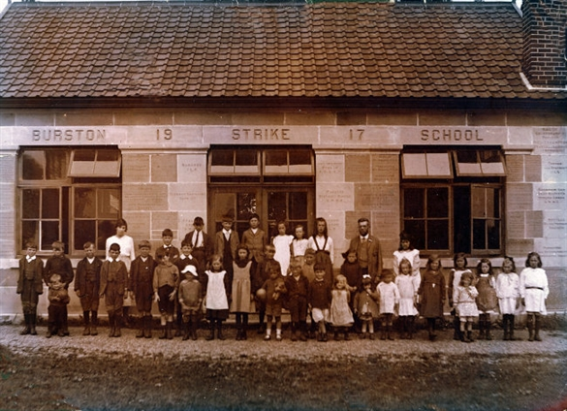

Kitty Higdon, Tom Higdon and the children outside the Strike School

In 1913 Tom Higdon caused a sensation by being elected to the Parish Council at the expense of the Rector. Sooner or later conflict with the School Managers would be inevitable. After complaining about conditions in the school building, Kitty Higdon was criticised for lighting a fire to keep it warm without express permission. Then she was accused of beating Barnado children. The Managers requested the Higdons be transferred, and although an Enquiry found that the only charge which could be sustained was one of discourtesy to the Managers, they were nonetheless dismissed.

The consequence was to be so novel and unexpected that the Rector at first thought it was an April Fool. On April 1st 1914, sixty-six of the seventy-two children of Burston School, supported by their parents, went on strike and marched around the village with placards demanding ‘Justice’ or ‘We want our teachers back’. At first the Higdons taught them in a marque on Church Green, but soon a ‘Strike School’ was opened in a disused workshop. Collections were made to pay school non-attendance fines. The cause attracted nation-wide interest, particularly in Trade Union and Women's Suffrage circles, and supporters, taking advantage of the easy train journey, would come down from London at weekends to speak at open-air meetings on the Green.

The strike divided the Chapel: members of the congregation who supported the strike held services on the Green, led by a lay preacher whereas others opposed to it resigned their membership. The Chapel virtually closed for some years as a result.

A nationwide fund was launched to erect a purpose-built Strike School and to pay the Higdons' salaries. Surprisingly perhaps, in the light of the controversy it must have caused at the time, the building, completed in 1917, stands confidently at the very heart of the village, between the Green and the Church. Its foundation stone, laid by George Lansbury, later to become Leader of the Labour Party, records why it was built and proclaims it as a "centre of rural democracy and a memorial of the villagers' fight for freedom". Other stones record the names of subscribers to the fund, which included many Trade Union branches as well as individual supporters.

The arrival of a new Rector in 1920 marked the start of a period of more friendly rivalry between the two schools in the village. The Strike School finally closed in 1939 following the death of Tom Higdon. By then there were only twelve children left to be transferred to the Council School.

The Strike School is now a museum covering the background and history of the strike. A commemorative rally is held on the green every September.

Although outside the conservation area, the mill to the north of the village has had quite an impact on the village. In 1922 William Tuck bought the old windmill at Mill Green and began animal feed production. The mill remains an important local rural employer, however HGVs accessing the mill along Mill Road have caused some damage to the verge side and the heavy vehicles disturb what would otherwise be a relatively tranquil village.

In recent years there has been the building of a number of substantial houses in the village, such as those in Higdon Close, and the houses opposite the Church, as well as the modernisation and extension of older cottages. These developments reflect the changing nature of the modern village, from a predominantly agricultural settlement into a desirable place from which to commute or retire.

The green formerly known as Crown Green to the east of the church is now a gravelled car park. The area was being used for parking for the Crown pub and this has been formalised, but with the area in front of the pub changing from a parking area to lawn. This has improved its immediate setting.

Despite new house building, the population of the combined parishes of Burston and Shimpling has only increased very slightly since mid-century. The population was 502 in 1951, 475 in 1961, 411 in 1971, 491 in 1981, 540 in 1991, 538 in 201 and 568 in 2011.

## Character Assessment

(Also see Streetscape and Natural Character Maps in Appendices 5 and 6 pages 19 and 20)

### Burston and its setting

Burston is set on a flat plateau north of the Waveney valley. It is some two and a half miles north-east of Diss and about one and a half miles west of the A140 road from Norwich to Ipswich. A network of minor roads as well as an unusually large number of public rights of way crisscross this area, and Burston marks the meeting point of several roads and footpaths. The main railway line passes the village at a level crossing about half a mile to the east.

The centre of the village retains a very rural character with buildings set at varying orientations and amongst landscaping. There are however limited views of the open countryside from within the village.

### Conservation Area Boundary

The Conservation Area was designated in 1994 and centres on the two greens of Church Green and Crown Green, although Crown Green has now become the car park for the Crown public house. It also includes the Church and the Strike School both situated between the two greens, development west along Diss Road as far as Valley Farmhouse and development north along Mill Road as far as Crown Farm. The conservation area has been extended to include the archaeological moated site to the north east and an area of trees along Rectory Road.

### Street Patterns and Historic grain

The village was historically relatively dispersed fronting onto historic lanes. There is no consistency in curtilage size, building orientation, buildings lines or setbacks, which contributes to the more informal rural character of the village. Later infilling has concentrated development along Diss Road, and there is large estate to the east of Rectory Road known as Audley Close, which lies outside the conservation area.

### Perambulation

**Diss Road**

Starting with the western approach into the village from Diss, the first building is the grade II listed Valley Farmhouse, dates back to the 17th century. It is typically timber framed and rendered and in terms of appearance relatively plain with a simple form and casement windows. Unusually the roof is a mix of red and dark coloured pantiles, but in no discernible pattern. Hedgerows and trees are already important in providing character to the street.

The next house, Beechwood, is relatively modern, but with a traditional gabled form, and notable for its mock timber framed porch, which could be considered incongruous within a rural Norfolk setting. Unfortunately, the garage and solar panels are also prominent, but the house is set back from the road so these do not have a significant impact on street views. The next house, Elm House, is also a humble timber framed rendered cottage and 17th century in date. It has an attractive porch with a decorative bargeboard. To the left of the elevation is a screen wall capped with a castellated parapet which provides some interest. The roof has a lower pitch, indicating a later date, with red pantiles and a central replacement stack.

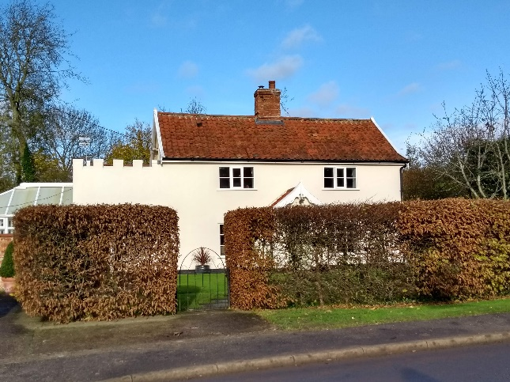 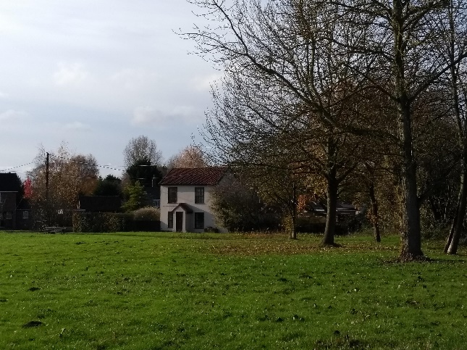

Elm House Amberwood

The road now crosses a brook which runs relatively discretely through the village and therefore not a prominent and defining feature of the settlement. On the right hand side is Rose Villa, a long and narrow house with an unusually shallow plan and set at an unusual angle to the road. This was previously three cottages amalgamated into one, which would account for its elongated form. The house is constructed in red brick with black glazed pantiles, and with quite large and wide casements windows (the central opening window being metal), stone/plaster lintels with decorative vermiculated keystone, and gault brick dressing to the side of the windows. This is the only example of such brickwork in the conservation area. The building has a date stone on the west gable: J.S. 1868.

On the west side is a modern bungalow called Dun Roamin’, and is positioned relatively discretely behind a hedge. In contrast the south side of the road opens out with a front lawn to a modern house, Fenlands. The openness of the front lawn without defining hedgerow marking its boundary would be considered detrimental to the character of the conservation area, however in this case it complements the openness and spatial qualities of the village green opposite. The blank gable end facing west, being featureless, is a little unfortunate. This is followed by the large 19th century house, ‘The Firs’, notable for its twin gables and decorative 19th century bargeboards. On the north side is a 19th century house called Amberwood, which fronts towards The Green.

The village green is an important part of the conservation area and one of its defining features. As previously mentioned, Amberwood fronts directly onto the green with a symmetrical elevation of sash windows, which is unusual in the village. It is important that the relationship of the house to green is maintained. Unfortunately, the currently windows are replacement with ‘mock sashes’ with top opening casements rather than sliding sashes. Thick landscaping obscures views of open countryside to the north and consequently there is not a visual connection to it. To the east of the green the Burston Strike School is situated in a very prominent position also fronting onto it.

The green is a significant historic space in the village, having been the place where the strike school teachers first held their lessons in a tent, and where the Strike School was chosen to be built. A yearly commemoration event takes place on the green on the first Sunday in September and is attended by notable public figures of the trade union and labour movements, including well known members of parliament. Also located on the green is a small modern brick war memorial with a flagpole, and the village sign which is a totem pole designed and made by Martyn Welch. Thick landscaping obscures views of the church and the graveyard to the east. Because the church no longer has a tower it is not as prominent or as much of a landmark as parish churches in other villages, although it is still very much remains a focal point for the community.

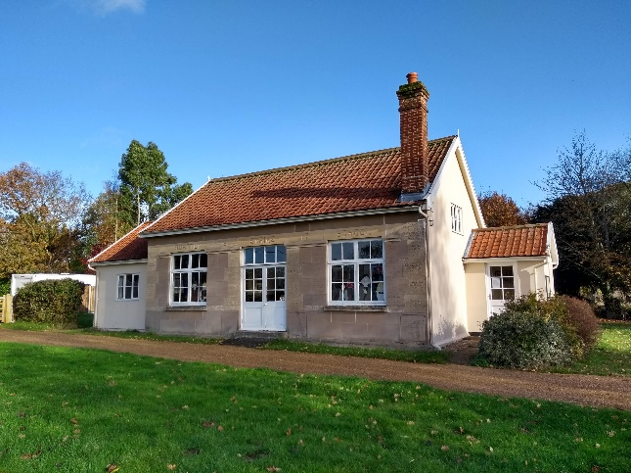 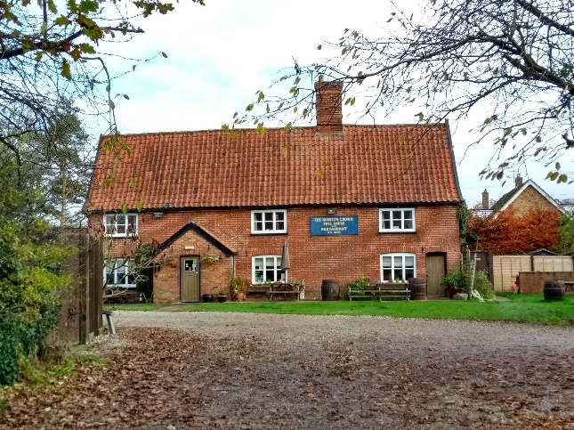

The Burston Strike School The Crown

The modern housing on the south side of Diss Road is designed with traditional gable forms and red brick. With the associated frontage landscaping they do not detract from the setting of the conservation area and can be considered to have a neutral impact. The conservation area includes on the south side an important group of trees but not the modern houses. A further group of trees along Rectory Road have now been included to complement the existing group of trees around the junction.

On the north side of the road is the church of St Mary within its landscaped churchyard setting. There are numerous trees within the churchyard, which is also surrounded on the south and east sides by a ditch and hedge. Consequently, the church and its churchyard have a relatively ‘contained’ setting.

**Mill Road**

Mill Road is a narrow rural lane without a footpath. There is not much general traffic on the lane, but it is a route used frequently by HGVs accessing the commercial mill to the north of the village. These lorries have caused quite a lot of damage to the verge adjacent to the churchyard and it may be considered suitable to give it some extra protection.

On the east side of the lane is the Crown Inn, originally a C17 house but now the village pub. Between the road and public house was an historic green called Crown Green. In the tithe map this is shown as an open area and later C19 map shows it as an open green with a diagonal footpath. The green is now gravelled and used as a car park for the pub, however the previous area in front of the pub (which was gravelled) has now returned to lawn, improving the setting of the listed building. Parked cars are quite effectively screened by the boundary hedge in street views. The inn is a red brick facing with an earlier timber frame core. The steep sloping roof pitch indicates that the building was originally likely to have been thatched. To the north is a house called The Old Pavilion, which used to be pavilion for the old bowling club.

Further along Mill Road on the west side is the Red House. This has an important principal elevation fronting the churchyard rather than the lane, and there is interesting pargetting (decorative plasterwork) which is more common in southern reaches of the county. The historic attached barn was actually erected in the early 2000s, and according to the Norfolk Record Office (NH37371) is a French barn relocated from St Gilles in France.

The small rendered chapel remains in use but is very plain in appearance. Nos 5 & 7 is a traditional 19th century clay lump semi, unfortunately now with modern casement windows and concrete tiles. The next building is a relatively new terrace of four houses with broken massing, dating from 1993. The middle cottages are a full two storey whereas the two end units are a storey and half. The barns relating to Crown Farm are modest red brick farm structures which need some attention in terms of repair. Crown Farmhouse is an interesting building originally being timber framed and dating from the 17th century, but encased in brick in the 19th century, and with casement windows installed, as well as drip mouldings to windows and decorative bargeboards. The house is largely obscured from the street views by the thick hedging to the front.

To the east it is proposed to include the land and orchard, which is important archaeologically as the site of a former medieval house with the existing moat still partially extant and visible.

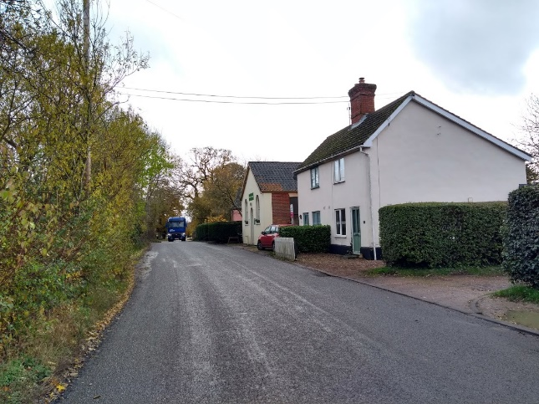 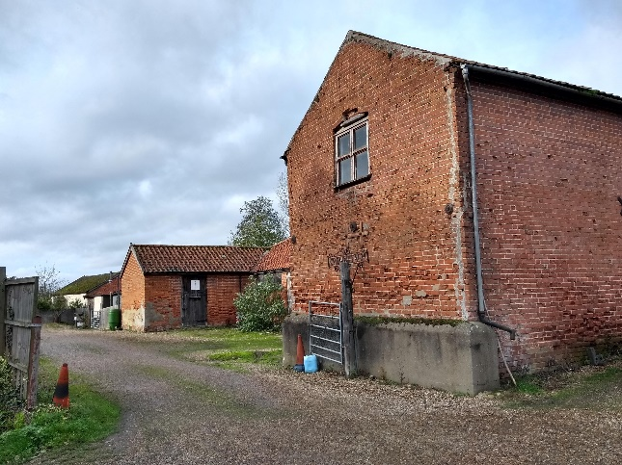

The Chapel and 5 & 7 Mill Lane Barns associated with Crown Farm

### Traditional Materials & Architectural Details

|  |  |
| --- | --- |
| Examples of most of the building materials traditional to South Norfolk can be found within the conservation area.  Clay pantiles are the most prevalent roofing material. These are mixture of black and red pantiles. Slates are found on the Church dating from its restoration in 1853. Bargeboards are a feature of a number of houses. With older properties the opportunity to replace concrete tiles with clay tiles would enhance the character of the village.  There is a mixture of earlier rendered timber framing and red brick, although some white gault brick has been used for detailed elements at Rose Villa. In some cases the brick has been used to re-face earlier timber framed buildings, as at Crown Farmhouse, the Crown public house and Rose Cottage, or as a face to clay lump construction, as at the Chapel (side walls).  There are a number of rendered buildings, in some cases over timber frames, as at Valley Farmhouse and Elm House in Diss Road, and, in Mill Road, at Red House. In others, possibly over clay lump, as at a house opposite Church Green, Nos. 5 and 7 Mill Road and the Strike School. The Red House has pargetting (decorative patterns) on its rendered elevations, a tradition more associated with Suffolk than in Norfolk, but sometimes found in the south of the county.  The Church is mainly of flint construction. The front wall of the Strike School is stone faced ("ashlar") with a number of names of donors and supporters of the school, including Leo Tolstoi, the son of Leo Tolstoy the Russian writer. These building materials are specific to these two properties and should not be taken as the general material for houses in the area. | A photo of a house displaying render and pargetting  Render and pargetting  A photo of a house displaying steep gables, pantiles, red brick and bargeboards  Steep gables, pantiles, red brick and bargeboards |
|  |  |

### Natural Character

|  |  |
| --- | --- |
| A photo showing the extensive tree coverage in the centre of Burston village  Extensive tree coverage in the  centre of the village | The natural character is important to retaining the rural character of the central area of the village. Although only a small village, the central areas and approaches to the centre feel quite self-contained without views into surrounding open countryside. |

### Street Furniture, Walls and Railings

|  |  |
| --- | --- |
| **A photo of Burston village's new war memorial**  The village’s new  war memorial | The village sign (see front cover) and war memorial are situated on the village green in a prominent position. The war memorial is a relatively new addition with a flagpole.  There are no walls or railings of note in the village, mainly being characterised by rural character with hedges. |
|  |  |

## Conservation Management Guidelines

### Highways

|  |  |
| --- | --- |
| A photo showing verges on Mill Road | The verges on Mill Road have been eroded and scarred by the heavy goods vehicles.  **Although verges should be kept informal there may be a need to give some protection to the verge on the west side of the road.** |

### Upgrading Windows and Doors

|  |  |
| --- | --- |
| A photo of a house in Burston | In some cases windows and doors have been replaced with different materials such as uPVC and/or different styles.  **If door or window frames need to be replaced they should ideally be replaced with the original style of windows and materials. The opportunity should be taken to reinstate traditional style windows where they have been unsympathetically replaced in the past.** |

### Fencing and walls

|  |  |
| --- | --- |
| A photo showing hedgerows in Burston | The village centre retains a rural character with hedgerows as well as spaces linked to the village green. Inappropriate boundary treatment such as close boarded fencing would be harmful to the character and appearance of the conservation area.  **Boundary treatments require careful consideration to ensure the rural character of the village is preserved.** |

### Painting/colour washing buildings

|  |  |
| --- | --- |
| A photo of a house in Burston which is painted in a muted pastel colour | A number of properties within the conservation area are timber framed and rendered. Although there is a variety of colours, the colours chosen are generally muted pastels to match historic limewash and currently well chosen.  **Colours should be well chosen to match historic limewash.** |
| Verge car parking A photo showing a car parked on a verge | Properties built without adequate parking spaces on Rectory Road, which is relatively narrow and does have large agricultural vehicles passing along it, has led to verge parking. This has consequently damaged verges and is unsightly.  **Enhancement opportunities should be considered to provide adequate parking for residents without damaging the verges, such as grasscrete plastic matting**. |

## Appendix 1 (i)

**Listed Buildings**

Diss Road Valley Farmhouse, Church of St. Mary (Grade II*)

Church Green The Strike School (Grade II*)

Crown Green The Crown Public House

Mill Road Red House, Crown Farmhouse

## Appendix 1 (ii)

**Unlisted Buildings of townscape significance**

Diss Road (north side) Elm House

Amberwood

Diss Road (south side) Rose Villa

The Firs

Mill Road Burston Chapel

Nos. 5 and 7.

Barn & attached buildings belonging to Crown Farm

## Appendix 2

**Policy background**

In recent years, the approach to conservation area designation has changed considerably. It is now recognised that development plan policies, development control decisions, and proposals for the preservation or enhancement and the management of conservation areas, can best be achieved when there is a sound understanding of the special interest of the conservation area.

This position is reinforced as follows:

The Planning (Listed Buildings and Conservation Areas) Act 1990 in section 66(1) makes it a duty of local authorities when considering applications to have special regard to the desirability of preserving a listed building or its setting or any features of special architectural or historic interest.

Under section 72 of the same Act, it is a duty with respect to any buildings or land in a conservation area, to pay special attention to the desirability of preserving or enhancing the character or appearance of that area.

Department for Communities and Local Government. National Planning Policy Framework (NPPF) 2018 Paragraphs 184 to 202 cover “Conserving and enhancing the historic environment”.

Joint Core Strategy- Policy 2 : Promoting Good design South Norfolk Local Plan

The South Norfolk Local Plan Development Management Policies Document was adopted in 2015 and policy 4.10 covers Heritage Assets.

**Public Consultation**

An informal ‘walkabout’ of the area was organised with the Parish Council on 21st January 2020. This informed the proposed boundary changes and the conservation management guidelines within the draft appraisal. The public consultation on the draft appraisal took place from 15th February to 15th March 2021, with attendance at the parish meeting on 16th March. Due to the Covid-19 Lockdown regulations the public meeting was carried out through virtual attendance at the parish council meeting online. The consultation and parish council meeting were advertised through:

• An advert in village notice board and local publicity by the parish council

• The draft appraisal being available to view on the council’s website.

• Emailing Ward Councillors, County Councillors, the Parish Council and Historic England.

• Contacting residents directly affected by the proposed boundary changes by letter informing them of the consequences of being included in the conservation area.

As a result of the consultation corrections were made to the appraisal and a further conservation management guideline was added relating to verge parking on Rectory Road.

## Appendix 3

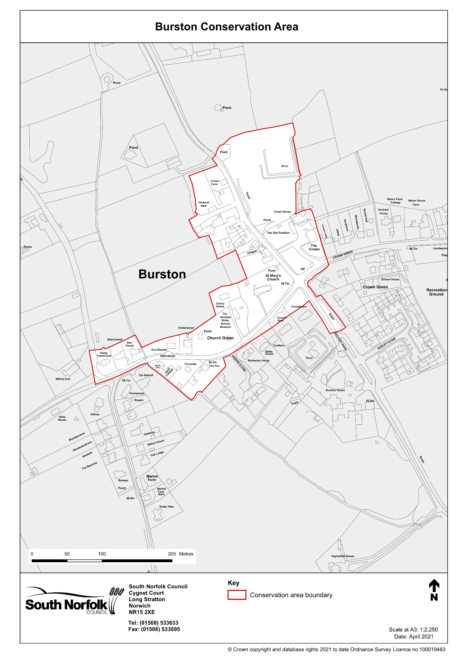

## Appendix 4

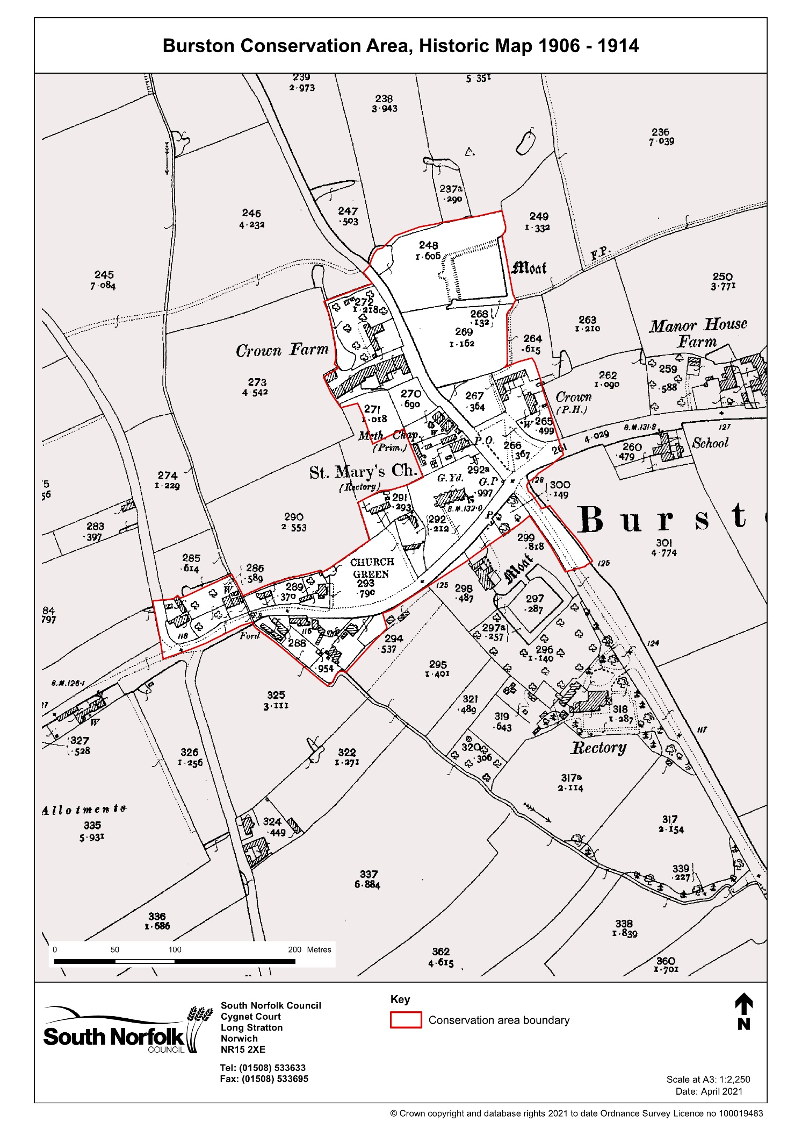

## Appendix 5

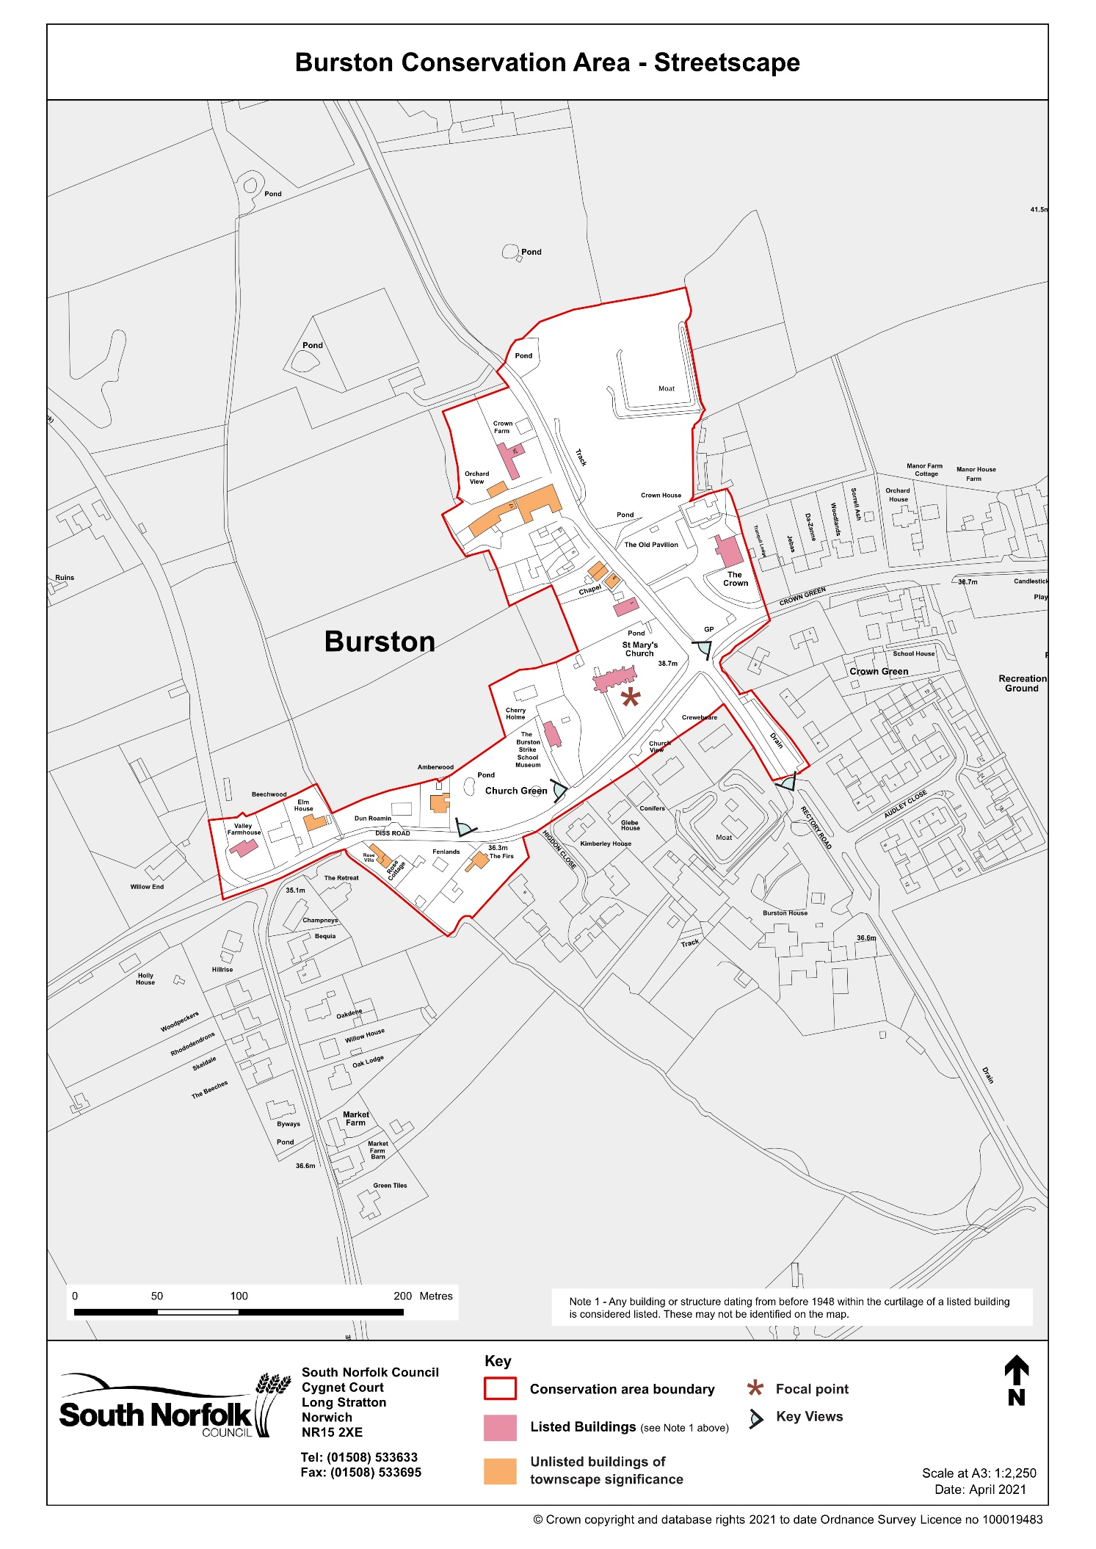

## Appendix 6

