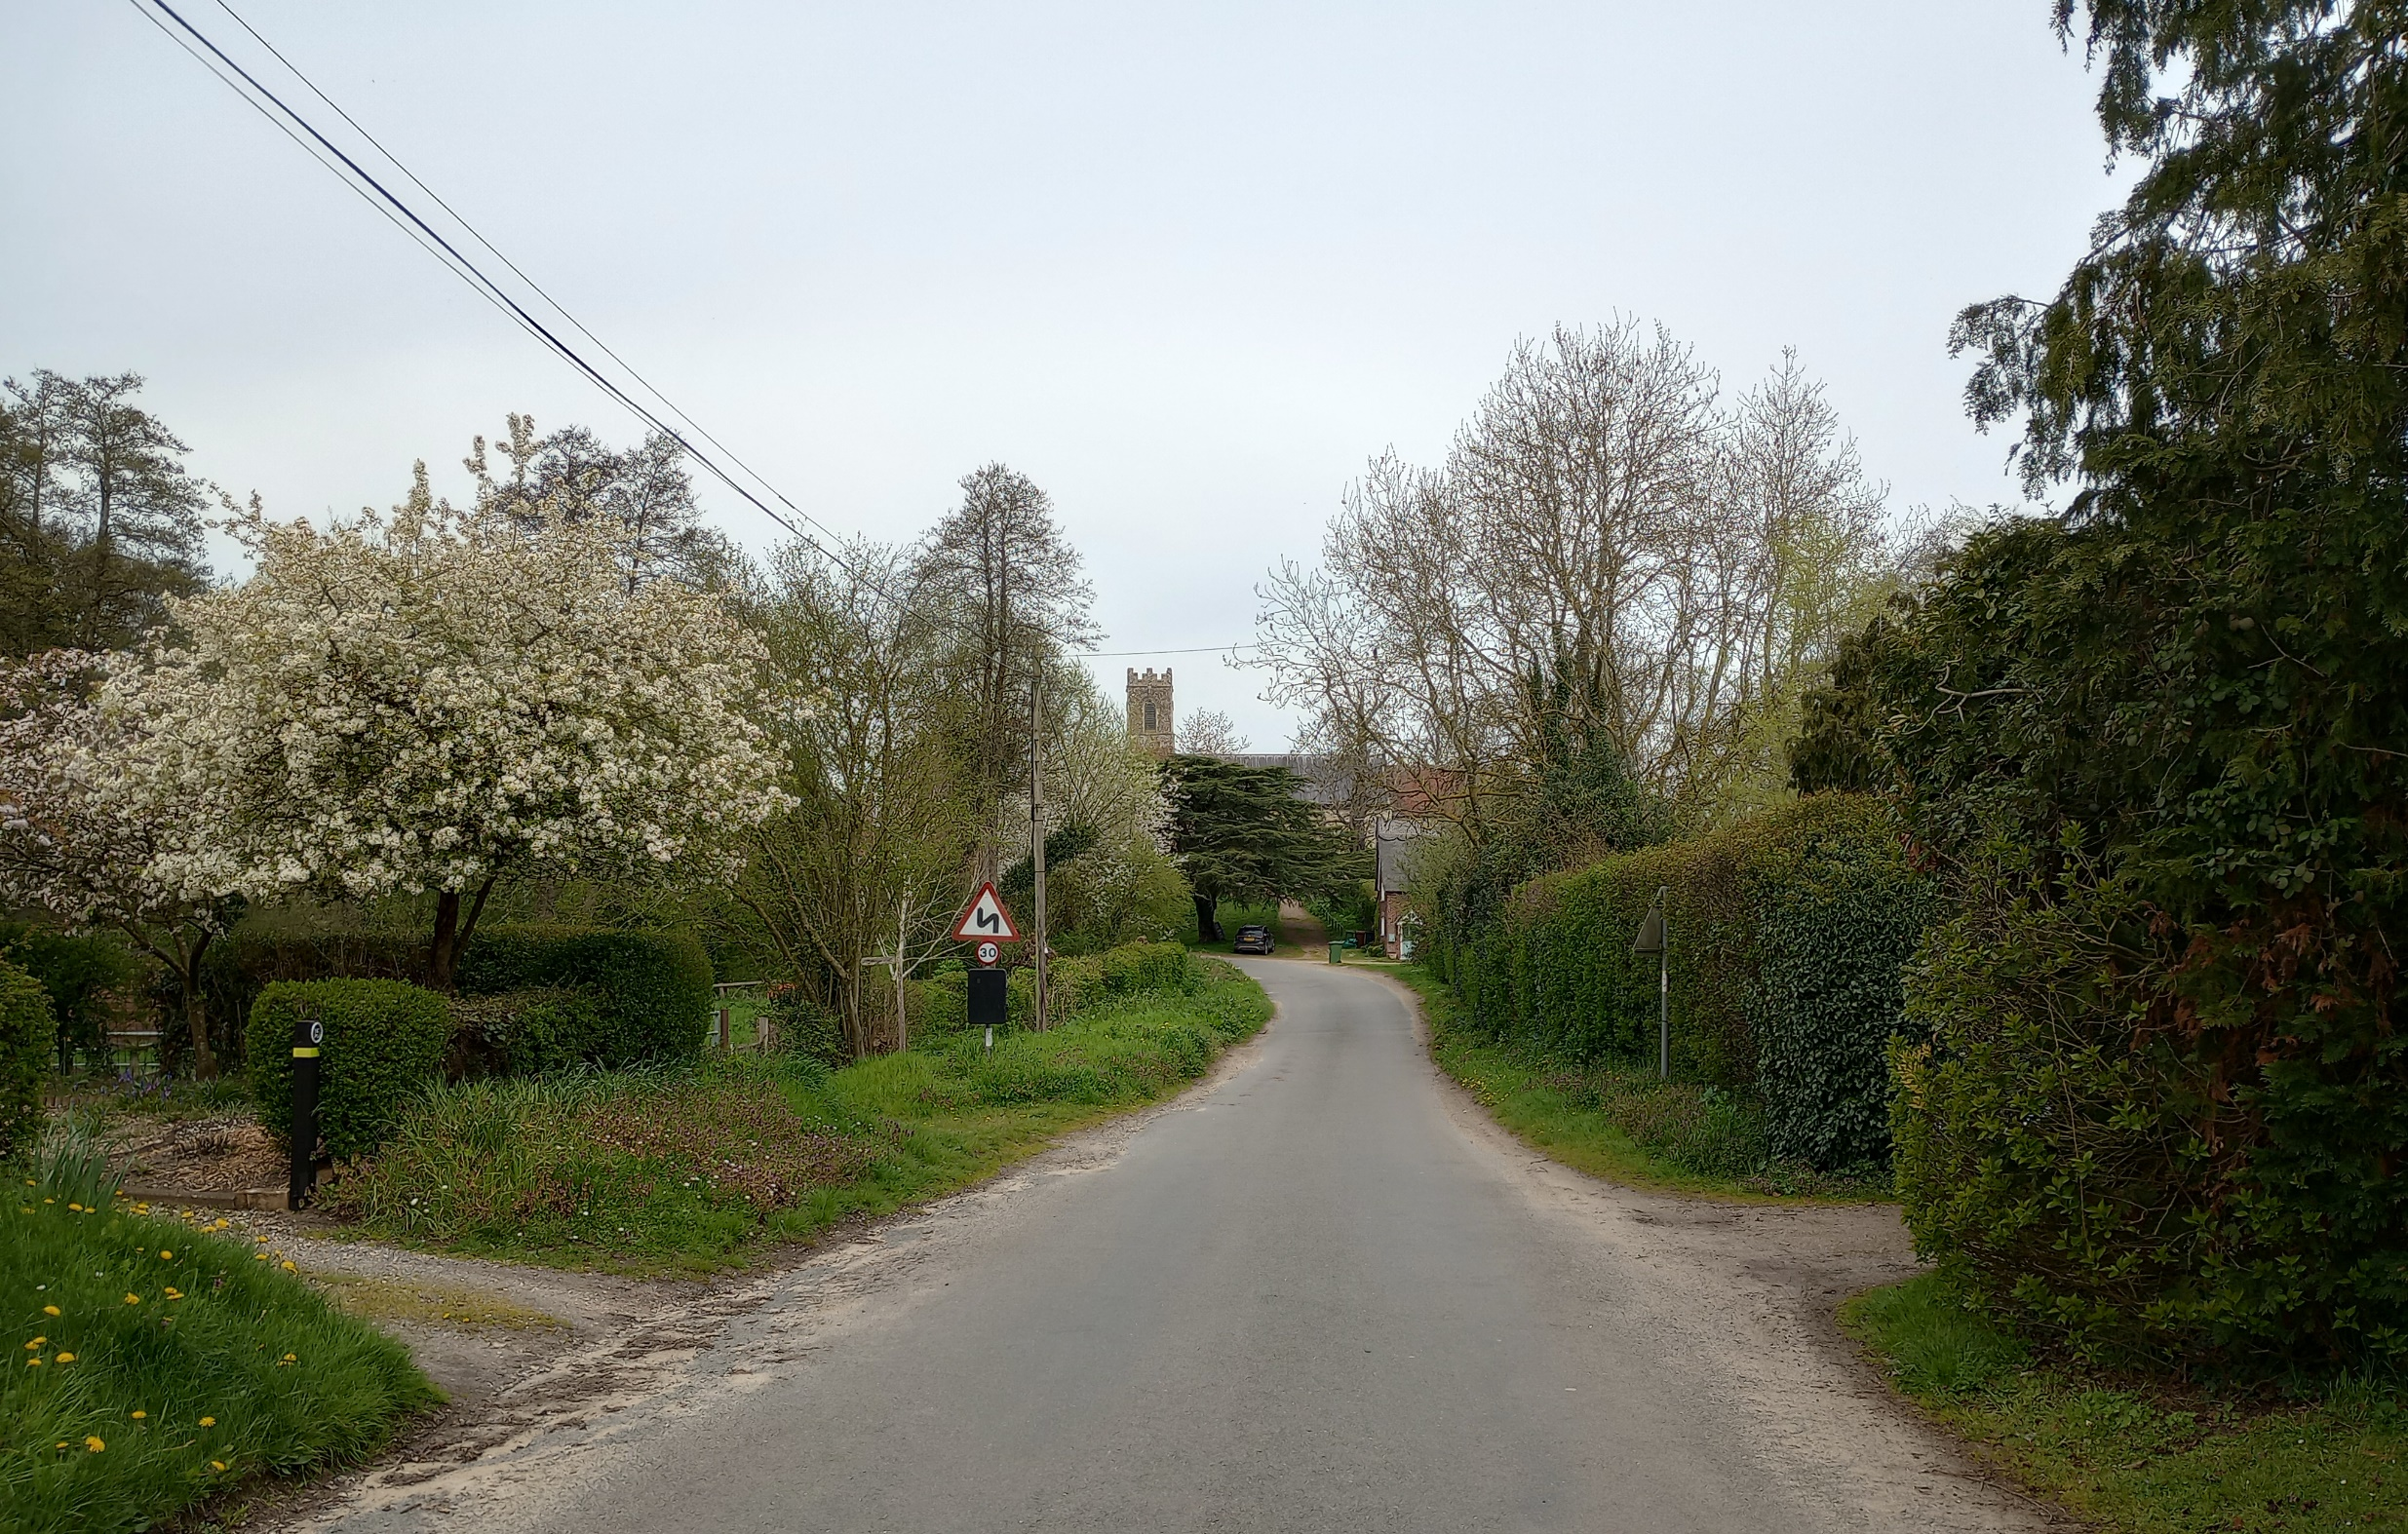
Hedenham & Ditchingham Hall
Conservation Area Character Appraisal
and Management Guidelines

May 2024
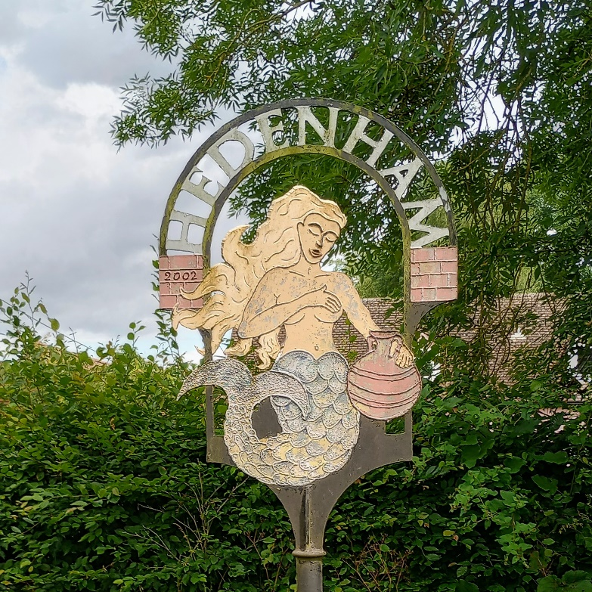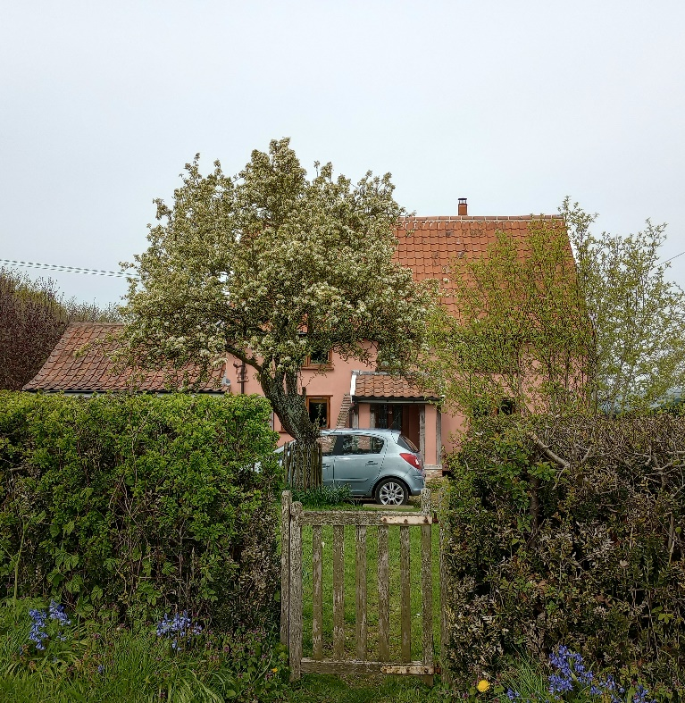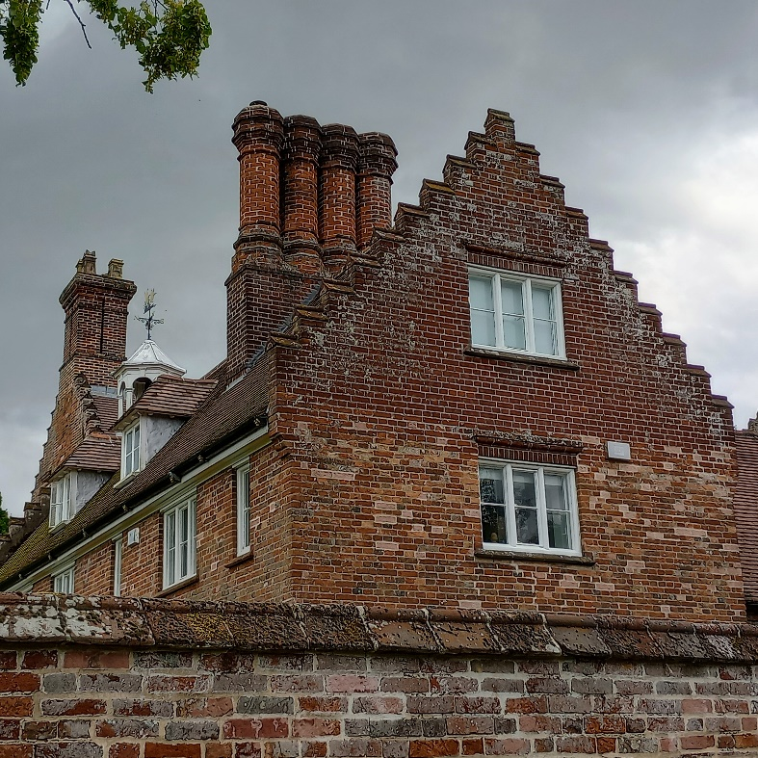

Content

Introduction 3

Historical Development 4

Character Assessment 5

Conservation Management Guidelines 14

Appendix 1(i) Listed Buildings 15

Appendix 1(ii) Buildings of Townscape significance 15

Appendix 2 Policy 16

Appendix 3 Map showing proposed extension 17

Introduction
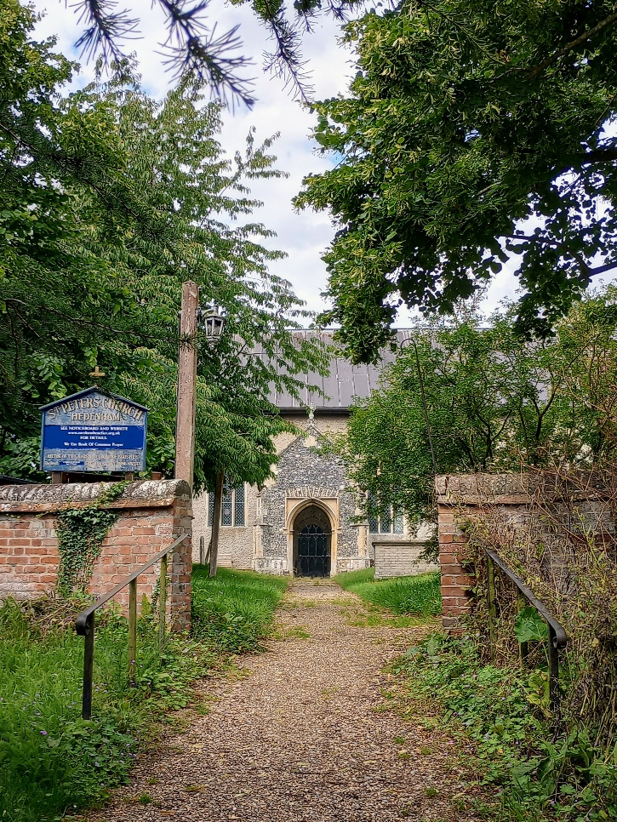  Church of St. Peter | Hedenham lies 4 miles NNW of Bungay and 11 miles SSE of Norwich off the B1322 Norwich Road. The main road divides the village into two.  The country houses of Hedenham Hall and Ditchingham Hall and their respective parkland dominate the area to south-east of the village and the east side of the approach from Ditchingham along Norwich Road.  Smith’s Knoll is a distinctive part of the conservation area with a higher density and more modern development of 1950s housing, carefully planned and positioned at the time on Church Road to minimise the impact of new development on the existing rural character of the village.  The settlement as a whole has a strong rural character relatively unaffected by more recent development, with the areas either side of Norwich Road having a different settlement character.
When first designated in 1994 the conservation area did not include within its boundary the area to the south known as Hedenham Green. This area contains a number of historic properties and a historic landscape rural settlement pattern resulting from the enclosure of a common land in the 19th century. Following the appraisal and public consultation this area is now included.
Under the terms of the Planning (Listed Buildings and Conservation Areas) Act 1990, the local planning authority is required to identify areas of special architectural or historic interest whose character or appearance it is desirable to preserve or enhance, and to designate them as a conservation area. The 1990 Act also requires local authorities to prepare management guidance and proposals for conservation areas. This document should be read in conjunction with the adopted Local Plan, the National Planning Policy Framework and Planning Practice Guidance
Key Characteristics
- B1322 runs through the village effectively dividing it into two.
- The large Hedenham Hall and Ditchingham Hall estates, which include extensive parkland, dominate the area to the south-east.
- Rural lanes lined by thick hedgerows and large matures trees
- Spaced out vernacular and estate housing along Church Road and the approach to St. Peter’s Church
- A carefully planned small 1950s Tayler and Green housing development, Smith’s Knoll, on the west side of Church Road
- ‘Hedenham Green’ - a more dispersed part of the village to the south around a former common.

Historical Development
In the Domesday Book (1086) Hedenham is referred to as Hedenaham. The name is Anglo-Saxon in origin and is thought to derive from the ham (homestead or village) [of] Hedena (a person's name). Roman settlement in the parish is suggested by the discovery in 1858 of the remains of a kiln and of Roman cinerary urns, as well as by the roman road known as Stone Street.

It appears that there were originally two manors at Hedenham: Hedenham itself, granted in 1066 by William the Conqueror to his nephew, Hugh de Abrincis, and Parks Manor the forerunner of the present Hall - held, by feudal tenure, of the manors of both Hedenham and Ditchingham. In the 14th century a fine was imposed whereby Parks Manor was conveyed from Robert de Hedenham to John de la Park. It remained in his family until the 16th century when it was sold to the Richmonds. In the 17th century it was passed by marriage to the Garneys. A coat of arms survives at the Hall, with Richmond "impaling" Garney and the motto 'God's grace guides Garneys". The Hall has changed hands many times: in the 18th century it was owned by the Husseys, in the 19th century by the Bostons, and more recently by the Carrs.

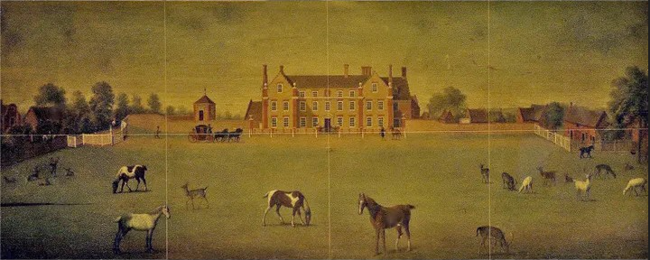
Hedenham Hall South Front in the 18th century

Hedenham Hall dates from the 16th century and is basically an E-shape plan house which was remodelled in the early 18th century. 17th and 18th century estate maps show extensive areas of woodland, including Long Row, a surviving pre-enclosure field edge woodland strip.

A landmark building on Norwich Road is the former Mermaid Inn, which originally dates to 17th century but was a coaching inn from at least 1789 and likely earlier. During the 19th century the inn had well-known nursery grounds attached to it and was a Rosary (for the cultivation of roses.) At that time it was known as the Mermaid & Rosary. During the 2010s it traded as a Balti restaurant before being converted to a house during the early 2020s.

The north side of Hedenham along Church Road has remained essentially an "estate village” throughout the 20th century with very little development. The one exception is the social housing built by Loddon Rural District Council at Smith's Knoll dating from 1949-50. This is the same style of Tayler and Green social housing as seen across other parts of the former district to the north and east.

Hedenham Green to the south side is a grouping of mainly farmsteads and cottages dispersed around a former common area that was enclosed in the 19th century. The area is characterised by paddocks and ponds with boundary hedges. There are also areas of medieval to post medieval field boundary earthworks in the area (Norfolk Historic Environment Record reference 43754-6)

To the south-east Ditchingham Hall dates from 1715 replacing an earlier hall. The present hall was built by the Bedingfield family and later owned by the Carr family in the late 19th century. The design of the picturesque landscaping with the serpentine lake is attributed to Lancelot ‘Capability’ Brown and the parkland now incorporates both that of Hedenham Hall and Ditchingham Hall.
The connections to the estates and the Carr family can be seen in the design of casement windows along Church Road which show they are estate houses as well as plaques including “MC 1911” on 49/50 and “MC To WGC 1931” on 51/52. In the north-east corner of the churchyard there are unusually flat white gravestone tablets laid directly onto the ground for the Carr family.
St Peter’s Church dates back to 15th century and contains monuments to the local gentry who lived in the halls, as well as burials and gravestones of local residents.
The population of the parish has remained consistent with very little development since the 1940s. Census figures show a parish population of 195 in 1961, dropping to 158 in 1991. The population rose to 237 by 2021 but this is due to Thwaite and Hedenham parishes counted together.

Character Assessment
Hedenham and its setting
The village is set within a relatively flat plateau which at the north end drops down to a small stream, Broome Beck, which flows eastwards. The Church is situated on the other side of the stream at the north end of the village, with the road passing through quite a deep cutting to its west side.
To the south-east is the extensive wooded parkland of Hedenham Hall and Ditchingham Hall, with a significant serpentine lake to the east of Ditchingham Hall created from the damming of the stream.
To the south the land is relatively flat clay land with ponds, drainage ditches and wooded areas. There is a strong sense of enclosure within the settlement with high hedgerows and trees bordering small paddocks and meadows, whereas to the southern edge there are expansive views over large agricultural fields.

Conservation Area Boundary
The boundary includes the few properties either side of Norwich Road, properties along Church Road, as well as Hedenham Hall and Ditchingham Hall and their respective parklands.
Following this appraisal the boundary has been extended to the south to include the area known as Hedenham Green. This part of the village has its own distinct settlement pattern around a historic common area that has been enclosed, with a more dispersed settlement pattern. As is typical with development around historic commons in South Norfolk, houses are positioned spaced out and further back from the road behind hedgerows and paddocks. Houses are either historic or fit in with this general settlement pattern. Willow Farm to the north has a number of historic buildings including a flint barn, and other houses have earlier historic fabric incorporated into later remodelling.
Street Patterns and Historic grain
Norwich Road has been a principal thoroughfare through the centre of the village for many years. Unlike other villages there has been very little development along the road itself, but instead the settlement formed in a spaced out linear development to the north along Church Road up to the church, and to the south with a more dispersed pattern around Earsham Road.
The Mermaid and Hedenham Hall with its high garden wall are visually prominent buildings in the centre of the village close to the road, creating strong visual landmarks for the Church Road and Earsham Road junctions on Norwich Road. To the north the former school house and school are set back a little from the road on the south-west side, whereas The Old Rectory is a larger country house further set back within a larger curtilage with associated outbuildings to its rear to the north-east.
Initially when entering Church Road from Norwich Road there is a contrast between the open paddock enclosed by the hedgerow to the left side, and Hedenham Hall with its high red brick boundary wall and associated buildings to the right. At the point of Rectory Road, which is more of a side lane/track, this flips to housing behind thick hedging on the west side, and glimpsed views through to the open parkland of Hedenham Hall on the east side.
Following the housing behind thick hedgerows the streetscene opens out with a small area of open space to the west to the front of the Smith’s Knoll housing. The low rise bungalows are parallel to the street and set back, with the two storey terraces set at right angles with their gable ends to the street. The development, by the notable mid-century local architects Tayler & Green, was evidently planned in this manner to minimise the impact of new development on the rural character of the village as well as introducing publicly accessible open spaces for recreation.
Following some more housing set back behind hedges, Church Road then leads over a small brick bridge with the brook below, and then up to the church which is situated in an elevated position. The church effectively provides another strong landmark terminating views at this end of the village with no further development (The Mermaid terminates views at the other end of Church Road). In front of the church the road opens out further to a small green before the road significantly narrows between the high earth embankments with the churchyard to the east.
To the south Hedenham Green has an altogether more dispersed character and finer (spaced out) grain. Buildings set back at varying distances to the edge of settlement and except from the southern approaches houses are mostly partially obscured in streetviews by the high roadside hedging. Consequently, with the exception of Hedenham Lodge, much of the housing is only glimpsed and goes largely unnoticed when passing along Earsham Road. This has its drawbacks with the road being a shortcut to the A143 and cars speeding more than they might otherwise do passing through this part of the village. On the north side of the road behind hedging Scotfer pond is also a significant landscape feature which can be passed without hardly noticing.
Perambulation
Earsham Road and Sexton Road
From the south-west the village is approached along Earsham Road and Sexton Road. Along the two approaches cottages are close to the roads before houses become more set back – indicating where the roads converged and the former open space of the village common opened out. This has now been enclosed with high hedging which has created a more enclosed feel.
69 Sexton Road is a small vernacular cottage, likely 18th century or earlier, with a rendered front, steep pantile roof with bargeboards and low eaves and brick gable ends. As the road bends around 70 (Pineside Cottage) & 71 is a small C19 red brick semi with a central stack, lower roof slope with dark tiles and casement windows (now modern) and extended to both sides. On the Earsham Road is Old Leaf Cottage, also C18 red brick but with red tiles with a higher 19th century at the south end. The original part is unusual with the brickwork extended up to increase the height.

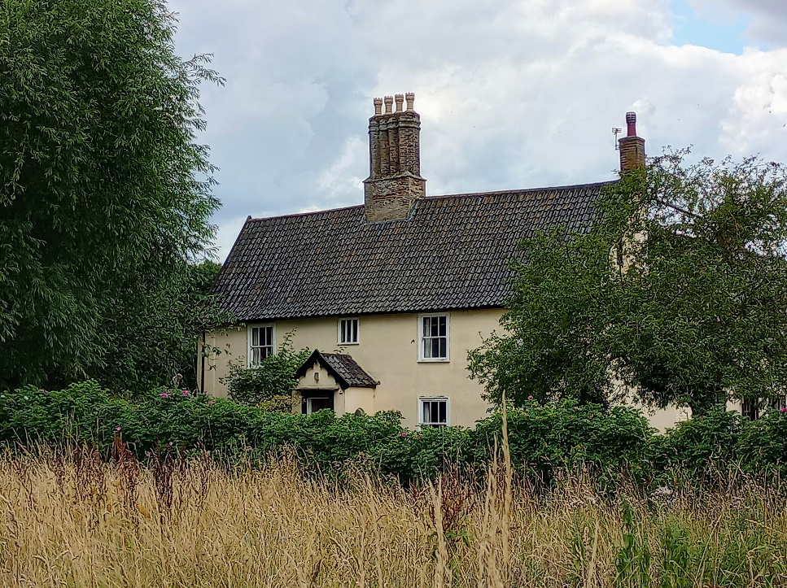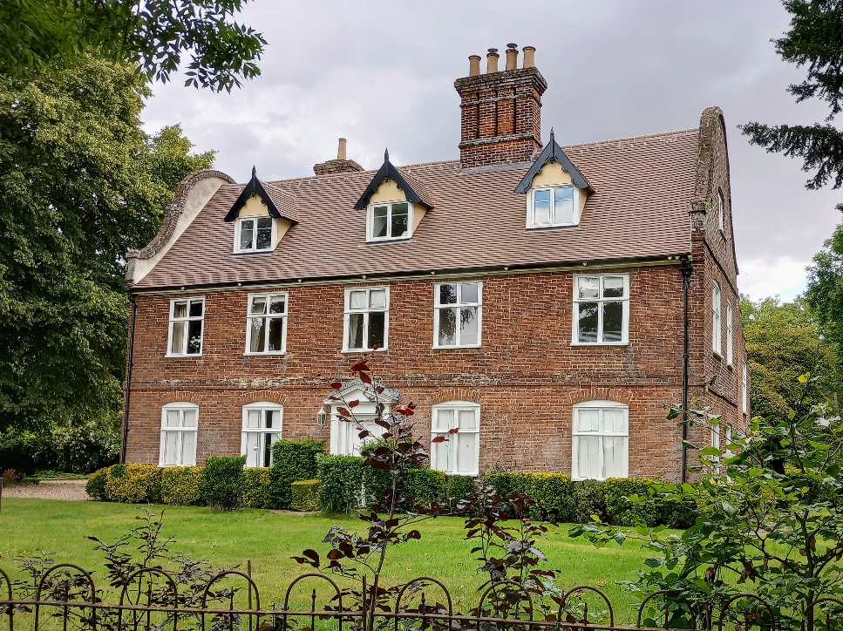
Willow Farmhouse Hedenham Lodge
There are two options for walking through Hedenham Green: either following the public footpath through the paddocks towards Scotfer Pond; or along Earsham Road – but note there is no footpath. The former option gives a better understanding of the typical South Norfolk rural village character and the relationship between the open spaces and buildings.
To the west the most substantial building is Willow Farmhouse, a 17th century L shaped timber framed grade II farmhouse with the rear wing dating to 1709. The house overlooks a paddock to the east. It is rendered with chalky white render and has black glazed pantiles. A long driveway reaches the farmhouse through paddocks to either side. To the north of the farmhouse are a number traditional farm buildings including one constructed of flint.
Then there is a larger, more recently constructed house, currently painted green, followed by a smaller cottage, Willow Farm Cottage, a modern red brick house now painted, and Marshony, also modern. An earlier small red brick cottage, although much altered, is Blithe Cottage.
On the east side of the Earsham Road houses are mostly well set back and only partially visible. Visible to the south and accessed via a path (although the vehicular access is onto Norwich Road) is the rendered The Garden House. The Historic Environment Record describes this as the remaining fragment of a much larger 16th century house – probably the parlour. Three walls are brick but the south wall remain wattle and daub. Hedenham Green is a traditional looking house set back some distance from the road.
Then there is a modern house with a traditional form, Hedenham Cottage, followed by Hedenham Lodge, which is the finest house in this part of the village. Unlike other houses along Earsham Road the house has a very visible Georgian style frontage to the street dating from the 18th century. The Dutch gables are also very prominent to the sides. The rear wing is more vernacular in style indicating the house was remodelled and/or added to in the 18th century. The front railings are of some age and have some rural charm in their bent and rusted state. The garden is well kept and contributes positively to the character and appearance of the conservation area.

Norwich Road
Upon reaching Norwich Road Hedenham Hall becomes visible, glimpsed through the trees above the hedgerow and wall. Almost unnoticed is an unusual large plaster sundial set within the gable end. The hall lies behind a high wall with crowstepped gables – making the hall appear quite different to any other buildings in the village and making it stand out where it is visible.
On the south side is the former Mermaid public house occupying a very prominent roadside position, perhaps due to the need to attract passing custom from the historic route between Bungay and Norwich. Next to the former pub was a weatherboarded timber barn. The frame was partially reused, the barn extended and converted to a house.

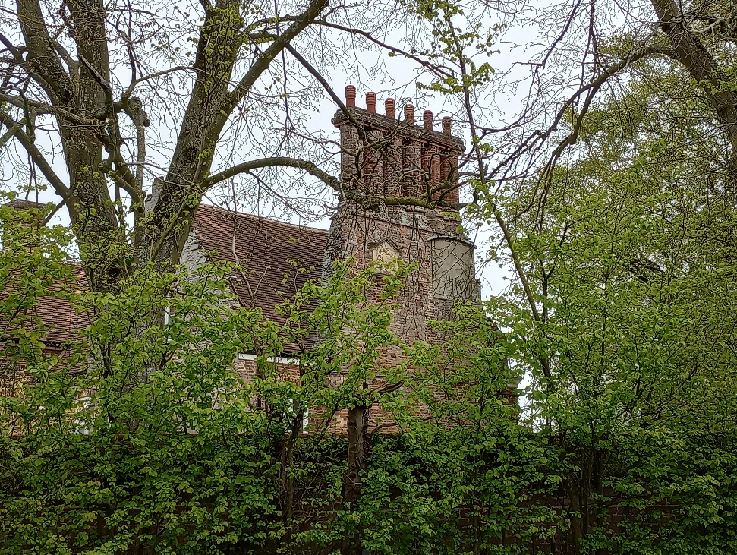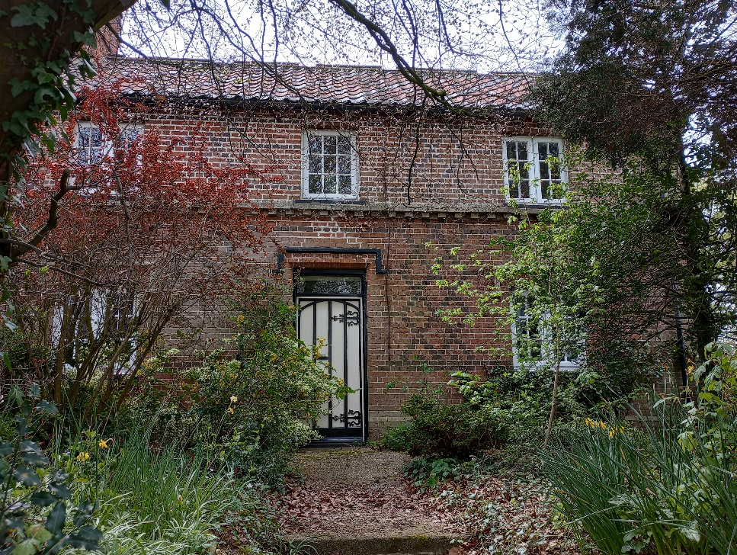
Hedenham Hall sundial and stacks The converted former school
seen from Norwich Road

Further along Norwich Road the former school has been converted into a house with the adjoining village hall to the rear. Like a number of houses in the village the front is characterised by diaper brickwork in Flemish bond with dark headers forming diamond shapes. Between the Mermaid and the school there used to be single storey brick barns also with diaper work, but these were demolished in the late 20th century and a new house has been approved but not yet constructed.
To the right is the gated access to The Rectory, a substantial house with a walled garden and with an associated paddock to the east. It is well set back from the road within large grounds and is screened from views by the verdant roadside planting. Some dwellings and outbuildings lie behind the rectory, reached long Rectory Lane, which is really more of a track, off Church Road.
To the south-east of the village is Grade I listed Ditchingham Hall, which in contrast to Hedenham Hall is set well back from the road within its extensive parkland. The piers and gates to Norwich Road are relatively modern, added in 1951. The Hall has been altered since its original 1715 construction with sash windows likely replacing earlier mullion and transom windows, and a slate roof rather than the original plain tiles. The original part of seven bays faces south towards the lake.
Wings and open courtyard were added to the rear (north side) in the late 18th century. The house is a fine example of 18th century Georgian architecture with good Georgian proportions, described by Pevsner as “a very fine and restrained design of c1715.” Within the park there is the Keeper’s Cottage near to the lake which dates back to at least the early C19th and opposite in an isolated position 34/35 Norwich Road which is a good example of a early 20th century semi-detached estate villa in red brick and the initials CC and date 1909.

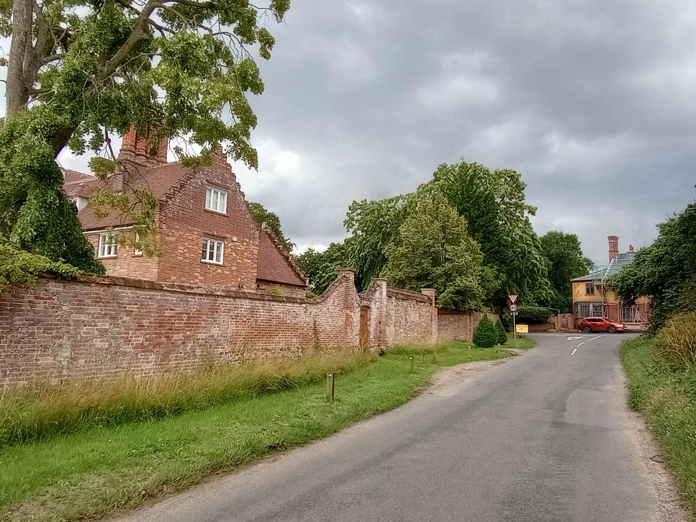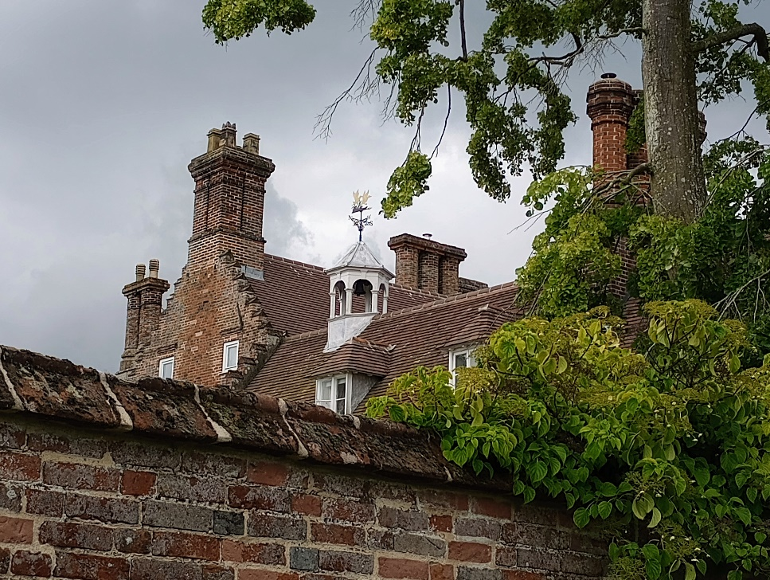
Hedenham Hall & The Mermaid Hedenham Hall roofscape

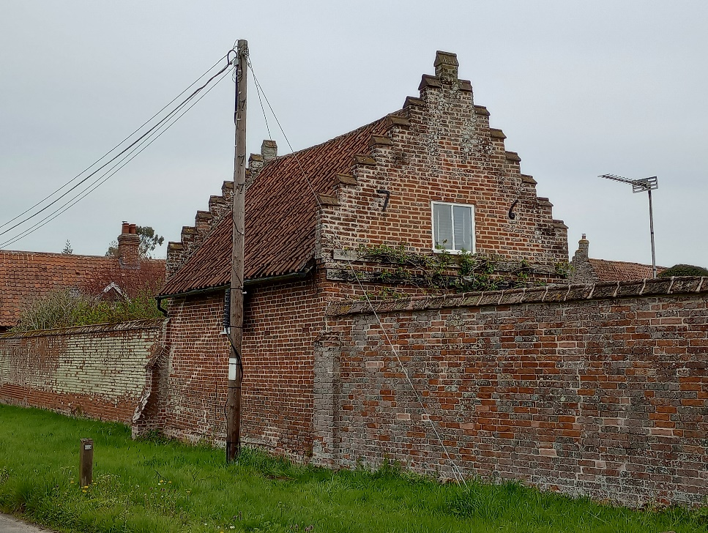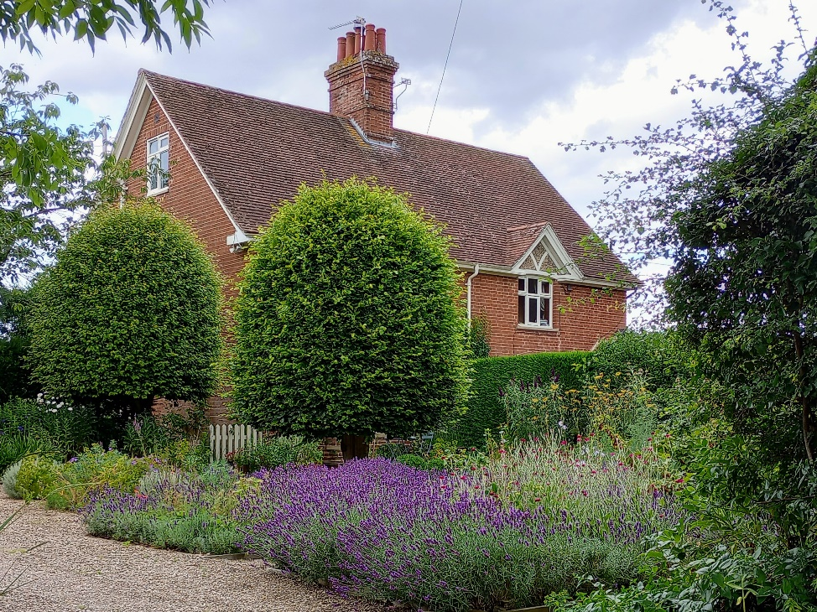
Garden Building to Hedenham Hall 49 & 50 Church Road

Church Road
The entrance to Church Road is marked on the south side by an imposing brick wall behind which is built Hedenham Hall with its crow stepped gable ends and proliferation of chimney stacks. The hall originally dates from the 17th century, and was built on an E shaped plan, although now it has a more irregular plan resulting from subsequent additions with a more erratic roofscape. The boundary wall at one point has an unusual semi-circular curve – this reputedly was the site of a village well, which had its origins in Roman Times. It is now planted with a tree.
Further along the wall is an attached garden building with iron clamps marking the date 1676. Within the estate is the Stable Block, also in the same materials and style. Further north and also in the Park is the single storey Park Lodge, built in the classical style with a pediment containing a putto in a niche in the centre of the west elevation and sash windows with large panes, which give it a grand scale for its actual size. A little to the east of the lodge is the (Listed) Dovecote dated 1769 (there is an inscription above the door). It is hexagonal, of red brick with angle pilasters and with a plain tiled roof surmounted by a domed cupola.
To the west side of Church Road is a large paddock which was historically shown as part of the land associated with the Rectory, perhaps the reason for it not being built on. On the north side there is the track (Rectory Lane) leading to the house at the rear of the Old Rectory and the houses associated with the Old Rectory’s walled garden which is accessed from the lane.
The first of a number of houses on the left side of the road is No 46 dates from 18th century. A porch has recently been sympathetically added using the same C19/early C20 window casement style as other houses in the village (see later.) Then there are 20th century estate cottages in two pairs: 49 & 50 and 51 & 52. These are styled in an early to mid C20 modest arts and crafts/tudoresque appearance – 49/50 has ‘1911” and “WC” 51 & 52 has 1931 ‘MC to WGC” Then follows the post war Tayler and Green housing known as Smith’s Knoll. Nos. 1 & 2 are two bungalows fronting Church Road but set quite high on the bank. 3-6 is a terrace which faces the rear gardens of 7-11 further north. 9-11 front towards a small public space/recreation area, as do 12 & 13 which face east. The dwellings are characterised by a more modern post-war look with pastel rendered painted properties and pantile roofs. No7 has the building number in red pantiles on its roof.

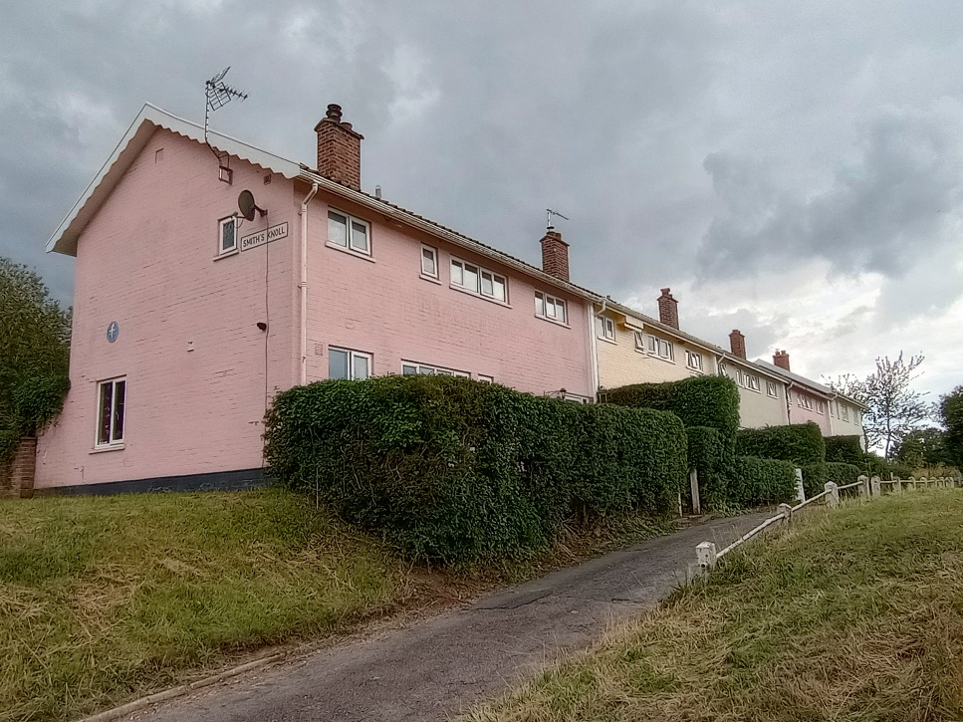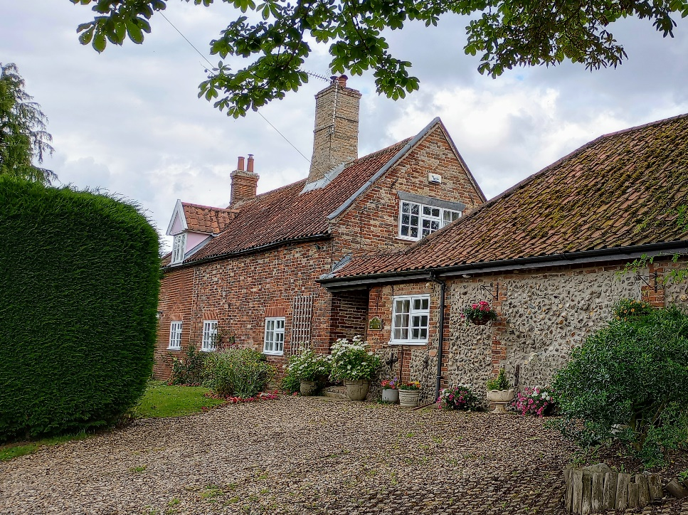
7-11 Smith’s Knoll The Old Forge

Following Smith’s Knoll on the left side are a further two estate style cottages, nos. 14 & 15, of a later date and architecturally simpler and of less interest than the earlier cottages. These face the single storey, The Old Forge, partly built in flint and with an interesting variety of fired bricks. Also on the east side and quite well hidden behind the hedge is Valley Farmhouse, which is grade II listed. This timber framed house now encased in brick is of particular historic interest being originally an open-hall house with a cross passage dating from the 16th century and floored in the 17th century.
Following the small village green with the village sign – a seductive mermaid - are Nos 56/57. These are also grade II listed dating from 16th century with a steeply sloped thatch roof, and have now been combined into one house. The building is brick clad over the original timber frame. Further back to the south is no 55, which although built with a traditional form and looks old, is actually a relatively modern house.
There is a significant Cedar Tree at this point next to the path leading up to the Church of St Peter which is grade I listed and dates from the 14th and 15th centuries with 19th remodelling. Constructed in flint with limestone dressings the church has a 15th century west window and south porch. The church was historically connected to the gentry living in Hedenham Hall and Ditchingham Hall and there are some very fine monuments inside the chancel belong to the Bedingfield family of Hedenham and dating from the 16th and 17th centuries.
Beyond the bridge on the west side facing the church is Glebe Farm. This cottage has low eaves and quite ornate joinery to the dormer windows that sit at eaves level. The house has the same 19th century style casements as other estate style houses in the village.

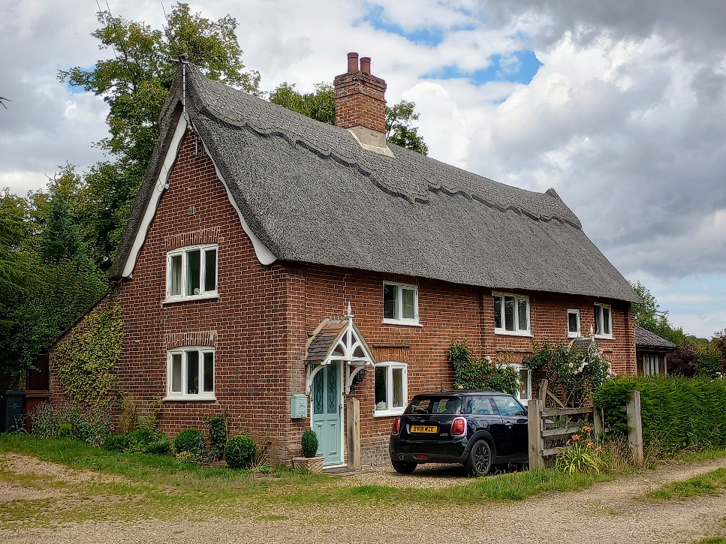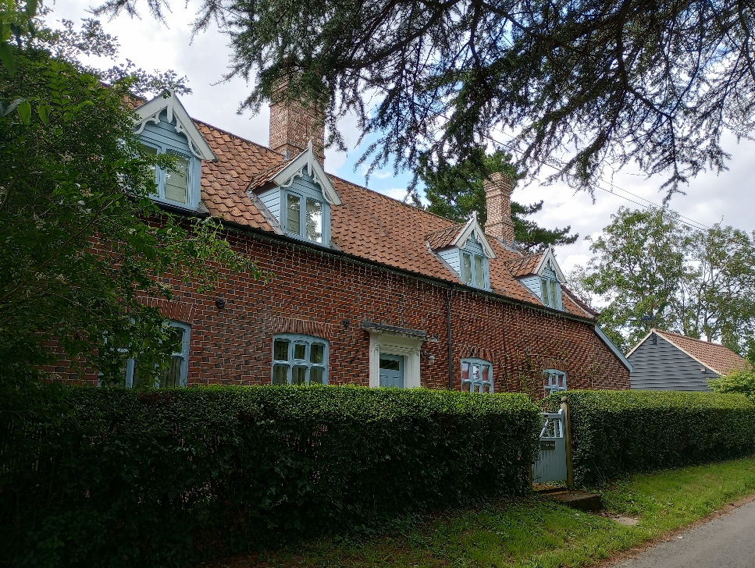
Nos 56/57 Church Road Glebe Farm

Traditional Materials and Architectural Detail

The church stands out as the oldest building in the village and has its own distinct architectural being very early in date and built predominantly in flint. Ditchingham Hall and Hedenham Hall are both high status houses for the landed gentry and also have a distinct high status ‘polite’ architectural character. The Old Rectory and Hedenham House are more significant houses with some ‘provincial architectural pretension’ such as the incorporating Dutch end gables.

Otherwise to the south houses in Hedenham Green houses have a simpler more rural vernacular character and to the north along Church Road there is a mix of vernacular houses and more estate style housing with common design details. Valley Farmhouse is of particular importance dating originally from the 16th century – its rich timber frame encased by brick. Parts of The Garden House and Willow Farm also dating back to the 16th century. Smith’s Knoll has its own distinctive 1940’s/50’s modern take on the Norfolk vernacular.

The predominant roofing material are the orangey red clay pantiles. In some cases these are a darker grey / black especially at Smith’s Knoll. Hedenham Hall and Hedenham Lodge both have plain red pin tiles. Ditchingham Hall is a bit unusual with the earlier use of slate, being a replacement material dating from the 18th century. 56/57 Church Lane is the only thatched house remaining in the village.

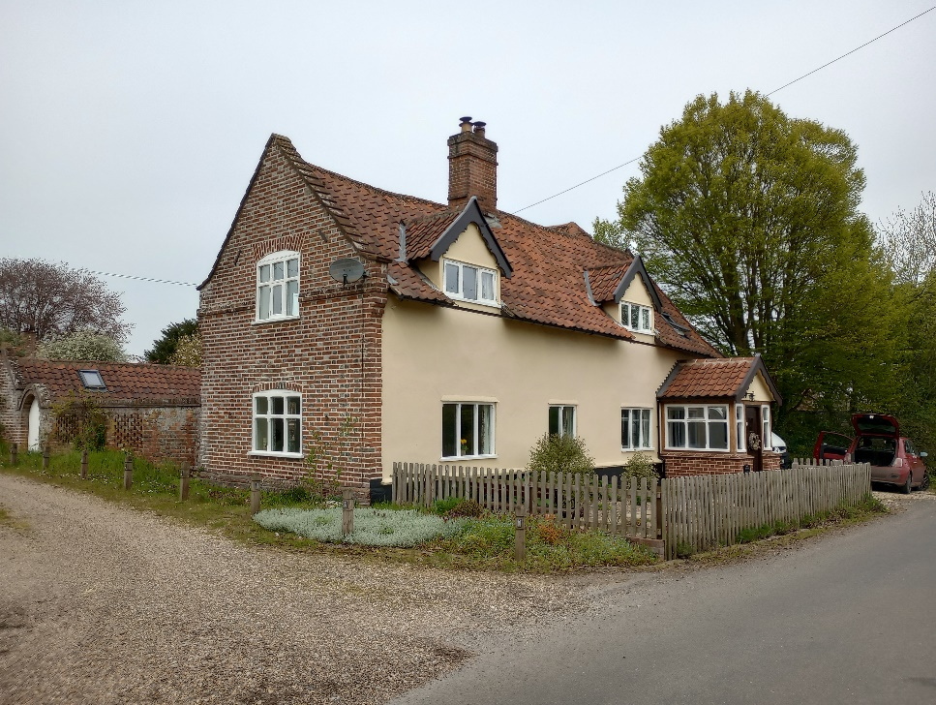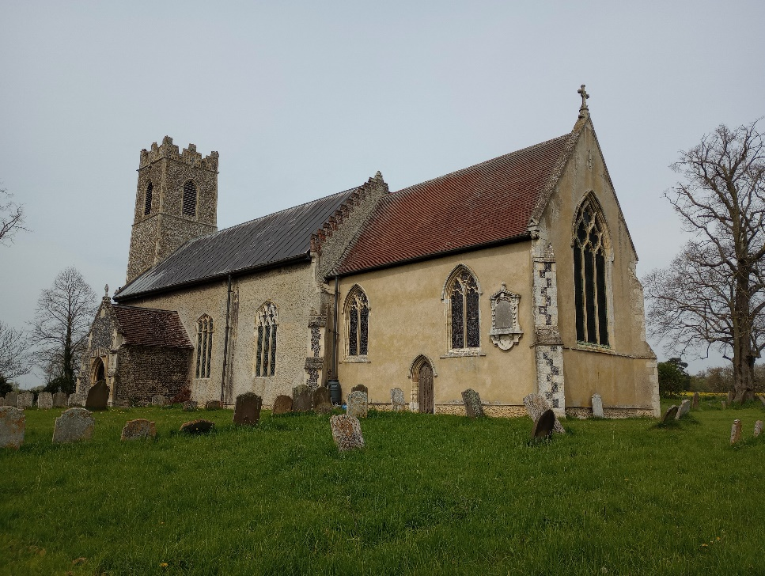
46 Church Road St Peter’s Church

The brick houses are built with red brick, however diaper brickwork with burnt headers in Flemish bond is a characteristic of the area – particularly demonstrated at the former school and Glebe Farm. There are some timber framed buildings which are rendered in Hedenham Green, and at Smith’s Knoll some houses painted with pastel brickwork to break up the continuous elevation. The church stands out being very early in date and constructed predominantly in flint. Flint is otherwise used on quite lowly outbuildings as secondary material at the Old Forge and the barn at Willow Farm.

An interesting characteristic is the special type of casement window in many of the houses with the chamfered external timber mullions and transoms. This is most likely a characteristic of the houses being estate buildings tied to the Hedenham and Ditchingham Hall estate with the same joiner making up the frames in this particular style to give the village an identity linked to the estate.

Natural Character and open spaces

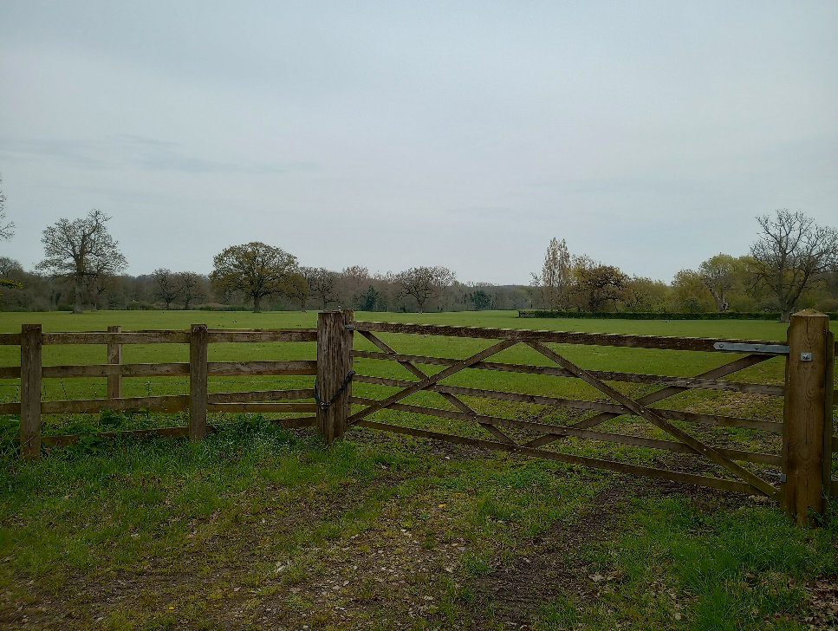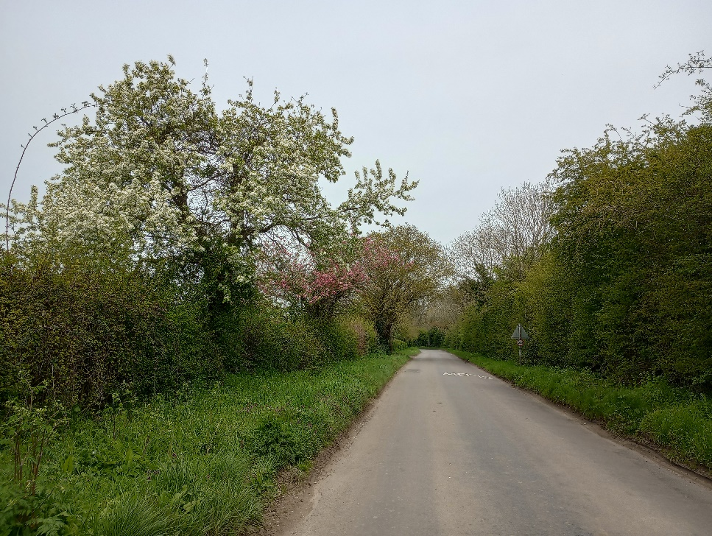
View toward parkland from Church Road Earsham Road with high hedges
The most organised and ‘designed’ landscaping in the village is the parkland of Hedenham Hall and Ditchingham Hall (Grade II) with characteristics of parkland trees, a picturesque stream and serpentine lake, and grassland and tree belt plantation planting to the north in the style of Lancelot ‘Capability’ Brown. There is also more formal style of planting closer to the halls. There are intermittent views of the parkland from Church Road and Norwich Roads.

To the north of the conservation area Broome Beck has its own distinctive character of a rural stream thick with vegetation and plenty of wildlife. The cedar tree to the north is also a very prominent feature in the townscape leading up to the church where a further planting of limes is also very prominent. There is a small green area where the village sign is located.

Apart from the walls to Hedenham Hall and to the front of the Mermaid all the roads are characterised by thick hedgerows and boundary trees which give a very rural character to the village. Smith’s Knoll is an exception where some space has been created with a knee rail – but sympathetically done and there is a small public green to the north of the terrace.

In Hedenham Green a footpath runs through the attractive landscape area beside Sculfor Pond and then through a former part of the common which is now grazed land in front of Willow Farm. Paddocks and houses with driveway accesses intermingle either side of the road behind high hedges.

The churchyard is an interesting space with old gravestones and some interesting white flat slabs belonging to the Carr family.

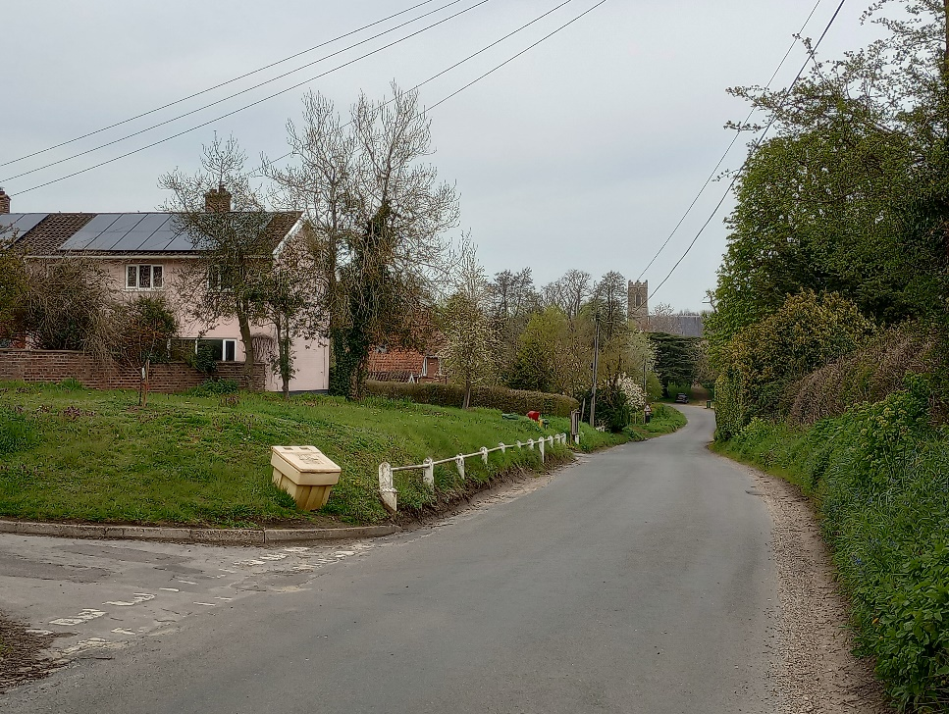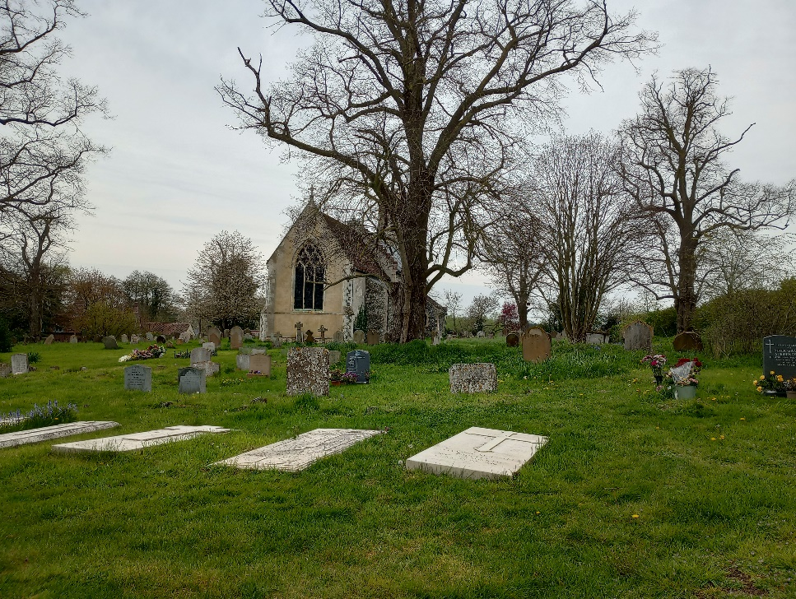
Smith’s Knoll along Church Road St Peter’s Churchyard

Street Furniture, Walls and Railings

Hedenham Hall has an imposing brick wall to the street, signifying it as being the seat of gentry in the village and pre-dating Ditchingham Hall. There are also walls to the front of the Mermaid – more a case of being on a busier through road. The wall at Hedenham Hall is unusually built around a tree which must have for some reason been of some significance to the owners – and has been replanted.

There are some early railings of interest in front of the Hedenham Lodge with some rustic charm. Elsewhere boundaries are defined by hedgerows, although there are some more modern low white metal knee rails at Smith’s Knoll original to the scheme. These are characteristic of Tayler and Green development and are contemporary with the 1950’s date.

Being a village, street furniture includes the village sign and a bench on the small green to the south of the church. There is a village postbox dating to George V reign, and a small bus shelter on Norwich Road which has been pantiled.

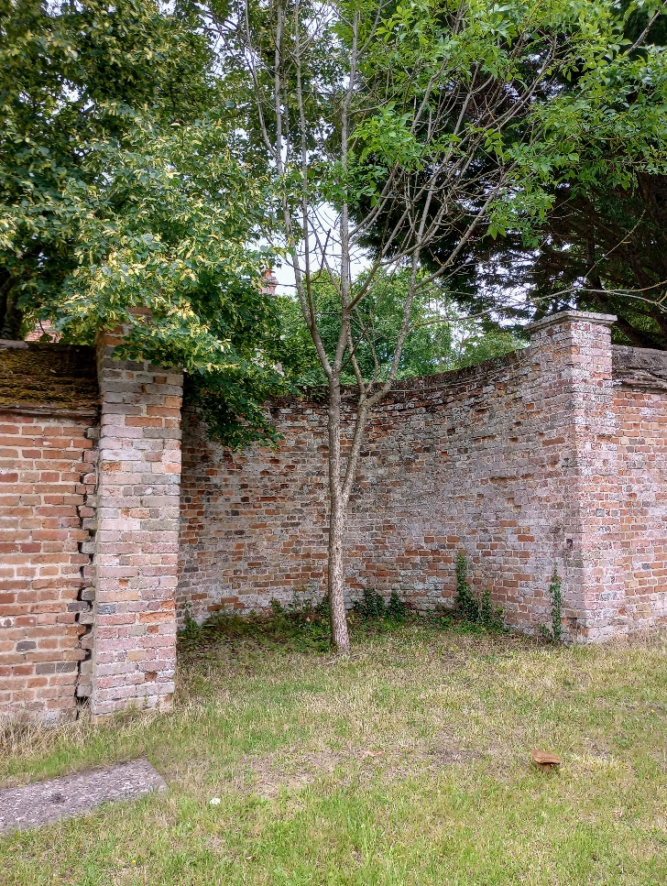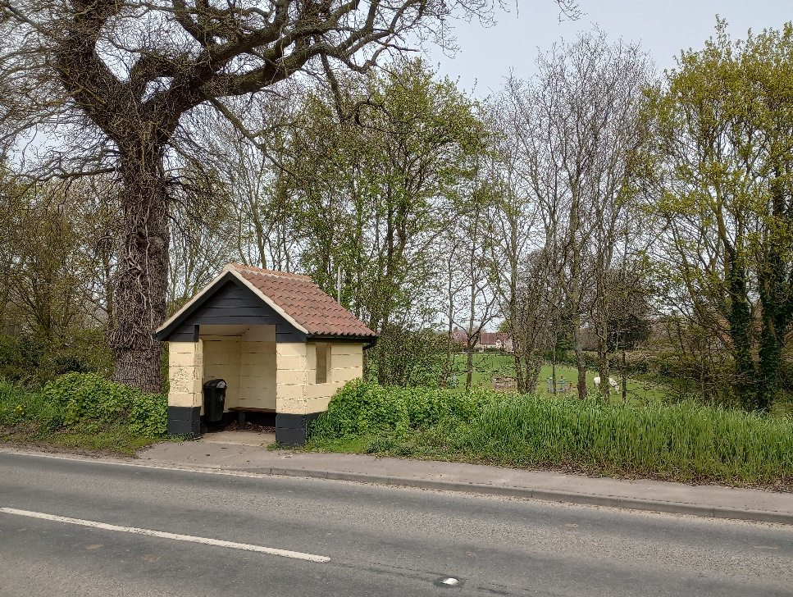
Hedenham Hall wall Village bus shelter on Norwich Road
(possibly site of village well)

Conservation Management Guidelines
Highways
Hedgerows and verges are a characteristic of the rural setting along the village lanes. There are also few signs.
The lack of highways signage and tarmac footpaths and pavements helps to retain the traditional rural character of the conservation area. The use of road kerbs should also be avoided as these will only detract from the rural character.
Upgrading windows and doors
Hedenham has retained many original window styles with some very bespoke characteristic estate style casement windows used on various historic properties and reflective of the detailing of estate housing.
If original doors or windows need to be replaced then this should be done using the same original material and to the same design. If different materials are used then the new units should still match the original design. It would be beneficial for any extensions, such as porches, to replicate this style. Replacing materials and doors should be mindful of historic and/or estate housing details. Tayler and Green housing also has uniformity in its design and care should be taken to maintain appearance if upgrading windows.
Front boundaries
An important feature of the conservation area are the mature boundary hedgerows in front of properties. There are some walls along Norwich Road and Church Road to Hedenham Hall
Hedges should be retained and front wall and fences should not be erected – except along Norwich Road to the side of the former Mermaid Inn
Ground surfacing
All road surfacing is tarmacadam between natural grass verges with the majority of driveways having a natural gravel finish.
The use of more modern surface materials such as paviors on driveways should be avoided as this can create a more urban character rather than the more informal rural gravel surfacing.

Street furniture
There is very little street furniture within the conservation area to detract from its traditional and natural character.
Only signage that is absolutely necessary should be installed within the conservation area and where possible it should be positioned and designed so as not to detract from existing views.

Appendix 1 (i)
Listed Buildings

Church Road Hedenham Hall (Grade I)
Stable Block approx. 50m N of the Hall.
Boundary Wall enclosing garden to N and W of the Hall.
Garden Building in west garden wall of the Hall.
Garden Cottage at N end of west garden wall of the Hall.
Dovecote, immediately east of Park Bungalow.
Valley Farmhouse.
Nos. 56 and 57.
Church of St.Peter (Grade I)

Norwich Road (North Side) The Old Rectory
Ditchingham Hall (Grade I)

Earsham Road (East side) Hedenham Lodge

Earsham Road (West side) Willow Farmhouse

Historic Park and Garden

Norwich Road Ditchingham Hall

Appendix 1 (ii)
Buildings of townscape and local significance

Church Road (South side) Park Bungalow.
The Old Forge.

Church Road (North side) 46*
Nos. 49 and 50.
Nos. 1 to 13 Smith's Knoll.
Glebe Farmhouse

Earsham Road Old Leaf Cottage*
Outbuildings to Willow Farmhouse*

Norwich Road (south side) The Old Schoolhouse and Village Hall.
Mermaid Inn.
Garden House*
Pair of cottages approx. 530 metres east of
Earsham Road junction.

Sexton Road 69*

*Additional buildings of townscape and local significance added 2024

Appendix 2

Policy background

In recent years, the approach to conservation area designation has changed considerably. It is now recognised that development plan policies, development control decisions, and proposals for the preservation or enhancement and the management of conservation areas, can best be achieved when there is a sound understanding of the special interest of the conservation area.

This position is reinforced as follows:

The Planning (Listed Buildings and Conservation Areas) Act 1990 in section 66(1) makes it a duty of local authorities when considering applications to have special regard to the desirability of preserving a listed building or its setting or any features of special architectural or historic interest.

Under section 72 of the same Act, it is a duty with respect to any buildings or land in a conservation area, to pay special attention to the desirability of preserving or enhancing the character or appearance of that area.

Department for Communities and Local Government. National Planning Policy Framework (NPPF) 2018 Paragraphs 184 to 202 cover “Conserving and enhancing the historic environment”.

Joint Core Strategy- Policy 2 : Promoting Good design South Norfolk Local Plan

The South Norfolk Local Plan Development Management Policies Document was adopted in 2015 and policy 4.10 covers Heritage Assets.

Trees: It is important to note that six weeks notice is required for any works to trees within the conservation area. Further information can be found in the council’s website.

Public Consultation

An informal ‘walkabout’ of the area was organised with the Parish Council on 10th February 2023. This informed the proposed boundary changes and the conservation management guidelines within the draft appraisal. The public consultation on the draft appraisal took place from 5th December 2023 until 15th January 2024, with attendance at the parish meeting on 10th January 2024. The appraisal was advertised:

• An advert in village notice board and local publicity by the parish council
• The draft appraisal being available to view on the council’s website.
• Emailing Ward Councillors, County Councillors, and the Parish Council.

As a result of the consultation some minor changes were made to the appraisal and the boundary changes were supported.

Appendix 3
