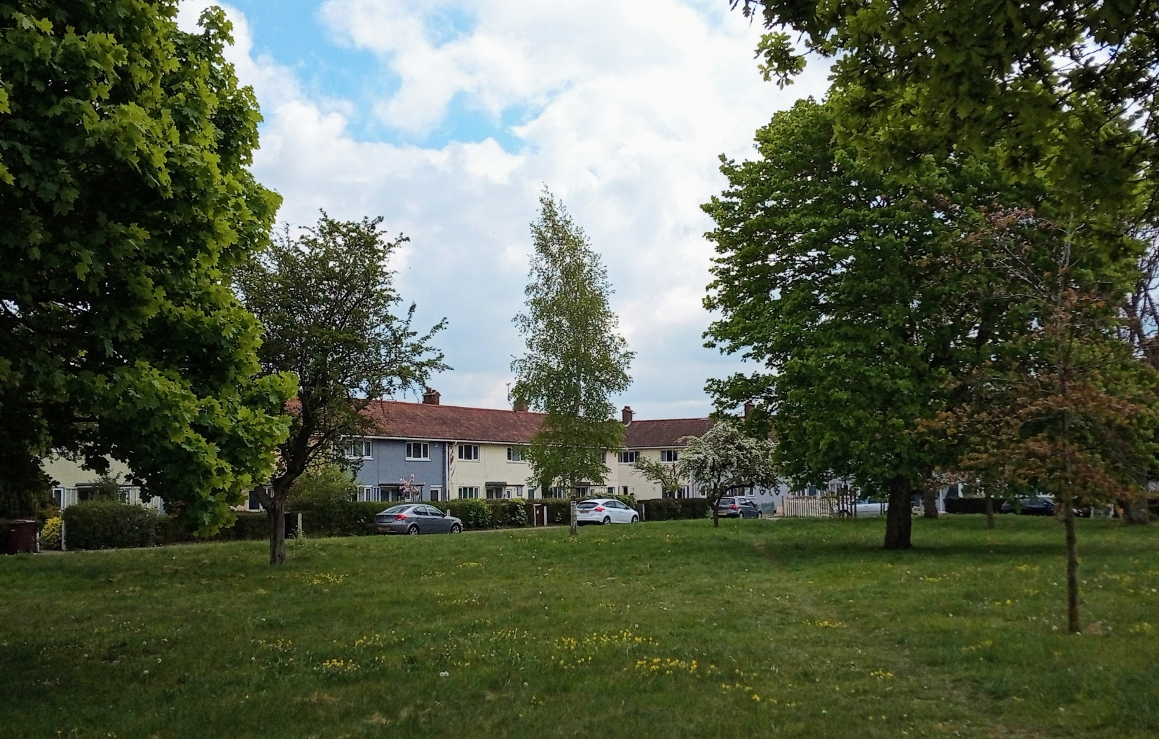

Ditchingham

Conservation Area Character Appraisal

and Management Guidelines

December 2022

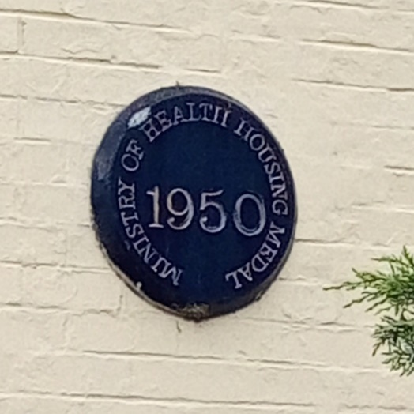 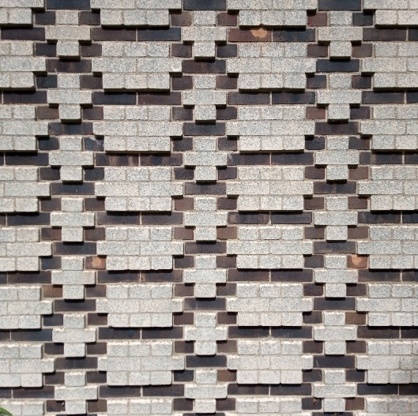 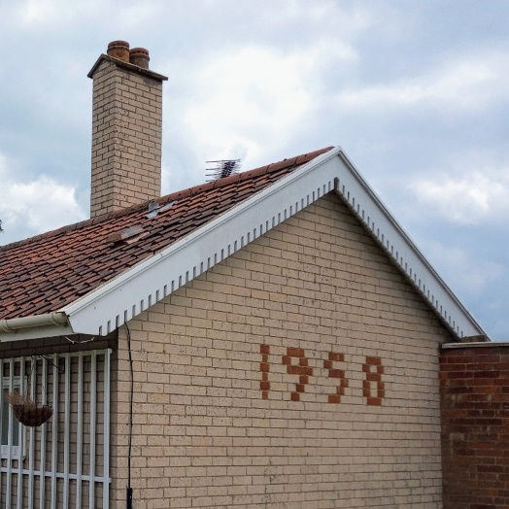



Content

Introduction 3

Historical Development 4

Character Assessment 5

Conservation Management Guidelines 14

Appendix 1(i) Listed Buildings 17

Appendix 1(ii) Unlisted Building of 17

townscape significance

Appendix 2 Policy Background and 18

Public Consultation

Appendix 3 Boundary Map, Streetscape 19

and Natural Character

Appendix 4 Further Reading 20

Introduction

|  |  |
| --- | --- |
| Photo of house on the North side of Windmill Green  House on Windmill Green (North side) | The conservation area was designated to cover an area of critically acclaimed mid 20th century housing to the north of the settlement for the former Loddon Rural District Council by the architects Tayler and Green. The development was praised for its unique response to provide modern yet traditionally based and locally distinctive social housing within a rural context. The architectural critic Ian Nairn commented that the architects were able “to fit each individual village and to interpret local pattern – not by reproducing local details, but by understanding the genius loci and then expressing it in twentieth century terms.’ |

|  |  |
| --- | --- |
|  | Under the terms of Planning (Listed Buildings and Conservation Areas) Act 1990, the Local Planning Authority is required to identify areas of special architectural or historic interest whose character or appearance it is desirable to preserve or enhance, and to designate them as a Conservation Area. The 1990 Act also requires local authorities to prepare management guidance and proposals for Conservation Areas. Ditchingham conservation area was originally designated on 28 October 1994. This document should be read in conjunction with the adopted Local Plan, the National Planning Policy Framework and Planning Practice Guidance. |

Key Characteristics

* Exceptional example of 1940-60s social rural housing
* Modern interpretation of vernacular styles with economy of materials
* Attention to detail with architects designing the ‘complete package’ of buildings, plans and landscape.
* Nationally recognised importance receiving housing awards, being amongst the first post-war listings in England, and reviews in architectural journals.

Historical Development

This part of the village is designated as a conservation area due to the post-war houses built by Loddon Rural District Council (RDC) and designed by the architects Herbert Tayler and David Green. They designed over 700 such houses throughout the former district, which now all lie within the district of South Norfolk. Following WWII many rural areas still lacked running water and electric lighting. Loddon RDC had already recognised the need for good homes to encourage young families to stay in the countryside, and by the late 1930s had already begun the acquisition of land to provide social housing.

 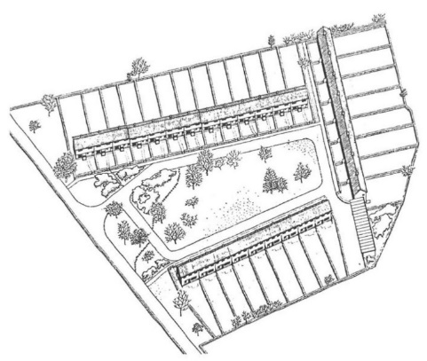

Herbert Tayler (l) and David Green (r) Sketch plan of Windmill Green

Herbert Tayler (1912-2000) was born in Java to a Scottish father and Dutch mother. Encouraged by an art teacher at Shrewsbury School, Tayler entered the Architectural Association in 1929 at a pivotal period when teaching was moving from a focus on neo-classicism to a more modernist approach. At the ‘AA’ he met David Green (1912-1998) who was born in Lowestoft to an architect father. Tayler was to take the lead in the architectural appearance of the properties and how they were planned to fit into their surrounding contexts including deciding on shapes, materials and colours, whereas David Green took on more the technical side of the designs.

In 1938 Tayler and Green as a partnership were commission to design a house for a Punch Cartoonist Roger Pettiward (Paul Crum) called “The Studio” in Highgate, London. The house demonstrated their move towards a more Scandinavian influenced modernism finishing the building in a softer terracotta render rather than the stark white render which was the prevailing architectural fashion of the time. However, before being able to establish themselves as a practice, the war intervened and both architects were sent by the war office to Lowestoft, where Green’s father had recently died, to help repair air raid damage.

Following the war the architects were commissioned by Loddon RDC and the terrace houses at Windmill Green (1946-8) are amongst the first and therefore some of the most important Tayler and Green designed houses in the district. The land had been purchased by the council from Lady Haggard in December 1949, daughter of the author Rider Haggard who had lived at nearby Ditchingham House.

It is difficult to appreciate just how bold and different these houses would have looked at the time with their bright colours and modern crisp detailing in comparison to the ubiquitous rural red brick semis, and how well they used the materials then available considering the post war austerity that was then in place. The arrangement of housing and the planning of the interiors was also very modern and far from typical.

Another historically important aspect of the development was the use of local builders such as Harvey and Leech at Kirby Cane. This was a very modern approach to building design but one that was also very much embedded within the existing rural context and local community. By 1949 they were already receiving national attention with the Windmill Green housing featuring in the national Housing Manual and in 1950 Windmill Green won a Housing Award (see plaque on front page.)

These first houses were primarily aimed at providing good housing for rural workers, partly to ensure that they did not leave for the towns and cities. However, the demand for better housing for the elderly was also soon recognised and bungalows were also planned. Agnes Hood Terrace, consisting of eight bungalows on the west side of Hollow Hill Road, dates from 1951 and is notable as the first of the Taylor and Green terrace schemes to also have a slight curve.

Scudamore Place, a later scheme of bungalows, was built in two phases, 1958 and 1964 on the east side of Hollow Hill Road, however a block plan showing the basic layout and block form had been prepared by Tayler as early as 1950. The first two terraces to the south were officially opened by Sir Edmund Bacon in 1960. The scheme was commended in the 1964 Housing Medal Awards. Bungalows were also added in 1958 and 1963 to either side of the Windmill Green development along Thwaite Road.

In 1973 local government reorganisation led to the Loddon Rural District Council being dissolved and the area was incorporated into the larger South Norfolk Council District. With the changes being made Tayler and Green decided to retire to Spain, however they left over 60 plans with the council to continue with the housing work following some of the same fundamental design principles as the earlier designs.

During the first post-war listing review carried out by Historic England and Elaine Harwood during the mid-1990s the housing again came to national attention and featured in a BBC2 “One foot in the past” episode in 1996 and a touring exhibition, curated by Alan Powers, for the Prince of Wales Institute in 1998. In 2009 Windmill Green also received recognition as an historic winner of a Housing Design Award.

To the north of the conservation area is Lower Wells Close. Designed by Norfolk architectural firm Parsons and Whittley. It is notable as being one of the first passiv house projects in the county, and also won a South Norfolk Design Award in 2012 (a stone plaque is on the wall.)

Character Assessment

Setting

The housing is located to the north-west of the village along Hollow Hill and Thwaite Roads. The original development at Windmill Green is situated further east along Thwaite Road and is arranged on three sides of a green to the north-east, south-east and south-west. Originally the development was built with open views of the countryside to the north-west. Ian Nairn described it as “an attempt to entrap the whole of East Anglian space in one great gesture. It is a kind of oath of allegiance to the landscape.”

The council purchased the land opposite Windmill Green to preserve views, but unfortunately during the 1980s the land was development. The design has made some attempt to contextualise with the houses sympathetically painted in pastel renders, decorative bargeboards and with some interest to the porches, although the arrangement of housing, which is quite ‘gappy’ does not enclose the green in the same way as the historic housing. The 1980s housing along Wildflower Way and Poppy Close is of no architectural or historic interest. Unlike Windmill Green, views remain to the north of Scudamore Gardens over open fields with Lower Wells Close similarly designed to front towards the open space to the west. Scudamore Gardens was designed with pathway access. Being housing for the elderly parking the relatively low number of parking spaces provided has fortunately not been much of an issue

Agnes Court Terrace fronts towards the public space and landscaping along the west side of Hollow Hill Road and the open space and mature trees, a variety of plane and maple provide a particularly attractive and spacious setting. It is a single terrace with the blank gable ends of the later Beevors Gardens development from 1970 unfortunately visible behind. A path runs to the rear of the terrace with open gardens and short picket fences. Although also by Tayler and Green the planning of Beevors Gardens is considered more generic and does not have the same spatial qualities of the earlier Taylor and Green housing. It also has what can be considered contextually poorer materials and less distinctive detailing.

Conservation Area Boundary

The Conservation Area boundary has been drawn to include the earlier Tayler and Green projects: Windmill Green dating from 1946-49 to the east (Bungalows on Thwaite Road to either side 1958 to north-east and 1963 to south-west respectively), Agnes Green Crescent (1951), and Scudamore Place (1958 and 1964). Also, to the north, is the more recent terrace known as Lower Wells Close (2012). Although there are additional Tayler and Green houses to the west (Beevor Gardens) these are not considered to be of equal design merit in term of layout, which feels quite cramped, and design detailing. It is not therefore proposed to change the conservation area boundary.

Street Patterns and Historic grain

A very important aspect of the original Windmill Green housing at Ditchingham was the creation of the sense of place through partially enclosing the green spaces with the development of continuous terrace housing, leaving the north-west side of the green open to views of the countryside. This was considered to help with generating a sense of community with well-maintained shared public spaces to the front and enclosed private gardens to the rear.

Rather than being the narrow and deep plan ‘cramped’ Victorian style of terracing, or the ‘gappy’ inter-war semis with draughty side passages, the houses were specifically designed with broad frontages with through passages for services so that there was both a ‘front door’ entrance and a separate access to a private and enclosed rear garden – omitting the common ‘back passage’.

The ranges of houses at Windmill Green are the longest groups of Tayler and Green houses in the district. Following completion, the housing committee were concerned that their appearance was too ‘barrack like’ and consequently later terraces in other settlements are shorter, have more variation in materials, or were designed to be slightly curved or staggered.

Demand to provide suitable housing for the elderly later led to the development of bungalows at Agnes Hood Terrace and Scudamore Place which are also terraced, as well as bungalows built to either side of Windmill Green along Thwaite Road.

Agnes Hood was built on the south-west side of Hollow Hill Road and is different because it has a slight curve to create more interest. Rather than fronting directly onto the street, it fronts onto a green where there is also situated a village sign, bus shelter and a K6 Gilbert Scott designed telephone box.

Scudamore Place is arranged with back-to-back gardens, fronting onto a communal footpath running centrally between the inner two blocks, with open front gardens fronting north-west and more enclosed gardens to the south-east behind low hedging.

In addition, the Scudamore Place scheme is designed with a communal hall and the wardens house at the south-west end and a twin garage at the north-east end to complete the block. The two later terraces to the north were built slightly later with the rear gardens enclosed by crinkle-crankle walls at either end. This traditional design for rose bush gardens but was now practical for economical building with additional structural strength created by the curves allowing the wall to be one brick deep. A similar crinkle-crankle can be found alongside

To the north is the more modern Lower Wells Close which is a curved block with parking court behind, accessed through an undercroft. The parking court has a crinkle-crankle wall to the north side – referencing the earlier boundary wall detail.

Perambulation

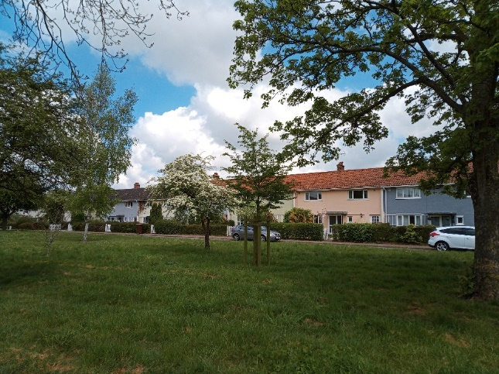 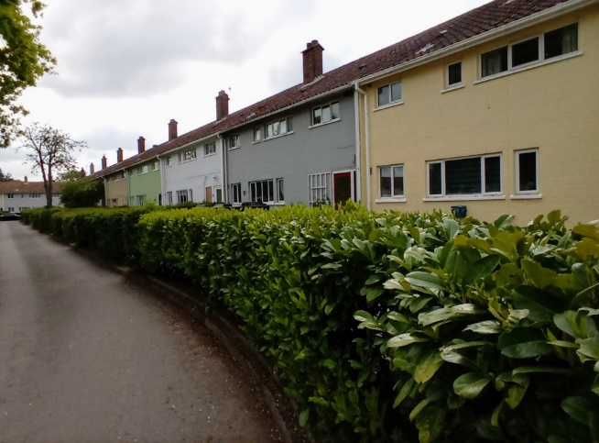

Windmill Green north-east side Windmill Green south-west side

**Windmill Green**

Starting at Windmill Green, which was the original development completed in 1948 and which originally opened out onto open countryside to the north-west.

The green itself as an area is an irregular rectangle with an informal loose arrangement of tree planting recently supplemented with additional tree planting. This area surrounded on three sides by the street, which is in turn fronted onto by the three rows of broad fronted terraces houses.

There is a continuous building line although the north side does step down in height to create three sections. The fenestration of the houses is not symmetrical, although the windows are more balanced and spaced on the north side in terms of alignment.

Houses have quite generous front gardens enclosed by hedgerows and picket style garden gates. In some cases the houses have lost the boundary definition, with in one case the garden becoming a parking area and the hedge being removed. Preserving front gardens, hedgerows and keeping parking to the street is encouraged especially as it provides a more efficient parking arrangement.

The houses are painted brick in a variety of pastel colours based on historic limewashes. This was a simple way to introduce traditional variety and interest when only common fletton bricks were available (a result of post-war brick shortages at the time.)

On the south and east sides of the development the original entrance to the properties was through an open sided undercroft passageway to a service area and then rear garden, and these have all now been infilled with doors. Large lounge windows were provided on the south-east sides to the rear.

On the north side the housing is slightly different with the main front entrance moved to the centre, and a separate door or provided to the rear to the side. The larger lounge window was on the front of the house to its south side. The original ‘Tradesmen and Callers’ sign has been preserved on some houses and is an interesting historic feature. There is also a distinction between the original front doors which are panelled with large plain windows, and the vertical close boarded with small windows doors for the entrance to the rear. This difference in design is important and should be preserved/retained with any replacement doors. The front door also has metal flat roof porch area, and there is a white trellis between the doors.

There is also a subtle difference in the position of the chimney stacks which have the characteristic angle top. On the south west side these sit forward of the ridge on the front roof slope, on the south east side they are on the ridge, whereas they behind the ridge on the north east side.

In the south-west and south-east corners are garages. It is unclear how much these are still used for car parking and most are likely used for storage. They are not very secure areas as they are not well overlooked. The original scheme planned for ranges of smaller storage sheds. Tin design erms the garages and the spaces with them are modern additions and of no interest, and in terms of retention do not make a positive contribution to the conservation area.

Other issues now present include the width of the streets. With modern day car parking along the restricted width of the road and with larger vehicles accessing the site the kerb has been damaged on the north street. This has happened to the extent that a new informal edge to the space has been created and some thought could be given to re-establishing the kerb line slightly set back at this point to where it has now been established by default, combined with protection for the existing green.

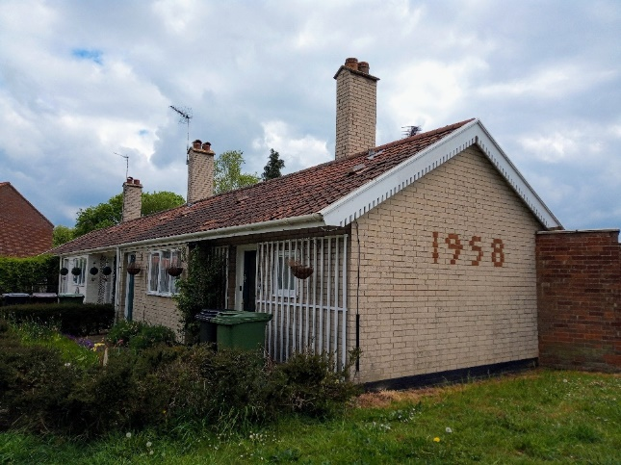 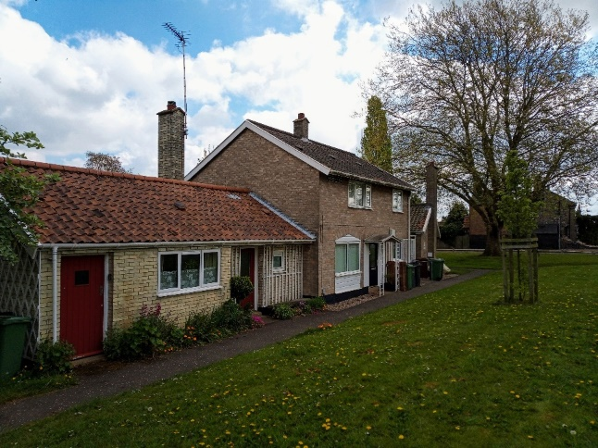

Nos 16, 17 & 18 Thwaite Road Warden’s House to right

**Thwaite Road**

Additional bungalows were built alongside Windmill Green to the west and east. To the north east nos 16, 17 & 18 were built in a later buff/gault brick with red pantile roof, prominent tall chimney stacks, and also have the trade mark white timber trellising to the front with 1958 set out in red brick in the gable end (the date of 1948 for Windmill Terrace in the adjoining red brick wall.) The space in front unfortunately now feels like left over space, especially as there are the remains of the stump of a large felled tree which has not been replaced.

On the original plans trees were planted here and it would be beneficial to plant a new tree – perhaps a smaller specimen such as hawthorn or cherry blossom for example. To the south west are the later nos. 14 & 16 which are designed without chimney stacks and have trellising continued to cover the entirety of the gable end, which was a later characteristic/feature.

**Scudamore Place**

Moving south further along Thwaite Road on the north west side is a development of bungalows known as Scudamore Place. These are set out in four long single storey back to back rows. The first two earlier rows dating from 1959 are back to back with the south west side are two storey wardens house and community room, with a later garage to the north east side. It is pleasing to the see the garages have a pantile roof, when many at the time would have just have been flat roofs. Chimney stacks remain a feature. Houses are predominantly buff bricks with some yellow and some coloured black for variation. The front gardens have low hedge boundaries or a low white wooden rail, and are generally well maintained and variety of colourful plants provides interest. Front elevations feature white trellising in different patterns.

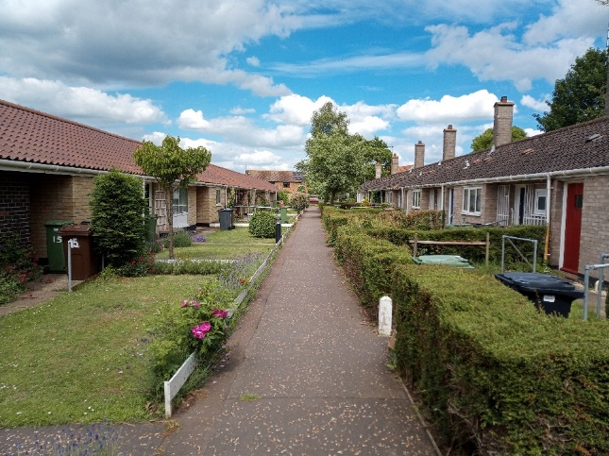 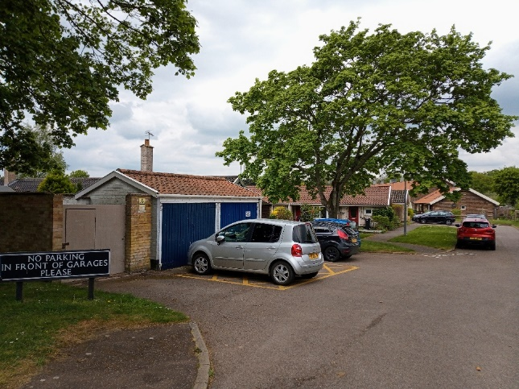

Attractive hedging and front gardens Garage with pantile roof

at Scudamore Place

Further northwest are two more rows dating from 1963, with private gardens enclosed by Cringle Crankle walls. The north east gable end have a chequerboard brickwork pattern of white/buff gault bricks and blacks bricks, whereas the south west is a just one brick. Although notable they do not have chimney stacks and this does have some impact on the rhythm with the terraces being very long

White trellising is a feature of both terraces. The north terrace unfortunately has replacement concrete tiles. If these were replaced with traditional clay tiles that would be beneficial.

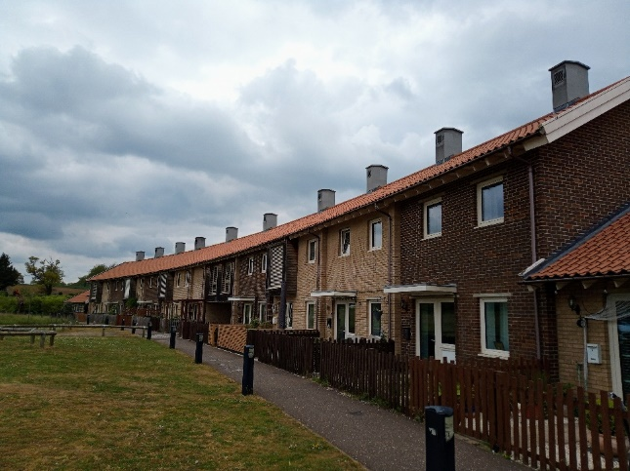 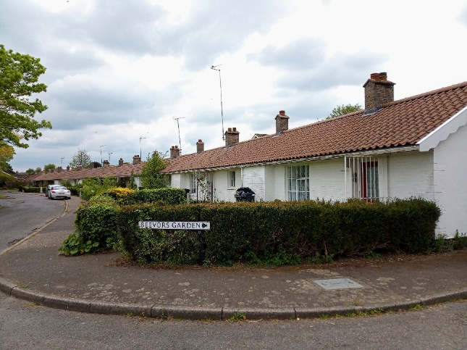

Lower Wells Close Agnes Hill Court

**Lower Wells Close**

To the north of Scudamore Place is recently built Lower Wells Close. This has been designed to reference some of the design characteristics of the earlier housing with a long curved continuous terrace partially enclosing the space to its south west. It is mainly two storey, with two single storey bungalows at the south end. Parking is provided relatively discreetly at the rear of the property with small garden areas. The materials of red brick, weatherboarding and pantiles assist in making the building relate to local distinctiveness. Chimney stacks/flues are placed to reinforce rhythm as created in the earlier terraces with the characteristic lower pitch orange pantile roof.

**Hollow Hill Road – Agnes Hill Court**

On the south west side of Hollow Hill Road is the Agnes Hill Court dating from 1951, and being one the earliest bungalow developments. It is set out in a slight curve. There is small garden at the rear with low fence to a path. The front has an overhang and a slight recess in the door area – with separation between properties provided by a white trellis. The roof is pantile with a strong rhythm of chimney stacks alternating from one pot to two pots, and with the characteristic sloping detail to the top. Bricks are mostly painted although there are some lighter red brick at the south end. The large window is more old fashioned looking than other housing being multi-paned with the opening casement within the window.

Materials & Architectural Details

|  |  |
| --- | --- |
| Part of the success of the design was the careful specification of materials to reflect the local vernacular character, especially at a time when materials were scarcer and housing design had become very generic. All the housing have their original clay pantiles unless replaced. Some replacements have been carried out with clay tiles, whereas other unfortunately with ‘heavier’ concrete tiles. All roof pitches are relatively shallow slopes. Chimney stacks where they exist on earlier properties are also very characteristic with a unique angled tile capping.  The earliest houses on Windmill Lane are characterised by painted bricks but this changed as a greater variety and better quality finish of bricks became available. Later bungalows have more traditional red (although a lighter red than the typical ‘Norfolk red’), buff gault bricks and quite darkly stained bricks. These combinations of bricks have also been used to great effect in diaper brickwork patterns to create interest.  Windows were originally timber or steel opening casements, however many of these have now been replaced by uPVC. The materials have been considered acceptable in the past as long as they replicate the existing window style which is not always the case. Many doors have also been replaced – sometime unsympathetically. It would be a beneficial enhancement to replicate the doors in terms of style, particularly replicating the difference in design between the glazed front doors and vertical boarded second doors, as shown to the right.  For secondary details the houses and bungalows have white timber trellises which is an important detail and used to encourage planting. These should be retained and kept white as an important feature. Also, simple metal porch detail for Windmill Crescent. Bargeboards, guttering and downpipes are also characteristically white rather than black.  Also noticeable is the absence of wires and aerials. The architects were keen to remove these visually as much as possible.  An interesting features of the terraces is the raised slab on bricks, or ‘bench’, to the side of the entrances for resting and putting deliveries on. | **Photo showing typical feature chimney stack**  Characteristic chimney stacks  Photo showing White trellis, original doors and Callers and Trades sign  Attached white trellises and original doors. “Callers + Trades” sign  **Photo showing patterned brickwork in gable ends and Crinkle-crankle walls**  Patterned brickwork in gable ends and  crinkle-crankle walls |

**Natural Character**

|  |  |
| --- | --- |
| Photo showing Windmill Green - a large green space with mature trees  The large open space of Windmill Green  Photo showing feature tree on the corner of Hollow Hill Road and Thwaite Road  Feature tree on the corner of Hollow Hill Road and Thwaite Road  Photo showing front gardens of Scudamore Place fronting onto Thwaite Road  Importance of front and rear gardens (Scudamore Place fronting Thwaite Road) | A strong element of the planning was setting out the terraces with generous shared open spaces to the front. These spaces, having been set out over 70 years ago, now have matured examples of trees and there are some outstanding examples. Some of these trees pre-date the development and were thoughtfully integrated into the development rather than being felled. A particular feature tree is the plane tree on the corner of Hollow Hill Road and Thwaite Road.  Gardens are also a particular characteristic feature of the area and are generally well maintained and looked after, adding a lot of vibrancy and colour to the area. Windmill Green also has very long private rear gardens designed for a time when many residents ‘grew their own’, whereas the bungalows have much smaller more easily managed gardens. Front gardens are enclosed by short hedgerows except in some cases where the boundary treatment has been removed, in one case for parking, and this can be considered detrimental to the character of the area.  There are some areas to the front and sides of development which are lawned and have trees. The trees are a mix and can be ornamental cherry blossoms. To the south side of Thwaite Road a tree that pre-dated the development has been felled but unfortunately not replaced – a smaller tree may be suitable here as at present it appears as an empty space. |

Street Furniture, Walls and Railings

|  |  |
| --- | --- |
| **Photo showing Bus Shelter commemorating 2000 to the right and K6 telephone box to the left**  K6 telephone box and bus shelter  Dating from 2000  Photo showing the village sign  Village sign on Agnes  Hood Green | Around Windmill Green to the south are short white painted concrete posts and metal rails to prevent car parking. These should be retained and maintained as an original feature.  Elsewhere front boundaries are characterised by front hedges or picket fences. Close boarded fences should be avoided.  There are also interesting surviving plaques – the original green and black street signs on Windmill Green. Several properties on Windmill Green and Agnes Green retain their “tradesmen entrance” signs.  Unfortunately, there are also various ‘no ball games’ signs which are quite large and prominent and detract from the conservation area. Bins are also a problem and some coordination in where to put bins would be welcome.  A new bus shelter was built on Hollow Hill Road for the 2000 jubilee. This was designed in a style similar to the Tayler and Green houses, with white timber and a red pantile roof and includes a decorative bargeboard. Next to shelter to the left if K6 Gilbert Scott telephone box, and to the right the village sign. |
|  |  |

Conservation Management Guidelines

**Highways**

|  |  |
| --- | --- |
| Photo showing damaged kerb and grass on north side of Windmill Green | Verges on Mill Road and Windmill Green have been eroded and scarred. It is recognised that refuse trucks and delivery vehicles are larger, as well as cars in general.  **Consideration should be given to moving the kerb line of Windmill Green space with a strong kerb edge to prevent vehicle damage or laying down matting such as grasscrete which will help protect grass growth from vehicles.** |

**Upgrading Windows and Doors**

|  |  |
| --- | --- |
| Photo showing Windows to the left do not have vertical glazing bars/divisions | In some cases windows and doors have been replaced with uPVC and/or different styles.  **If door or window frames need to be replaced they should be replaced with the original style of window. The opportunity should be taken to reinstate traditional style windows where they have been unsympathetically replaced in the past. If the windows are in a different material such as uPVC the existing style should be matched as closely as possible whilst being designed to be energy efficient such as double glazing.** |

**Fencing and walls**

|  |  |
| --- | --- |
| Photo showing parking space upsetting views and continuity of hedgerow | It is important to retain boundary treatments where they exist as they help to delineate between public and private areas as well as providing a sense of enclosure and definition to the street/pavement. It is recognised that there may be some demand for on plot parking so cars can be electrically charged.  **Boundary treatments require careful consideration to ensure the preservation of existing character. If creating an access for on plot parking this should only be allowed if a significant section of hedgerow is retained to preserve the streetscene and a boundary for the garden.** |

|  |  |
| --- | --- |
| **Preserving white trellising**  Photo showing white trellising | The white trellis is an important original architectural feature and should be preserved.  **In some areas the trellising has been removed, and it would be an enhancement to reinstate it. Putting up different colour trellis in the same areas should be avoided.** |

**Painting/colour washing buildings**

|  |  |
| --- | --- |
| Photo showing colourful pastel painted houses on south side of Windmill Green  **Redevelopment of Garage Areas**  Photo showing corner garages  **Maintenance of railings**  Photo showing damaged knee rail | There are a variety of traditional colours, generally muted pastels to match historic limewash. This was a conscious design consideration to make the housing more locally distinctive.  **Colours should be well chosen to match existing palette of pastel colours based on historic limewashes.**  The garage areas are quite untidy.  **Areas could be better landscaped and surfaced to encourage use. There is a possibility, subject to consultation, to repurpose this area to create an off street area for electric charging points.**  The railings are an original feature of the development and characteristic of the post-war period. In some places they have been damaged and not repaired.  **Concrete posts and railings should be repaired in a timely manner when damaged. This will be investigated with the land owners.** |

Appendix 1 (i)

**Listed Buildings**

Hollow Hill Road 25-39

Scudamore Place 1-28 (including attached screen walls and garages)

Thwaite Road 12 and 14, 16-20

Windmill Green 1-9, 10-17 and 18-30

These properties are also subject to an Article 4 Direction which requires planning permission for: alterations and extensions to dwellings; Provision of hard surfaces and gates, fences, walls and other means of enclosure to visible elevations; The painting of the exterior of any building. See the Council website for further details.

Appendix 1 (ii)

**Unlisted Buildings/Structures of townscape significance**

Hollow Hill Road K6 telephone box, Bus Shelter, Village Sign

Appendix 2

**Policy background**

In recent years, the approach to conservation area designation has changed considerably. It is now recognised that development plan policies, development control decisions, and proposals for the preservation or enhancement and the management of conservation areas, can best be achieved when there is a sound understanding of the special interest of the conservation area.

This position is reinforced as follows:

The Planning (Listed Buildings and Conservation Areas) Act 1990 in section 66(1) makes it a duty of local authorities when considering applications to have special regard to the desirability of preserving a listed building or its setting or any features of special architectural or historic interest.

Under section 72 of the same Act, it is a duty with respect to any buildings or land in a conservation area, to pay special attention to the desirability of preserving or enhancing the character or appearance of that area.

Department for Communities and Local Government. National Planning Policy Framework (NPPF) section “Conserving and enhancing the historic environment”.

Joint Core Strategy- Policy 2: Promoting Good design South Norfolk Local Plan

The South Norfolk Local Plan Development Management Policies Document was adopted in 2015 and policy 4.10 covers Heritage Assets.

**Public Consultation**

.

An informal ‘walkabout’ of the area was organised with the Parish Council on 10th February 2022. This informed the proposed boundary changes and the conservation management guidelines within the draft appraisal. The public consultation on the draft appraisal took place from 1st July until 31th July 2022, with attendance at the parish meeting on 18th July and a pre-council exhibition at which a council officer answered questions. The appraisal was advertised:

• An advert in village noticeboard and local publicity by the parish council

• The draft appraisal being available to view on the council’s website.

• Emailing Ward Councillors, County Councillors, and the Parish Council.

As a result of the consultation some corrections were made to the appraisal and additions to the conservation management guidelines section.

Appendix 3

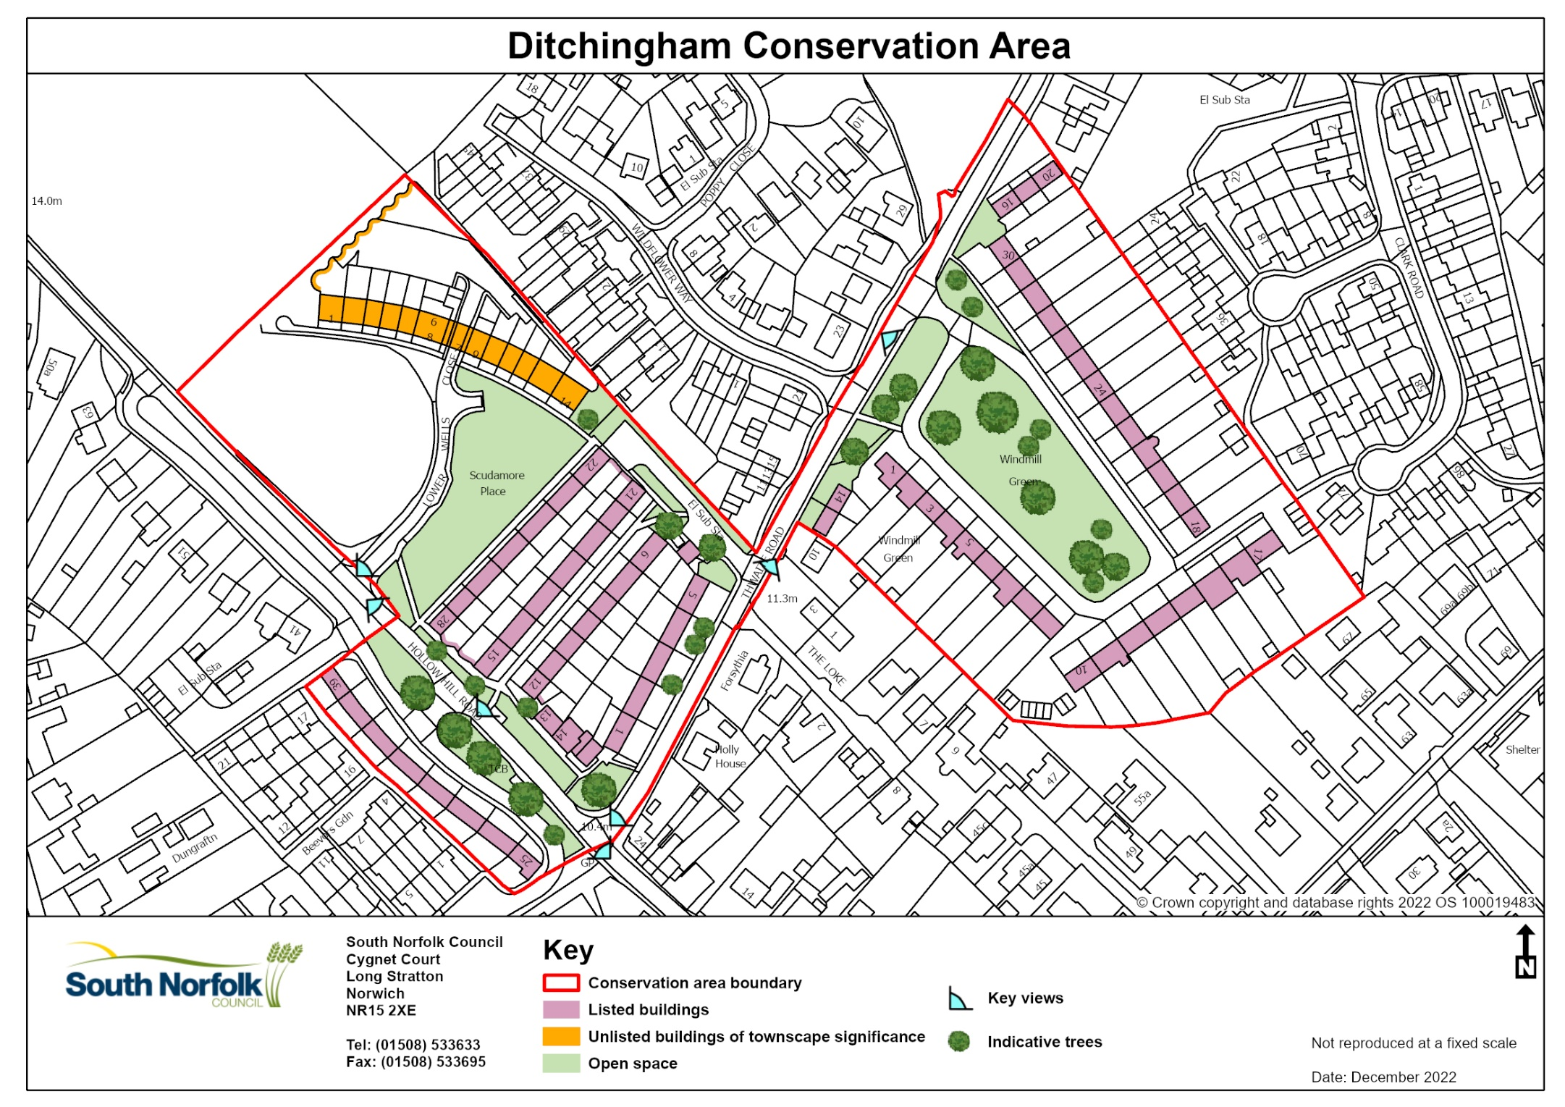

Appendix 4

**Further Reading**

Tayler and Green Architects 1938-1973 “The Spirit of Place in Modern Housing” (1998) Harwood and Powers

Internet pages: https://www.ruralise.co.uk/tayler-green/

RIBA Journal LIV October 1947 pp607-9

Ideal Home LXXXVII June 1963 pp 66-69

Architects’ Journal 16 September 1964 p625

Official Architecture & Planning XXVII No10 October 1964 p1178

Design in Town and Village, London HMSO, 1953, -15

South Norfolk Place Making Guide (2012) Appendix A Case Study 2 p4-7

Housing Design Awards 2009 Historic Winner