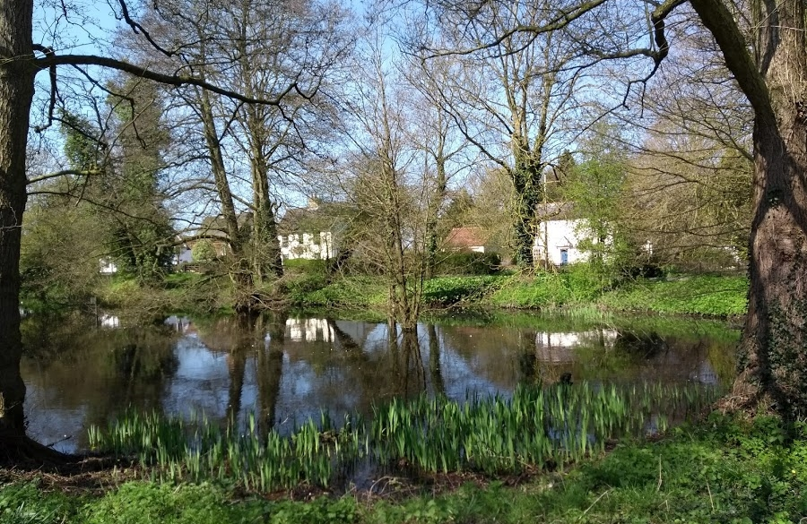
Brooke and Kirstead
Conservation Area Character Appraisal
and Management Guidelines

Draft January 2025
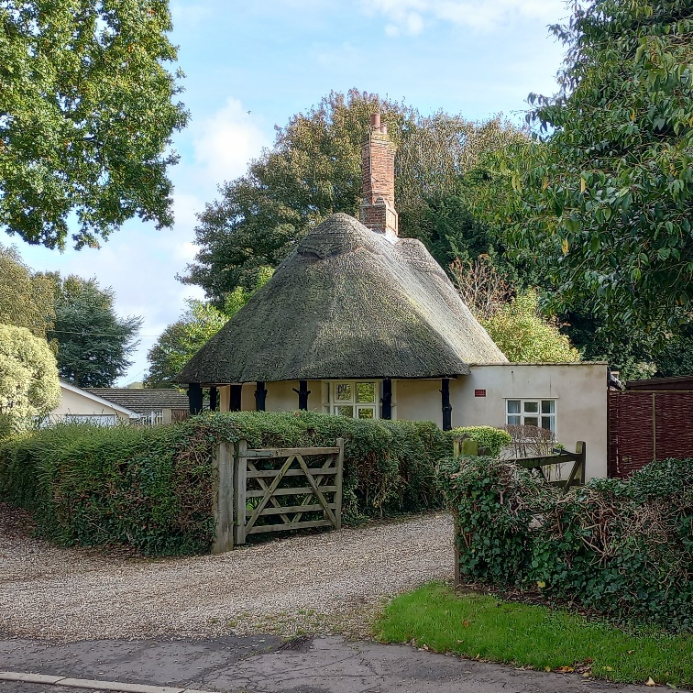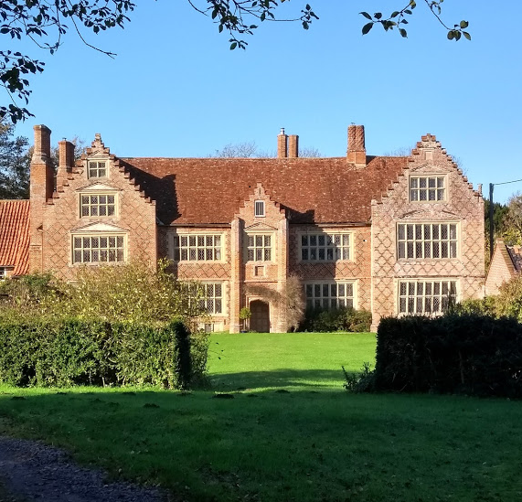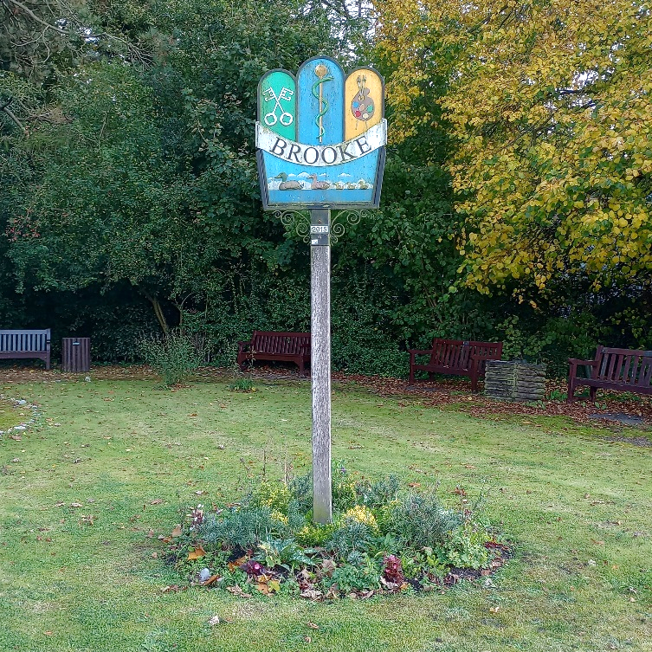


Content

Introduction 3

Historical Development 4

Character Assessment 5

Conservation Management Guidelines 16

Appendix 1(i) Listed Buildings 17
Appendix 1(ii) Unlisted Buildings of 17
townscape and local significance

Appendix 2 Policy Background & 18
Public Consultation

Appendix 3 Map showing proposed boundary 19
changes

Appendix 4 1904-1914 historic map with 20
proposed new boundary

Introduction
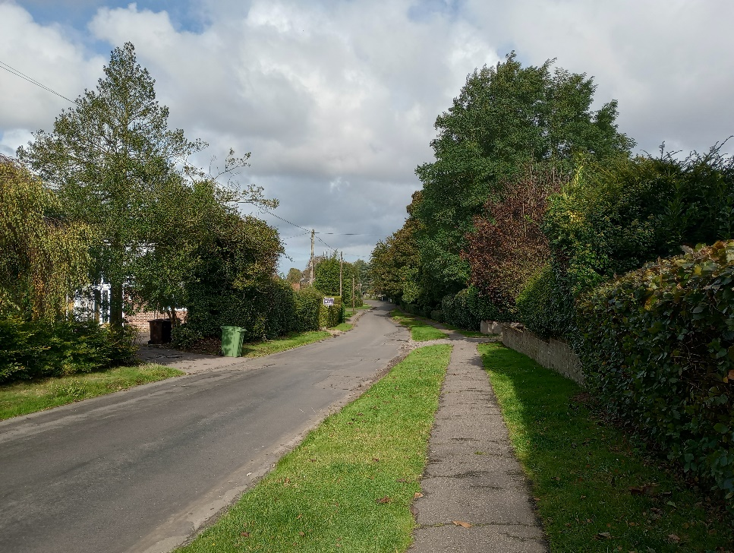  Rural streets (High Green) | Brooke is a small rural village situated on the Norwich to Bungay Road (B1332), 7 miles south of Norwich and 5 miles west of Loddon.  The conservation area covers an area which varies in character with four character areas identified: The linear south-west to north-east settlement area of the historic village; the former landscaped estate grounds to Brooke Hall and Brooke House to the south-east; the modern post-war Swedish houses and Tayler and Green properties to the north-east of the settlement, and the historic development around Kirstead Hall to the south-east.
Under the terms of Planning (Listed Buildings and Conservation Areas) Act 1990, the Local Planning Authority is required to identify areas of special architectural or historic interest whose character or appearance it is desirable to preserve or enhance, and to designate them as a Conservation Area. When considering the designation of conservation areas, local planning authorities should ensure that an area justifies such status because of its special architectural or historic interest, and that the concept of conservation is not devalued through the designation of areas that lack special interest. The 1990 Act also requires local authorities to prepare management guidance and proposals for Conservation Areas. The Brooke Conservation Area was originally designated in 1975 and revised to include Kirstead in 1994. T
This appraisal recommends futher amendments as outlined in the map at Appendix 3 on page 19. It is proposed to remove some areas of more recent development from the current area, which can be considered ‘neutral’ in terms of contributing to the character and appearance of the conservation area. It is also proposed to add the historic parkland area of the former Brooke Hall to the south east due to its recognised historic significance and contribution to the character of the village, as well as a small realignment of the boundary to the south on Church Road to tie in with property curtilages. This document should be read in conjunction with the adopted Local Plan, the National Planning Policy Framework and Planning Practice Guidance

Key Characteristics
- Small rural village
- Historic linear south-west to north-east settlement along High Green and The Street
- Historic village meres along The Street
- Architecturally outstanding grouping of Kirstead Hall and Church.
- Former estate parkland of Brooke House and Brooke Hall providing the setting to the village to the south-east.
- Post-war Swedish style prefabs and Tayler and Green houses.

Historical Development
Brooke simply means in ‘old English’ a ‘brook’ and the meres at the centre of the village are very significant in defining the overall character of the settlement, making it a unique village within the district. Although there have been some Roman finds, there is no evidence of an established Roman Settlement, although there is a Roman Road that ran through the west side of the village (NHER no:2298). The oldest building in the village is the church with its characteristic early flint round tower, typical of 12th century church design in Norfolk.
Adjacent to the north of the church was the original Manor House, historically the birthplace of the famous early 19th century royal surgeon Sir Astley Paston Cooper. All that remains is the dovecote and part of the former garden walls, some of which have been incorporated into the front walls of later houses.
The two village meres are within the original area of common land for grazing that extended from Welbeck to High Green and that can be clearly seen on Faden’s Map of Norfolk 1797. During the 19th century the character of the settlement changed with the Brooke Enclosure Act of 1801. This enclosed part of the common and led to the village becoming more estate based with major landowners and their tenants. In a return to the village in 1836 Astley Cooper refers to the meres seeming smaller, many cottages being removed and other cottages enclosed in gardens. The changes resulted in many large front gardens with hedgerows and railings that is now an important part of the village’s rural character.
The old Manor House was owned by the Holmes family and they were responsible for its demolition and the construction of a new house, the stylish Brooke Hall, designed by the nationally renowned Norwich based architect William Wilkins Junior. This house was constructed further into the countryside to the south-east in c1830 but was subsequently demolished in 1949 after being used by the army during WWII. The parkland has now reverted back to agriculture however the tree belt plantations and the lake remain as identifiable landscape features from the original Repton style landscape. The coach house also remains and has been converted into a house and the two driveway entrance lodges with thatched roofs can still be seen along The Street (see later.)
Further to the west near to Norwich Road the Norwich merchant Sir Roger Kerrison built Brooke House in 1780. Kerrison later became a significant land owner in the village in the early 19th century and was responsible for turning areas of common land into private landscape area and demolishing cottages. Despite this he passed away with significant debts in 1808 and his heir was forced to sell to Thomas Kett. Following the purchase of Brooke House by the confectionary factory owner Eric Macintosh in the 1930s the house was demolished and replaced with a more fashionable vernacular inspired house in 1935, which is now the Brooke Nursing Home. There are various buildings in the village which are historically associated with the estates.

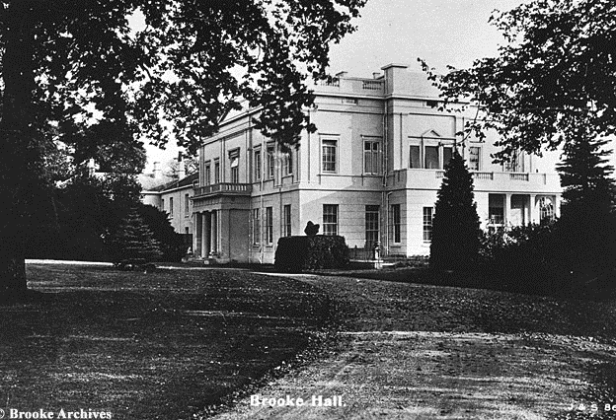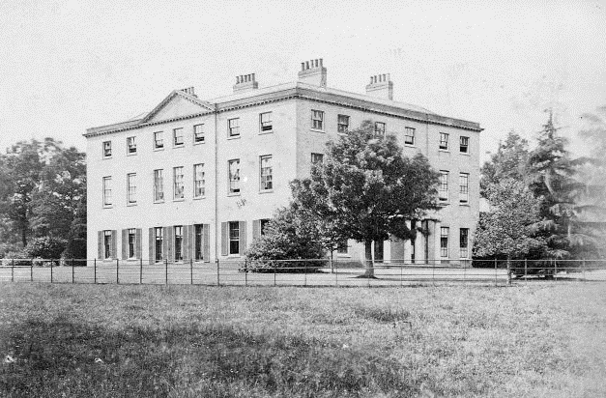
Former Brooke Hall (now demolished) The original 18th century Brooke House
In 1881 the Kelly’s directory describes Brooke as a ‘pleasant village 7 miles north from Flordon station, 7 miles south from Norwich and 7 miles north from Bungay.” Brooke Hall was described as a “large mansion, in the Grecian style…pleasantly situated in the midst of a beautiful park, thickly studded with oak and other trees, and contains a fine piece of water.’ Brooke House was described as a plain square brick building in a large well wooded park. Occupations in the parish included wheelwrights, a thatcher, tailor, tinman, harness makers, shoe maker, blacksmiths, vet, cattle dealers, fruit dealers, farmers, carpenters, butchers, and bricklayers (builders).
The post-war era saw more modern houses built to the north-east of the village which now can be considered to be or architectural and historic interest. The ‘scandanavian’ weatherboarded houses along St Peters Road were built soon after the war and were the gift of the Swedish government. Brooke has the largest surviving number of these houses in the country. The postwar houses in Churchill Place and Entrance Lane were designed by the Lowestoft architects Tayler and Green as part of their programme of designing and building over 700 houses for Loddon Rural District Council from the 1940s to the 1970s. Their houses received various national awards including Festival of Britain, Civic Trust and Ministry of Housing awards.
The separate historic hamlet of Kirstead is a group of buildings associated with Kirstead Hall, a grade I listed Elizabethan ‘E shaped’ Hall of 1614, but also possibly containing historic fabric from an earlier house. It is one of the finest historic vernacular houses in South Norfolk, and various outbuildings including an octagonal dovecote (rebuilt in the 18th century), barns and stables with stepped gables are also listed. During the 19th century the house was part of the Brooke House estate. St Margaret’s Church, which dates from c.1200, is close by, but was significantly rebuilt in the 19th century when a large Victorian Rectory was also constructed to the south.
To the south-west of Kirstead Hall, on the periphery of the former Brooke House parkland and close to Kirstead House, the first edition OS Map from the 1880s shows the possible location of a third church, St Stephens (NH, associated with a now ‘deserted’ settlement called Langhall. The parish was once referred to as Kirstead-with-Langhall.

Character Assessment
Brooke and its setting
The conservation area lies within a relatively flat plateau with the shallow valley of the Wellbeck, a tributary to the Chet, to the north-east. Consequently, there are views towards the settlement from the surrounding fields, however, with much of the housing being interspersed with verdant landscaping and tree belts around the settlement, views of buildings within the settlement from the open countryside are limited. The exception is the Tayler and Green development to the north-east where the lack of a field boundary hedge on Entrance Lane allows for sweeping views across farmland and views back towards the houses. The village however maintains a rural backdrop of agticultural fields, with the boundary backing onto open countryside all along the south side of the village, and an important landscape gap to the the north of the Meres at the rear of several historic and listed buildings.
The main approaches to the village are from the north and south and are different in character – the north passing by modern housing prior to reaching an old stables and the Kings Head public house. To the south the approach is more characterised with landscaping, with the road tree lined and scattered buildings set back and more dispersed. The approaches from the north-east and south-west are more abrupt changes, to the north-east the approach is defined by climbing up from the shallow Wellbeck valley to the east and reaching the North Lodge, whereas the southwest approach is a transition from flat farmland to trees and housing. The approach along Hunstead Lane feels more like a ‘back entrance’ into the village’s central area of the meres through landscaping between Kirstead Hall and Brooke House parkland – with the Hunstead Lane belt of former parkland plantation planting to Brooke Hall on the west side. The north approach to the north east corner along Entrance Lane is dominated by the modern Tayler and Green housing estate and more open views of farmland to the north with mature field trees scattered along the edge of Entrance Lane.

Conservation Area Boundary (including proposed changes)
The conservation area boundary is proposed to be slightly amended to take out modern properties to the south-west off High Green, and to the north of the Kings Head and the converted barns – 1 to 3 Edward Seago Place, which remain included.
It is also proposed to extend the boundary to include the former parkland to Brooke Hall as an important area of designed landscaping complimenting the landscaping of Brooke House that is already in the conservation area. This provides a strong designed rural setting to the south east of the village and a landscape gap between Brooke and Kirstead, which is also important for the setting of the grade I listed hall. Some minor boundary changes are proposed to dwellings along Kirstead Lane to fit in with present day property curtilages.

Street Patterns and Historic grain
Historically Brooke followed a mainly linear settlement pattern from the south-west to the north-east with some clustering close to the church. Cottages are grouped around the former linear common area, and following the 19th century reorganisation through enclosures, garden boundaries were brought forward resulting in generous front gardens that are a distinctive feature of the conservation area. The village continues to have picturesque and verdant streets. The exception are parts of the central area along Norwich Road which lacks trees and landscaping, partly due to widening of the Norwich Road and loss of front gardens. This could be improved and enhanced so that the main road is less dominant.
To the south Kirstead forms a distinctly detached historic grouping of properties largely unaffected by modern development. The separation between the Hall and Brooke, together with the open fields and tree belt planting of the former estates, help to maintain and preserve the separation between the two settlements

Perambulation

The Street
Starting at the north-east end of the village, North Lodge (one of the two former lodge to Brooke Hall) is an architecturally notable local landmark. The lodge is now in effect the gateway building to the village, although the former function of the building means that it does not front toward The Street, but towards where the former drive to the hall once ran to the side. This passed between the two gate piers that still remain in place. The stye of the the building is typical Victorian ‘Tudorbethan’ in red brick with mock timber framing and render applied to the projecting west gable, as well as a thatched roof. The tall octagonal stacks and a section of fleur-de-lis railings to the front are also of note.
The north side of the road is characterised by hedgerows and verdant landscaping, with the red K6 telephone box being a prominent feature in the streetscene. The soft landscaping to the north side strongly contrasts with the high red brick former garden wall of the demolished Manor House on the south side. The listed dovecote is set further back within Dovecote Close and only glimpsed from The Street. Parts of the former garden wall of the manor house remain incorporated into houses within Old Hall Gardens, although some parts have been replaced. On the north side most housing is modern and brick, fronting towards the street, with Church Apiary (111) dating from the early 19th century, set back and at 90 degrees to the street, with the blank red brick gable being quite prominent.

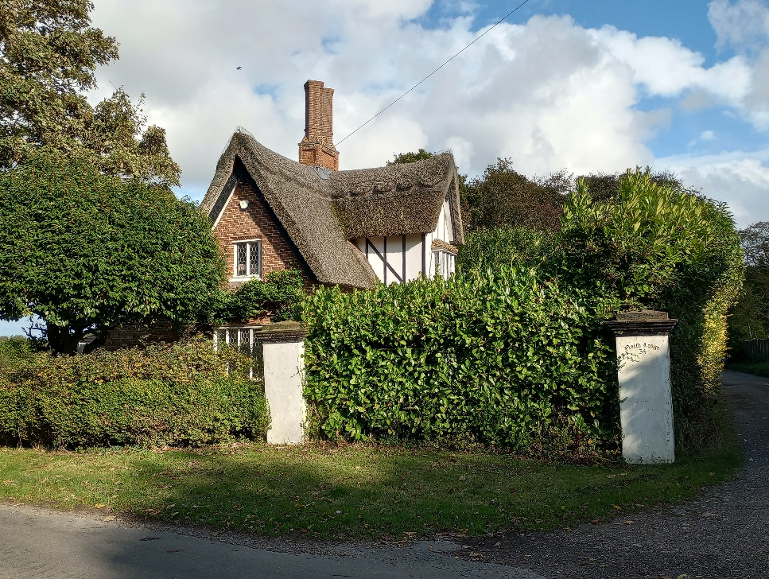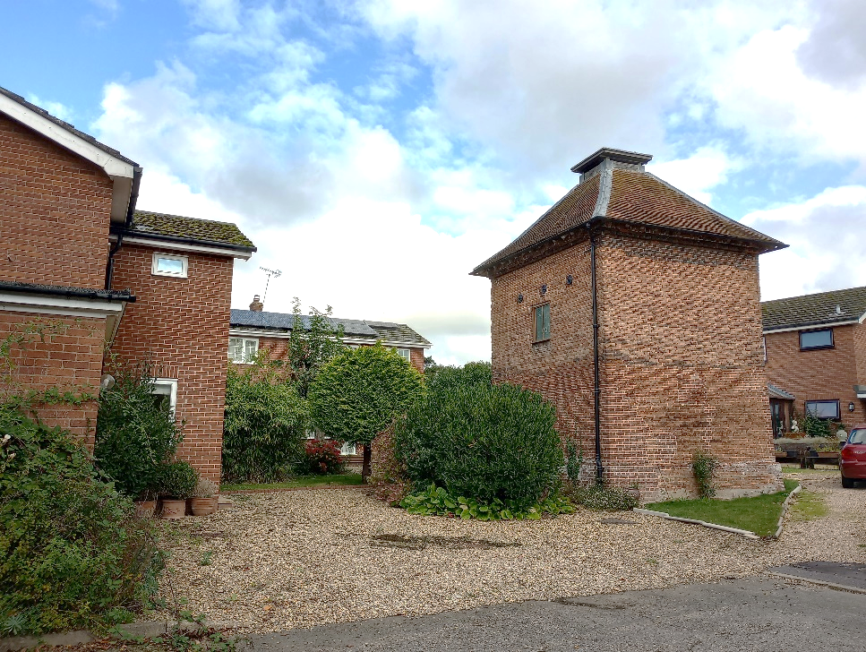
North Lodge with gate piers to the former The listed dovecote that now lies
driveway that led to Brooke Hall. within a modern housing estate
On the north-east corner of the churchyard, following the modern estate, is an interesting small building. The front wall has been rebuilt and has a brick with ‘J.P. Dodds 1939-80 stamped on it. The churchyard is enclosed with 19th century railings to the north and a red brick wall to the west. Of note is the small gothic gated entrance through the brick church wall to the old Vicarage.
St Peters Church is by far the oldest building in the village and is grade II* listed. Although architecturally quite plain with a simple 12th century round tower, the tower has been capped with late medieval decorative flint flushwork (decorated stone and flint). The west porch is also simple and undecorated, but hides within it a much finer 12th century surround to the door with two carved faces and a medieval oak door. The relatively new but sensitively designed extension, also constructed in flint, is glimpsed through the landscaping to the north. The gleaming white stone of the grade II listed war memorial cross stands out in the churchyard next to the church path.
Across from the churchyard to the south is the original 17th century vicarage, just visible above the red brick cemetery wall. The old vicarage is orientated towards the church rather than the street and is now largely obscured by the verdant landscaping and the church wall from street views. The modern red brick vicarage can be found on the opposite side of the street also facing the churchyard.
The east side is then similarly characterised by dense and verdant landscaping with modern houses set back and in the summer months the houses are largely hidden from view within generously landscaped and verdant gardens.
The next building of note is the small round thatched cottage ornee house, 34 The Street (also a former lodge to Brooke Hall) followed by Porch House, a grade II* listed building dating from the 17th century. Porch House is one of the most characterful houses in the village with its red brick moulded details and was reputedly the former dower house to the demolished Manor House. Pevsner describes the house as “extraordinarily ornate for its size.” The house now has a red pantile roof, but had a thatched roof up until the 1970s.
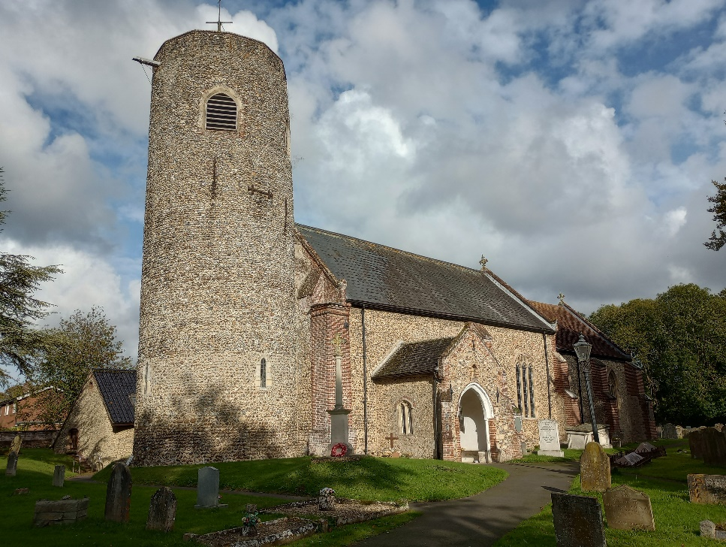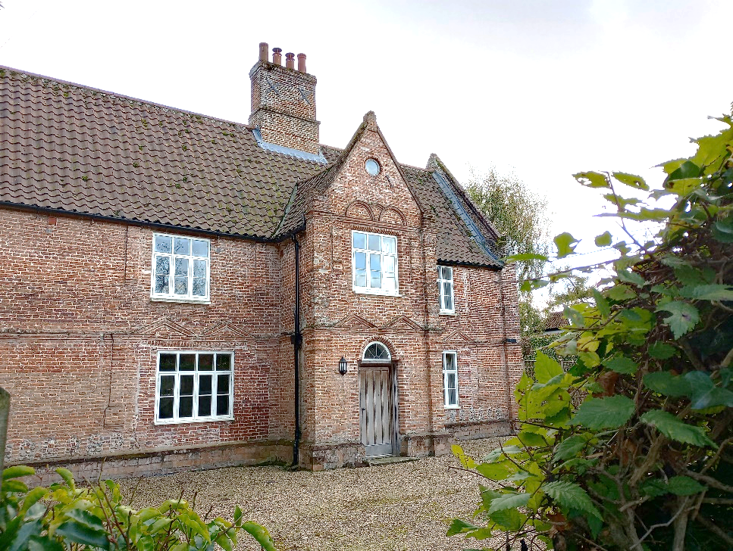
St Peter’s Church Porch House
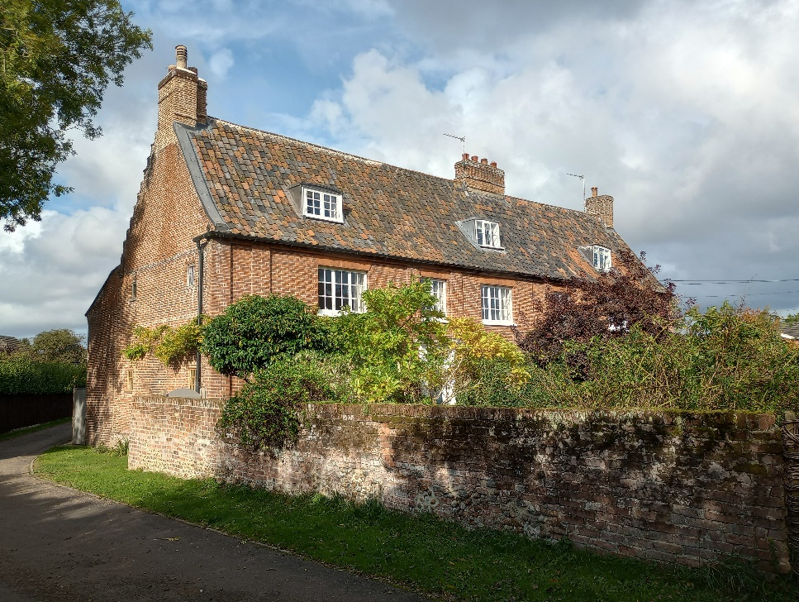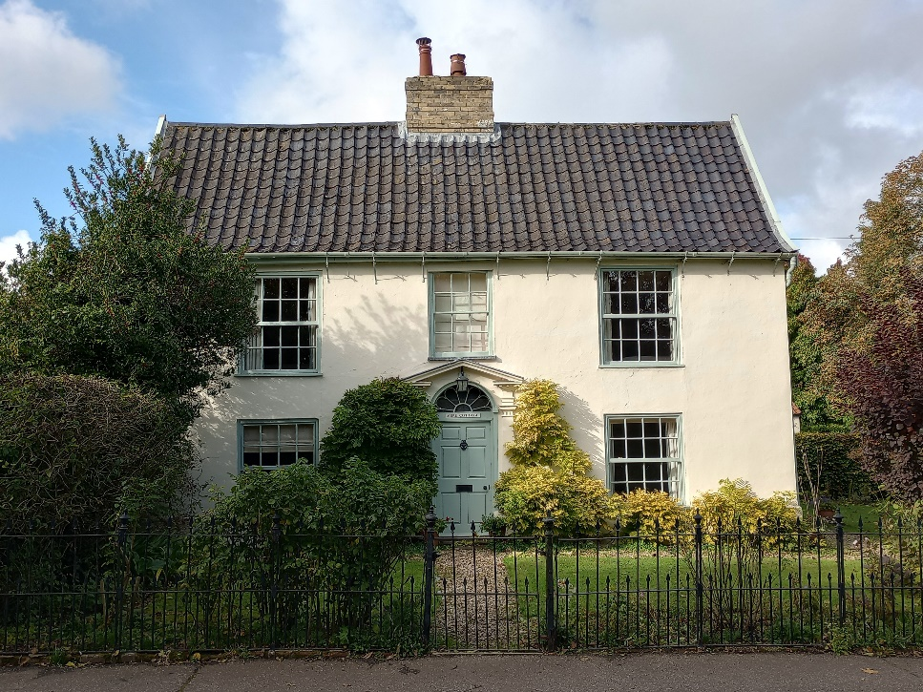
79-83 (odd) The Street Mere Cottage On
To the north side of The Street, following a number of modern bungalows and houses with frontage hedgerows, is situated Nos 79-83 (odd). This is a large 17th century timber framed property, which was later subdivided into three houses during mid-late 18th century (The brick range to the rear is dated BW 1781) and re-fronted in red brick. Of note at the rear is the crow stepped gable to the west side. The far east side section was formerly the village reading room.
There are then a number of modest 18th and early 19th century cottages which are either rendered or with white washed brickwork and casement windows, providing an attractive village grouping of cottages set back behind front gardens with established hedgerows. No 73 stands out as being a little unusual, being detached with a shallow hipped roof and front railings and nos 65/67 remain red brick. There are then a handful of modern 1970s chalet bungalows which are quite different in character but through being modest in size do not jar with the older houses. Here the The Street forks to go around either side of the Meres.
The majority of historic buildings (nearly all listed) are however on the north side of the Meres and there are three detached houses of some note. The first house, Mere House, is set back quite far from the street and originally dates from the 17th century but has later alterations. The house is rendered and quite plain, but of interest is the large group of five clustered octagonal central stacks and the rusticated pilasters on the front either side the entrance. No 55 is closer to the street and dates from the early 19th with its characteristic shallow slate roof - a typical feature of that period. The door has an unusually large pediment. Closer to the street again is the elegantly proportioned Mere Cottage, which originally dates from 17th century with a timber framed interior, but was remodelled in the 18th century with sash windows and central split porticoed doorcase. Also, some fine wrought iron spearhead railings to the front with intermittent urn post tops.
There is then a very small single storied rendered cottage squeezed into the gap before reaching the White Lion Inn public house. Likely to be 17th or early 18th century with a steep thatched roof, the building was re-faced in red brick on the south and west sides in 18th or early 19th century and now also has more modern windows. A house is then orientated at right angles to the street with access tracks to outbuildings at the rear and then a pair of simple cottages – again notable for their early 19th century shallow pitched slate roofs.
The next house, the Laurels, is white painted brick and quite plain in its overall appearance, but has a good doorcase and decorative 19th century bargeboards for each gable. There are further houses to the rear along the track (which is a footpath) including an earlier thatched cottage and barn. The variation of roof forms, eaves and ridge heights all provide interest in glimpsed views from The Street.
This part of the village is notable for the tracks which lead through to paddocks at the rear to the north and south of the village, with the historic buildings backing immediately onto open countryside. This connection to open countryside is particularly appreciated and experienced when passing along the footpath (FP3) to the side of the Laurels, which eventually takes you all the way to Aplington.

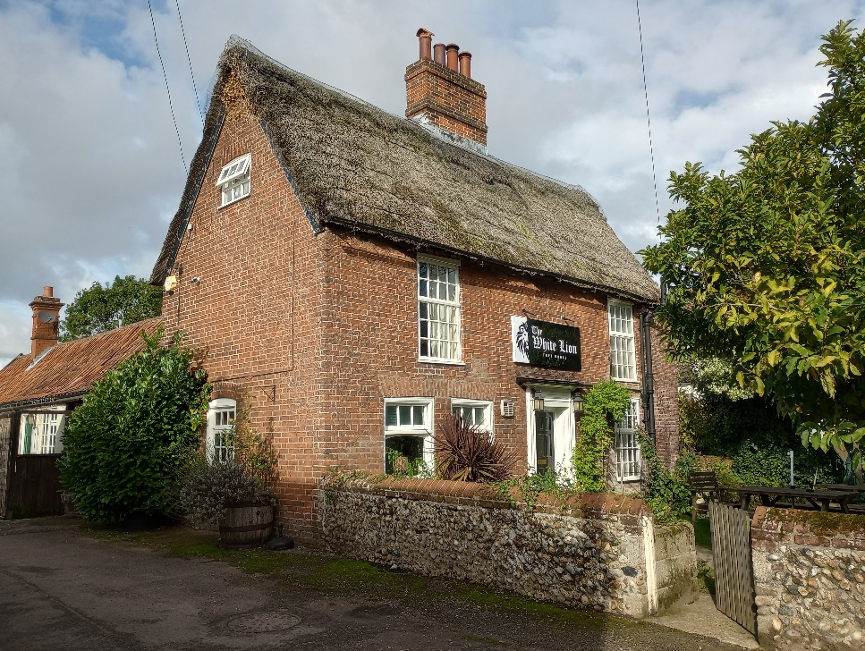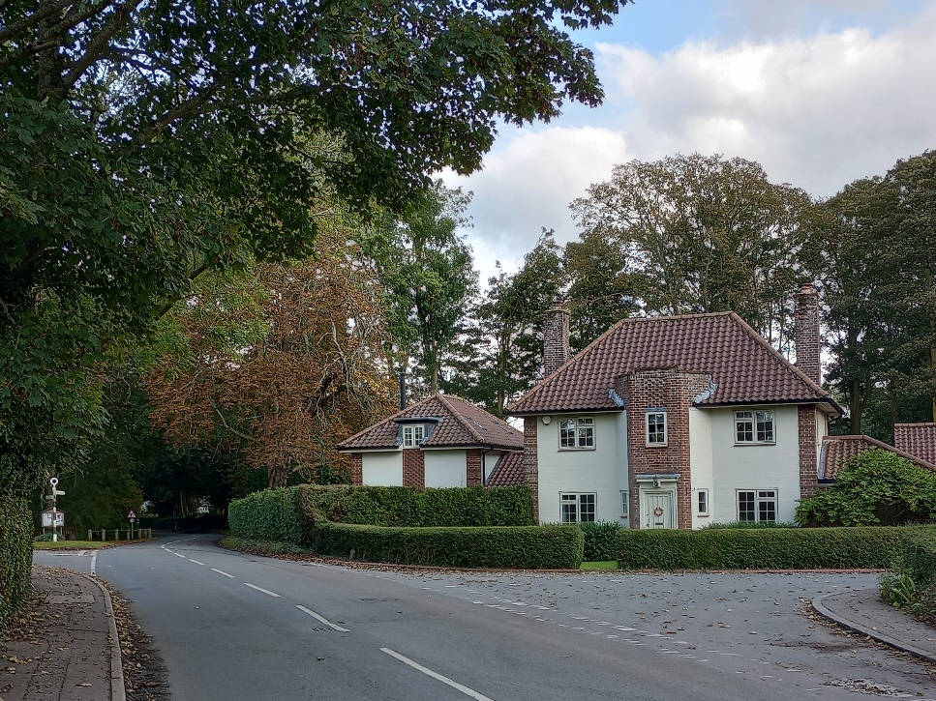
The White Lion Pub One of two lodges to Brooke House
Nos 31 The Street is a small cottage and 29 The Street is a rendered 19th century house with casement windows, two storeys with two ground floor bay windows and end stacks and black pantiles. Its best feature is the central porticoed doorcase. Nos 23-28 The Street (odd) is a terrace of three dwellings dating from the 17th century, but remodelled as a terrace in the late 18th century in red brick. The long horizontal form of the terrace of ‘rich’ red brick provides a striking contrast with the properties either side. Nos 19 and 21 The Street is a mid 18th century property extended to the left side to make 2 cottages in the early 19th century, although now once again one dwelling. Of note is the thatched roof and eyebrow dormer windows. Except for Nos 15 & 17, the following properties are mostly modern and are set far back from the street with extensive front gardens and hedgerows apart from the converteted red brick stables to the Hall “Old Hall Stables” and some interesting iron gates to No1 “The Old Hall” itself which cannot be seen from the street but has an altered 18/19th century appearance.
Returning to the east and just before taking the south fork of The Street, the next couple of small cottages are: a simple white painted cottage with low eaves, Nos 30 The Street with low eaves, dormers and black/smut pantiles, and Nos 26/28 – a semi with a very prominent thatched roof. There are then two rendered houses orientated at 90 degrees with their gables fronting close to the street, whitewashed brick and centralised windows, followed by more modern houses. The Street passes by Mereside, a small 1970s housing estate designed by Michael Innes of Norwich architects Lambert Scott and Innes, a contemporary take on the rural vernacular form with contemporary windows and ‘open’ front gardens. It has retained much of its character and is an attractively laid out cul-de-sac of the period with attention given to landscaping and spacing of the buildings to fit in with the village’s rural character. The corner property to Hunstead Lane is historic, rendered and thatched, with a rendered terrace group adjacent to the road.
The opposite corner of Hunstead Lane is well landscaped with the extensive wooded grounds of 8 The Street which is set back and virtually hidden in street views, particularly in summer months. There is also a 1950s county council signpost (another signpost is at the west end of the Mere where north and south parts of The Street reconnect.) There are twin gateway lodges that mark the approach to Brooke House. These are designed in the interwar neo-vernacular style in a similar manner to Brooke House, which is further along the driveway. There is an unusual low interwar column which may have had direction place names on it? And an attached light. The 19th century stables to the original 18th century house have been converted and survive to the east. The rest of The Street on this side of the road is very verdant and heavily wooded, before reaching the small village green on the corner of Norwich Road, where the village sign is located.
.
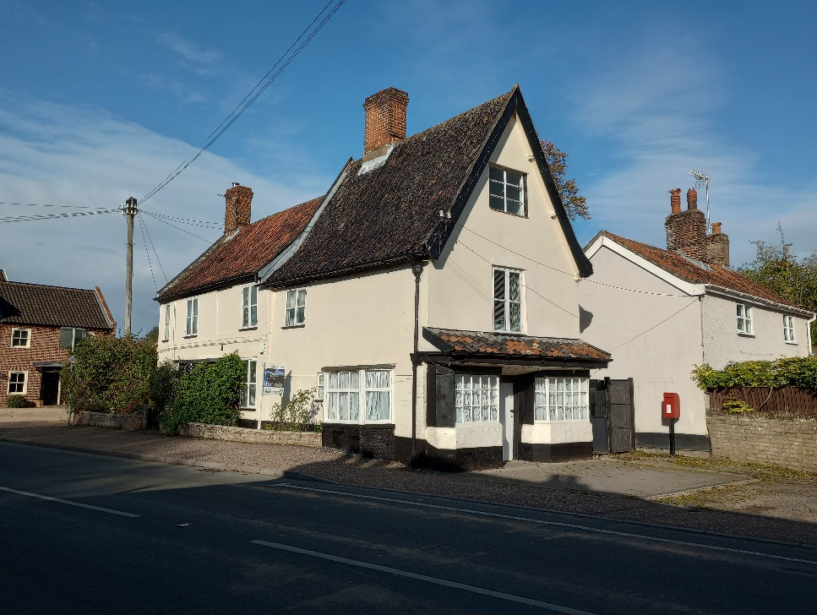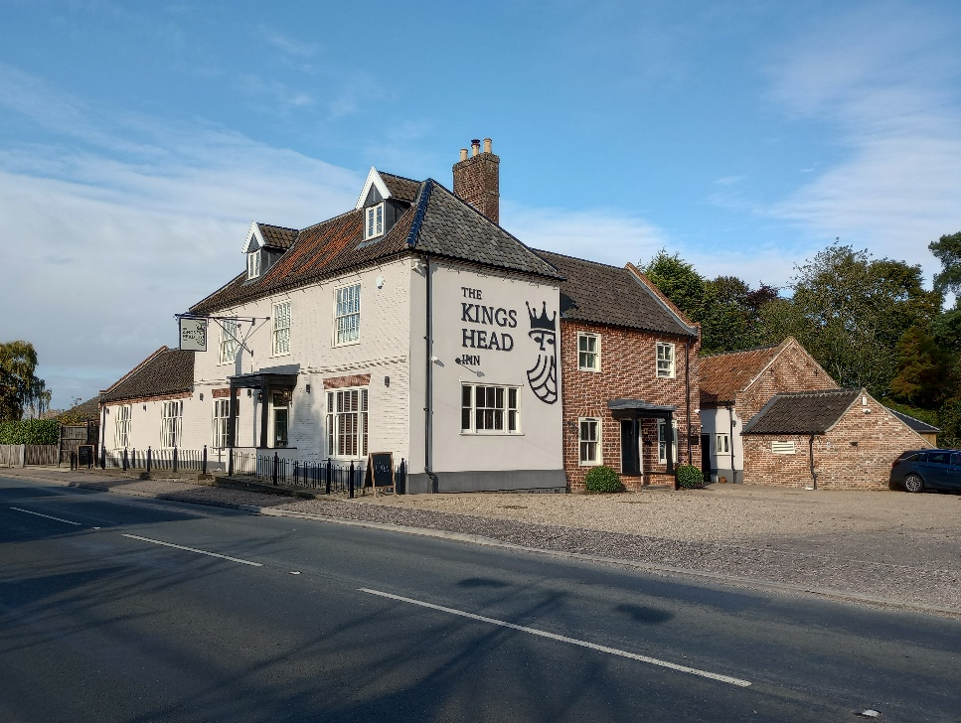
The Old Post Office The Kings Head public house
Norwich Road (North)
Historically Norwich Road was the commercial ‘heart’ of the village. The former post office and the Kings Head public house are on the east side of the street and former village stores on the west. The former post office and the house behind it our both originally 17th century in date, white washed brick and rendered. The Kings Head public house with its large ground floor windows, hipped roof with gabled dormers has a suitably imposing presence as a former coaching inn.
The west side of the road is first characterised by a historic grouping of simple rendered cottages with pantile roofs, to the back of the pavement, but separated from the road by flint cobbles. The corner building used to have shopfronts on both sides of the corner, and the cottages used to have front gardens and a fence with hedging. This is a potential area to carry out some enhancement work with less hard landscaping. The large gabled dormers of the corner property stand out as a feature.
Following the village garage with its large forecourt area, the next two houses are modern and red brick, followed by the whitewashed No 15 with very shallow hipped red pantile roof. A rather plain building, but with a decorative lattice gable hood to the door of interest. The next building is the converted barn with its modern dormers but attractive historic red brickwork. The east gable end, flush to the pavement, is quite imposing and provides a suitable historic marker for the revised conservation area boundary.
Norwich Road (South)
To the south on the east side of the road there is a small white washed cottage behind the hedge with pantile roof, followed by the early 19th century white brick lodge to the original Brooke House. The lodge has been extensively modified and extended, but retains an interesting pedimented portico with column shafts and round headed window openings. On the west side is the Methodist Church of 1924, now used as a hall, with services conducted in the modern extension to the south.
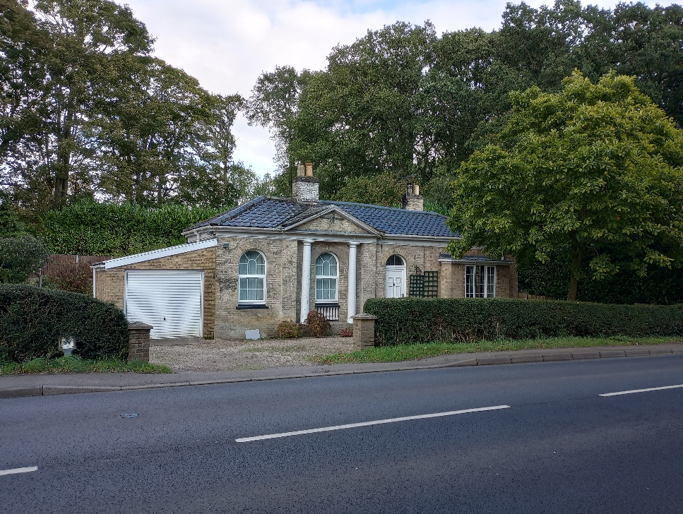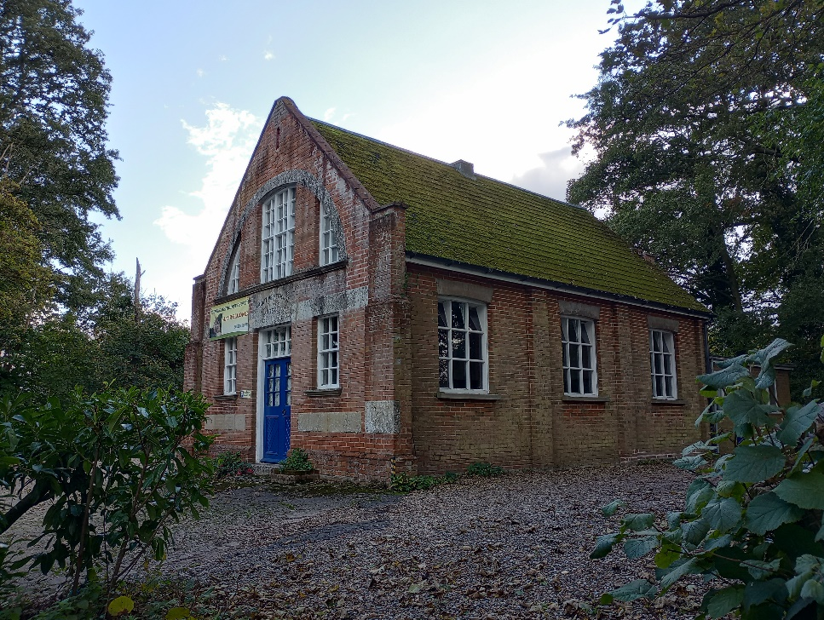
The old South Lodge to Brooke Hall The Methodist Church

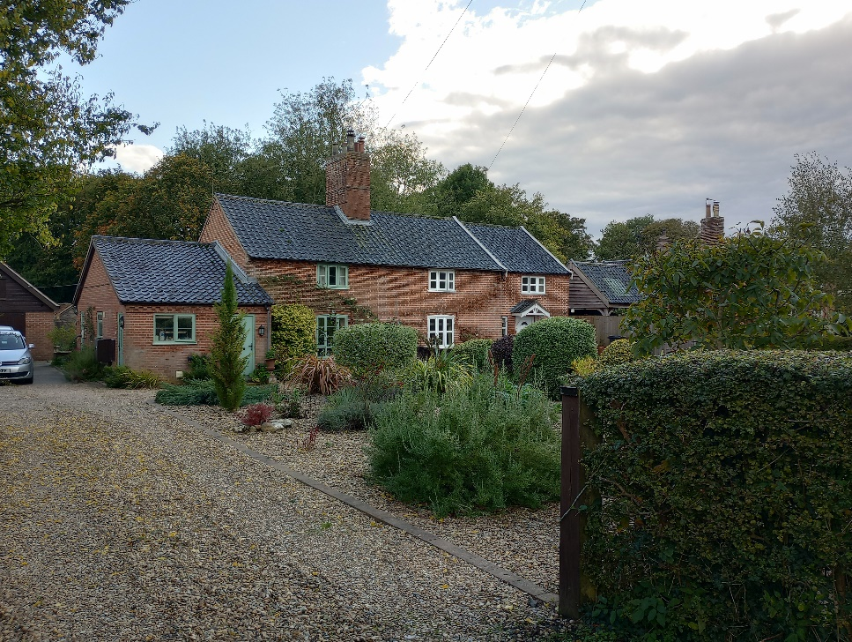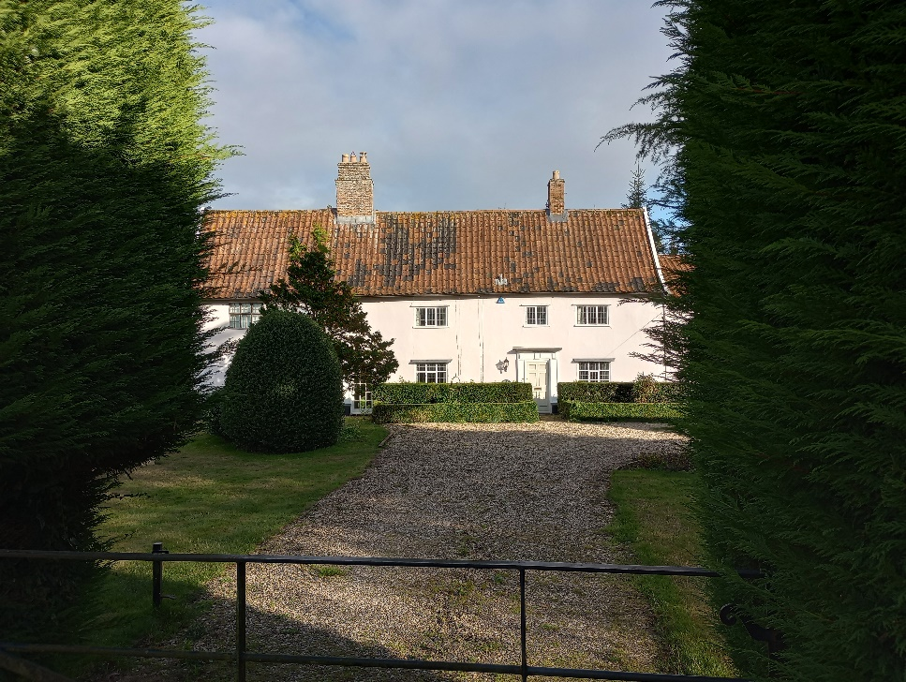
Cottage on south side of High Green The Warren
High Green
Nos 4 High Green, which was for a time the old school house, is well set back from the road, and consequently not so noticeable in street views, although it has an attractive thatched roof. The roof structure is a historically notable crown post roof which potentially dates the building back to the 15th century and could therefore be the oldest house in the village. Immediately to the west is the Victorian school built in 1838, with the playground and car parking to the front.
On the corner of High Green and Beech Road is a prominent Georgian double pile red brick house set behind a large front lawn. It has a very tall screen/garden wall to the west side. A pleasant small corner green provides a break between buildings in street views, with the modern estate quite far back from the street, and not that visible behind tall hedges.
On the south side there are a series of 18th and 19th century brick cottages with simple casement windows, some red brick, some rendered and some painted brick, set back some distance from the street. The small building with the hipped pantile roof close to the road is the old forge. This is followed by the timber weatherboarded commercial units which are set back from the road. These were converted from old stable buildings in 1998 and provide local shops and services in a discreet location without affecting the historic and architectural character of the conservation area.
Passing the green, the next section on the north side is characterised by more extensive streetside landscaping, which obscures views of the properties during the summer months. Modern properties sit discreetly within street views, and three historic properties of some note can be glimpsed over the hedging and through the trees. The first of these is no 24, a handsome Georgian style white brick property with a large conservatory/greenhouse to its east side. Also 30 and 32, of which 32 is painted and with good proportions.
On the south side there are a handful of historic red brick cottages, including the semi-detached pairs of Nos 31/33 and Nos 35/37, which look like they were built as former estate worker houses with their drip mould window detail, but have been modified with modern windows and extensions. The Warren (nos 45) stand outs with its large curtilage, and is a listed 17th century farm house of some size. It is sandwiched between Nos 43 and 47, both red brick cottages, 43 a good example of replacement flush fitting timber casement windows. Development on this side of the street is then mostly modern and most of the housing is set back with good landscaping to front gardens and hedging, which contributes to the rural character of the village in street views.
Following the three large detached houses on the north side houses become smaller and more modest with the tighter street frontage and grain. The very simple red brick terrace 40-48 (even) is followed by the village Baptist Chapel, probably all built at the same time. The chapel with its white render and crow stepped gables is a very prominent building in the street and a local landmark. Built in 1831, Pevsner notes it as being unusually early Tudor revival style for such a building when most buildings of this date were still designed in the classical manner. At the time of writing it is being converted to a dwelling.

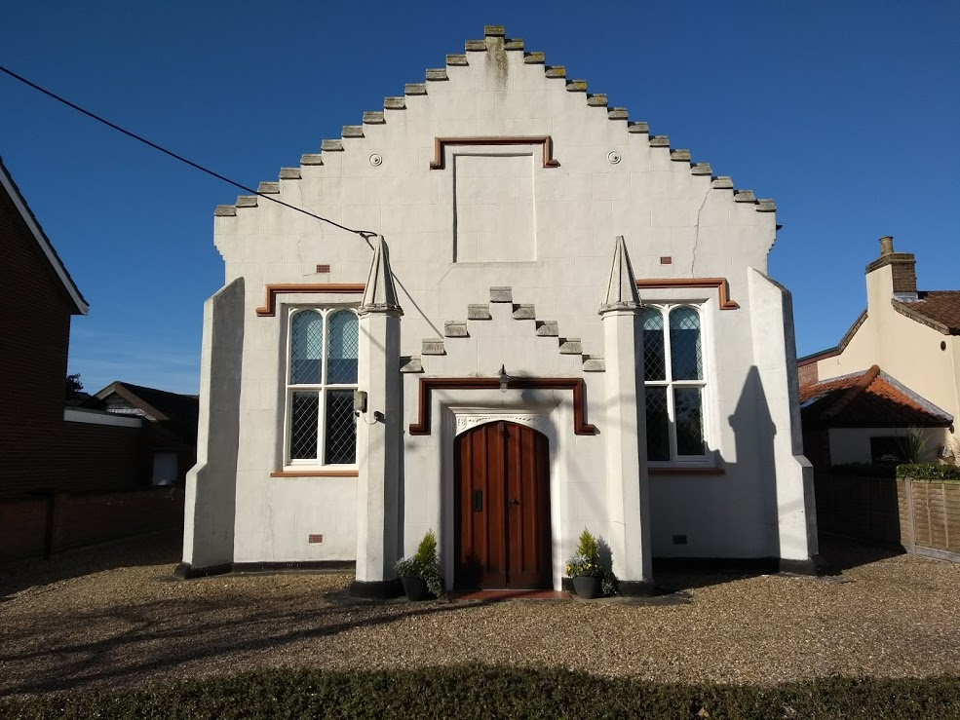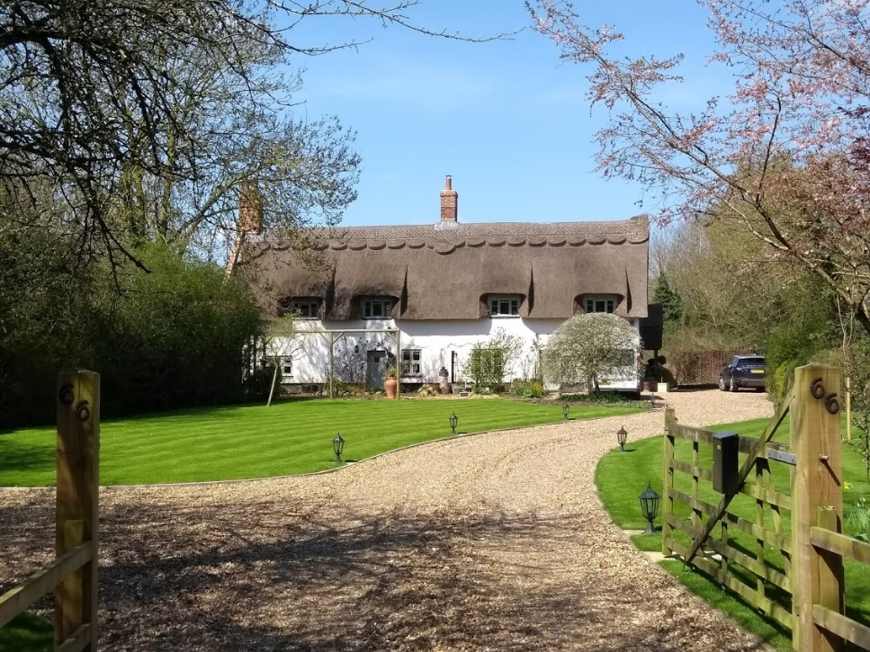
The Baptist chapel prior to converson (2018) 66 High Green
Modern housing then characterises both sides of High Green, with chalet bungalows on the south side and pseudo Georgian style on the north side. The open lawn frontage of the houses on the north side appear a little incongruous within a street characterised by hedgerows enclosing front gardens, and it may be beneficial to plant hedgerows here if desired. Nos 56/58 & 60 are all small simple red brick houses, but are followed by No 66 High Green, an attractive timber framed rendered cottage with thatched roof set back from the road. The landscaping at the west end of the conservation area then becomes again more verdant and thicker, providing an attractive arrival point to the conservation area after passing through agricultural fields.
St Peters Road and Churchill Place/Entrance Lane
In the north-east corner of the settlement, St Peters Road and Churchill Place are both early post-war areas of modern housing of some architectural and historic interest. St Peters Road is characterised by prefabricated ‘Swedish Houses’. The grouping remains very much intact with any alterations being sympathetic to their character. The houses retain their original black stained weatherboarding and tiles and these are important elements for preserving the group character – some have been cleaned to reveal their original pinkish colour that has weathered over time.
Churchill Place and Entrance Lane was design by Tayler and Green in two phases of 1952 and 1964 (marked in the brick gable end of 12 Churchill Place). They use a variety of bricks, predominantly red and buff, with brick patterns in the gable ends, pantile roofs and lattice timberwork to porches. They are arranged in long terraces with broad frontages and in a very regular, rectangular plan. The planning of dwellings around landscaped spaces is an important element of character. The long terraces were a design response by Taylor and Green who disliked the repetition of the semi-detached houses that were ubiquitous across the country and which were begun to be built at the end of St Peters Road in 1938 before the war halted development housing in Churchill Place
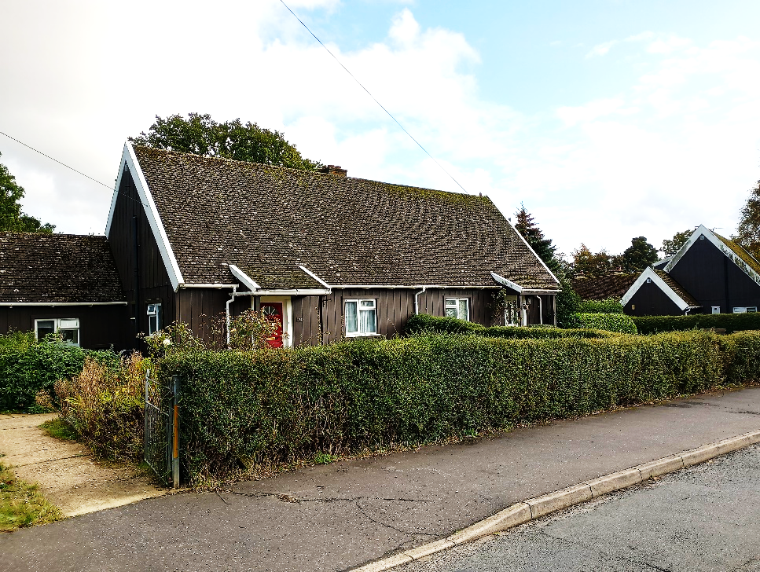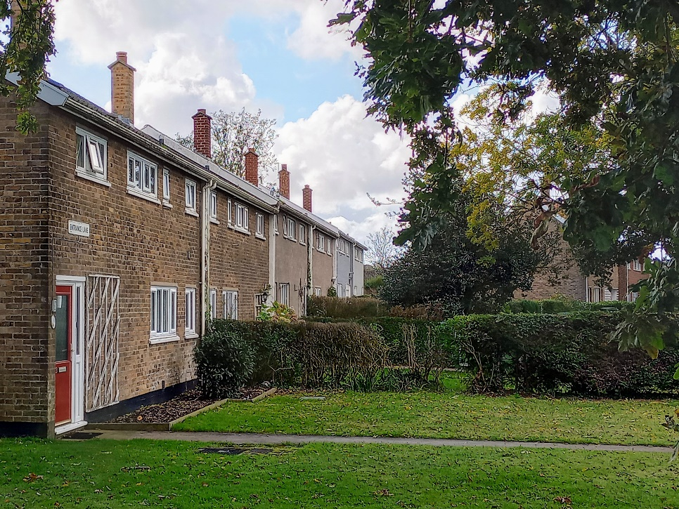
Swedish bungalows on St Peter’s Rd Taylor and Green housing Entrance Lane
Kirstead

This small group of buildings around Kirstead are associated with the outstanding grade I listed Kirstead Hall, an E-shaped style house dating from 1614 (possibly incorporating earlier fabric) with very characteristic projecting stepped gables and sets of mullion windows, and which can be glimpsed from the road through the vegetation (see front cover.) The various outbuildings which are also glimpsed through the vegetation to the side of Hunstead Lane include a listed barn, stables, forecourt wall and the dovecote with its octagonal form.
St Margaret’s Church is listed grade II* listed and stands within its churchyard on the opposite side of the road. The church was nearly all rebuilt in 1864, however the south porch remains from 12th century. The adjacent rectory is also Victorian with some Tudoresque detailing,

Parkland south of former Brooke Hall and Brook House and buildings along Church Road

Although most of the former parkland to Brooke Hall and Brooke House is now under plough, the tree belts are still in place and define the historic extent of parkland. The landscaping makes an important contribution to the setting of the village to the south, and assists in separating two settlements. The converted stables and a modern bungalow lie in a wooded area near to where some foundations of the former hall are still extant. The Lake is a prominent feature.
Kirstead House is positioned on the south side of the tree belt called Park Plantation at the southern extremity of the conservation area. The red brick facing material disguises its 17th century origins and earlier internal timber frame. Together with the outbuildings it retains its rural setting within the open countryside. Further east on the north side is Church Farmhouse, dating from 19th century and built in white brick but with modern windows. It is notable for having a thatched roof – not common in the district on a white gault brick house. To the west of the parkland on Norwich Road is Park Cottage, which is not listed but of some historic value, also with a thatched roof.

Traditional Materials & Architectural Details

There is a variety of Norfolk materials present within the village ranging from timber framed vernacular properties which have been rendered and painted in white or pastel colours, and brick properties, with in some cases later brick disguising earlier timber frames. Red brick is the predominant brick, although Nos 12 and 22 High Green, both higher status houses, are built in white gault brick which was historically a more expensive brick. The post-war Tayler and Green houses use a variety of brick colours to fit in with the vernacular brick types. Tiles are principally an orangey/red or black glazed/smut pantiles, and a small handful of properties have shallower pitched slate roofs from the early 19th century. The village has a number of thatched properties, with other examples now tiled also previously thatched – a tell-tale sign being steeper roof pitches

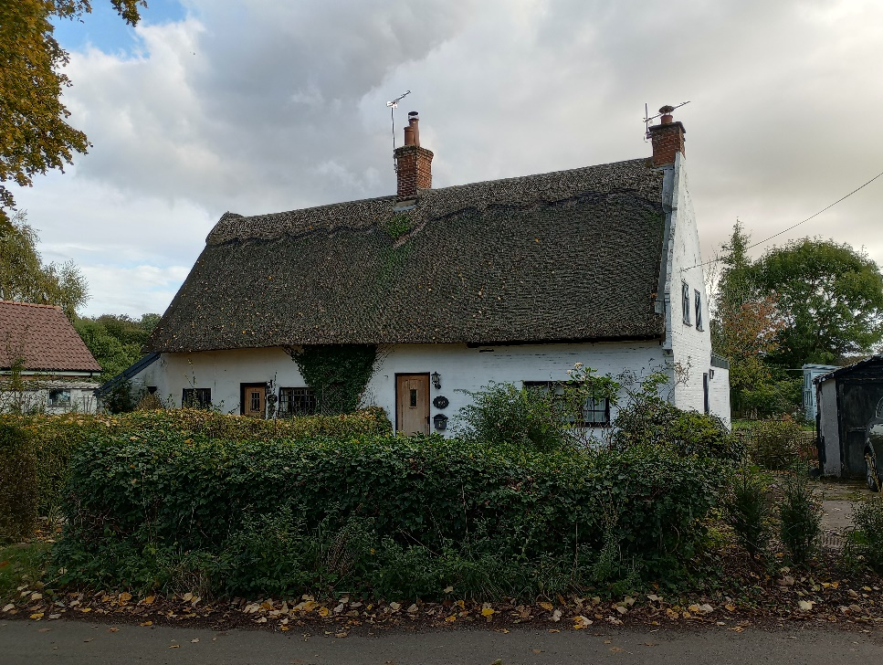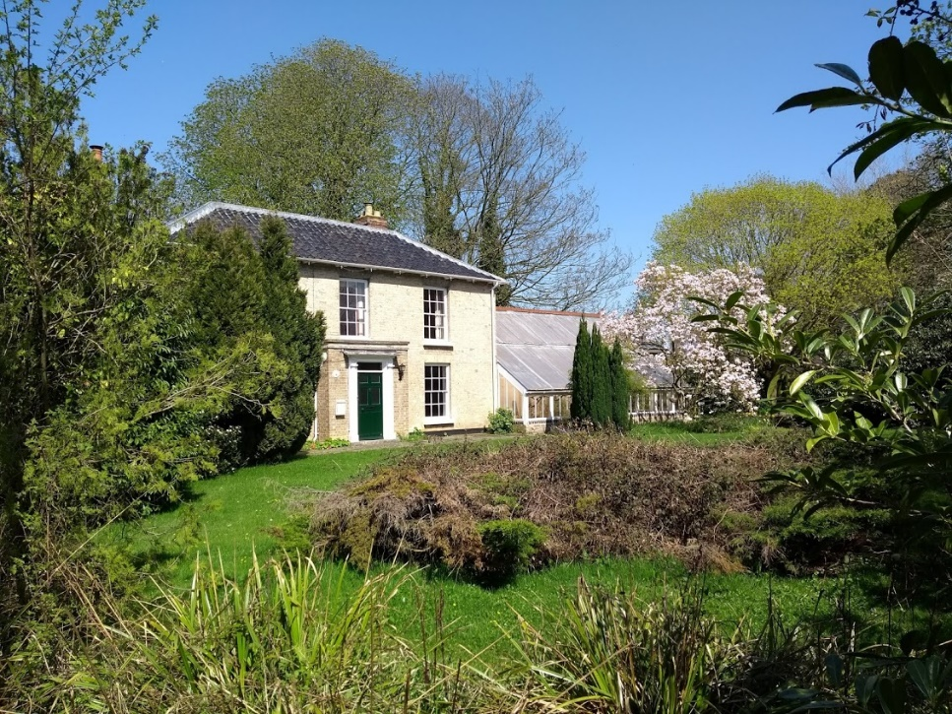
Vernacular cottages (26/28 The Street) Georgian style (12 High Green)
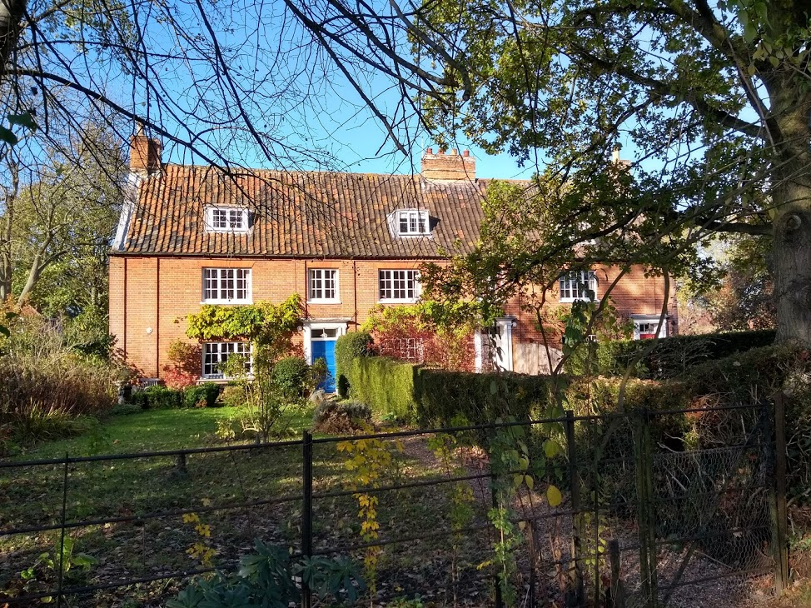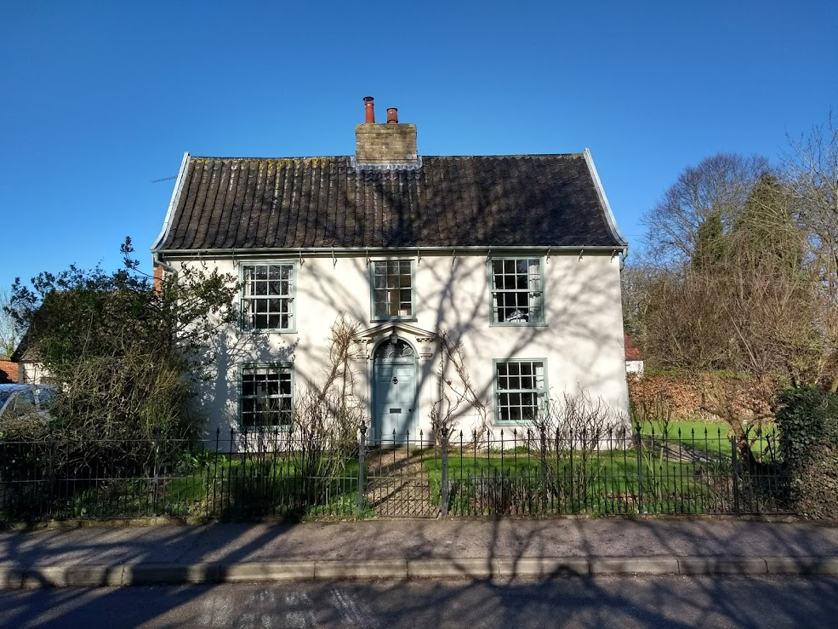
Norfolk red bricks and clay pantiles Simple render and black glazed pantiles
(83-87 The Street) (Mere Cottage)

Early properties tend to have windows with wider proportions and casements windows (the outline of earlier wide mullion windows which would be similar to Kirstead House but in timber can be seen in the brickwork of Porch House.) Later Georgian properties have more vertically proportioned multi pane sash windows. Sash windows have in some circumstances replaced earlier windows such as at Nos 83-87 The Street. Remnants of earlier mullion windows can sometimes be found within the timber framing behind brickwork.
Most early 17th – 19th century properties are simple cottages. Nos 45 High Green is an example of a larger 17th century timber framed farmhouse. The impressive Porch House is an example of earlier decorative brickwork – the expense of brick over timber framing in this period when built indicated this was a higher status property within the village.
The good proportions of provincial Georgian architecture with simple and elegant symmetrical elevations and some fine doorcases are also well represented in the village with examples including Mere House along The Street and Nos 10, 12 & High Green House, High Green. Brooke House is the only remaining higher status hall in the village and is in the vernacular revival style of the 1930s, together with the two gate lodges either side of the entrance from the street. North Lodge and no 34 The Street are both the original driveway lodges to Brooke Hall but are in a different architectural style to the earlier Georgian style lodge for the former Brooke House on Norwich Road.
There are three examples of 19th century Tudor revival architecture – North Lodge with its thatch and prominent chimney stacks – note the similarity between these stacks and the original stacks on Mere Cottage - and Nos 34 The Street is a good example of the cottage ornee style. The Methodist Chapel on High Green is a good example of early Tudor gothic revival from 1831.
Most of the more recent housing replicated more tradtioanl forms and styles. 12 High Green is a good example of modern vernacular based design for a rural house.

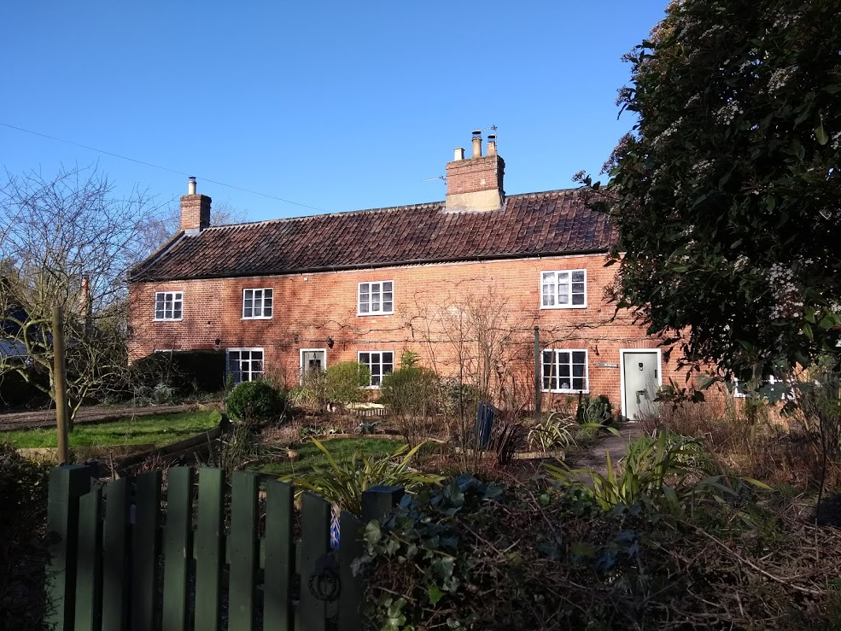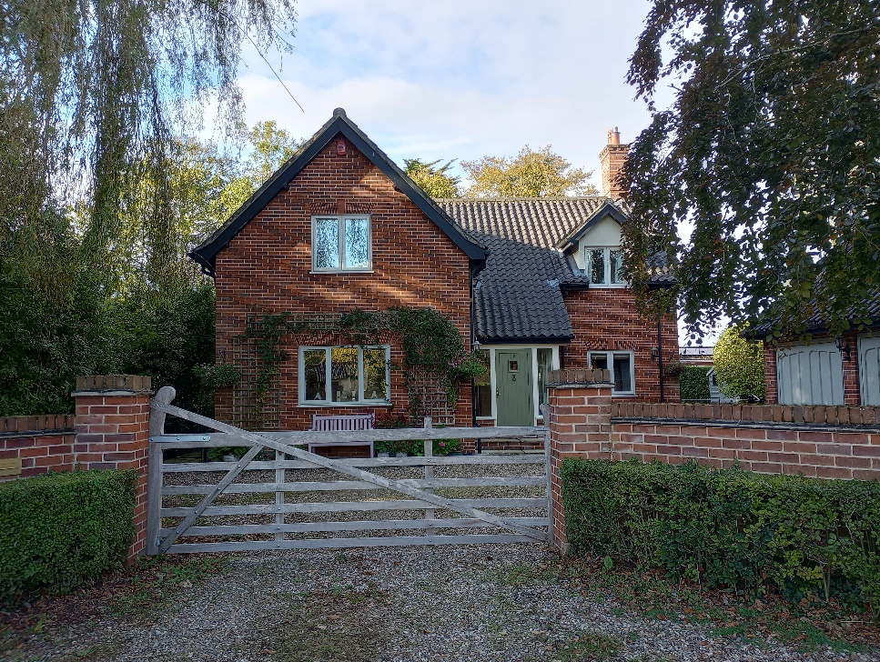
Simple cottages (23-27 The Street) Traditional style infill (12 High Green)
Natural Character and open spaces

The Meres are a strong defining characteristic of the conservation area to the east. They also provide an important natural amenity area for residents.
Along The Street and High Green hedging is more prominent than garden walls, and there are a number of street trees arranged in a relatively informal manner. This all contributes to the more informal rural character of the village.
Both the churchyard of St Peters, Brooke and St Margarets, Kirstead, provide picturesque settings for the two listed churches. The rear of St Peters’ churchyard offers the best views of the dovecote of the former Manor House.
The village green is on the corner of The Street and Norwich Road. Unfortunately, the proximity of Norwich Road and heavy traffic lends the green a less tranquil setting compared to the village meres where additional seating has been placed in recent years. Paving for the village green area is looking tired and worn and the area would benefit from some enhancement.
The former estates of Brooke House and Brooke Hall both retain their existing landscaped tree belt plantations, with Brooke House still providing a landscaped setting to the south of the house built in the 1930s. The village cricket ground is also located in this area to the south. Other tree belts to the south and north of the housing on High Green also separate the village from the open countryside.
The parkland landscaping historically associated with Brooke House also contributes to the landscape gap between Kirstead Hall and Brooke so that the two areas retain quite different and detached character. The importance of the Kirstead Hall as an important listed building with its grouping of historic buildings is important to keep separate in views from Brooke. Also, the parkland and tree planting is important to the setting of the village retaining its character of being not very visible from open countryside. For this reason it is proposed to include the former parkland area to the former Brooke Hall in the conservation area. The extent of the parkland can be clearly seen on the historic OS map from 1904-11.

Street furniture

There is limited street furniture, although some areas of seating as mentioned above. There is an historic country signpost on the south side of the mere pointing towad Hunstead Lane and also at the west side of the Mere.

As previously mentioned there is a unusual light column fixture on the road leading to Brooke House nursing home with deco styling.

Opposite the church is a Giles Gilbert Scott red K6 red telephone box.

Conservation Management Guidelines
Highways
Norwich Road is quite wide and could benefit from measures to slow traffic such as pinch points and a different surface for the main part of the village to give it a softer landscape feel. Access across the road could also be improved to make it more pedestrian and access friendly and safer.
Opportunities to give the centre of the village a more rural character with softer landscaping to connect the east and west parts. For example cobbled areas could be improved with features such as planters to make a more attractive centre. Also, possibility of change in street surface and possible other measures to allow for safer pedestrian crossing and helping to visually connect both sides of the road.

Streetside Advertisements
Care need to be taken to ensure that temporary signage boards do not harm the village’s character, especially on the corner of the Street and High Green.
Consideration should be given to more sympathetic signage/sign board which could group together the various business located further along High Green in a more co-ordinated and managed manner.

Upgrading windows and doors
In some cases, windows have been replaced using less traditional materials. If frames need to be replaced they should ideally be replaced with the original materials. However, if different materials are chosen then the window style should remain the same. The opportunity should be taken to reinstate traditional style windows where they have been unsympathetically replaced in the past.
If external doors or windows need to be replaced then this should be done using sympathetic materials to an appropriate design, particularly on pre-20th century buildings. Where less traditional materials are used then the new units should still match the original flush fitting casement or sash design sash for principal elevations rather than modern storm-proof casement or ‘mock sash’ design.

Painting buildings
Rendered properties are mainly white or pale pastel colours and this helps to create an harmonious street appearance.
Bright and excessively contrasting paint colours that ‘stand out’ and jar with neighbouring properties should be avoided.

Boundaries
The majority of boundaries are defined by mature hedgerows and trees with a small percentage having traditional post-and-rail or metal railings. Erecting close boarded fences significantly harms the character and appearance of the conservation area as a rural village where landscaping to frontages forms an important part of the village character.
Any new boundary treatment should be in keeping with existing types of boundary treatment which are sympathetic to the rural character of the conservation area. Erecting close boarded fencing to frontage will be considered harmful (any boundary treatment to the highway over 1m in height requires planning permission.)
Appendix 1
(i) Listed Buildings

Brooke

High Green 2 & 4 High Green, The Warren, 10, 22 High Green House, 66 High Green,

Norwich Road Telephone Kiosk adjacent to Kings’ Head Public House, Kings’ Head Public House Post Office & House to rear of Norwich Road

The Street Laurel Farm House, Barn 20m to North of Farm House, Church of St. Peter (II*), 19 & 21, 23 to 27, North Lodge and garden railings, Mere Cottage, Mere House, Old Vicarage, Porch House (II*), 26 & 28, 45, 79, 81, 83, Old Dovecote

Kirstead

Brooke Road Kirstead Hall (I) Forecourt wall to Hall, dovecote, Stables, Barn at Hall

Church Road Church of St. Margaret (II*), Kirstead House

(ii) Unlisted Buildings of Townscape and Local Significance

Brooke Gardens Brooke House, Former Coach House

Burgess Lane 1 & 3 (Swedish prefab housing)

Churchill Place 1-53 (Tayler and Green)

Church Road Church Farm, The Old Rectory

Edward Seago Place 1-3

Entrance Lane 13-29 (odd) (Tayler and Green)

High Green Primary school, 12, 20, Baptist Chapel, 40 – 48, 54-60 (odd)
5, 7, 9, No 11 (Old Forge), 13, 17, 31-37 (odd), 43, 47

Norwich Road 1, 5, 7, 15/17, Georgian Cottage (former lodge to Brooke Hall), Park Cottage, Methodist Church

St Peters Road 7-16, 17-28 (Swedish prefab housing)

The Street 2, 6, 8, 10, 22, 24, 34,
1, the Coach House, 3 ,13, 15, 29, 31, 47, 49, 51, 55, 65-75 (odd), 111

Appendix 2
Policy background

In recent years, the approach to conservation area designation has changed considerably. It is now recognised that development plan policies, development control decisions, and proposals for the preservation or enhancement and the management of conservation areas, can best be achieved when there is a sound understanding of the special interest of the conservation area.

This position is reinforced as follows:

The Planning (Listed Buildings and Conservation Areas) Act 1990 in section 66(1) makes it a duty of local authorities when considering applications to have special regard to the desirability of preserving a listed building or its setting or any features of special architectural or historic interest.

Under section 72 of the same Act, it is a duty with respect to any buildings or land in a conservation area, to pay special attention to the desirability of preserving or enhancing the character or appearance of that area.

Department for Communities and Local Government. National Planning Policy Framework (NPPF) Section 16: “Conserving and enhancing the historic environment”.

The South Norfolk Local Plan Development Management Policies Document was adopted in 2015 and policy 4.10 covers Heritage Assets.

Public Consultation

This section will report the outcome of the public consultation which is to be undertaken from the 13th January to 10th February 2025.

Appendix 3 - Proposed boundary changes
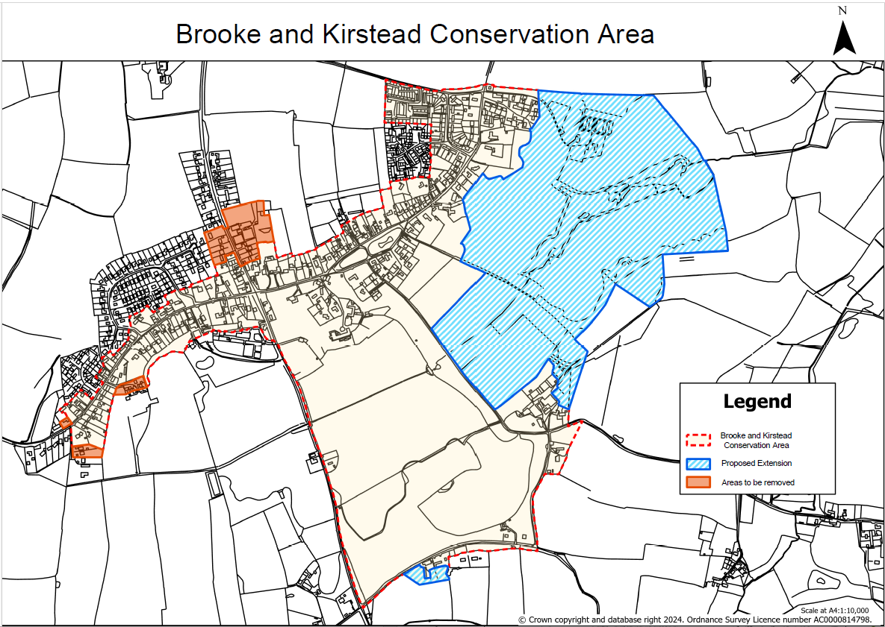
Appendix 4 – Historic Map
