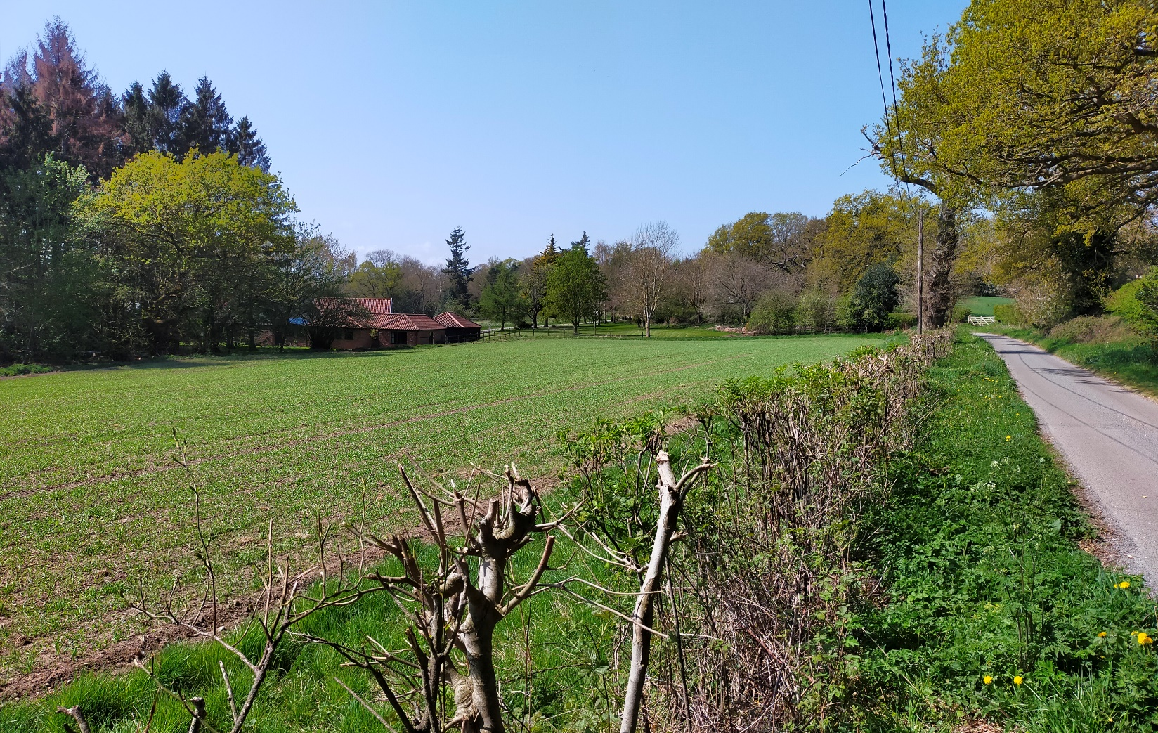Bergh Apton

Conservation Area Character Appraisal

and Management Guidelines

December 2022

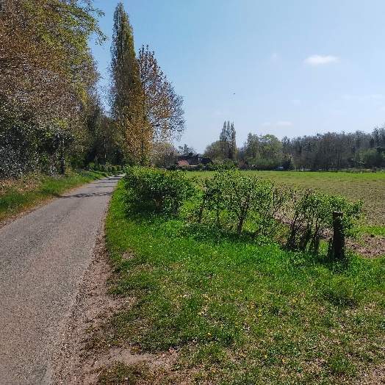 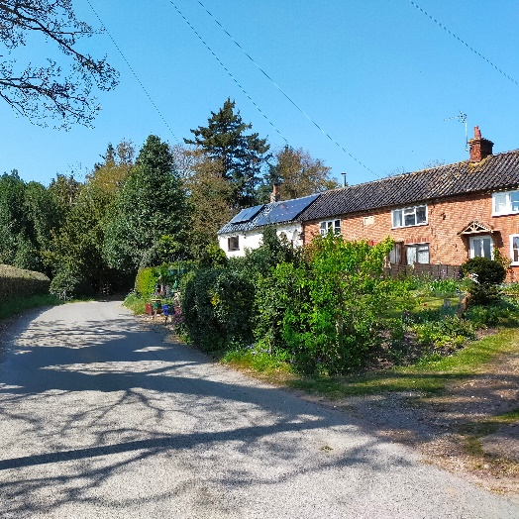 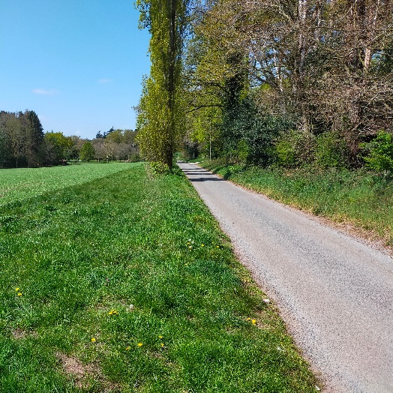



Content

Introduction 3

Historical Development 4

Character Assessment 5

Conservation Management Guidelines 11

Appendix 1(i) Listed Buildings 12

Appendix 1(ii) Unlisted Buildings of 12

townscape significance

Appendix 2 Policy Background & 13

Public Consultation

Appendix 3 Boundary Map, Streetscape 14

and Natural Character

Introduction

|  |  |
| --- | --- |
| Photo showing 54 & 55 Bussey Bridge Road  54 & 55 Bussey Bridge Road | Bergh Apton lies five and a half miles to the south west of Norwich and to the south of the A146 Norwich to Lowestoft road. It is one of a series of parishes located within the triangle of land formed by the A146 and the A140 (Norwich to Ipswich) roads as they radiate out from the city centre. This matrix of parishes is based primarily on agriculture with village, hamlet and farmsteads dotted around the gently rolling countryside |

Bergh Apton is best described as a parish of "dispersed" settlement that has no really strong village "core" in the physical sense. It is criss-crossed by a series of minor roads (all named), bridle paths and foot paths reflecting previous settlement and which continue to connect the scattered farms, houses and cottages.

Under the terms of Planning (Listed Buildings and Conservation Areas) Act 1990, the Local Planning Authority is required to identify areas of special architectural or historic interest whose character or appearance it is desirable to preserve or enhance, and to designate them as a Conservation Area. The 1990 Act also requires local authorities to prepare management guidance and proposals for conservation areas. The Bergh Apton Conservation Area was originally designated in 1994. This document should be read in conjunction with the adopted Local Plan, the National Planning Policy Framework and Planning Practice Guidance

**Key Characteristics**

* Strong natural character
* Buildings concentrated east and west sides
* Dense woodland
* River meadows
* Hidden self-contained valley
* Former estate land

Historical Development

The modern parish of Bergh Apton is some five miles to the south west of Norwich and represents a culmination of a settlement pattern which began in pre-Roman times.

The history of the settlement has essentially been one of a dispersed village community based around agriculture and typified by scattered farmsteads, larger halls and manor houses, small hamlets and isolated cottage clusters.

The word "Bergh" comes from the old English term "Beorg", meaning hill or mound but the origin of “Apton” is less clear.

Bergh Apton was originally two separate settlements. "Bergh" lay to the south of the parish and stretched northwards to the current parish church of St. Peter and St. Paul. Apton occupied the northern part of the parish and contained its own parish church (St. Martins), of which nothing remains today. Its close proximity to Alpington and the fact that the latter has no parish church lends weight to the argument that Apton and Alpington were possibly one village.

The place name definition does, however, give a clue for the reason behind the settlement. It was once based on good defensive high ground which enabled the fertile soil of the area, including the slopes down to the River Chet valley, to be cultivated. Its soils have sustained cultivation from pre-Roman times.

Evidence of Roman settlement has been found and the parish is not too far from the important Roman town site of Caister St. Edmund, which lies approximately four and a half miles to the north west.

In the 1970s a significant Saxon burial ground was found to the west of the current parish church whilst it was being quarried for gravel, providing evidence of an important Anglo-Saxon settlement.

At the time of the Doomsday Survey the area was divided into two separate parishes, Apton being held by the Diocese of Ely. The post-Conquest period witnessed the emergence of the settlement pattern based on the feudal manorial system dominated by village, hamlet and farmstead communities and a complex market economy related to agriculture. In Bergh Apton’s case the settlement appeared to consist of a loose scattering of manors and farmsteads, presumably with associated clusters of cottages and hovels which may have formed village "cores".

At some stage, possibly as a result of a major upheaval such as the black death in the mid fourteenth century, a major change took place to the settlement pattern. It was at this time that the two villages seemed to have merged (Apton church was downgraded to a chapel in 1350) and the stage was set for the development of the parish as it is today.

Bergh Apton reflected the changes in agriculture during the post-medieval period with the enclosure system of land division. For a large part of this period up until the early 20th century the majority of the land was under the ownership of two separate families: the *Dennys* at the Manor and the *Cookes* of Washingford. They both controlled the development of land and those who worked on it. After this period land has been gradually parcelled off with more modern large scale farming methods taking over resulting in the loss of the previous field and hedgerow system.

Character Assessment

**Bergh Apton and its setting**

|  |  |
| --- | --- |
| **Photo showing River meadows viewed from the significant tree along Sunnyside**  River meadows viewed from the  significant tree along Sunnyside | The parish occupies the southern slopes of the River Chet valley, the river itself flowing towards Loddon, before its confluence with the River Yare near Reedham. It is in this area that the conservation area is located.  In general terms the landscape is dominated by the large modern field system which typifies current agricultural practice. A sense of enclosure and intimacy is only provided near the clusters of dwellings and most dramatically within the conservation area located within the River Chet valley. |

There are significant woodland areas in the parish and these tend to largely be a remnant of the great estates and the great "replanting" which took place in the eighteenth and nineteenth centuries. Within the conservation area, the north slope of the valley is mostly woodland. A much larger area of woodland can be seen just beyond the south boundary of the conservation area across the river.

The parish contains 17 listed buildings, generally manor houses, cottages and barns. The one exception is the parish church of St. Peter and St. Paul which stands in splendid isolation to the south overlooking the surrounding farmland and the Chet valley.

**Conservation Area Boundary**

The conservation area lies to the south east side of the parish occupying the north slope of the River Chet valley. The north boundary follows the "hard edge" line between the open field system and the softer enclosed landscape provided by woods and hedges. To the east the boundary follows the line of the minor road "Bungay Lane" and is again on the line of the hard edge between wood and open fields. To the south the boundary follows the line of the River Chet which meanders eastwards towards Loddon and to the west it follows the line through woodland which was once part of the Canterbury Estate.

**Street Patterns and Historic grain**

The conservation area is probably best described as being centred around the bottom half of a ‘U’ shaped road pattern that extends southward from the Loddon Road. The eastern part is centred around Bungy Lane with the southern and western parts centred around Sunnyside, which runs more or less parrallel with the river until it turns up the hill towards the Loddon Road. This road pattern reflects the historical development of the area, the western leg of the U being formed in Victorian times as part of the development of the Brooke House Estate around Holly Lodge.

In the south east corner, where Bungay Lane meets Sunnyside, is a small hamlet based around a bridge over the River Chet, known as Bussey Bridge and a farm (Bussey Bridge farm). This bridge forms the south-east boundary of the conservation area. The road across it continues north up the valley slope towards the parish of Seething.

**Perambulation**

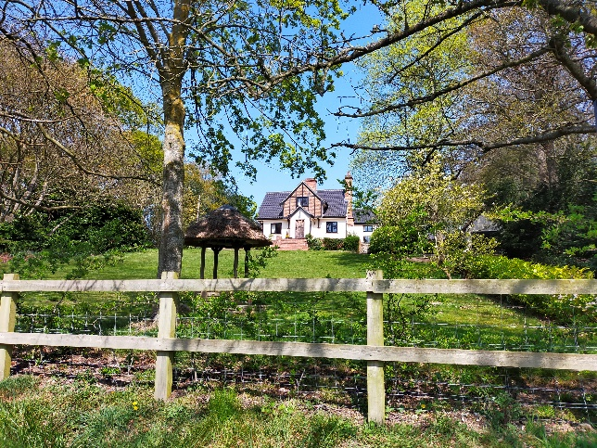 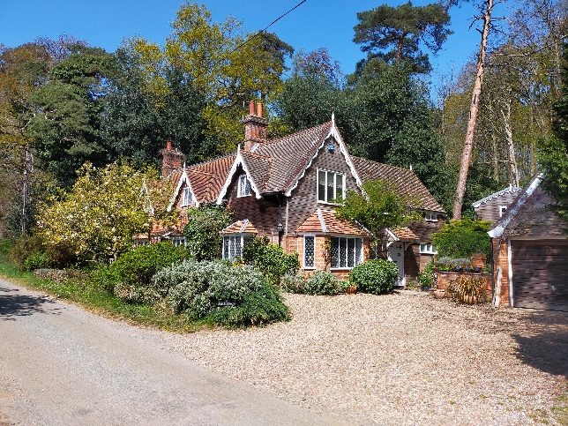

Cherry Tree Cottage Watermeadows

Buildings in the conservation area are generally no more than two storeys high and apart from Holly Lodge, are of modest domestic proportions. Most date from the early 19th century or the Victorian era and were part of the Brooke House Estate, also known as the Canterbury Estate. After the mid-19th century estate land was gradually parcelled-off with most properties being in individual ownership. Despite this change there remains very little in the way of modern 20th century additions to the conservation area.

Archaeology would inevitably show that older buildings once existed in the area. When Bussey Bridge Farm burnt down some years ago evidence of Elizabethan footings were apparently found, indicating earlier settlement.

In terms of its buildings, the conservation area is essentially divided into three separate areas; the Sunnyside hamlet to the west side, Bussey Bridge hamlet to the east side, between which is a large area of woodland and open meadow containing three dwellings – The Stables, Watermeadows and Cherry Tree Cottage.

There are the only two listed buildings in the conservation area. These date from around the early 19th century; the first is to the east, a thatched "Gothic" cottage comprising 54 & 55 Bussey Bridge Road (May Cottage & Bluebell Cottage) and the other to the west,a superb example of a "Cottage Orneé," Lodge Cottage.

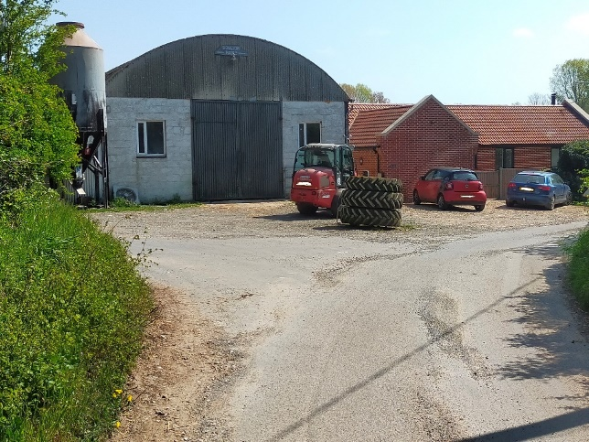 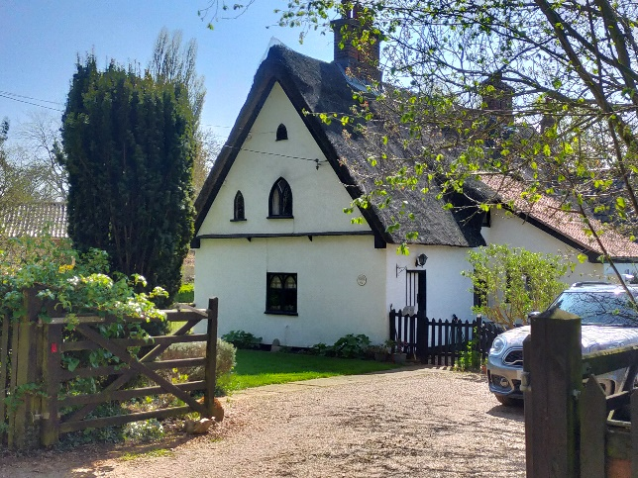

New bungalow at the junction of Bussey Entrance to May Cottage (No.54)

Bridge and Bungay Lane +

Boulton & Paul agricultural shed

Although there are only two listed buildings in the conservation area, most of the buildings make a positive contribution in their own way to the character of the area.

Three dwellings, Holly Hill, Cherry Tree Cottage and Bluebell Cottage (55 Bussey Bridge Road) have all been substantially extended since the last conservation area review and all are generally sympathetic to the original buildng. Bussey Bridge Farm Bungalow is the only newly built dwelling in the conservation area.

**Bussey Bridge**

The bridge over the river to the south marks the start of the conservation area, from which there are attractive views of the river and landscape. Moving northeastward along Bungay Lane from the junction there is a group of farm buildngs, part of Bussey Bridge Farm, that dominate views. One of these buildings fronts the road junction with Sunnyside and the next to it is a relatively new red brick bungalow. This has been built since the last review of the conservation area. Although clearly a modern addition, its modest proportions, brick and pantiles finishes provide an appearance that is generally in keeping with the historic character of the conservation area, although its position so close to a large agricultural building does make it sit rather awkwardly in the street scene.

Opposite the bungalow is Jays Cottage, also part of the “Bussey Bridge” hamlet and formerly a pair of Victorian cottages, possibly clay lump. The building has a clay pantile roof over painted rendered walls and has a large extension to the rear. Its plastic windows are not so in keeping with its traditional character and are quite noticeable with the building being so close to the road, although the overall the building makes a positive contribution to the character of the conservation area.

**Sunnyside**

Along Sunnyside there are three noticeably larger Victorian buildings; Penny Hill, Watermeadows and Lodge Cottage. The last of these continues the "Cottage Orneé" style previously mentioned, which also dictates the style of Cherry Tree cottage, built in the twentieth century, which sits up the on the north slope of the valley. This has a clay pantile roof, which has replaced the original thatched roof, with projecting front gable of brick with timber noggins. It has been substantially extended to the rear, generally sympathetically. There is an attractive small well structure with thatched roof close to the front boundary with the road.

Watermeadows dates from the mid-eighteenth century and has a plain tile roof with gable dormers. Its decorative bargeboards are an original detail and add much to its character. They are a less characteristic detail of the area and may well have been made by the estate carpenter, for whom it is believed the house was originally built. The building has since been much extended and altered but all in a sympathetic manner, including the garage and outbuildings.

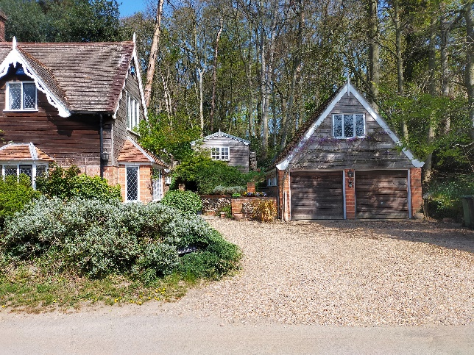 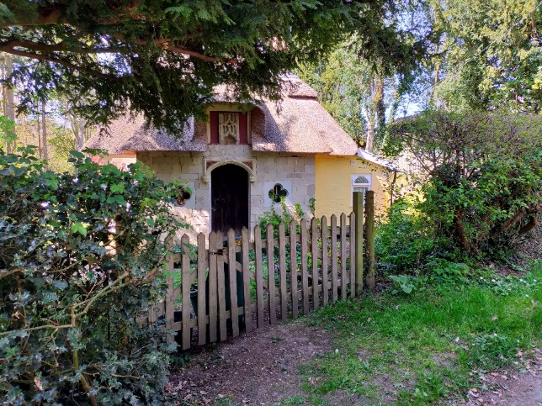

Garage Building at Water Meadows Lodge Cottage

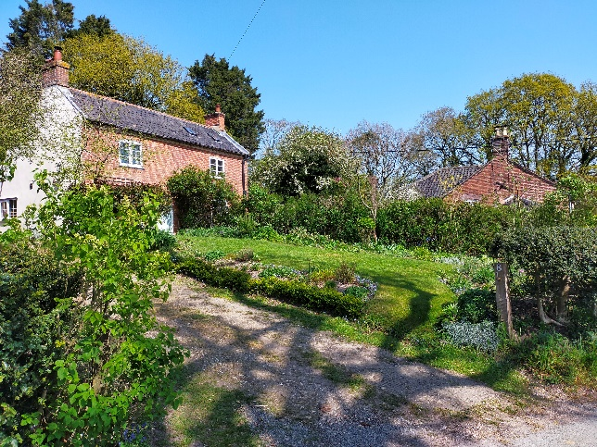 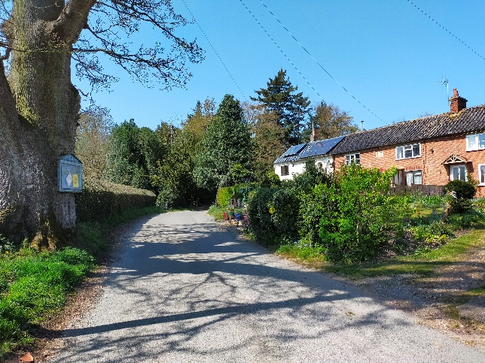

Victorian estate cottages, Sunnyside Victorian estate cottages with

significant tree to the left side

Where Sunnyside turns northward up the hill, there is a range of Victorian cottages, presumed built for estate workers. There is a stone date plaque 1889 on the western range marking when it was purchased by William Ford Thursby, a parish rector, for occupation by the village poor.There are modern extensions to the rear and most have unsympathetic modern windows and doors.

Opposite the group of Victorian cottages is Holly Hill, built as gamekeepers cottage in Cottage Orneé style. This has a thatched roof with timber loggia posts and is two storey with central brick stack and leaded lights in timber frames. The building has been substantially extended in recent years at its east side. There is an attractive garden area that slopes southwards towards the river.

Further up the hill on the right hand side of the road are two more semi-detached Victorian cottages and then Penny Hill, a Victorian House double fronted with slate roof over gault brickwork to the front and sides, with red brickwork to rear. It has a decorative timber dentilled eaves to the front, wooden sash windows and attractive projecting timber porch to the side with lead canopy. At the rear is a projecting garden bay. Beyond this moving northward is “Holly Lodge” and its former Coach House mark the north boundary of the conservation area. These buildings are largely screened by trees in views from the road. Holly Lodge is a large Victorian Hall residence, originally part of the Brooke Estate. It has a slate roof with lead hips and ridge, over gault brick walls and red brick outbuildings.

Opposite “Holly Lodge” is “Green Shutters”, a detached Victorian Cottage of some townscape value despite later 20th century alterations.

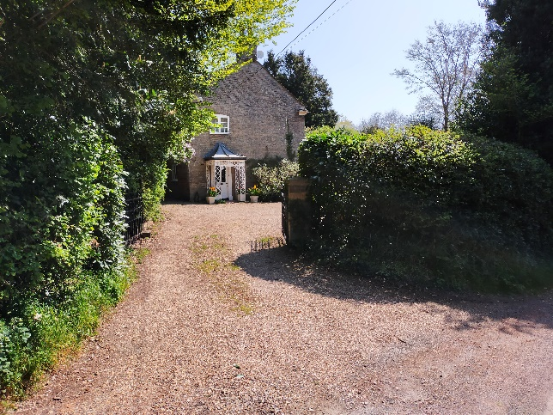 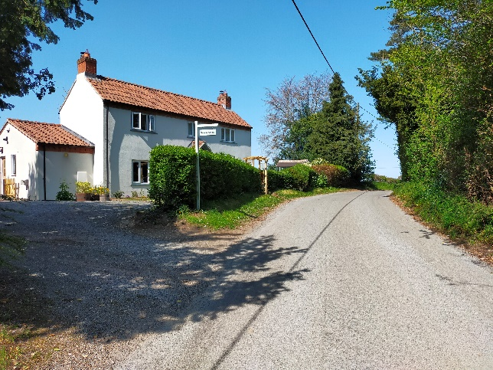

Penny Hill Green Shutters

**Building Materials**

**Roofs**

Thatch is found on three buildings, two of which are listed. The Victorian cottages are roofed predominantly in blue/black glazed pantiles. The two larger buildings, Holly Lodge and Penny Hill are roofed in natural slate, the former with lead hips and ridge reflecting their status and the fashion for using imported materials for such buildings in the Victorian era.

Red clay pantiles are found on the converted stable buildings being converted on the flat land of the valley and garage buildings inserted into the area over recent years.

Plain clay tiles are can be seen on Watermeadows, a mid Victorian cottage range.

**Walls/boundaries**

The Victorian cottages are generally in red clay brickwork, although some are painted. The cottages at Bussey Bridge are painted render. Listed building, “The Lodge”, a fine example of the “Cottage Orneé” , has some coursed limestone blocks into which has been fixed some much earlier ecclesiastical stone architectural details. Gault brickwork is found on Holly Lodge and Penny Hill, reflecting the status of these buildings. Horizontal timber boarding (natural) is found on "Watermeadows" above ground floor level as well as decorative timber bargeboards to the main roofs and gabled dormers.

Other than the red brick wall along Bungay Lane and two sections of red brick wall either side of the bridge over the river and front wall at 1 & 2 Sunnyside, boundary walls are generally absent from the conservation area. Picket fencing can be seen at the west side of the conservation area to define garden areas and there is a concrete post and metal rail section of fence adjacent to the bridge over the river. On the whole mature hedge rows define boundaries along roads.

Pebbledash can be seen on “Green Shutters” at the north western corner of Sunnyside adjacent to and further up the hill from “The Lodge”. A small amount of flint is seen on the converted stable buildings previously referred to.

**Architectural Details**

There are few architectural details of note within the conservation area. The majority of buildings are quite modest in scale and style, most being from the 19th century with typical brick, painted brick or rendered finishes, plain chimney stacks and casement windows. Perhaps worth mentioning are the decorative barge boards at Watermeadows, the Gothic arched windows at 54 & 55 Sunnyside and the curved leaded roofs of single storey extenions at Penny Hill. The Cottage Ornee style of The Lodge and Cherry Tree Cottage should also be mentioned, although the latter no longer has its original thatched roof. There are also a number of attractive metal front gates, as can be seen at Holly Hill and Penny Hill.

**Natural Character and open spaces**

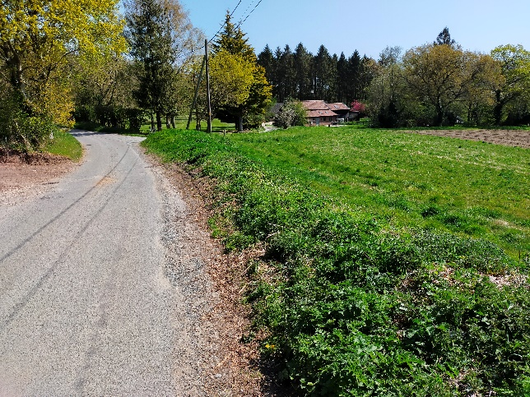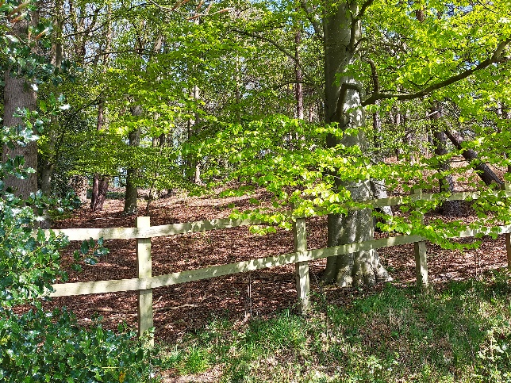

Looking East towards the stables Woodland north of Sunnyside

from Sunnyside

The conservation area is primarily rural in nature comprising the lush watermeadows of the valley floor, the wooded plantations, the grassy banks, hedgerows and isolated trees.

The water meadows have been cultivated in the south and south eastern part of the area, although part is used as grazing meadow (adjacent to Bussey Bridge). Wooded areas effectively enclose the conservation area. They are close to the road north of Sunnyside on the valley slope and contrast with the open river meadows on the opposite side of the road beyond which lies the significant tree belt of Seething Wood which, whilst not within the conservation area, forms a vital enclosing element to the setting of the conservation area. The wooded area to the west was once part of the Canterbury Estate and runs effectively from “Holly Lodge” down to the River Chet itself. There is a small copse of Fir trees located almost in the centre of the valley adjacent to the river and converted stable buildings.

Boundary hedgerows are an important feature of the conservation area, enclosing parts of the landscape, although historically some of these are much later additions, the open views south towards the river and north to Whipscrew Hill having been significant features of the valley.

Hedgerows along the western slope of Sunnyside, as it rises to the higher ground, combine with trees provide a tunnel-like quality along the road which adds to the experience of passing from the enclosed views of the valley slope down to the more open landscape of the river meadows below. A significant tree just forward of Holly Lodge seems to formally mark this change.

Smaller groups of trees and isolated specimens also contribute to the landscape quality. Of particular importance is the row of poplars on the south side of Sunnyside just beyond Bussey Bridge.

The other landscape feature which should be mentioned is the presence of gaps in the woodland on the north side of Sunnyside. The easternmost one contained a saw pit, sheds, stables, etc., connected to the Canterbury Estate, the western one adjacent to Cherry Tree Cottage was a "village pit" made available for the extraction of gravel. These "hollows" are important historic indicators of past settlement.

In summary, this particularly attractive valley landscape is one of softness and serenity contrasting dramatically with the hard edge provided by modern big field farming.

**Ground surface materials and street furniture**

The three roads through the conservation area are all tarmacadam with the majority of driveways being in natural gravel driveways/entrances. A couple of properties have a grey gravel finishes at their entrance from the road which is less sympathetic to the natural and traditional character of the area. One or two concrete hard standings can also be seen.

With regard to street furniture, other than an early 20th century red post box up half way up the hill along Sunnyside and a traditional parish noticeboard attached to a significant tree at the northeast corner of Holly Hill, there is nothing of note in terms of street furniture.

Conservation Management Guidelines

**Highways**

There is one modern directional highway sign amongst the hedgerow at the junction of Sunnyside with Bungay Lane but otherwise there are no highways signs in the conservation area. Roads have natural grass verges which are very much part of the rural character of the area.

**The lack of highways signage helps to retain the traditional rural character of the conservation area and therefore the lack of signage should be retained. The use of road kerbs should also be avoided as these will only detract from the rural character.**

**Upgrading windows and doors**

In some cases original timber windows and doors on traditional buildings have been replaced using different materials and/or to different designs. If original doors or windows need to be replaced then this should be done using the same original material and to the same design. If different materials are used then the new units should still match the original design

**Where windows/doors have been unsympathetically replaced in the past then the opportunity should be taken to reinstate traditional windows with more correct proportions.**

**Front boundaries**

An important feature of the conservation area are the mature boundary hedgerows in front of properties and lining the road.

**Whilst fencing has been used for a small number of boundaries every effort should be made to retain hedgerow boundaries, which form such an important part of the character of the conservation area.**

**Ground surfacing**

All road surfacing is tarmacadam between natural grass verges with the majority of driveways having a natural gravel finish.

**The use of more modern surface materials such as paviors on driveways should be avoided as this will only have a detrimental impact on the character of the conservation area.**

**Street furniture**

There is very little street furniture within the conservation area to detract from its traditional and natural character.

**Only signage that is absolutely necessary should be installed within the conservation area and where possible it should be positioned and designed so as not to detract from existing views.**

|  |  |
| --- | --- |
|  |  |

Appendix 1 (i)

**Listed Buildings**

54 – 55 Bussey Bridge (Bluebell Cottage & May Cottage) – Grade II

Lodge Cottage, Sunnyside (west side) – Grade II

Appendix 1 (ii)

**Buildings of townscape significance**

Holly Lodge, Penny Hill, Green Shutters, 1-2 Sunnyside, 4 - 11 Sunnyside, Holly Hill Cottage, Cherry Tree Cottage, The Stables, Watermeadows, Jay Cottages

Appendix 2

**Policy background**

In recent years, the approach to conservation area designation has changed considerably. It is now recognised that development plan policies, development control decisions, and proposals for the preservation or enhancement and the management of conservation areas, can best be achieved when there is a sound understanding of the special interest of the conservation area.

This position is reinforced as follows:

The Planning (Listed Buildings and Conservation Areas) Act 1990 in section 66(1) makes it a duty of local authorities when considering applications to have special regard to the desirability of preserving a listed building or its setting or any features of special architectural or historic interest.

Under section 72 of the same Act, it is a duty with respect to any buildings or land in a conservation area, to pay special attention to the desirability of preserving or enhancing the character or appearance of that area.

Department for Communities and Local Government. National Planning Policy Framework (NPPF) section covering “Conserving and enhancing the historic environment”.

Joint Core Strategy- Policy 2 : Promoting Good design South Norfolk Local Plan

The South Norfolk Local Plan Development Management Policies Document was adopted in 2015 and policy 4.10 covers Heritage Assets.

**Public Consultation**

An informal ‘walkabout’ of the area was organised with the Parish Council on 23rd  February 2022. This informed whether there should be any proposed boundary changes (no changes were proposed) and the conservation management guidelines within the draft appraisal. The public consultation on the draft appraisal took place from 1st July to 30th July 2022, which was extended to 31st August for the public meeting (questions to the officer) followed by presentation at the parish council meeting. The consultation and parish council meeting were advertised through:

• An advert in village notice board and local publicity by the parish council

• The draft appraisal being available to view on the council’s website.

• Emailing Ward Councillors, County Councillors, and the Parish Council.

As a result of the consultation corrections were made to the appraisal. One response requested that the boundary extend to the south of the river. The woodland area south of the river has not been included within the conservation area boundary because, whilst it acts as a backdrop to the hidden valley, it forms an extensive area of agricultural land that is detached from the key areas of settlement within the conservation area. Any planning proposals for such areas would however still be required to take into account impact on the setting of the conservation area.

Appendix 3

