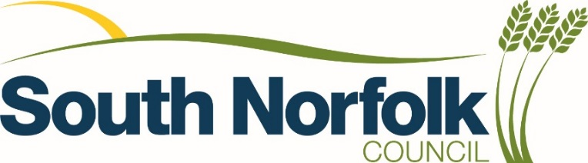
Terms and Conditions for Car Park Permit holders
Your season ticket is only valid for South Norfolk Pay & Display car parks and qualifying rules apply.
Long Stay car parks are:
Diss: Park Road, Shelfanger Road West, Church Street (Monday-Thursday only).
Wymondham: Town Green and Cemetery Lane
Loddon: Church Plain and The Staithe
Short Stay car parks for Residents Only are:
Diss: Chapel Street Lower, Chapel Street Upper, Mount Street and Weavers Court
Wymondham: Market Street and Back Lane
Car park Permits will be issued for the vehicle specified on the application form and ARE NOT TRANSFERABLE
No refunds will be given in respect of car park permits with less than 1 month’s duration.
Please inform South Norfolk Council is you no longer require your permit and wish to cancel the service by email to parking@southnorfolkandbroadland.gov.uk or by contacting 0808 178 1745.
If you move house or change your personal details, please inform us at your earliest convenience.
Penalty Charge Notices (PCNs) will be issued for:
- Failure to display a valid car park permit
- If the vehicle is parked in a designated disabled bay without displaying a valid Blue Badge
- Failure to park in the agreed car park
A car park permit does not guarantee a space
If you require any further information or advice, email parking@southnorfolkand broadland.gov.uk or call our Freephone telephone number 0808 178 7145

Data Protection Information
Civil Enforcement Officers patrol this site and utilise hand held camera devices in order to enforce the parking terms and conditions. Where these have not been complied with, your personal data may be collected, processed, shared and retained in order to carry out the performance of a public task and fulfil our legal obligations in the following ways:
To request details of the registered keeper of the vehicle from the DVLA in order to pursue a Penalty Charge Notice.
Shared with third parties for appeals and enforcement.
Shared with the police or security organisations to prevent or detect crime.

Your Data Rights
In relation to the personal data which we may hold about you, you have the right to request to be informed, have access or rectify incorrect information. You also have the right to object to or restrict our processing of your data.
Under data Protection law we must verify your identity and explain to you our reasons if we do not agree to carry out your request.

Contact and Further Information
If you would like more information about how we use your data, please read our Privacy Policy at https://www.southnorfolkandbroadland.gov.uk/data-protection/privacy-policy.

Data protection questions should be sent to right2know@s-norfolk.gov.uk

You also have the right to complain to the Information Commissioner’s Office at www.ICO.org.uk.

